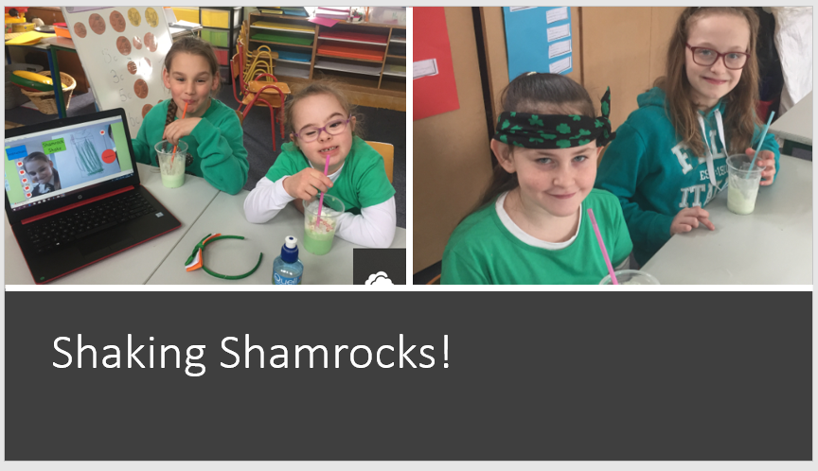
Some of the girls from third and fourth class had great fun making shamrock shakes to celebrate St. Patrick’s Day.

