Week beginning: 31/03 Class and Subject: English Group 1 Ms. Gleeson SEN Teacher: Ms. Hogan
Suggested work below can be carried out over a week. Don’t worry if it’s not all done. Uncompleted work can carry on to the following week.
Week 3  31/03 | Suggested Daily Reading:  - Oxford Owl: type Oxford Owl into search engine. Register and log in to download books for free. Suggested Reading: The Frog Prince, Incredible Animals and Tidy up Winnie.  - Please find attached a document with some readers. The reader can be viewed on an electronic device or printed. Please read:  - The Cat and The Rat,  - Sam’s Ram,  - A Blue Cap  - Here is Dan  - Continue with Reading Fluency sheets that are in the reading folder.  - Of course, reading includes any suitable book that you have at home or found online. If you are a member of the library you can borrow books using an App or through the website BorrowBox. It’s free and there’s a children’s section.  - Practice the ‘dolch’ words that are in your daughter’s writing copy. There is a copy of the dolch words at the end of this document. | Parents/Guardians  Comprehension questions to ask your daughter:  - Predicting- Before starting the book, discuss the cover and title- What do you think the story is going to be about?  - Connecting- Does that remind you of anything?  - Comparing- How is this different to when…?  - Inferring  - Creating Images- Draw a picture of your favourite scene so far. Draw a picture of your favourite character. Write a sentence under each picture explaining why you liked that event/character.  - Synthesizing- Think of what has happened so far…what do you predict will happen next  - Self-questioning  - Skimming – Have a quick look and tell me what you think the story is going to be about?  - Scanning – Can you find where it says Biff’s friend’s name? Can you find a word that means big?  - Re-reading- We’re going to read this page again and watch out for all the full stops. We will try to read with expression.  Things to do if we are stuck on a word  - Sounding out- let’s sound out the letters  - Reading on- Let’s skip that word for a minute and see if the rest of the sentences helps us figure out what it is.  - Chunking-Let’s break this word into parts e.g. to-get-her – together.  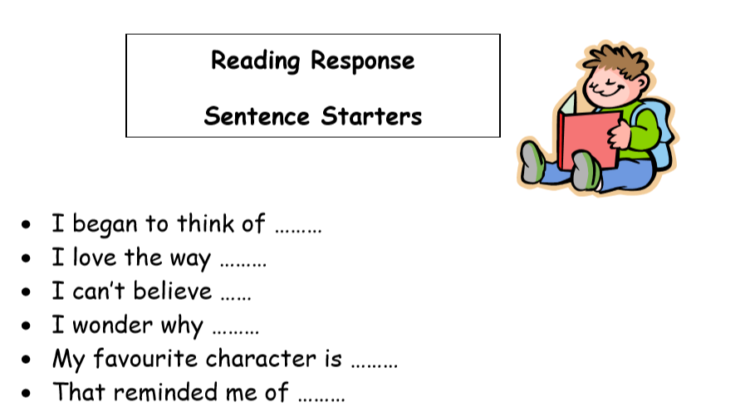
Dolch First Class Sight Vocabulary

after  again  an  any  ask  as  by  could  every  fly  from  give  going  had | has  her  him  his  how  just  know  let  live  may  of  old  once  open | over  put  round  some  stop  take  thank  them  then  think  walk  were  when

