Week beginning: 31-03-2020 Class and Subject: 4th class maths SEN Teacher: Ms. Conran
Work below is to be carried out over a week. Uncompleted work can carry on to the following week.
Week 31/03 | Activity Booklets  - Continue with the booklets that I made for you. You can work at your own pace. If you have clothes pegs or popcorn kernels at home, you can use these to help you count. | Time  - Download this app: “Interactive Telling Time” app. This app is a great way to practice telling the time. It is fun and is also free to download!  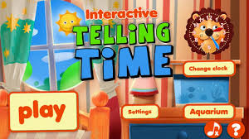 | Online Maths Games:  - “Top Marks” website.  - 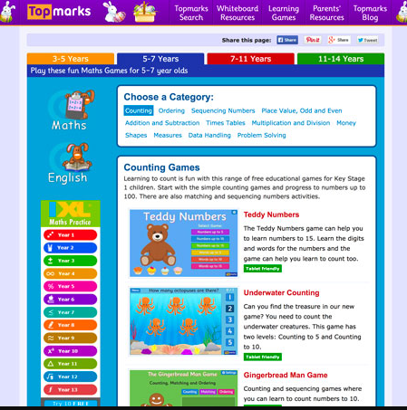  - There is some very enjoyable games for you to practice your maths. Here are some suggestions for games that you may enjoy.  - Counting: Teddy Numbers, Ladybird Spots, Helicopter Rescue, Chopper Squad.  - Sequencing Numbers: Caterpillar Ordering, Paint the Squares, Chinese Dragon.  - Addition and Subtraction: Mental Maths Train, Daily 10, Number Fact Families, Ten Frames.  - These are just some focused suggestions, but feel free to explore some of the other games. Enjoy.
 | Board Games  - Board Games: If you had ‘Snakes and Ladders’ at home, this would be great to practise your counting. You could also throw the dice twice and add the numbers before counting forward.  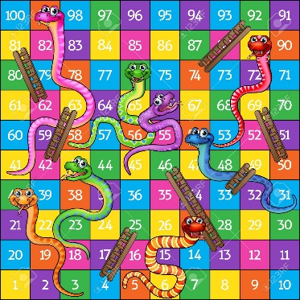 | Outdoor Games  - Outdoor Games: Throw a ball with a partner or in a circle of a few people and count on as you catch the ball. See how far you can count before the ball drops (you can count on from a higher number too, you don’t have to start at 1).  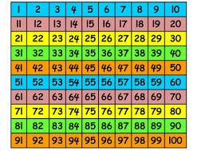 | - Money  - Everyday maths: Grocery shopping, rounding item prices up to the highest euro to find estimates on prices.  - Find items and prices on the Tesco or Supervalu websites. Estimate prices to the nearest euro.

