Week beginning: 20-04-2020 Class and Subject: 3rd class maths SEN Teacher: Ms. Conran
Work below is to be carried out over a week. Uncompleted work can carry on to the following week.
Week 31/03 | Activity Booklets  - Continue with the booklets that I made for you. You can work at your own pace. If you have clothes pegs or popcorn kernels at home, you can use these to help you count. | Time  - Download this app: “Interactive Telling Time” app. This app is a great way to practice telling the time. It is fun and is also free to download!  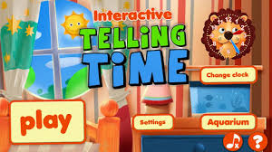 | Online Maths Games:  - “Top Marks” website.  - 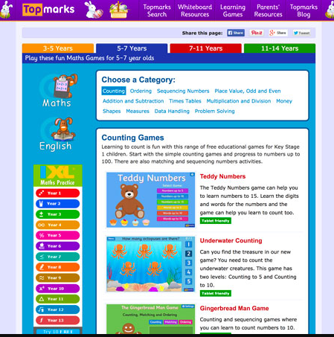  - There is some very enjoyable games for you to practice your maths. Here are some suggestions for games that you may enjoy.  - Counting: Teddy Numbers, Ladybird Spots, Helicopter Rescue, Chopper Squad.  - Sequencing Numbers: Caterpillar Ordering, Paint the Squares, Chinese Dragon.  - Addition and Subtraction: Mental Maths Train, Daily 10, Number Fact Families, Ten Frames.  - These are just some focused suggestions, but feel free to explore some of the other games. Enjoy.
 | Board Games  - Board Games: If you had ‘Snakes and Ladders’ at home, this would be great to practise your counting. You could also throw the dice twice and add the numbers before counting forward.  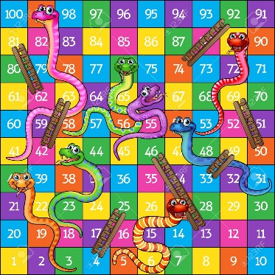 | Outdoor Games  - Outdoor Games: Throw a ball with a partner or in a circle of a few people and count on as you catch the ball. See how far you can count before the ball drops (you can count on from a higher number too, you don’t have to start at 1).  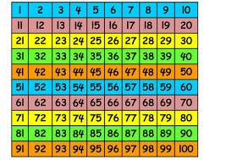 | - Money  - Everyday maths: Grocery shopping, rounding item prices up to the highest euro to find estimates on prices.  - Find items and prices on the Tesco or Supervalu websites. Estimate prices to the nearest euro.

Here are some relevant maths worksheets for you to complete for the week. If you have a printer you can print them and if not you can write them in a copy book.

