Week beginning: 20th of April Class and Subject: English SEN Teacher: Ms. Hogan
The suggested work below is to be carried out over a week. Don’t worry if you don’t get it all done. Uncompleted work could be carried on to the following week. Try your best. Spend 30 minutes a day on English. Scroll down through the document to get activities.
Week 4  20th April | Spelling  Continue with SNIP spellings.  Complete one session per week.  Get a parent or guardian to test you on Friday.  Revise spellings from previous weeks also. You are familiar with how to do this from how we test ‘old’ spellings on a Friday.

Monday
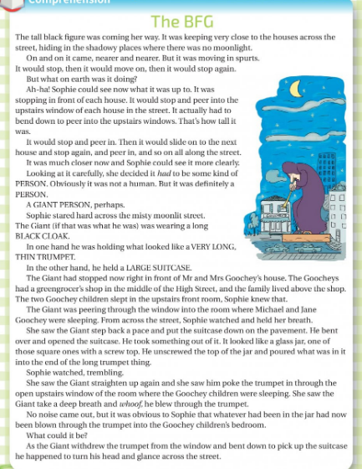
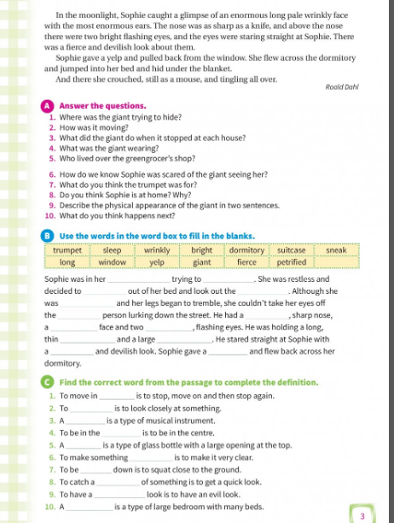

Tuesday

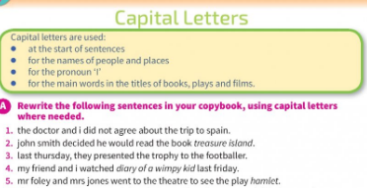

Wednesday
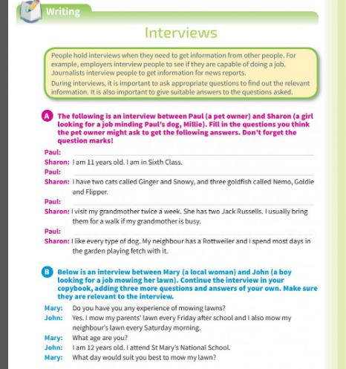
Activity
Watch this interview of clip interviewing Jason Momoa ( Aquaman) https://www.youtube.com/watch?v=rWb2gddZrMU
Imagine you are a newspaper reporter. You are interviewing your favourite singer or any celebrity. In your copybook/refill pad write out an interview that might take place between you.

Thursday
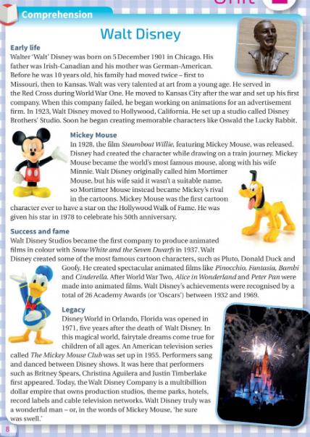
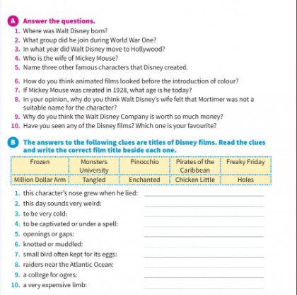

Friday
Read this text on animals. It’s just for fun. You do not need to write any answer questions. Enjoy!
