Week beginning: 20/04/2020 Class and Subject: 5th & 6th class English as an Additional Language Group SEN Teacher: Ms. Conran
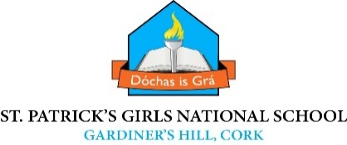
Work below is to be carried out over a week. Uncompleted work can carry on to the following week.
Week 3  31/03 | Enjoyable Online Reading Resources:  - Download the app: “Epic Reading” app, which is free to download for the first month free trial. Choose and customise reading for your child by choosing their reading level and interests. Stories will then be suggested for your child based on these criteria.  .  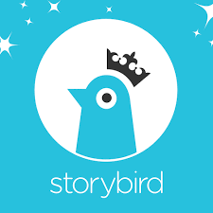 | Dolch sight words:  - Website: National Geographic Kids  https://www.natgeokids.com/ie/  - This website could be an interesting and fun resource for the girls to research project work on various animals or countries and the environment as a whole.  - Choose a topic to undertake a fact based project. As you are excellent artists you can add your own creative illustrations.  - This website also has some fun games and quizzes for children which you can set to varying difficulty levels. Some examples:  - Artic Animals Memory Game  - Cats Memory Game  - Quiz Whiz: The Moon | Tree Tops Reading  - Website: “oxfordowl.co.uk” This website will allow you to access ebooks of various levels once you set up an account.  - Read: The White Rhinoceros and complete the questions attached.  - Listen to your child’s reading. Focus on vocabulary development, discussing the meaning of certain words. Ask them questions about what they have read to develop their comprehension and understanding. Ask them to predict what will happen next in the story. The child can summarize the story in their own words afterwards.  - Also, talk to the child about the pictures in the book. Can they describe them? What do they see?
 | - Website: “Storybird”. You can sign up for a month free trial. There is a large variety of story books that your child can read. Focus on picture books and comics as there will be a lot to discuss with your child based on the pictures as well as the reading | Daily Writing Activities  - Encourage your child to undertake short focused writing activities and tasks. For example:  - My News  - Writing a short letter or postcard to grandparents  - Writing a procedure, e.g. a recipe, an experiment  - Writing a daily diary  - Writing imaginative short stories  - Engage in project work on a theme of your choice, e.g. wild animals, countries, the solar system, a historical person you admire.  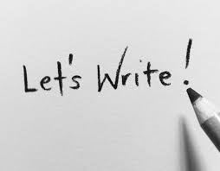 | Note to Parents:  - This is only a menu of work so feel free to pick and choose work that you feel is appropriate for your child and work away at your own level.

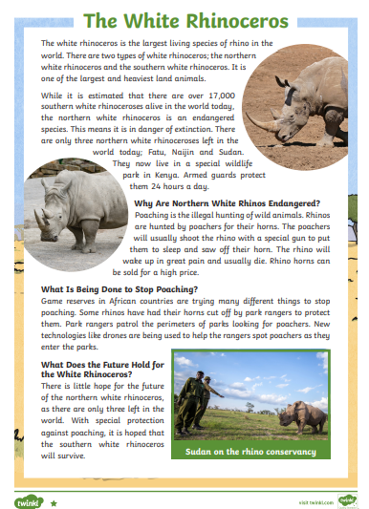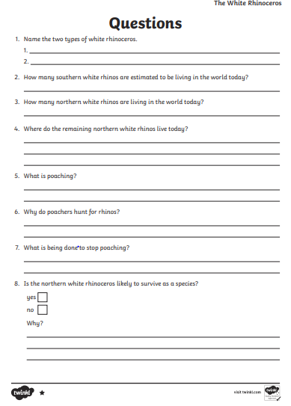
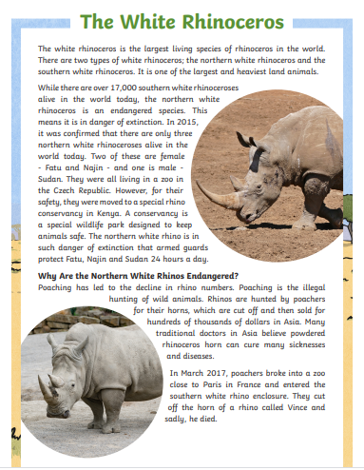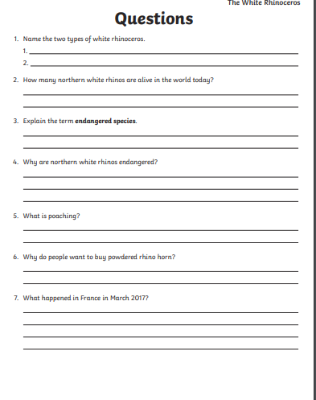
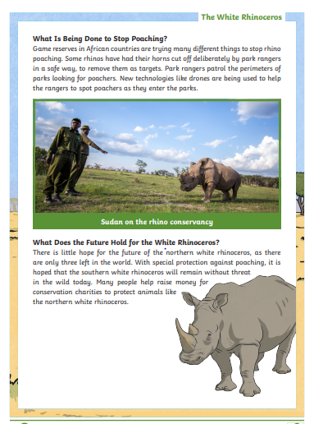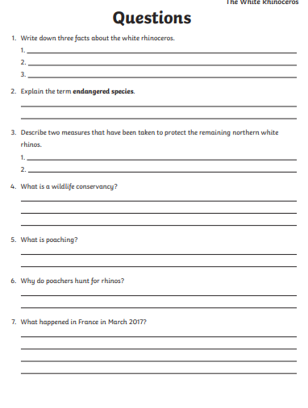

Some template ideas for writing about a country of choice:
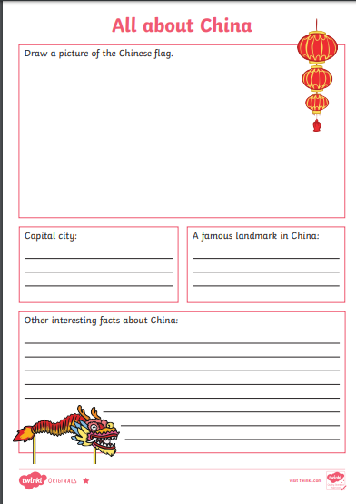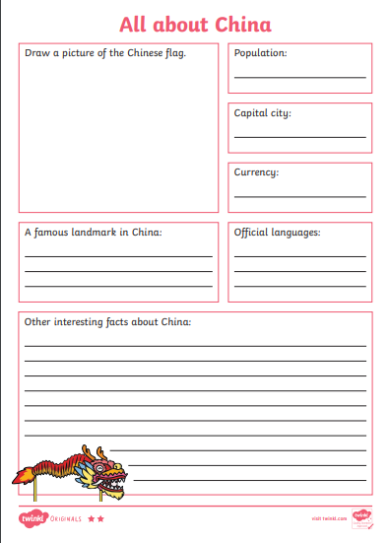
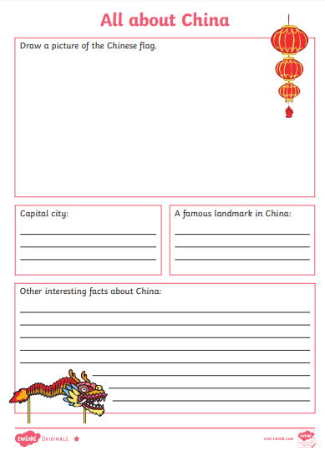

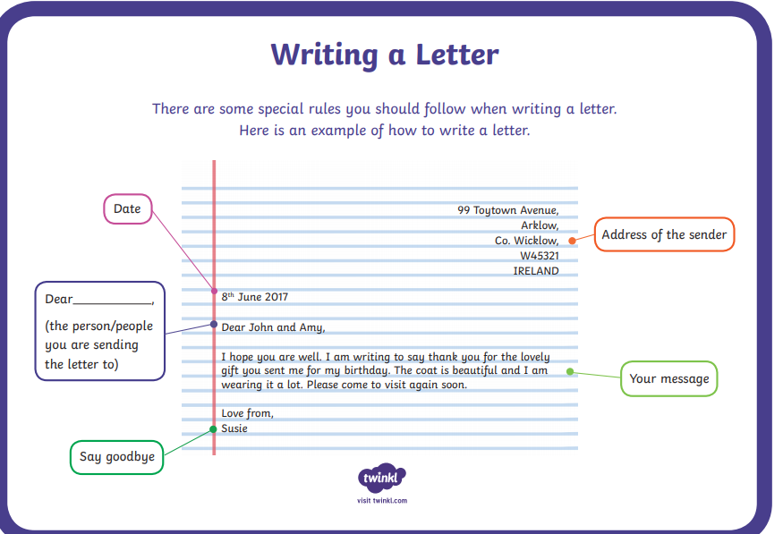

A suggested template for writing a letter
