Even more ideas.

Bowling at home – great idea! click here for bowling activity

Tuesday
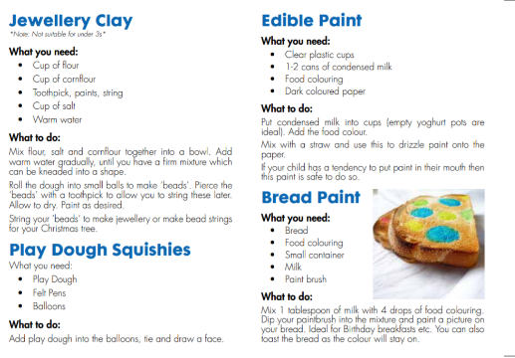

Investigate

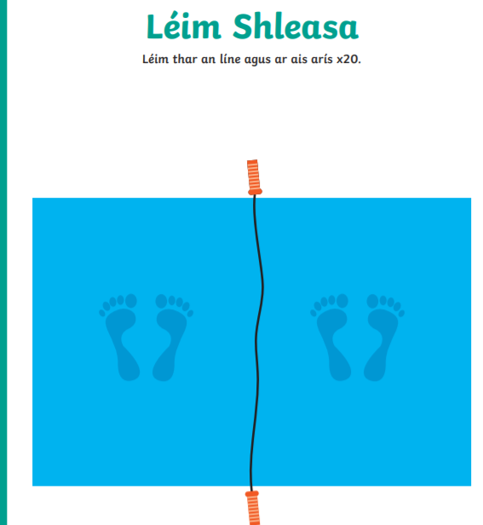
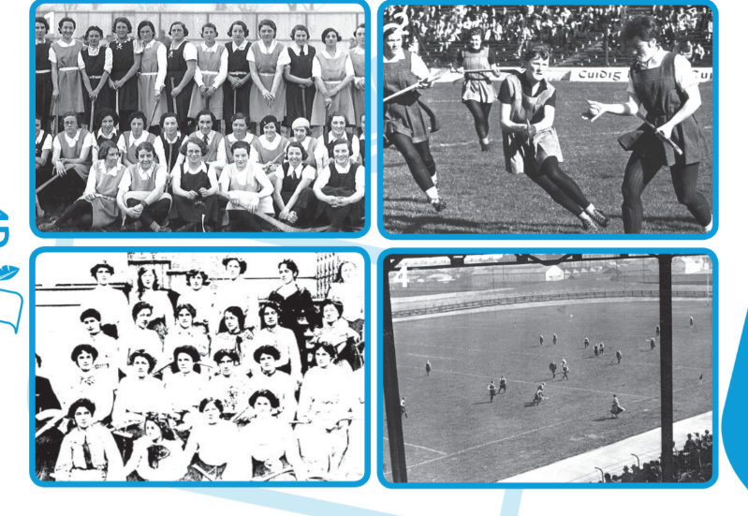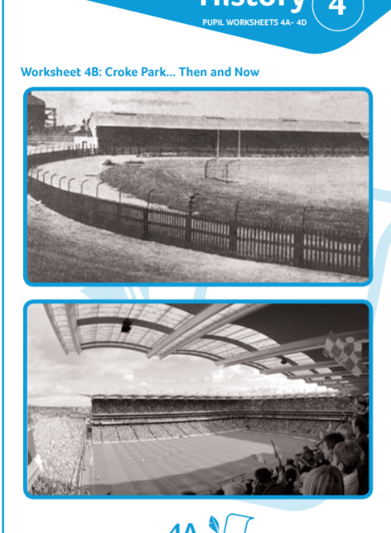
Look at the 2 photos
- Discuss similarities and differences between the photos
- Estimate what year these pictures were taken in
- Which is the oldest photograph? What changes have been made to the stadium, the clothing and playing equipment?

Wednesday
Skill
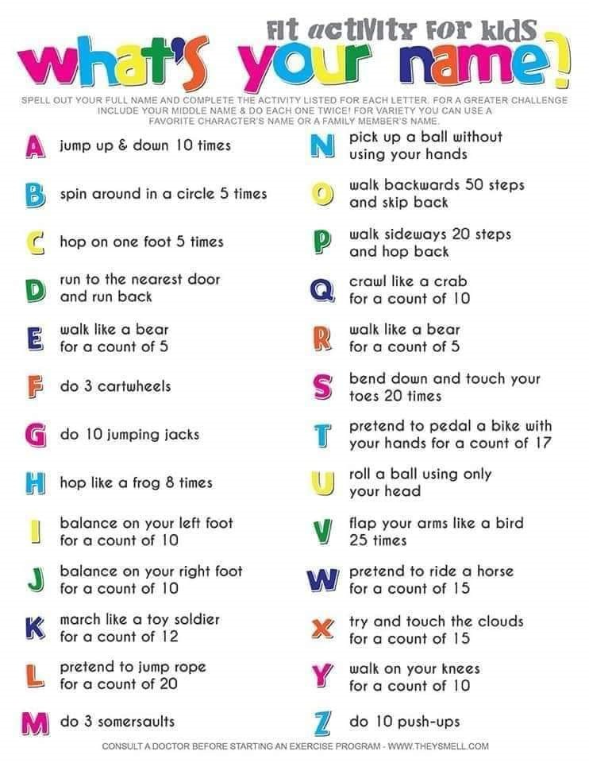

Friday
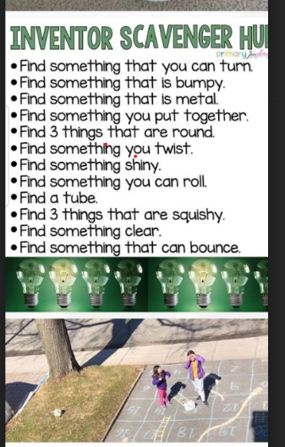

Try as many of these other activities as possible!

I like to Move it
Click on a song title to open link to dance
Can’t stop the feeling (learning video)
Can’t stop the feeling (performance)
I Feel Alive
I’m Still Standing
Twist and Shout
Believer
Footloose
I Gotta Feelin’
Wadillyocho
Always look on the bright side of life
I Don’t Care
Everybody
Keep in Touch

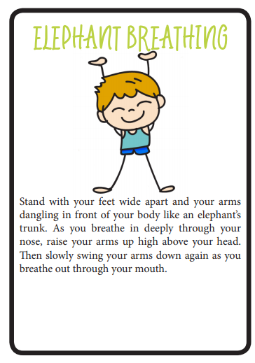
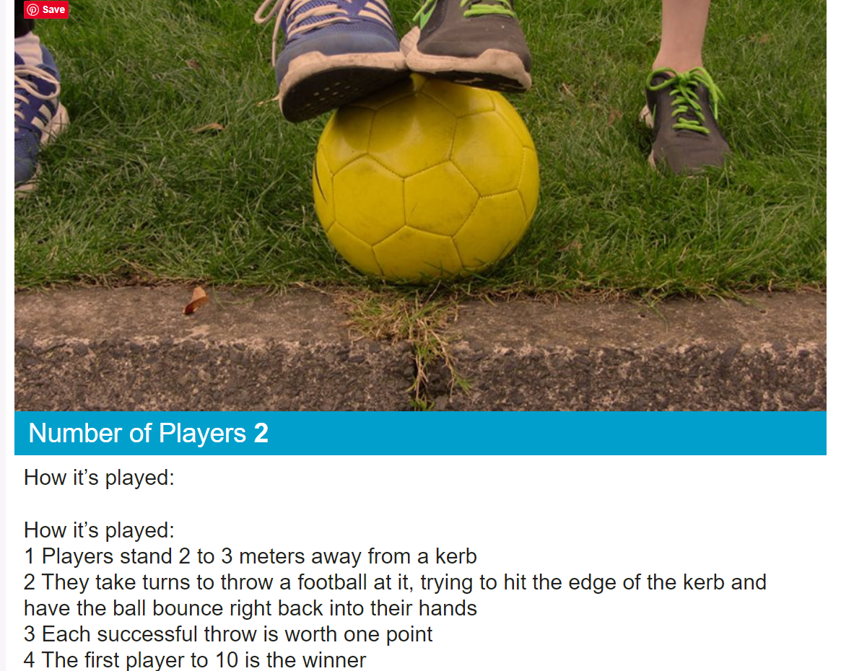

Click here for a lovely one minute mindfulness exercise

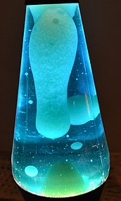

Lava lamps - Click on the link to make your own Lava Lamp How to make a Lava lamp Click here
https://www.youtube.com/watch?v=YeJGAhhIOYA (45mins in)

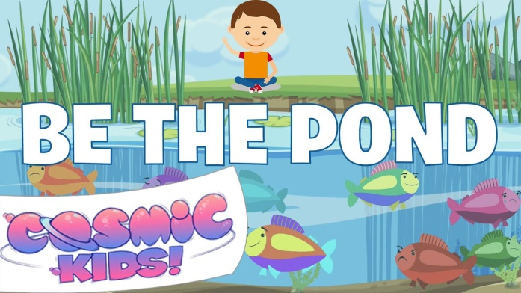

We are all experiencing many feeling at this time. Feelings are all normal. This exercise will help you with all your feelings.
Click here to watch a lovely video to help you to understand feelings

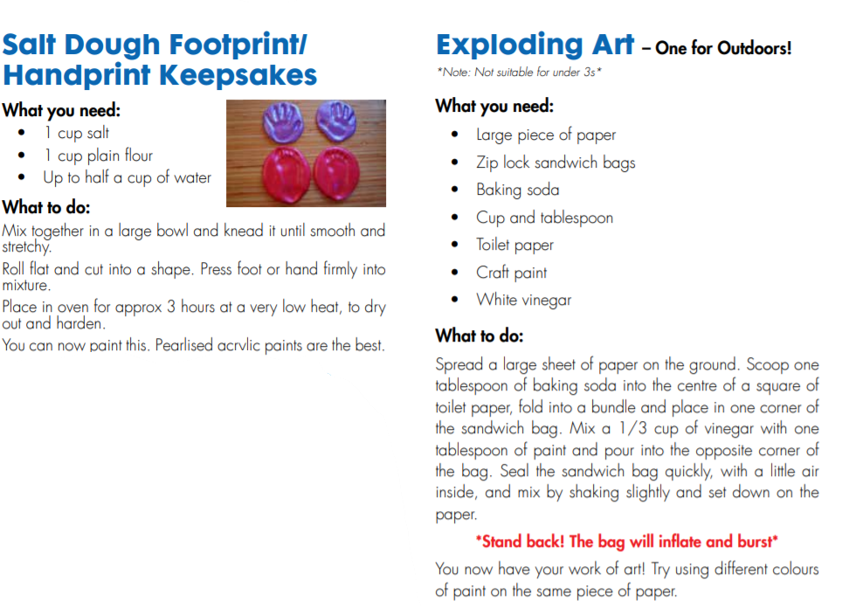
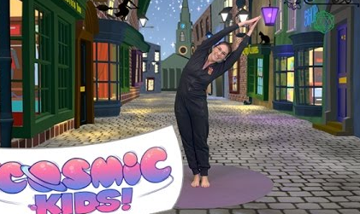
Some art activities

Click here for Harry Potter yoga

- Think about your favourite Yoga Pose
- Sketch a picture of it

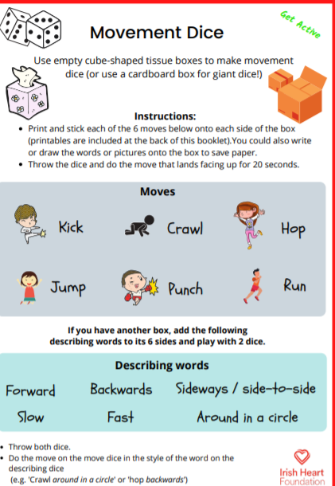

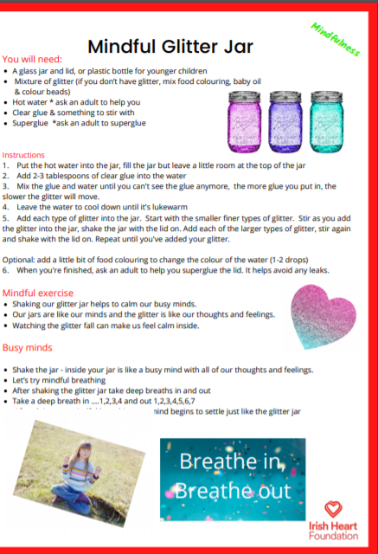

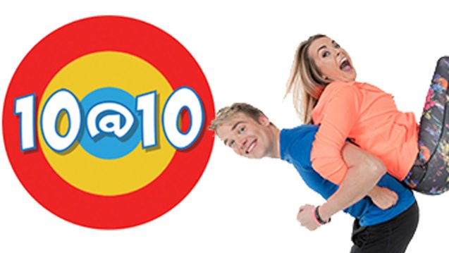
The 10@10 challenge
10 @10 10 Click here

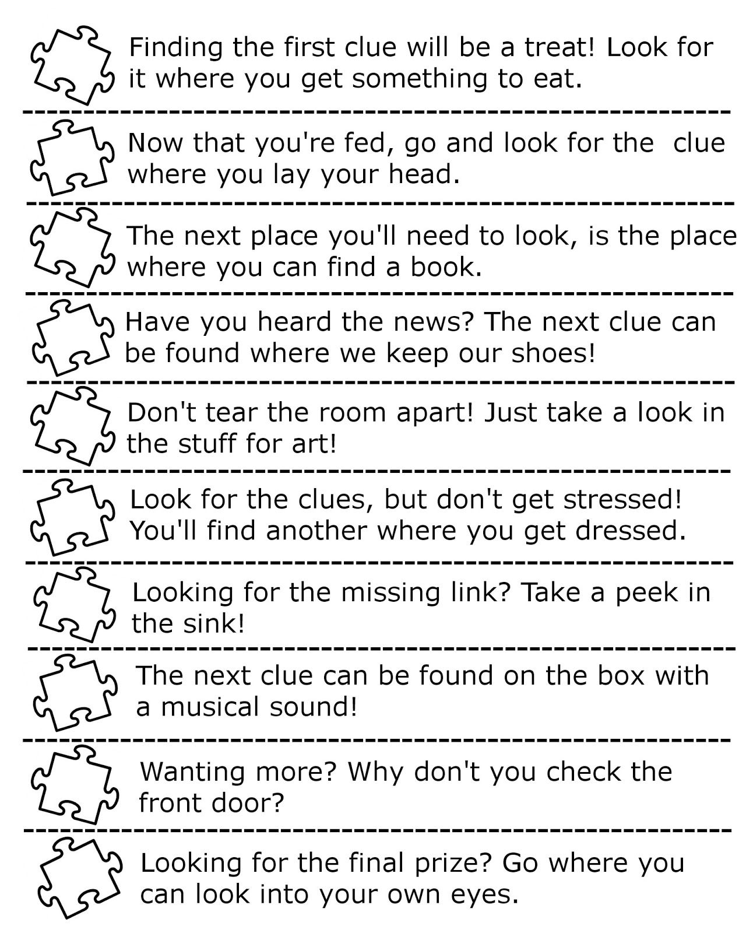

Why not design your own treasure hunt or scavenger hunt using these clues

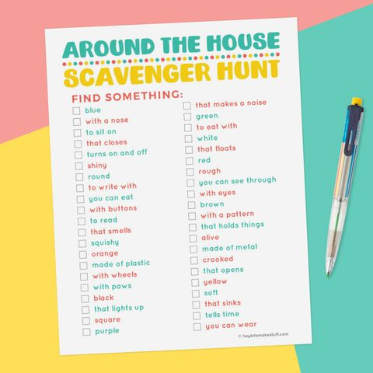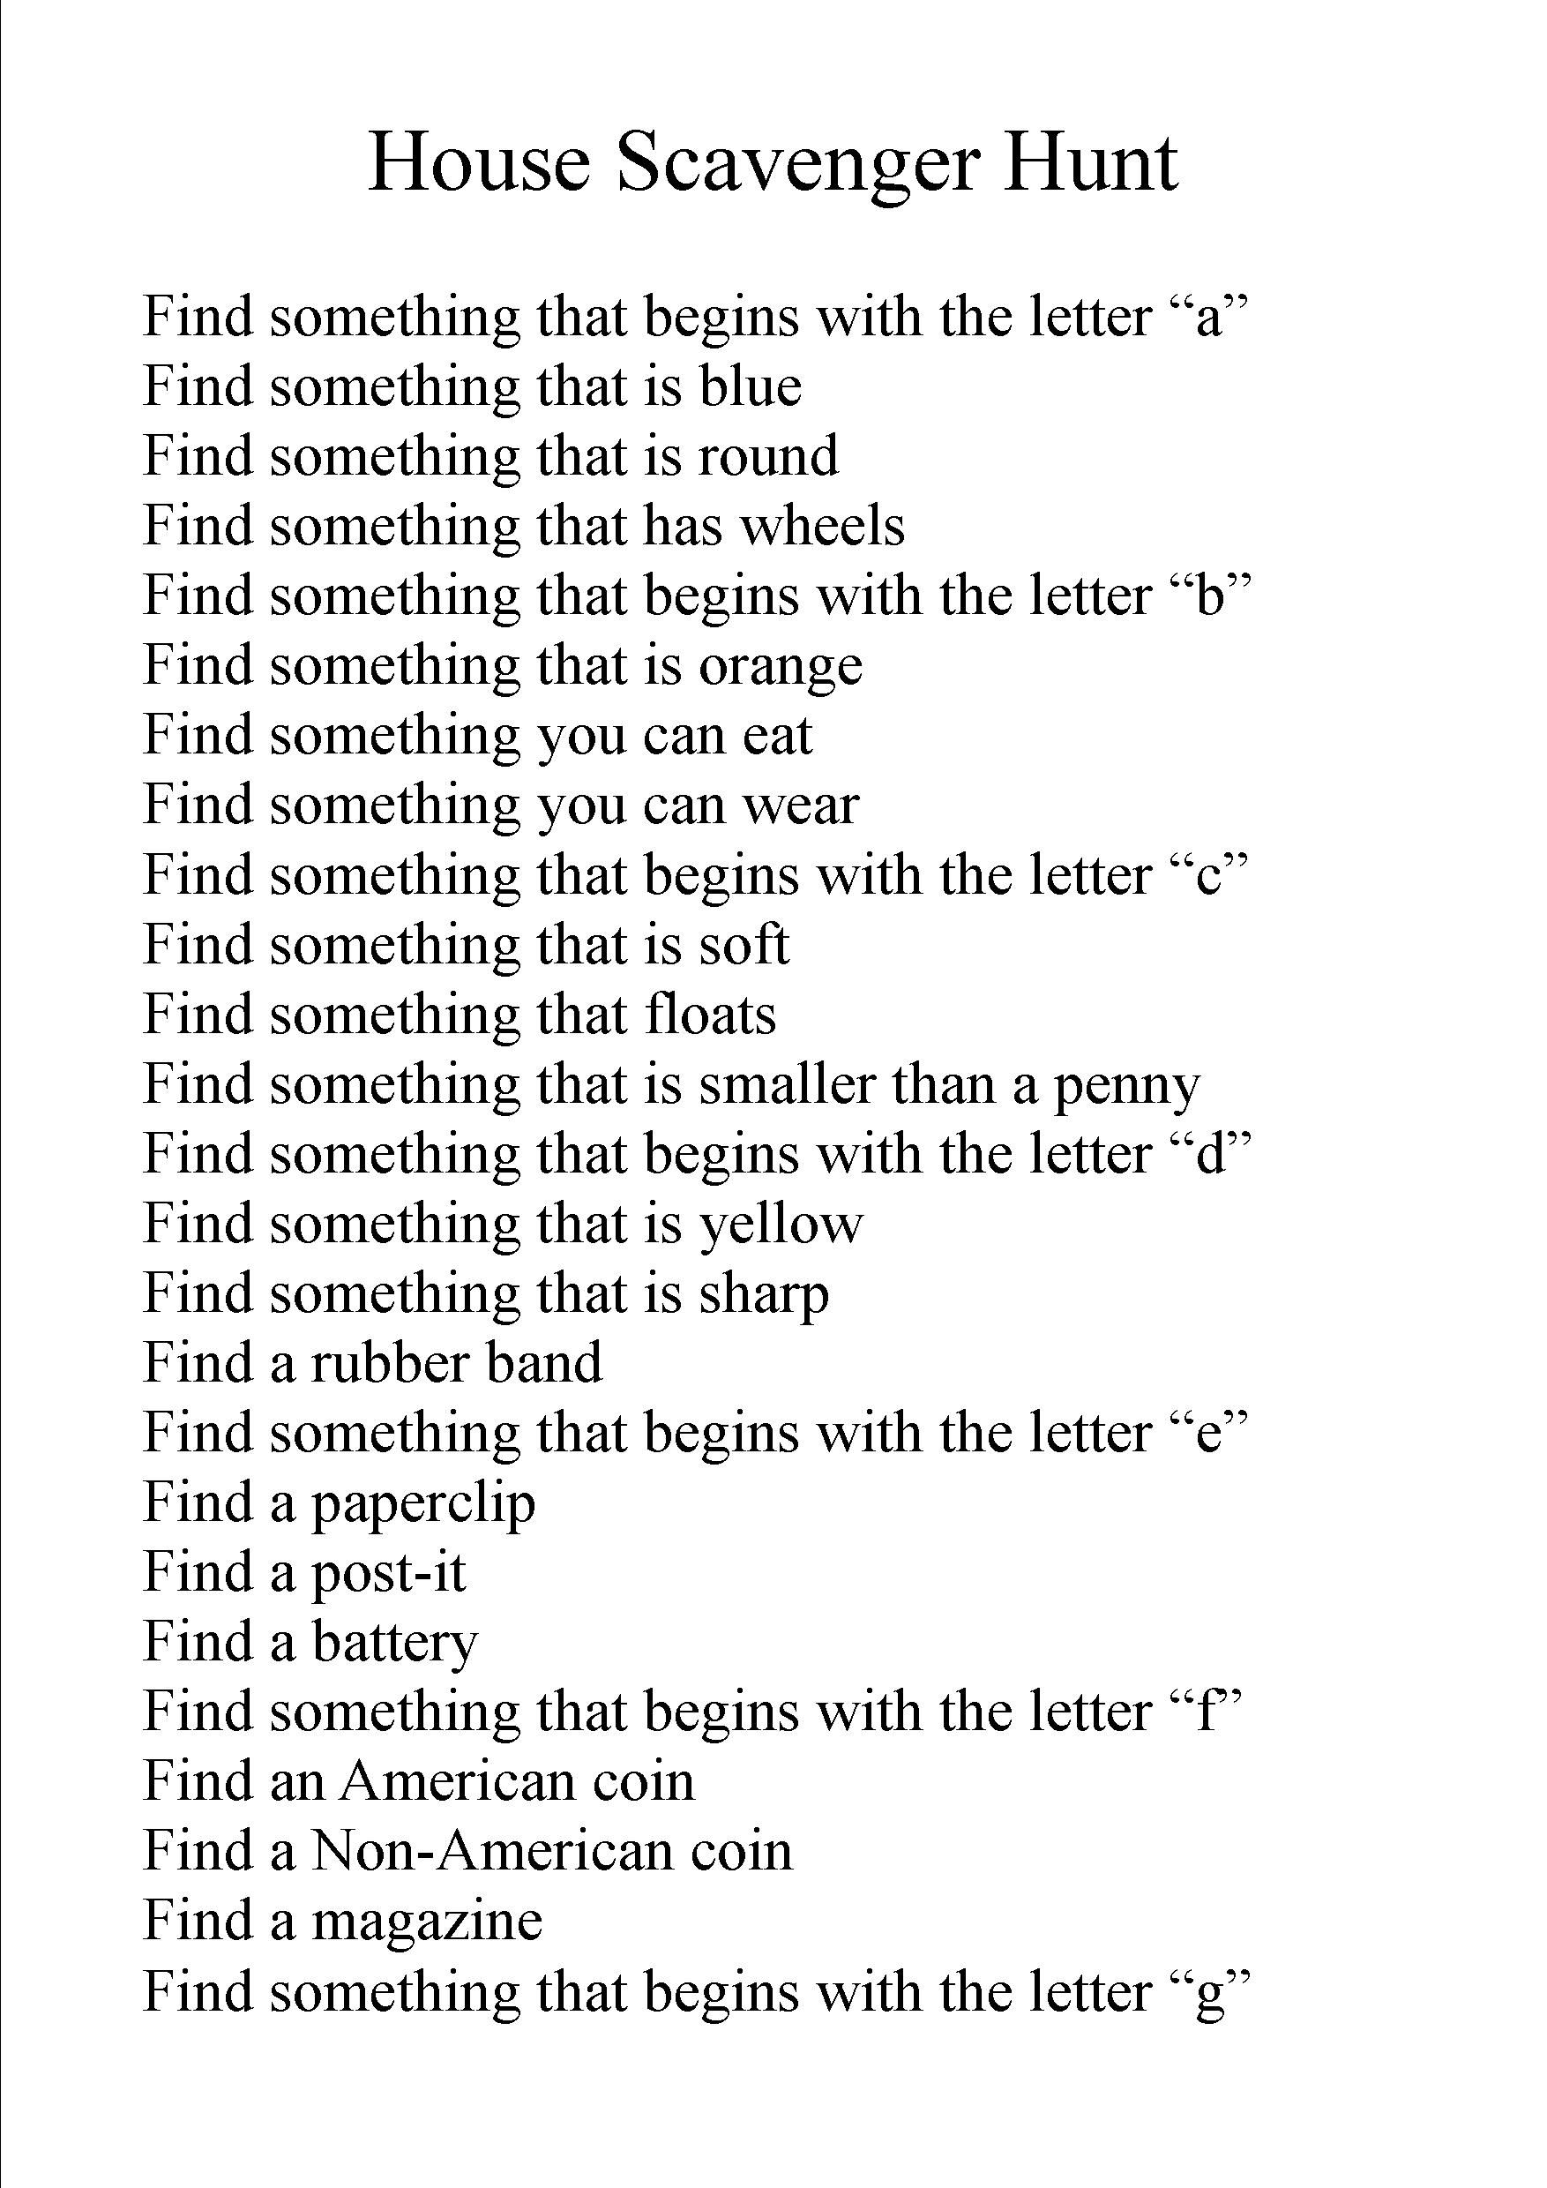
Change coin question to Irish/Non Irish coins!

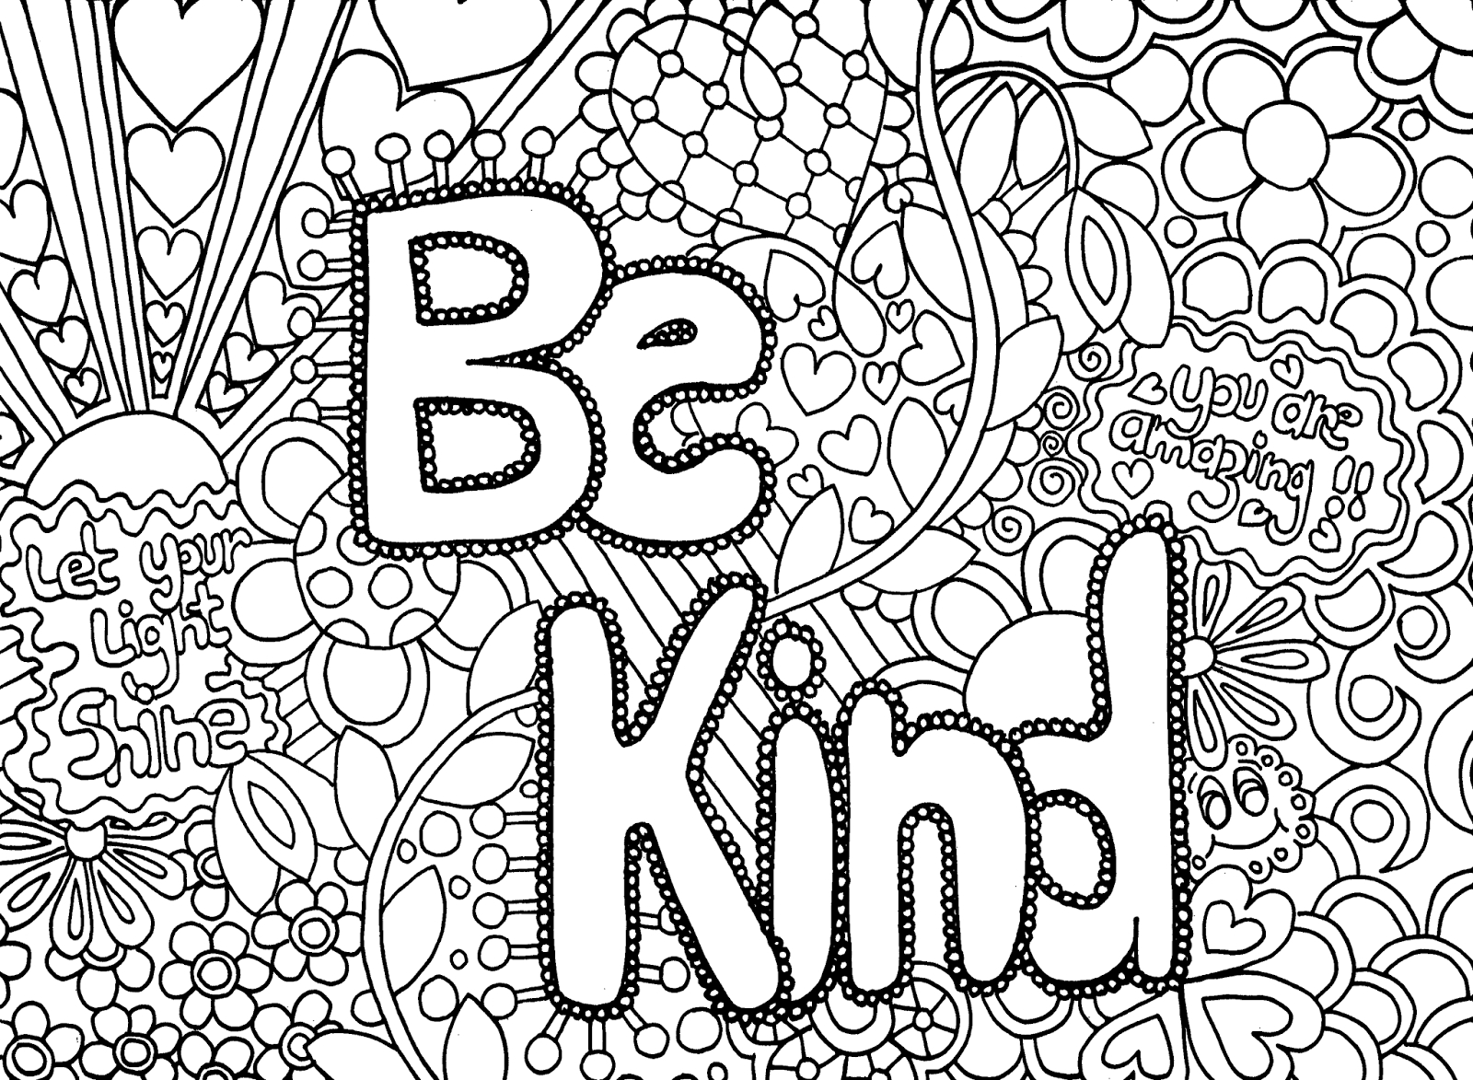
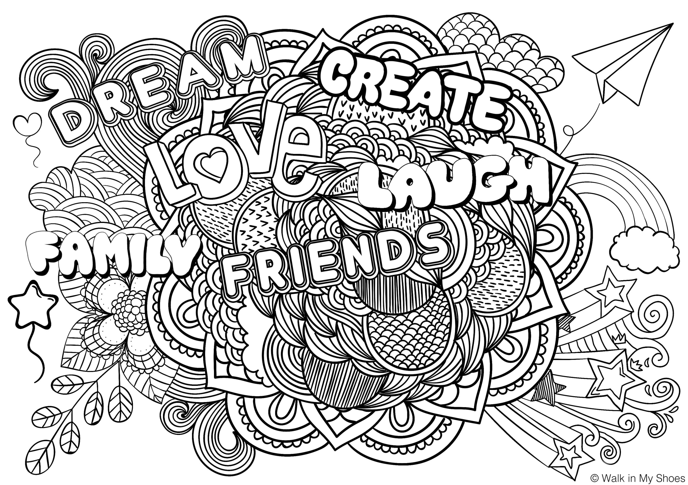

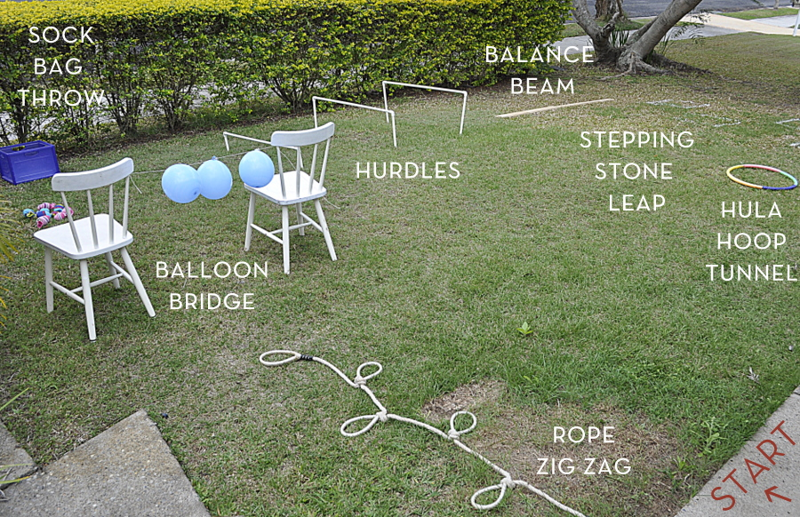
Why not try creating your own indoor or outdoor obstacle course?

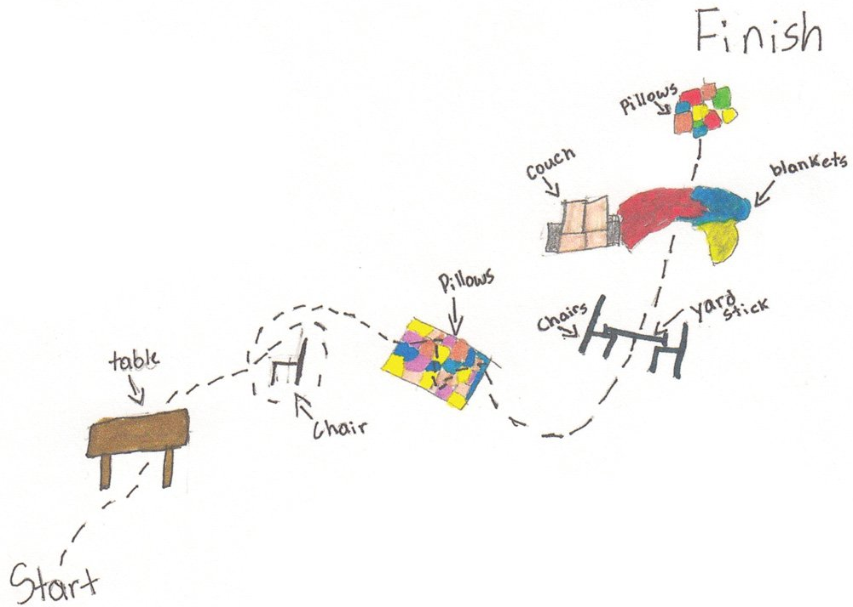
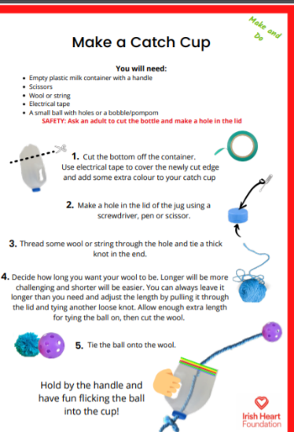
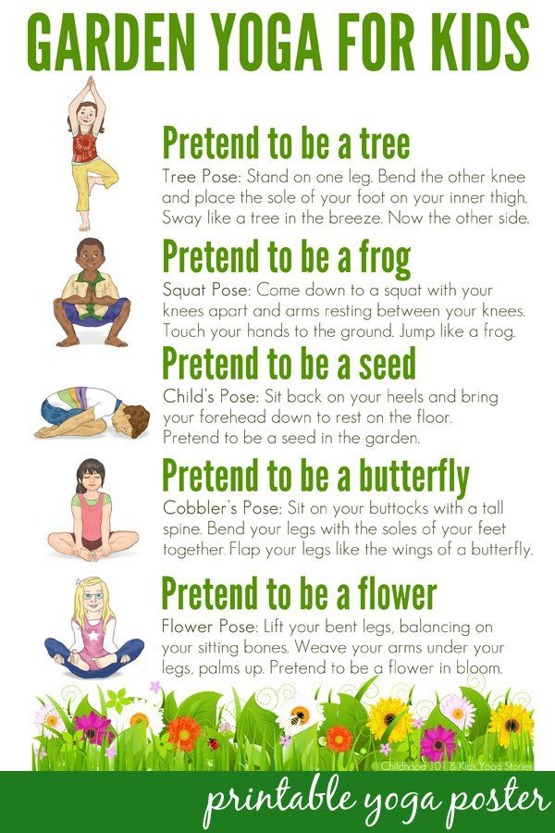

SkipnRope has fantastic skipping activities.

There are lots of youtube videos of Mark showing skipping skills https://www.youtube.com/channel/UChv0GUoeif1tHONdgg_bthQ

Try this to learn the “double under skip”
https://www.youtube.com/watch?v=48y6Bpsj8qA

