October news
by Ruth Callaghan and Sarah Porter (6th class)

It has been very exciting in 1st, 2nd and 3rd classes. Here is what they have gotten up to in October:

In 1st class they have started “Book Buddies”. They have teamed up with 4th class and are reading books. They are having a lot of fun.
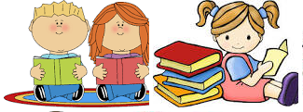

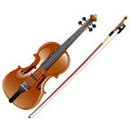
They have started to learn how to play the violin. It’s their first time playing the violin and they love it. They have also started to play camogie and are really enjoying it.

They had a lovely teddy bear picnic.
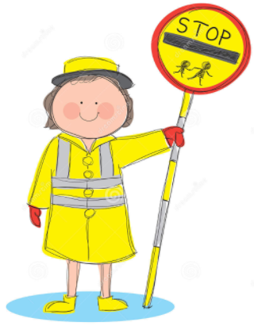
1st and 2nd classes both had a very important visit from Miriam the lollipop lady. They have learned how to cross the road and how to be safe.

2nd class visited Blackrock Observatory. 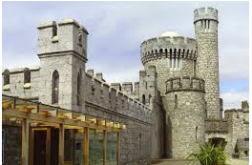They went to the top of the castle and learned all about space! They made a time capsule. Lastly, they went into a tent and they were able to look at the sky at night time! They also learned all about the stars.
On the 26th of October, 2nd class had their Enrolment Ceremony. This ceremony helps to prepare them for their First Holy Communion.

2nd class did amazing science experiments for science week, such as a condensation experiment and an egg experiment.
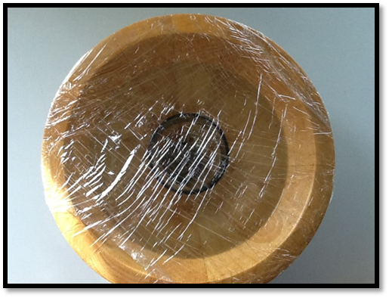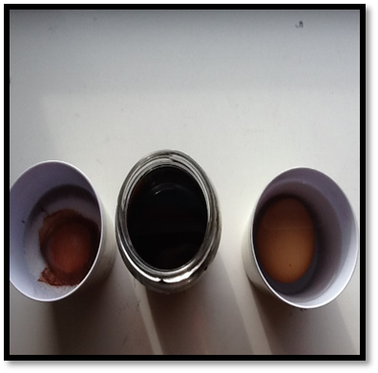

They also learned all about autumn and they made creative art with hedgehogs in the picture.
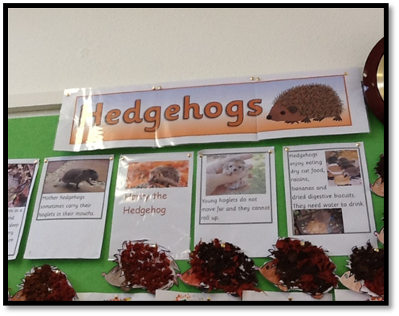

3rd class have also started violin and some of the girls are learning how to play the cello.

They have visited the library twice and have also gone to mass.

For science week they did an experiment. They were experimenting using acids and bases!

They have also done beautiful winter art!

All of the classes dressed up for Halloween and they were all very frightening!

They have had a fantastic time!!!

