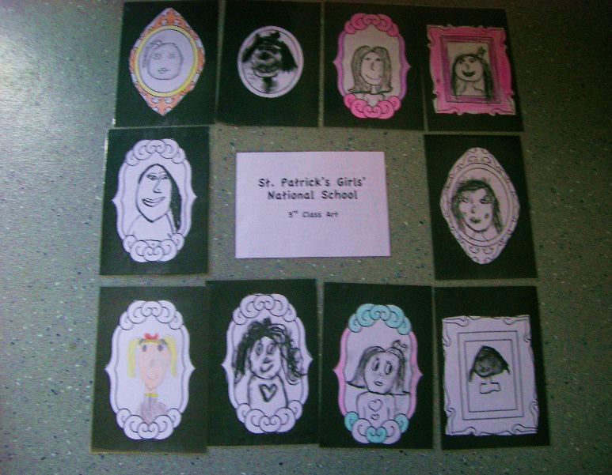

3rd class have settled into the school year very well! They have made beautiful Self-portraits. They made them using charcoal!

They have made their first trip to Mayfield Library. They received their new library cards and I’m sure very soon they will be excellent readers.

They have started gymnastics and are really enjoying it.

In Irish, they wrote all about themselves. There is a picture of themselves to go with the writing.

3rd class have had a lot of fun!

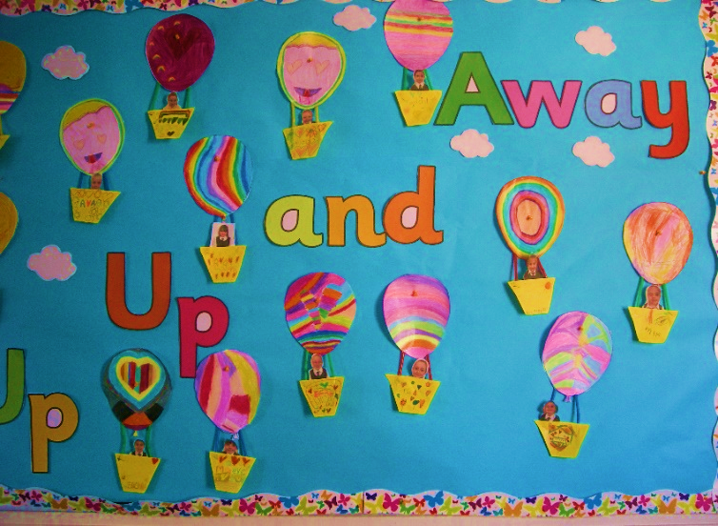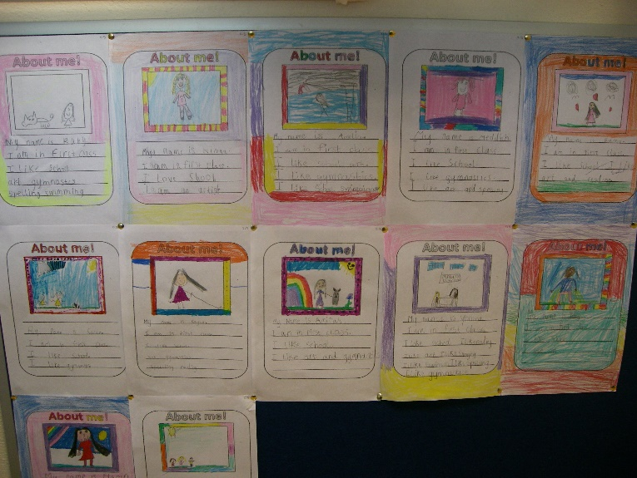

2nd class are having a great time.

They went to Mayfield swimming pool and are doing swimming for six weeks. They are like little fish!

They made lovely, decorative hot air balloons. They are so colourful and bright! They stuck in a picture of themselves so that it looked like there were in the balloon. They are very artistic!

I think that 1st, 2nd and 3rd class have started the school year incredibly well!!

1st class are really enjoying school!

They have started gymnastics and LOVE it!! They have taken pictures with their parents. The photos are lovely and everyone has gorgeous smiles!!!