Week beginning: 31/03 Class and Subject: MD Ms. Gleeson SEN Teacher: Ms. Hogan

Hi Molly,
Hope you are keeping well and in good spirits. Here’s a list of some of the work that you can continue doing at home next week. It follows the same format of literacy homework so I hope it’s easy to understand. No problem if you don’t get to complete everything. Uncompleted work can be carried onto next week.
Week 3  31/03 | Suggested Daily Literacy work:  - Picture and word vocab match: We usually learn 4-5 words per week. The words and pictures are in the folder.  - We read 1 Oxford Reading Tree Book per week. The books are in the folder.  - Handwriting Without Tears  - Listening and following directions activities in folder.  - Revise older words from previous books read  - Use the words to make your own sentences. | Parents/Guardians  Comprehension questions to ask your daughter:  - Predicting- Before starting the book, discuss the cover and title- What do you think the story is going to be about?  - Connecting- Does that remind you of anything?  - Comparing- How is this different to when…?  - Creating Images- Draw a picture of your favourite scene so far. Draw a picture of your favourite character. Write a sentence under each picture explaining why you liked that event/character.  - Re-reading- We’re going to read this page again and watch out for all the full stops. We will try to read with expression.  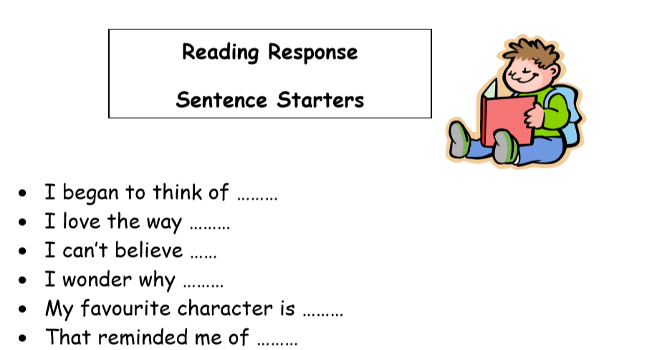
Dolch Words

a  and  away  big  blue  can  come  down  find  for  funny  go  help  here | I  in  is  it  jump  little  look  make  me  my  not  one  play  red | run  said  see  the  three  to  two  up  we  where  yellow  you

