|  |
| --- |
| Week beginning: 20th of April Class and Subject: **MATHS** Ms. Landers SEN Teacher: Ms. Hogan  E:\St. Patrick's GNS Stacked logo.jpg **The suggested work below is to be carried out over a week. Don’t worry if you don’t get it all done. Uncompleted work could be carried on to the following week. Try your best. Spend 30 minutes a day on maths.** Write the answers in your refill pad or maths copy. |

***Every Day***

1. Complete one box of work it out
2. One page of Maths Zone

Monday and Tuesday: 2 D Shapes

1. Watch this clip. <https://www.khanacademy.org/math/basic-geo/basic-geometry-shapes/basic-geo-properties-shapes/v/recognizing-shapes>
2. Hint for solving maths problems on 2-D Shapes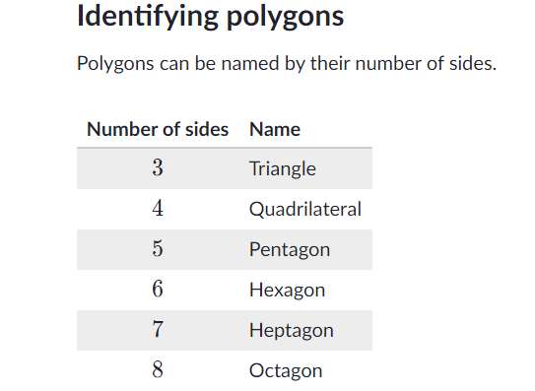

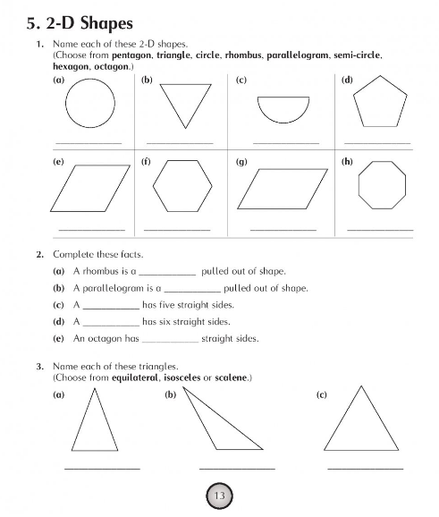

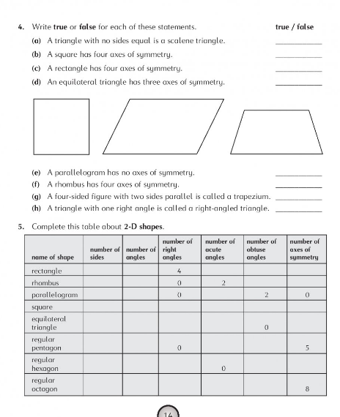

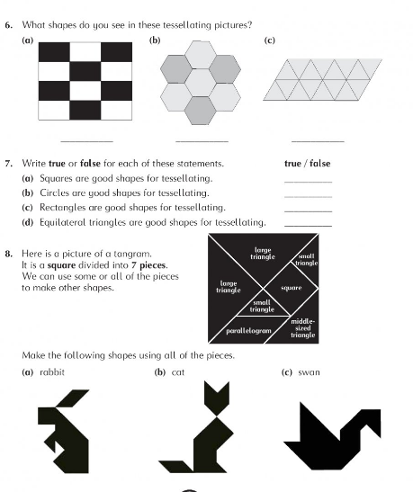

**Ideas for making tessellation art**

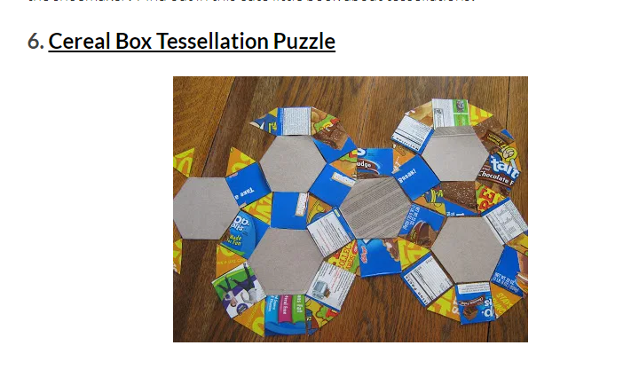

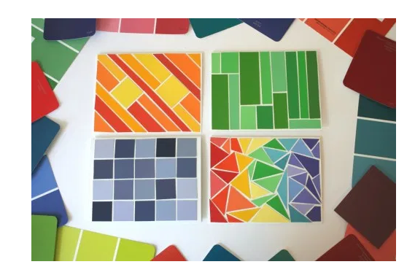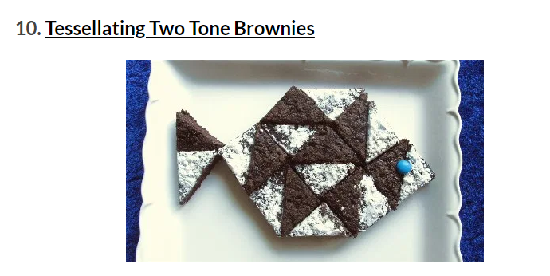

Wednesday

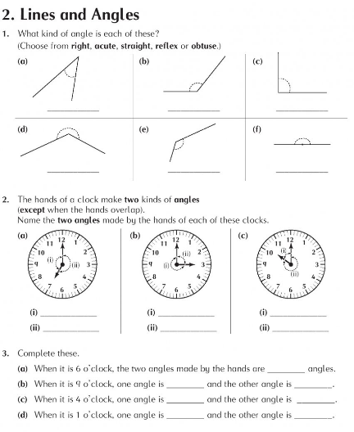

Thursday and Friday

**Watch these clips:**

1. <https://www.khanacademy.org/math/basic-geo/basic-geometry-shapes/basic-geo-geometric-solids/v/recognizing-common-3d-shapes>
2. <https://www.khanacademy.org/math/basic-geo/basic-geometry-shapes/basic-geo-geometric-solids/v/counting-faces-and-edges-of-3d-shapes>

