**Week 6 (Monday 4th May – Friday 8th May)**

**Letter to the girls**

Dear girls,

Lovely to hear your beautiful voices last week! This week’s work is a little bit different. You will be exercising your mind and body and giving the books and pencils a rest! You can still tune in to the Home-school Hub at 11am on RTE2 every day. Below is a menu with PE lessons, art ideas, yoga, dance videos and outdoor fun. I’m sure you can think of other activities yourself. If the weather is nice, spend time exploring outside and if it’s cold or raining, play board games or cards. Keep busy and happy, ladies!

Lots of love,

Mrs. Quill.

**Letter to Parents**

Dear Parents,

It was lovely to speak to many of you last week and to hear that you are doing ok in this different normality. This is Week 6 of our closure according to the school calendar, and for a change we’ll focus on mind and body. These days we need to take care of ourselves and it’s good to let the girls see that exercise and outdoor activities play an important part in our general wellbeing. Hope you enjoy doing these activities too!

Thank you for your continued support and interest.

Mrs. Quill.

**Religion (try to fit this in at some stage in the week)**

Go to the website  <https://www.growinlove.ie/en/>

Login in with the email [trial@growinlove.ie](mailto:trial@growinlove.ie)  and the password growinlove.

When in the website click on the image of the textbook – Second Class /P4.

Keep practising the Communion prayers p. 64 and 65.

Go to page 25 of your book and keep singing the psalm with your family. (On the website, click on Theme 4 and then scroll down and click on the icon with the musical note called ‘The Lord, He is my Shepherd’ – see image below to help).

(We will lift the roof off the church on your Communion day!)



**Monday 4th May – Bank Holiday (No Work).**

**Activity Grid to keep a record of your “work” this week:**

Try drawing this into your copy and fill in every day. Then, each day, write in the different activities that you do and record how long you spent at them. Add all the times up and put your total answer in the total time column – we’re aiming for 60 minutes each day!

|  |  |  |  |  |  |
| --- | --- | --- | --- | --- | --- |
| **Day** | Activity 1 | Activity 2 | Activity 3 | Activity 4 | Total Time |
| Monday | No Work – Bank Holiday | | | | |
| Tuesday |  |  |  |  |  |
| Wednesday |  |  |  |  |  |
| Thursday |  |  |  |  |  |
| Friday |  |  |  |  |  |

**Tuesday 5th May**

* Yoga – try these 12 poses. Try to hold each pose for 1 minute! Maybe you can make up your own one.

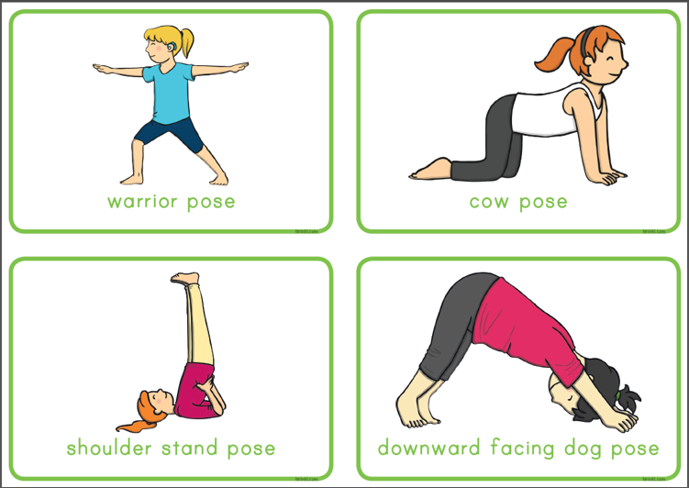

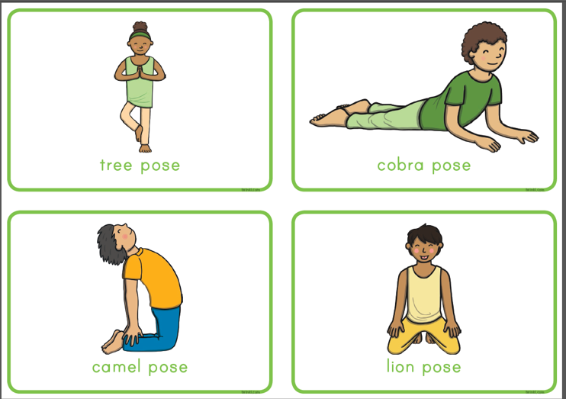

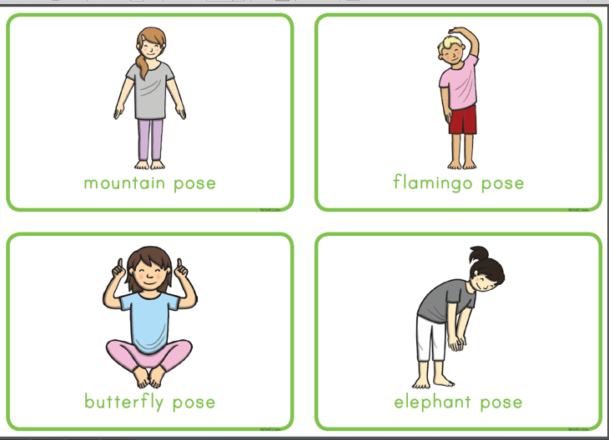

* Dance with the Kids Bop Gang

[KIDZ BOP Kids - Best Day Of My Life (Dance Along)](https://youtu.be/sNog54ovi8Q).

* Mindful Drawing.

Listen to Ms. Coughlan’s lovely calm voice as she shows you how to draw your own unique design.

See “Ms. Coughlan’s hand – Mindful Drawing” HERE].

* Nature Detective

Can you find any of these minibeasts outside?

(ant) (butterfly) (spider)

 (centipede)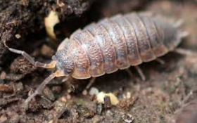 (Woodlouse) 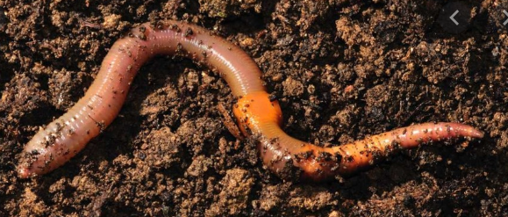 (Worm)

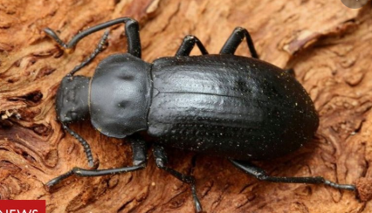 (Beetle) 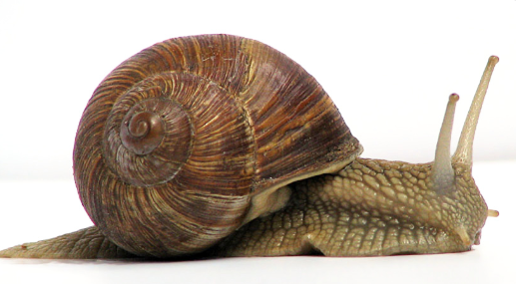(Snail)

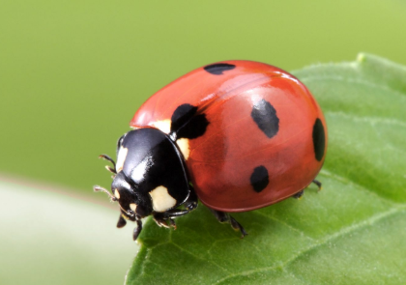 (Ladybird)

Did you know woodlice love damp, dark places? That’s why you’ll always find them under something. What about making a minibeast hotel? Place a cardboard box with toilet roll tubes under a bush and check after a few days to see have any “guests” booked in. Maybe put some leaves in too to make it more interesting for them! This is a picture of my minibeast hotel that I made using an old Easter egg box.

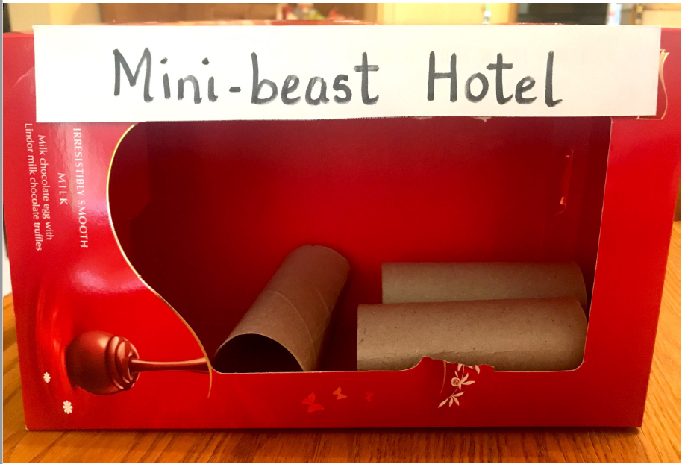

* Make a fortune teller

[How to make a fortune teller video](https://www.youtube.com/watch?v=b45Ga6Em3eA)

This video shows you how to make the paper fortune teller and also how to play the game. Some ideas for the messages inside are:

- I love your smile.

- Your hugs are great.

- You are a funny bunny.

You can think of your own to fill the rest of the spaces!

* Play a game of ‘Snap!’ with cards with someone at home.

Be gentle!

**Wednesday 6th May**

* Balloon fun!

Ask an adult to blow up a balloon.

On your own or with a partner, see can you keep tapping it upwards with your hand and try not to let it touch the ground for 5 minutes. You could even make this into a competition.

Try it another time using your foot.

Place the balloon between your knees and try jumping up and down the hall or outside 20 times without letting it fall.

With a partner place the balloon between your tummies and walk sideways along the hall or in the garden 20 times.

Take the balloon outside and play volleyball over the clothes line!

* Art Activity

On the same balloon, use a marker to carefully draw two big eyes, a nose and a mouth. Cut strips of paper from a magazine or newspaper and stick it on as hair. Think of a nice name for your balloon! Mine is called Belinda!

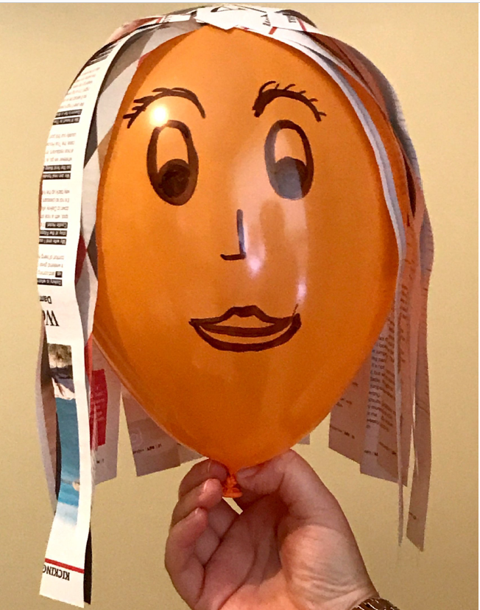

* Dance with the Kids Bop Gang.

[KIDZ BOP Kids - Fight Song (Dance Along)](https://www.youtube.com/watch?v=40uEcTuqIvM&feature=youtu.be)

* Pitch and Toss

Can you find three small stones of similar size that would fit on the back of your hand. Start with one stone, flick up your hand so that the stone goes up in the air and catch it with the same hand as it falls. When you’re good at this, try two stones and then three. Here’s a video of me giving it a go! If you can do four or five stones – you’re a champion!

See “Mrs Quill showing you how to play Pitch and Toss” ].

**Thursday 7th May**

* Balancing

Look at this video and try some of the moves. Balancing is a skill which improves with practise.

<https://vimeo.com/409588960>

* Make a Heart Mobile

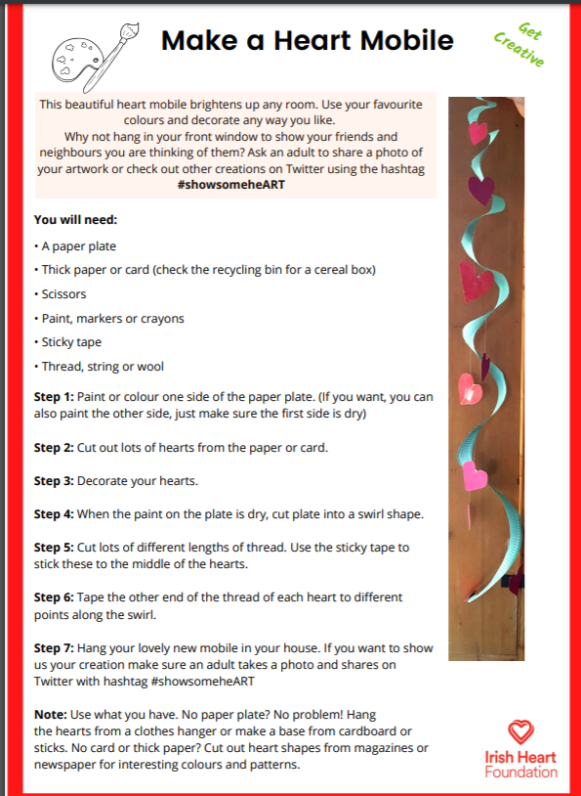

* Beanbag Games

If you haven’t got a beanbag use a balled-up pair of old socks or an old sock filled with dried rice, then knotted.

1) Balance the beanbag on different parts of your body.

2) Throw and catch the beanbag in different ways, either solo or with a partner (e.g. clap once before catching, clap twice before catching, clap once and spin around before catching, throw under one leg, throw backwards etc.)

3) See how far you can throw the beanbag. Mark your distance and see if you can throw it further each time.

4) Make an obstacle course and try to complete it while balancing the beanbag on your head, or while throwing and catching the beanbag.

5) Throw the beanbag in the air and try to catch it using different parts of your body.

6) Make different targets for throwing the beanbag into (e.g. buckets, plastic bowls, clothes basket, paper plates). Assign a different number of points to each target. Write down how many points you score for each throw and calculate your total score. See if you can beat this score next time.

7) Make a line on the floor with masking tape (inside) or chalk (outside). Walk along the line like a tightrope walker, keeping the beanbag balanced on your head.

8) Place the beanbag between your knees and see how many jumps you can do without dropping it. Or have a 'beanbag between the knees' race.

9) Arrange empty plastic bottles or toilet/kitchen roll tubes in lines like bowling pins and throw beanbag from a distance to try to knock them over.

10) Place the beanbag on your foot without bending your upper body. See how high you can lift your leg in front and to the side while keeping the beanbag on your foot. See how far you can walk while keeping the beanbag on your foot. Then try with the other foot.

* Let’s learn about Respect.

Watch this video.

[Sesame Street: Respect | Word on the Street](https://www.youtube.com/watch?v=GOzrAK4gOSo)

**Friday 8th May**

* Joe Wicks’ Fun PE Class.

On Friday’s Joe Wicks usually dresses up. You can dress up too if you like (as anything you want) and try this workout.

[Body Coach Scooby-Doo Dress up exercise video](https://www.youtube.com/watch?v=4hdR8Mlib3M)

* Create and Play Hopscotch.

Watch this video to show you how to draw and play hopscotch with a stone. You can draw the hopscotch with chalk or else use a stone to draw it.

[How to Play Hopscotch Video](https://www.youtube.com/watch?v=aUi0V6_ROWA)

* Draw a puppy emoji.

Watch this video for some help.

[How to draw a puppy emoji video](https://youtu.be/NatsdDyn6yY)

* Scavenger Hunt

Decide on a base e.g your kitchen table.

Each person must find objects which start with each of the letters in their own first name. The first person to make it back to the base with their objects to match all the letters in their name wins!

E.g if my name is Mary, I would bring back to the base:

- M – Money

- A – Apple

- R – Rug

- Y – Yoyo.

* Storytime

Listen to a story on <https://www.storylineonline.net/>

And relax after a busy and active week!