Week beginning: 01-06-2020 Class and Subject: 4th class maths SEN Teacher: Ms. Conran

Work below is to be carried out over a week. Uncompleted work can carry on to the following week.
Week  10 | Activities attached below  - Complete the activity sheets below at your own pace. You may print the activity sheets or else write the work into your copy. Don’t worry if you don’t finish all of the activities. Work at your own pace. | Time  - Download this app: “Interactive Telling Time” app. This app is a great way to practice telling the time. It is fun and is also free to download!  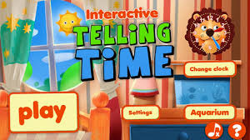 | Online Maths Games:  - “Top Marks” website.  - 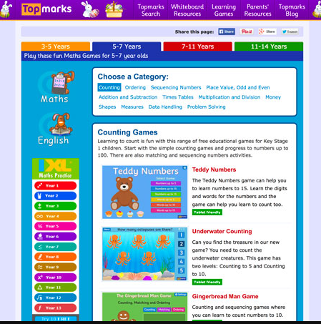  - There is some very enjoyable games for you to practice your maths. Here are some suggestions for games that you may enjoy.  - Counting: Teddy Numbers, Ladybird Spots, Helicopter Rescue, Chopper Squad.  - Sequencing Numbers: Caterpillar Ordering, Paint the Squares, Chinese Dragon.  - Addition and Subtraction: Mental Maths Train, Daily 10, Number Fact Families, Ten Frames.  - These are just some focused suggestions, but feel free to explore some of the other games. Enjoy.
 | Board Games  - Look at the fun selection of board games attached from previous weeks, that I had included in active homes week.  - These games will continue to be fun whilst practicing your maths skills! | Outdoor Games  - Outdoor Games: Throw a ball with a partner or in a circle of a few people and count on as you catch the ball. See how far you can count before the ball drops (you can count on from a higher number too, you don’t have to start at 1).  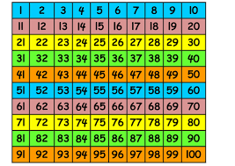  Maths Hopscotch  - Play hopscotch outside, hopping on one or both legs.  - Throw the stone twice and make a calculation for the two numbers.  - You can add the two numbers.  - You can subtract the smaller number from the same number. | - Money  - Everyday maths: Grocery shopping, rounding item prices up to the highest euro to find estimates on prices.  - Find items and prices on the Tesco or Supervalu websites. Estimate prices to the nearest euro.
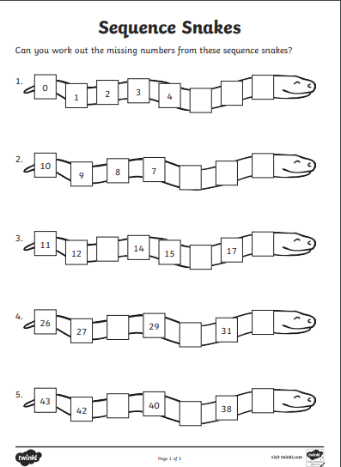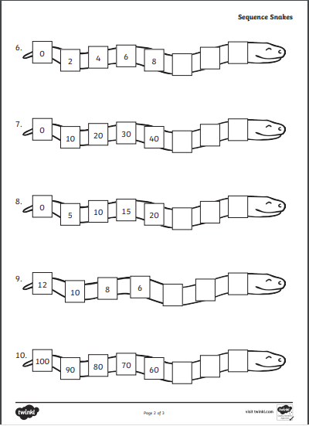
Use the 100 square to help you with these sequencing activities
