Week beginning: 01/06/2020 Class and Subject: 4th class Literacy SEN Teacher: Ms. Conran

Work below is to be carried out over a week. Uncompleted work can carry on to the following week.
Week 10 | Enjoyable Online Reading Resources:  - Download the app: “Epic Reading” app, which is free to download for the first month free trial. Choose and customise reading for your child by choosing their reading level and interests. Stories will then be suggested for your child based on these criteria.    - Website: “Storybird”. You can sign up for a month free trial. There is a large variety of story books that your child can read. Focus on picture books and comics as there will be a lot to discuss with your child based on the pictures as well as the reading  .  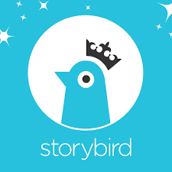 | Dolch sight words:  - Website: “dolchword.net” You can click your child’s level to access games and activities to familiarise your child with these sight words. Games include memory, matching & spelling activities as well as ‘jigsound’ games. Enjoy!    Communication  - Make a card to send to a friend or family member.  - Discuss the steps that you will need to take to make the card and for the card to reach the person you are sending it to.  - What would you like to write in the card?  - Perhaps you could write or type some of your news and include a copy of it in the card for the person you are sending it to.  - Use the vocabulary on the template provided to help you. | Oxford Reading Tree  - Website: “oxfordowl.co.uk” This website will allow you to access ebooks of various levels once you set up an account.  - Read:  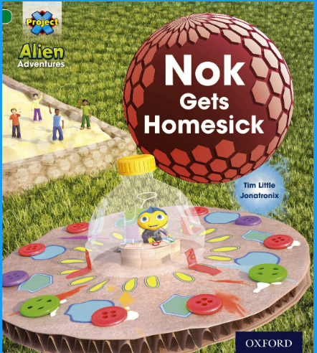  - Children can listen to and read along with the audio.  - There are interactive activities to supplement reading as well as post reading questions and reflections.  - Listen to your child’s reading. Focus on vocabulary development, discussing the meaning of certain words. Ask them questions about what they have read to develop their comprehension and understanding. Ask them to predict what will happen next in the story. The child can summarize the story in their own words afterwards.  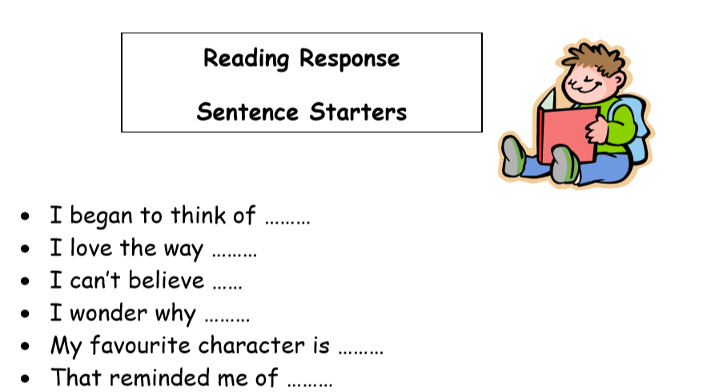  - In response to the reading, discuss why Nok was homesick. What was Cat’s plan?  - Do you ever feel homesick? What do you do to feel better?  - Retell the story in your own words using the main images in the story line. What were the main events from the story in sequence?
 | Typing Skills  - Website: You might like to try the website “typing.com”. If you have access to a laptop this would be good practice to familiarise the girls with letter typing and speed accuracy.   | Everyday Life Skills  - Making breakfast / preparing snacks.  - Helping to wash up or do chores around the house e,g, tidy your rooms, make the bed.  - Practice telling the time.  - Tying shoe-laces, getting washed, dressed and ready independently.  - Helping your parents make lists for food shopping & estimate item prices. | Note to Parents:  - This is only a menu of work so feel free to pick and choose work that you feel is appropriate for your child and work away at your own level.

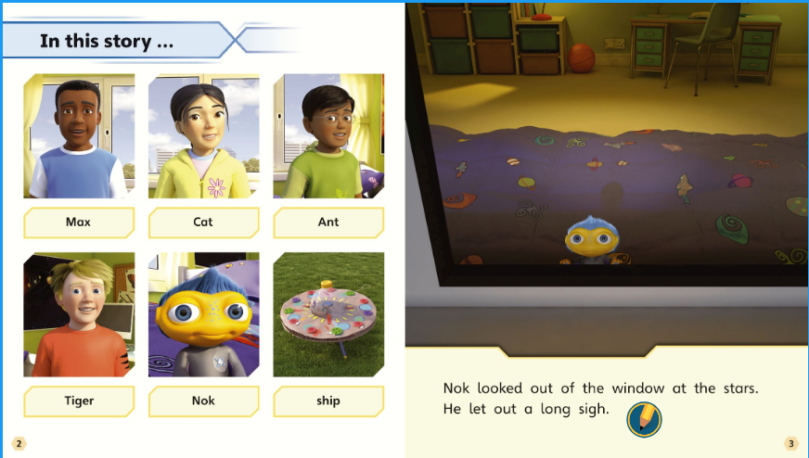

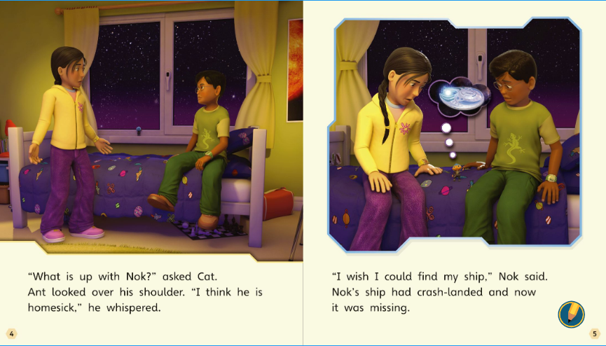

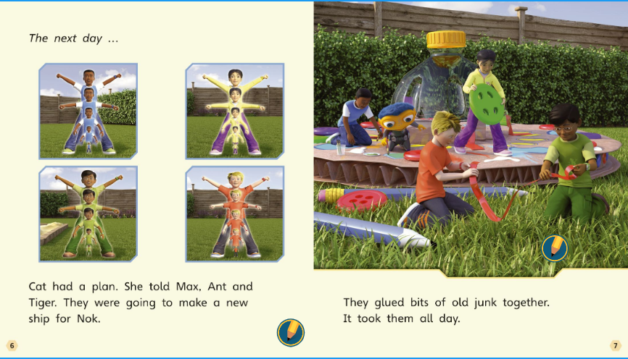

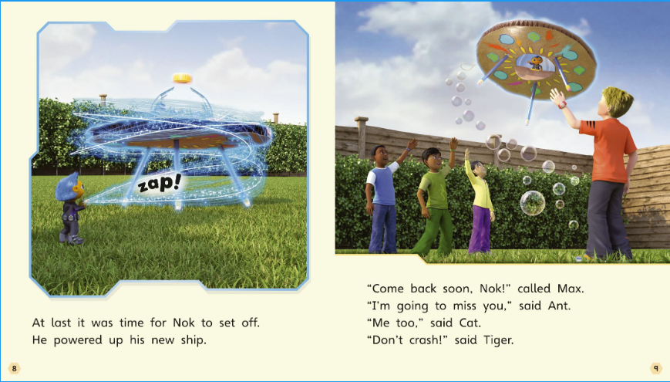

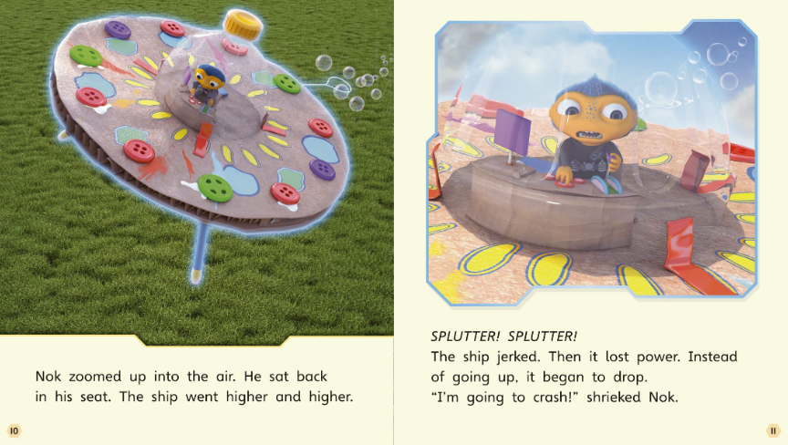

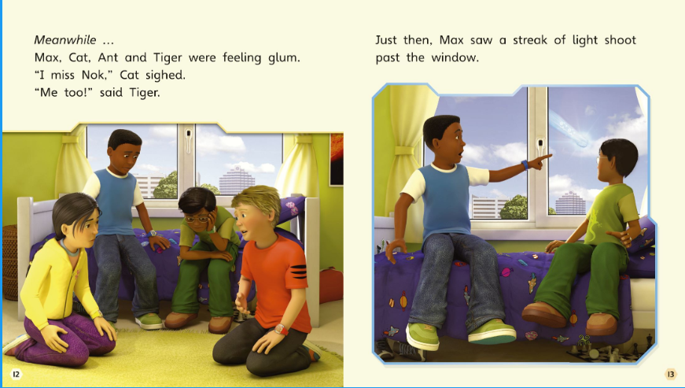

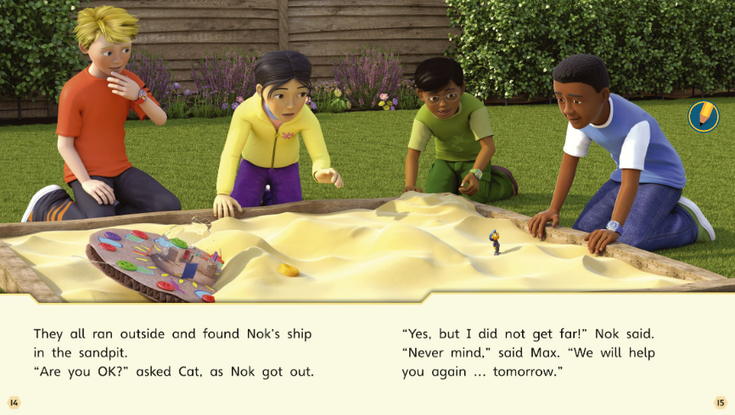

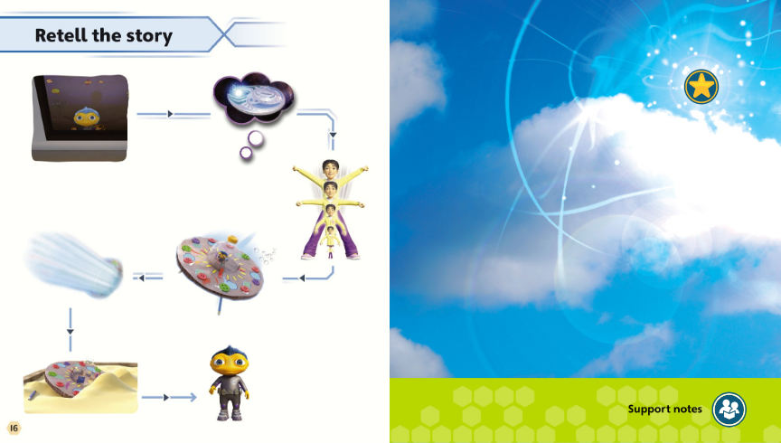

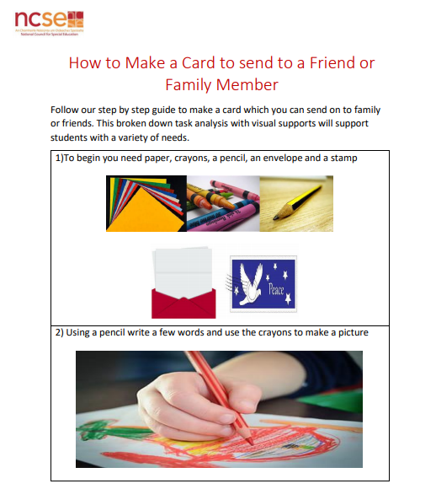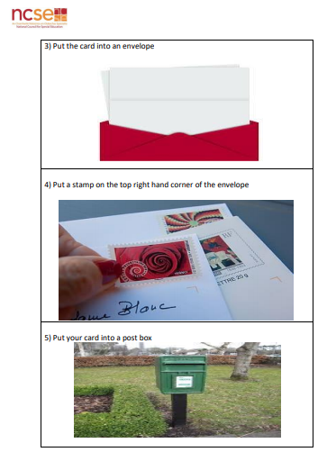
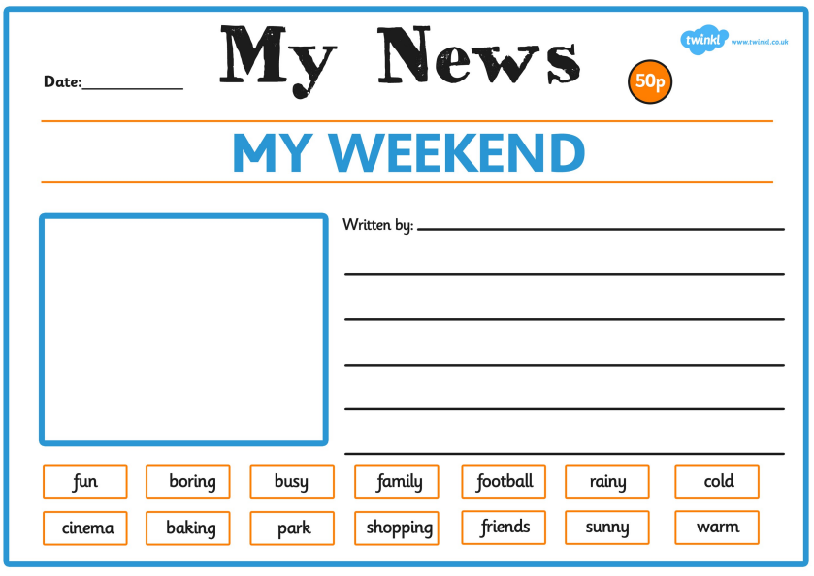
Question Prompts Cards
