Reading and audio

<https://www.worldofdavidwalliams.com/elevenses/>

<https://www.storylineonline.net/>

Art

**Draw a portrait.**

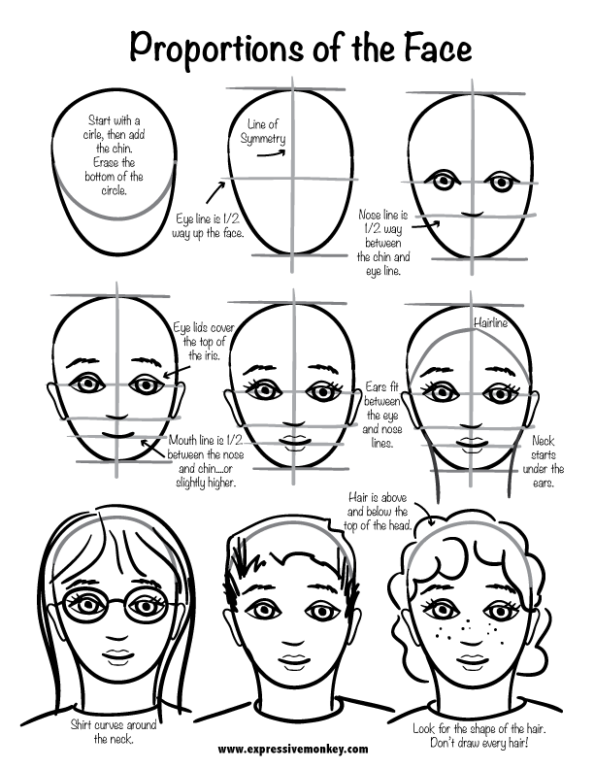**.**

Puppet Show

Making a puppet show can be a fun way to spend some time and there’s lots of different ways to do it now.

1. Make a sock puppet – <https://www.youtube.com/watch?v=e-mfUBQE3_s>
2. Make finger puppets – <https://www.youtube.com/watch?v=6eq370x_lvo>
3. Make an online Puppet Show – Puppet Pals App

The main thing is to write the scripts and record them! If you have a puppet show stage, great; if not, use a table to hide underneath!

Art- dogs!

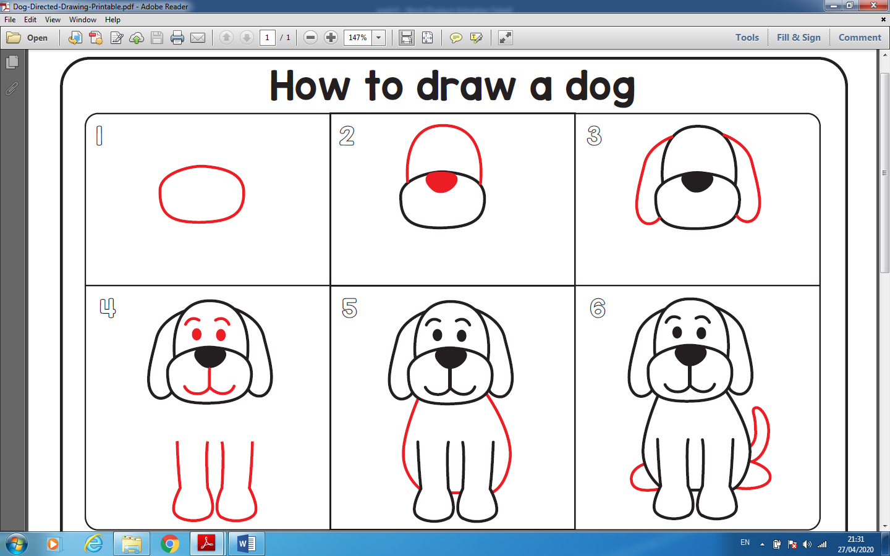

or design an emoji puppy <https://youtu.be/NatsdDyn6yY>

**P.E**

<https://app.gonoodle.com/login> – dance and movement

<https://www.cosmickids.com/> - yoga and mindfulness

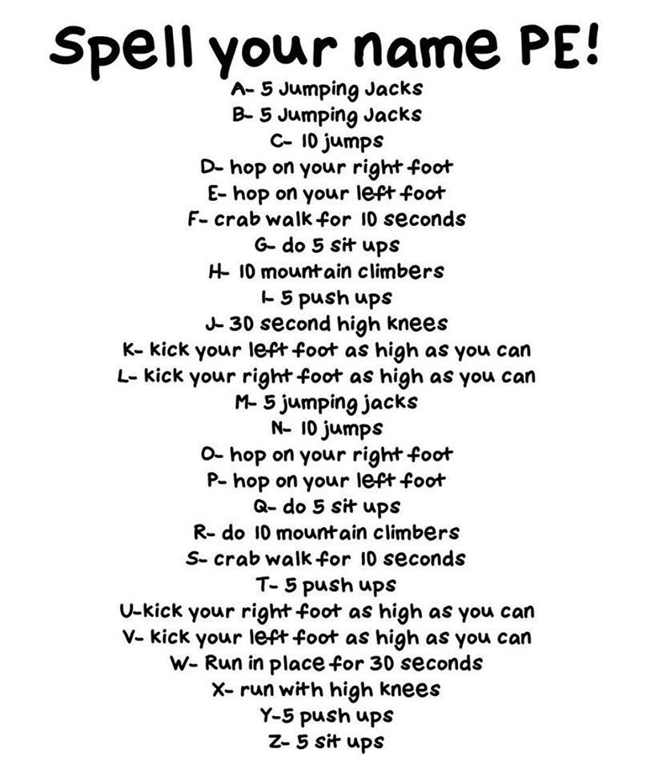

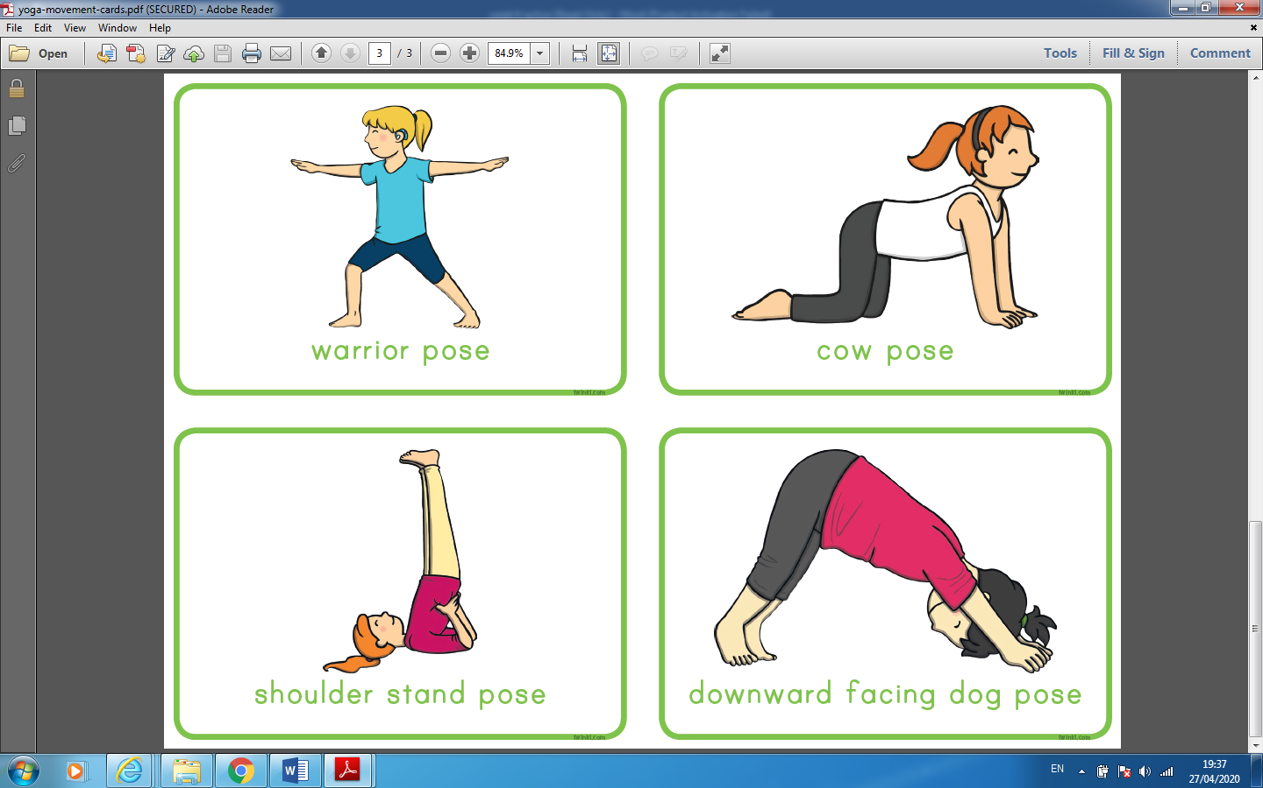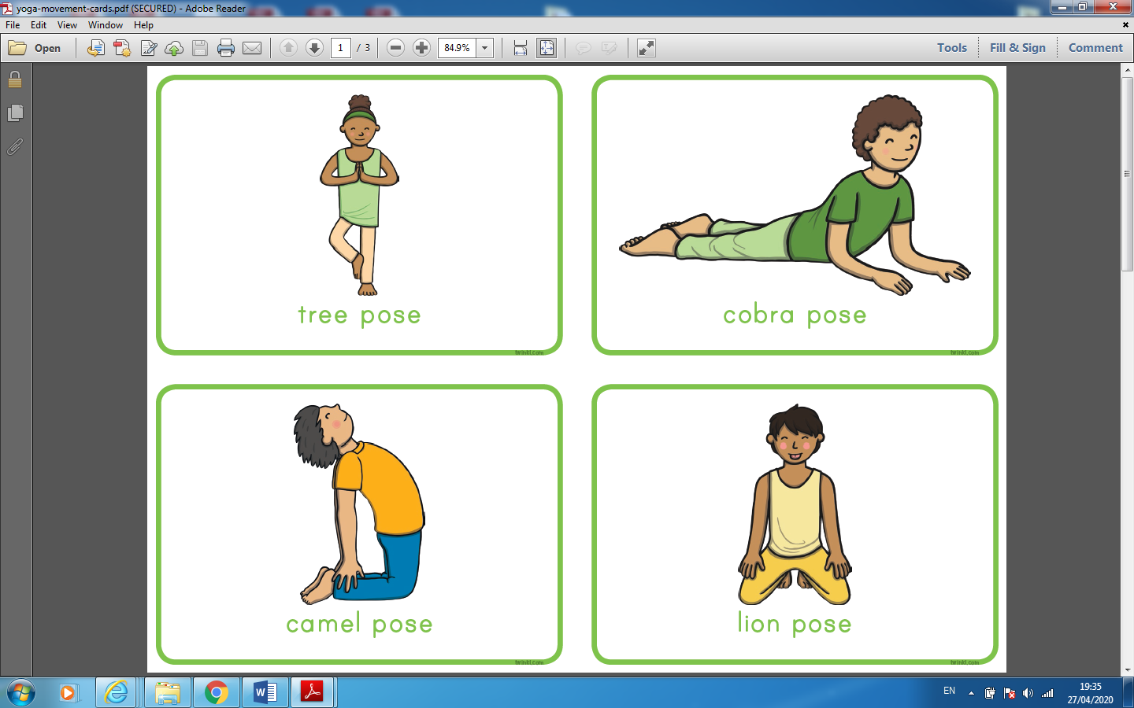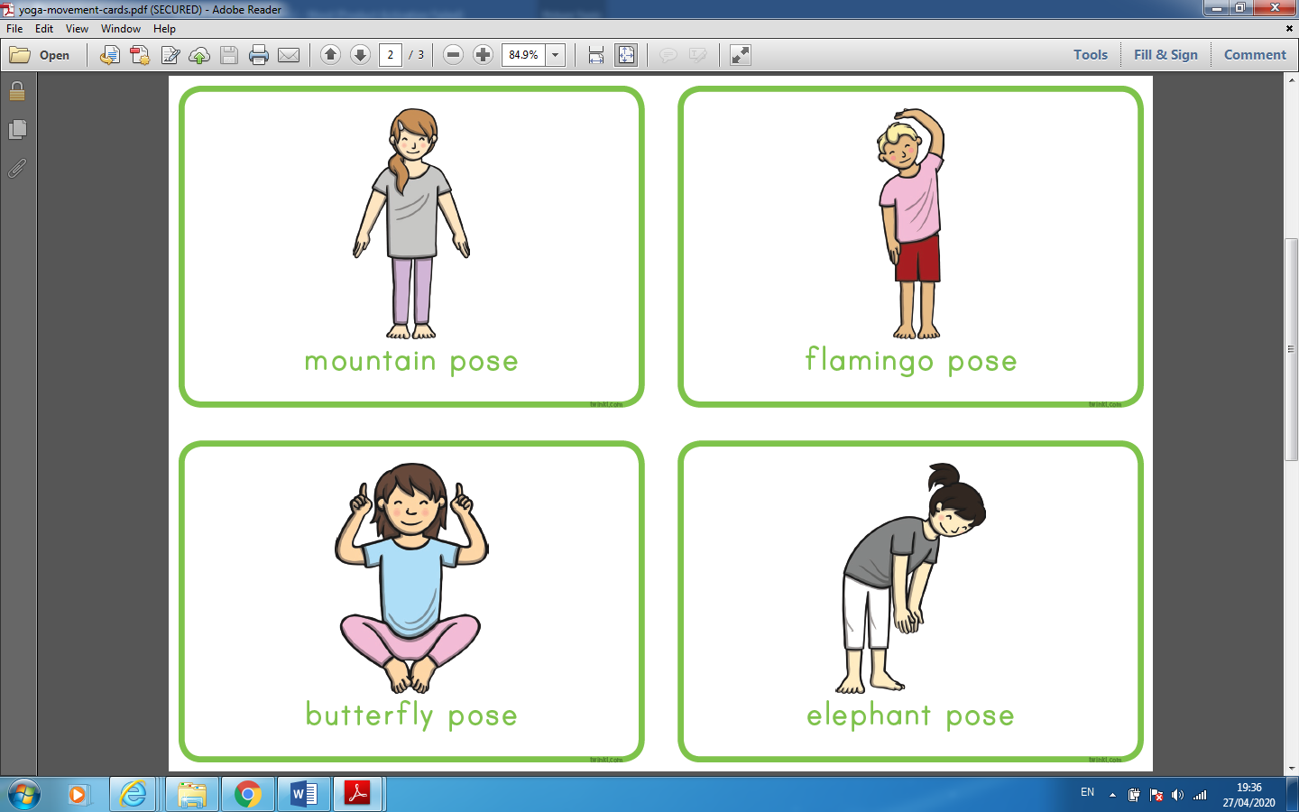

Dance with the Kids Bop Gang <https://youtu.be/sNog54ovi8Q> and <https://youtu.be/40uEcTuqIvM>

Games Tip the can No. of Players: 4 or more Indoor or Outdoor Equipment: An item to tip such as a can, wall, schoolbag etc 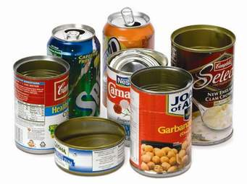

How to play: One player is chosen to be on. They count to thirty while the other players run to hide. When they reach thirty they go to find the others. 18 When they find a player hiding they have to run back to tip the can/wall/etc and say “tip the can I see (name)..” If the player who is on catches everyone the first person caught is on next. A player who is hiding can win the game by touching the can and shouting “tip the can I free all”.

Or

Play volley ball with a balloon or beachball over the clothes line. Score if your opponent fails to return the ball over the line or misses the ball. With the same ball, have a giggle. Balance the ball/balloon between your tummy and your sister’s or brother’s or parent’s tummy. Then try to balance between feet, noses, ears etc.

Irish apps

<https://www.duolingo.com/course/ga/en/Learn-Irish>

**S.P.H.E-**

S.P.H.E emotions board game- 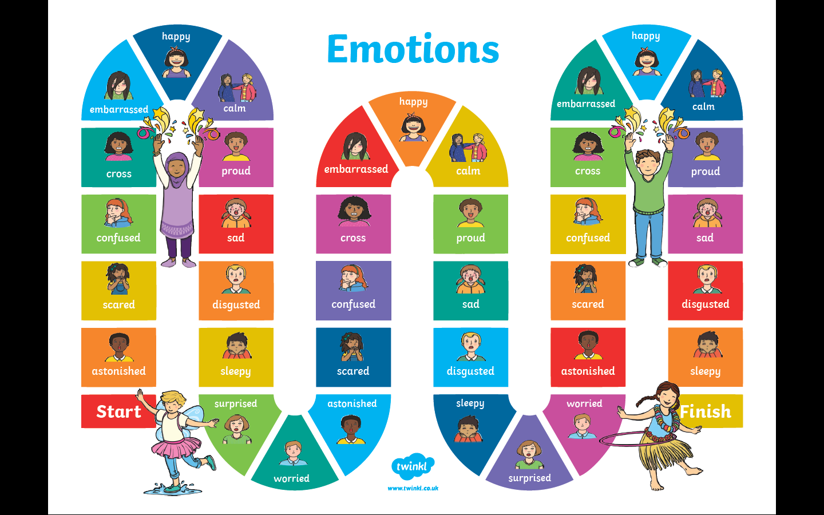

Copy the gameboard. Roll the dice to move. When you land on a feeling, mime it and tell about a time you experienced that feeling.

Storytime <https://youtu.be/87meeeysYlA> = In My Heart – A book about feelings.

Celebrate you! draw yourself and draw a rainbow coloured frame around you or copy this:

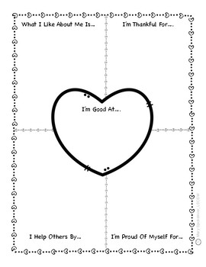

**Maths Games**

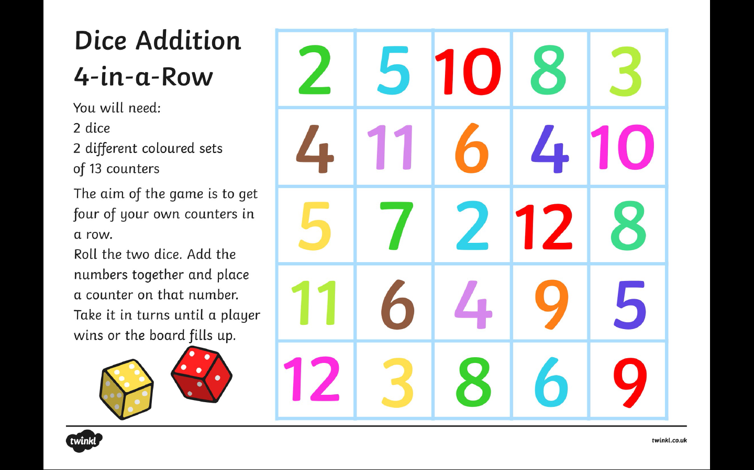

**SESE**

Nature - birds- Make a bird feeder for birds to enjoy. Decorate. You can then enjoy the colours of your visitors. Make some sketches.

Food for Birds: Some do’s and don’ts

**•** Peanuts, sunflowers and mixed seed in mesh

and plastic feeders are ideal for many small

birds.

**•** Over-ripe or slightly spoilt fruit is ideal for Blackcaps and thrushes, either left on the ground or

speared onto a branch.

**•** Some crumbs and stale cake will be mopped up by sparrows and larger birds;