**Religion**

**It is May – Mary’s month. See how your May altar is coming along.**

**Practise the Hail Mary.** <https://www.growinlove.ie/en/> Login in with an email of [trial@growinlove.ie](mailto:trial@growinlove.ie) and a password of growinlove.  **Theme 11, lesson 1, The Rosary. Try the actions for the Hail Mary as shown in the video. Let’s revise the last chapter in Jesus’ life. Pgs. 46 and 47 Grow in love. Theme 8 lessons 1 and 2.**

**Monday**

**English**

Spellbound, Week 30, p.62. Learn the first four spellings.

Think of 2 other words ending in –ark. Mark can be a boy’s name or a mark made with say a pencil – the difference made by the use of the capital letter for the boy’s name only.

Watch out for the silent “l” – hidden near the end of the words “talk” and “walk”.

**Reading**

We are finished with Starlight. There may be a few pages you haven’t written in to, but everyone’s list of pages will differ, so for distance learning purposes, we will put it aside. If you wish for advice on any pages from Starlight that you want to try, just email me. I’d be delighted to help.

Let’s look at **Feena’s Second Book of Facts**. Most of you should have it, but I will put up screen shots too.

*Look at page 4. This is called a Table of Contents. You would usually find one at the start of a book to guide you through it. It is very useful in a fact book like this one, as it helps you to find the information you need quickly.*

*No need to read the whole book if you are looking for particular information. Just look under the themes. Let’s say I want to read about dolphins. They belong to the theme of Sea Life and so I scan down through the category and find that all about dolphins is on page 60. I can even work out how long an article is, eg The Brain is on pages 18-19 – that is 2 pages long.*

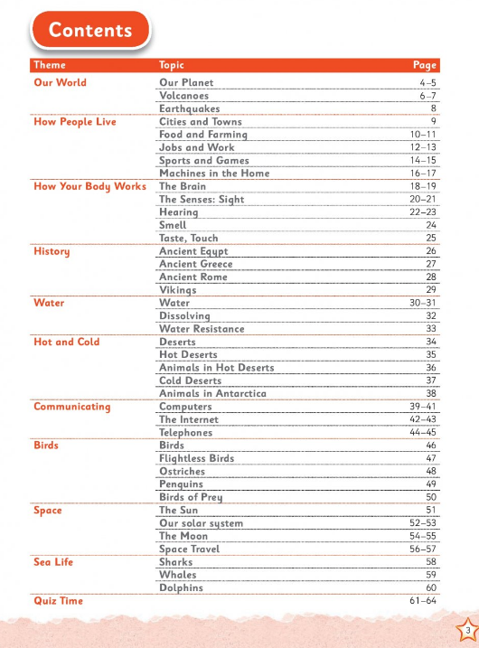

Now answer these questions;

1. In what section would you find out about “Vikings”?__________
2. What page does “Jobs and Work” begin on?_______________
3. What page does “Our Solar System” end on? ___________
4. How many topics are there in the section on “Birds”?____________
5. How many pages long is the piece on “Computers”?___________
6. Which section on “Sea Life” looks the most interesting to you._______________.

**Challenge (**–if you have the book). Find the section on Jobs and Work, and on the second page of the article find out how computers have changed the way we work.

**Irish**

Ag siopadóireacht (shopping) is our focus again. Go to Bua na Cainte p.93 I have a story to tell you that matches the picture.

[Click to hear Ag Siopadóireacht Audio Pg 93](https://youtu.be/c2pJ8XojMto)

Now you read it.

Tá Mamaí agus Daidí agus na páistí sa siopa.

Tá said ag siopadóreacht. Tá bagún ag Mamaí.

Tá cabáiste ag Ruairí.

Tá cairéad ag Róisín.

Tá prátaí ag Daidí.

Cheannaigh said bia deas.

Beidh dinnéar deas acu.

**Maths**

Work It Out week 29 Monday

More work on money. Now we will use €2 coins. Find coins up to the value of €2 and play shop with them. Compare size, colour and shape. Try Cracking Maths p. 145 number 1 and section 2 abcd.

**Tuesday**

**English**

Spellbound. Week 30, p. 62. 4 new spellings today. Try and put one into a sentence. Note that “wreck” has a silent w. See if you can think of other silent “w” words.

Read the rest of the words and then try exercise 1 on p.62.

**What a Wonderful World**

p.6 and 7. Read about Thomas Edison. Thanks to him we have light bulbs. Some new language in this text –

experiments 

basements – Some houses have a level underground.

oil lamps - 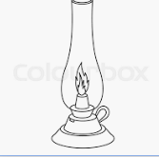

power plants – not like a green plant but an electricity factory.

Phonograph 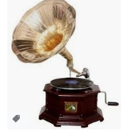

Watch this video about him.

<https://youtu.be/KgSi_R1Wcyk>

Draw your own invention on page 7.

What do you think is the most amazing thing about Thomas Edison?

* Writing

Write these sentences and fill in the blanks after reading all about Thomas Edison.

1. Thomas Edison was born in _____________.
2. His ___________ taught him at home.
3. As a boy he did ____________ in his basement.
4. He became famous for inventing the _______ __________ and also the _______________.

**Irish**

**Ag Siopadóireacht.**

Go to Bua na Cainte p.93. Watch my first video which will help you revise the topic.

[Click here to watch BNC Pg 93](https://youtu.be/c2pJ8XojMto)

Now the next video will help you do the activity on p.93.

[Click here to download BNC Pg 93 Discussion](https://youtu.be/oFl5JcOg_Yw)

**Maths**

Work It Out week 29 Tuesday.

<https://www.topmarks.co.uk/money/toy-shop-money/eur> Click on mixed coins – and then up to one euro. Experiment with under two euro.

Cracking Maths p. 146. Like last week we are writing money in two different ways with € sign and decimal point or with the cent sign- never both together.

**Wednesday**

**English**

Spellbound. Week 30. P.62. You are learning the 3rd box. Look at the word “quick”. See how “q” usually needs “u” to follow it to work properly.

The word “quickly” is an adverb- a word that describes how you do something. They often end in –ly. Watch this link all about adverbs.

<https://youtu.be/e1dXaDy5Mpg>

Try this activity. Choose from these adverbs:

Nervously, neatly, patiently, quickly.

1. I wrote _____________ in my best handwriting.
2. She ran ___________ way from the ghost.
3. He drove ___________ during his driving test.
4. We waited _____________ for the plane.

**Feena’s Second Book of Facts**

Yesterday we read about the learned about light bulbs and Thomas Edison. The telephone was invented by Sir Alexander Graham Bell. The first words spoken were “Mr Watson. Come here I want to see you”.

Read page 44 of **Feena’s Second Book of Facts.** In Feena’s factbox can you spot something Edison and Bell had in common?

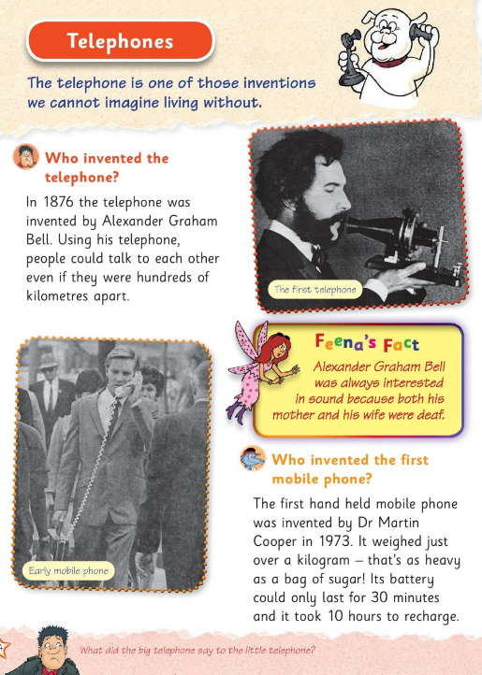

Watch this short video on how phones have changed.

<https://youtu.be/3G1or2SrmJs>

Here is a mission for you in scanning p.45.

1.Find out what Alexander Graham Bell wanted us to use as a way of saying hello on the phone. Hint: Feena will tell you.

2. What do people use phones for today? Hint:Ella will tell you.

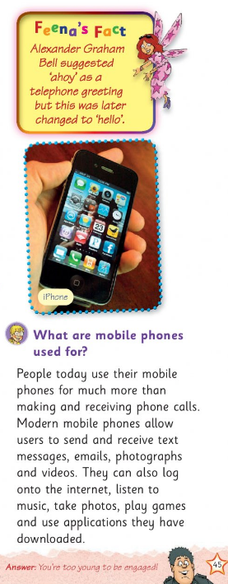

**Irish**

Bua na Cainte p.98. Look at my clues below to help you create “An Nuacht” You can pick the pets you saw and the one you bought in this imaginary shopping trip. Size and colour options for your pet are at the bottom of your page.

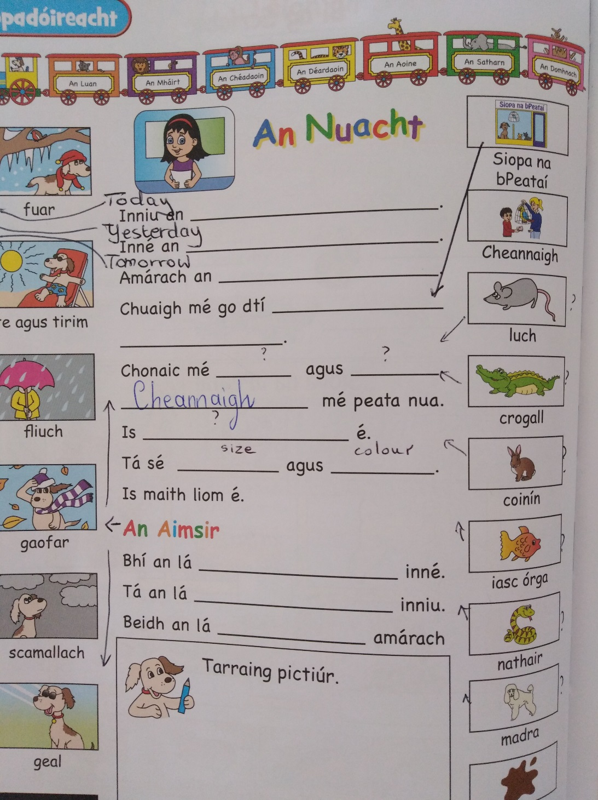

**Maths**

Work it Out. Week 29 Wednesday.

Cracking Maths p.147. I will show you how to work out your change in the video.

[Click here to watch CMP Pg 147 Change](https://youtu.be/h6G8YLaDvkU)

**Thursday**

**English**

Spellbound. Week 30. P.62. You are learning the 4th box. Make a rhyme with –ick words. It can be a silly one!

p.63 – Try the wordsearch. The arrows show the direction the word takes.

**Feena’s Second Book of Facts.**

We read about Thomas Edison yesterday. Inventions are amazing. Go to p.16 and the top of p. 17 of Feena’s Second Book of Facts. You will find out about all sorts of useful inventions and how they work.

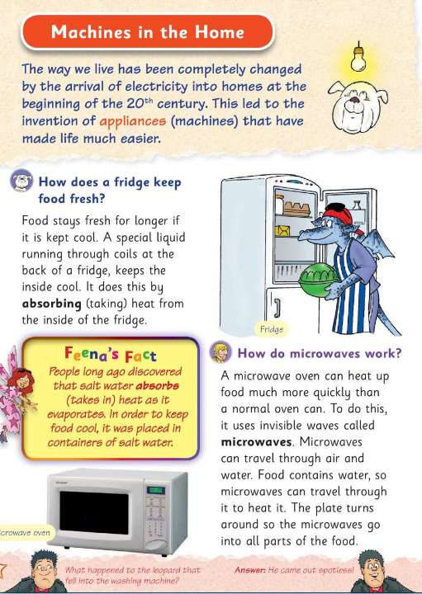

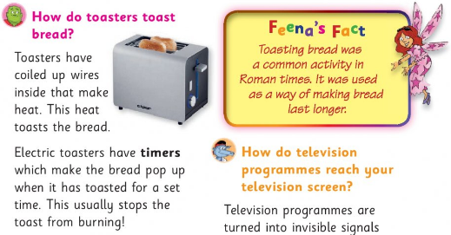

Now fill in the blanks.

Electricity was invented by ……………… Lots of household inventions use electricity. A ___________ keeps our food cool and fresh. To heat our food quickly we can use a _____________. A __________is useful for heating bread. The timer in a toaster usually stops the toast from _________. Ancient Romans toasted _________ so as to make it last longer.

**Irish**

Samhradh = summer. Go to p.101 Bua na Cainte. There is a nice join the dots activity. Label each drawing with the help words at the end of the page. Listen to me pronounce them and then repeat them.

[Click here to listen to An Samhradh](https://youtu.be/XgogPmXlYEE)

**Maths**

Work It Out week 29 Thursday.

More shopkeeping/ P. 149 Cracking Maths. I will remind you of our method briefly.

[Click here to download Page 149 CMP](https://youtu.be/iPmYYa_GuMM)

**Friday**

**English**

Spellbound. Week 30. P.62. Revise your choice of 10 or 12 and get an adult to test you. Best of luck!

What a Wonderful World

p. 44. Read about the Cuckoo. Look for the birds in the wordsearch on p. 45 and try to solve the clues. I have added hints below.

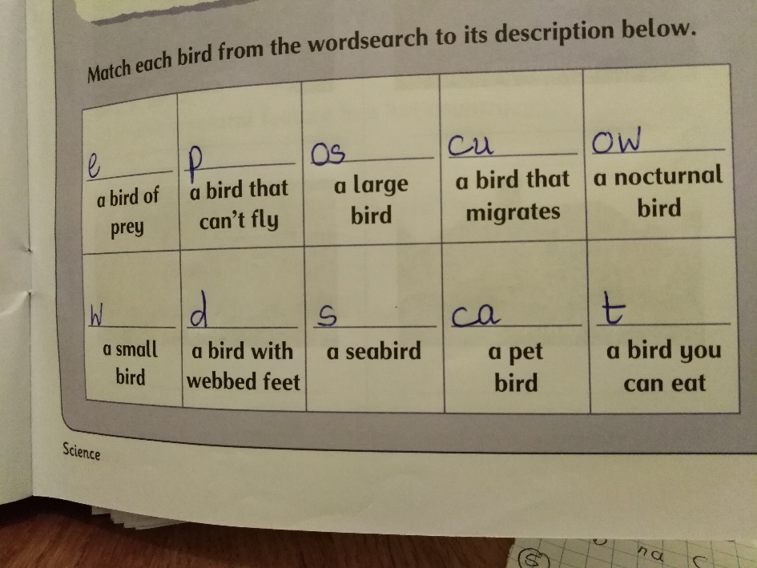

**Irish**

Mrs Quill is going to talk you through the different birds on p.99. Rí nan Éan – the king of the birds – is the smallest fellow- an dreoilín (the wren).

[Click here to listen to Ms Quill talk about Rí na nÉan](https://youtu.be/HtF4I0d6EWI)

Here is a fun quiz.

Revise your words on pages 81 and 86 of your Bua na Cainte (An Chistin agus An Seomra Suí).

Then, when you’re ready, complete this quiz which you can play against the rest of the class!

Click on this link

<https://kahoot.it/challenge/0825931?challenge-id=f65190f0-d7ee-4032-ad1f-d000be6a66e4_1589912065384>

A nickname will be randomly given to you, then you can start the quiz. All the girls who play will have their own nicknames too so nobody will really know how anybody else got on – it’s just a bit of fun!

You get points for being right and for being fast at clicking the answer!

**Maths**

<https://www.topmarks.co.uk/money/toy-shop-money/eur> Click on mixed coins – and then up to one euro. Experiment with under two euro.

Maths Games

Check out <https://www.mathplayground.com/> for some Maths fun

Or

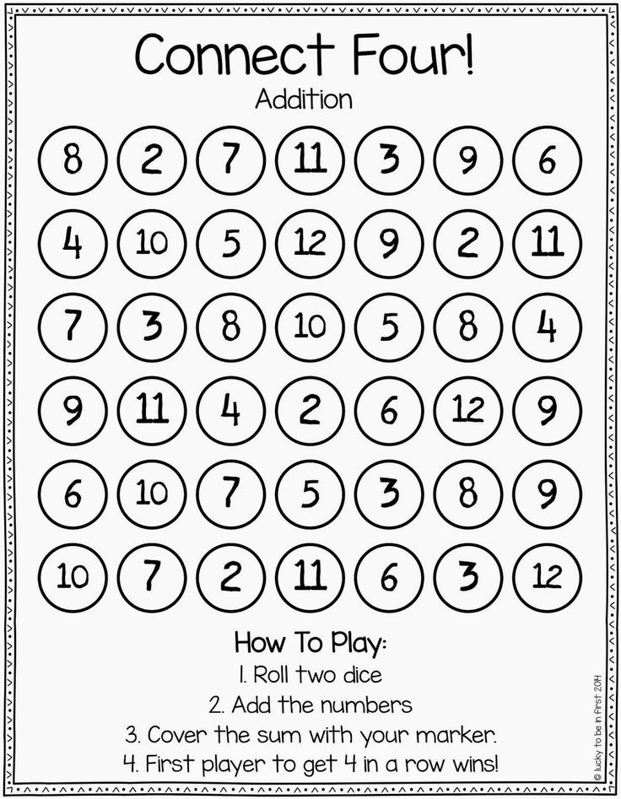

_____________________________________________

For fun if you like…

Design a mobile phone.

Draw a crazy invention.

Design a shopfront with the goods on display in the window (prices on them). It can be any shop you like.

Watch the videos about inventors.

<https://youtu.be/bLI0mFQG70k>

<https://youtu.be/i02IkTr4nNQ>

Gonoodle for movement and fun or cosmickids to chill out.

Listen to this music and draw what you feel. Watch the orchestra at work!

<https://youtu.be/1h4mAceHmrI>

This is cool. <https://www.classicsforkids.com/games.html> I had so much fun making music with this game.

Watch these video on kindness.

Try a random act of kindness today.

<https://youtu.be/rwelE8yyY0U>

<https://youtu.be/GdYJr03eJjE>