MY COVID – 19
TIME CAPSULE


BY: _________________________
Colour, Write and Decorate this book so you will remember what it was like during the Corona Virus in Ireland in 2020.

“YOU ARE LIVING THROUGH HISTORY RIGHT NOW”
ALL ABOUT ME

I am Years Old, I Stand Inches Tall

I Weigh My Shoe Size is

MY BEST FRIEND/S WHEN I GROW UP, I WANT TO BE.
_________________ _____________________________
_________________ _____________________________
_________________ _____________________________
SOME OF MY FAVOURITE THINGS
TOY: ____________________________________________________
COLOUR: ________________________________________________
ANIMAL: ________________________________________________
FOOD: ____________________________________________________
SHOW: ____________________________________________________
BOOK: ____________________________________________________
ACTIVITY: ________________________________________________
PLACE: ____________________________________________________
SONG: ____________________________________________________

HOW I’M FEELING
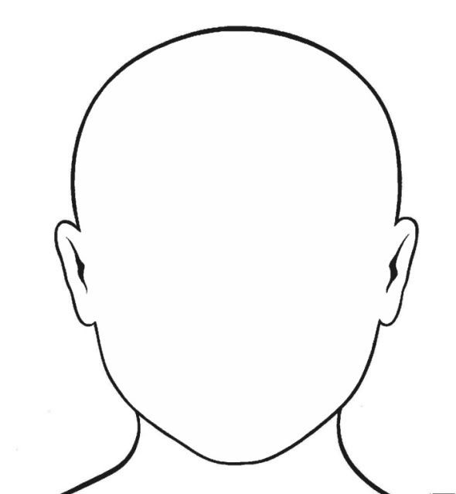
How my face looks
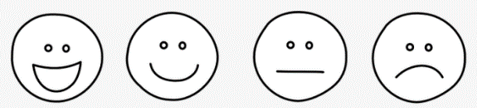
Words to describe how I feel: _______________________________
________________________________________________________________________________________________________________________
I Am Thankful for: __________________________________________
________________________________________________________________________________________________________________________
3 Things I am most excited to when this is over: ______________
____________________________________________________________________________________________________________________________________________________________________________________
What I miss the most: ______________________________________
___________________________________________________________
MY COMMUNITY
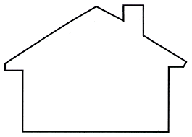
Where I am living during this time, Draw in the Picture.
How and who are you connecting with?
  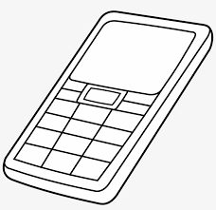 ____________________________________________________________________________________________________________________________________________________________________________________________________________________________________________
MY HANDPRINT
There are 2 pages here incase you would like to put in another print.

SPECIAL OCCASIONS
What Occasions did you celebrate during this time?
Write the list and what you did to celebrate
E.g. St Patrick’s Day, Birthdays etc.

EVENT | DATE | HOW YOU CELEBRATED

INTERVIEW A PARENT
………………………………………
What has been the How are you finding?
biggest change? Homeschooling?

……………………………………………………………………..
DAYS SPENT INSIDE What activities have you
Enjoyed most?
----------------------------------
----------------------------------
----------------------------------
----------------------------------
……………………………………………………………………..
What Tv show you watched: ________________________________________
Favorite Food to bake: ____________________________________________
Favorite time of day: ______________________________________________
Favorite Activity to do: _____________________________________________
What are you most thankful for: ____________________________________
LETTER TO MYSELF
Date: ___________________
Dear: ___________________
___________________________________________________________________________________________________________________________________________________________________________________________________________________________________________________________________________________________________________________________________________________________________________________________________________________________________________________________________
From: ___________________
LETTER FROM MY PARENTS
Date: ___________________
Dear: ___________________
________________________________________________________________________________________________________________________________________________________________________________________________________________________________________________________________________________________________________________________________________
__________________________________________________________________________________
From: ___________________

EASTER WORDSEARCH

e | r | e | s | p | r | i | n | g | c
a | e | a | s | t | e | r | l | c | h
b | h | g | a | t | e | b | y | b | o
u | o | e | g | g | s | a | h | o | c
n | l | g | a | o | l | s | c | n | o
n | i | c | h | i | c | k | n | n | l
y | d | s | h | c | t | e | i | e | a
s | a | b | o | c | e | t | k | t | t
e | y | h | u | n | t | h | n | a | e

Easter Chocolate Basket
Bunny Spring Hunt
Eggs Bonnet
Chick Holiday
Hoppy Easter
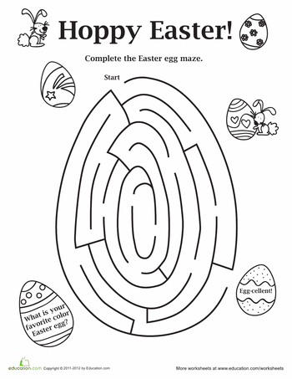
POPULAR AT THE TIME
Songs/ Bands: ________________________________
_________________________________________________
_________________________________________________
Movies at the cinema: __________________________
_________________________________________________
What is in the papers: __________________________
__________________________________________________________________________________________________
Other: __________________________________________
_________________________________________________
_________________________________________________
___________________________________________________________________________________________________________________________________________________
SCHOOL
My Teacher is: _____________________________________________
How I did my school work during the time: __________________
_________________________________________________________________________________________________________________________________________________________________________________

I have a computer for school Work: Yes No

Are you looking forward to going back to school: Yes No?
I am looking forward to going back to school because: _______
______________________________________________________________________________________________________________________Before school closed I sat next to: __________________________
My Favorite thing about school is: _________________________
___________________________________________________________

Here are some pages to put in pictures such as Newspaper clippings, Photos from this time, Art work you may do, Family/Pet Pictures or any special memories.

IT’S OVER
The date is: _______________________________________________________
I Feel: _____________________________________________________________
______________________________________________________________________________________________________________________________________
I went back to school on: __________________________________________
Things that changed because of Covid – 19: ________________________
_________________________________________________________________________________________________________________________________________________________________________________________________________


