|  |  |  |  |
| --- | --- | --- | --- |
| Week beginning: 11/05/2020 Class and Subject: 5th & 6th class English as an Additional Language Group SEN Teacher: Ms. Conran  E:\St. Patrick's GNS Stacked logo.jpg **Work below is to be carried out over a week. Uncompleted work can carry on to the following week.** | | | |
| **Healthy Eating Week**   * This week is healthy eating week, so I have included some fun worksheets below to tie in with healthy eating! | | | |
| **Week 7** | **Reading Comprehension:**   * Healthy recipe for Moroccan vegetable tagine. * Read aloud for an older adult at home and discuss the text with them. * What are your thoughts on this recipe? Is it easy to make? Would it be something that you’d like to try? Why is it so healthy? * Complete the short questions relating to the recipe.   . | **Healthy Food Journal**   * Make a note of all of the delicious healthy foods that you are eating during the week. * How many fruits and vegetables are you eating each day! * What are your favourite fruits and vegetables to eat and why? | **Design your own healthy food and smoothie recipes using the templates attached as a guide!**   * This ties in with procedural writing. * What ingredients and utensils/tools do you need? * What are the steps involved? * What will the finished product look and taste like? * Why did you choose this as a healthy recipe? |
|  | **Healthy Eating Wordsearch**   * Have fun find the fruits and vegetables in this word search. * What are your favourite fruits and vegetables? * Try to design your own word search and see if somebody at home can solve it! | **Healthy Recipes**   * Why not see if you can find some healthy recipes at home to try! * Here are some useful websites that you might enjoy! * <https://produceforkids.com/> * <https://www.healthylittlefoodies.com/> * <https://www.myfussyeater.com/> | **Note to Parents:**   * *This is only a menu of work so feel free to pick and choose work that you feel is appropriate for your child and work away at your own level.* |

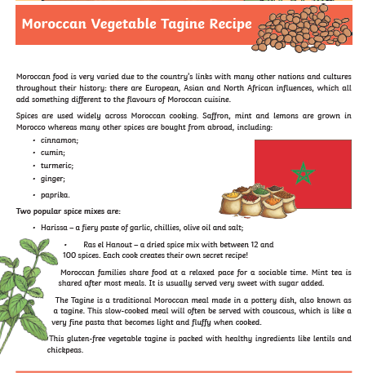

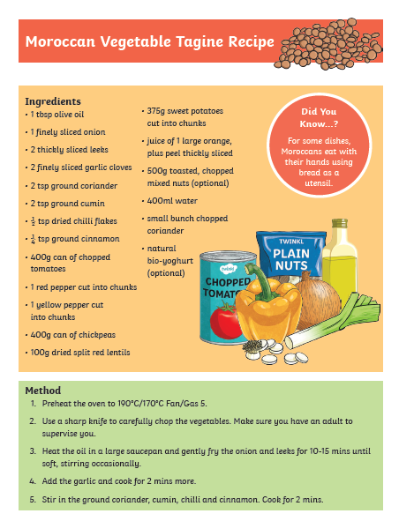

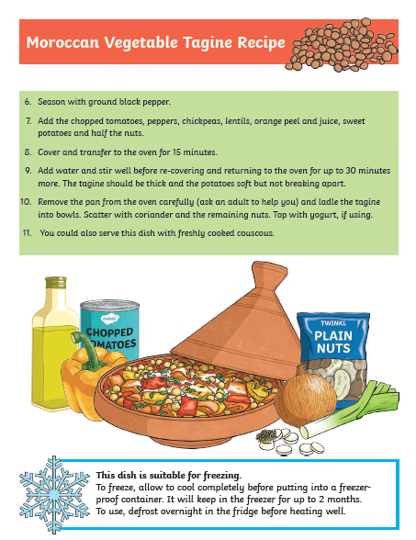

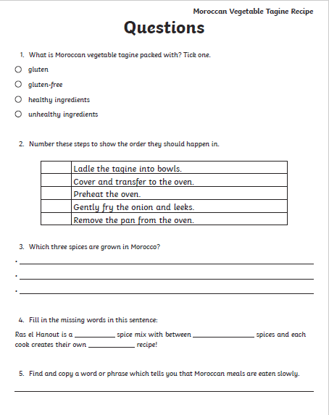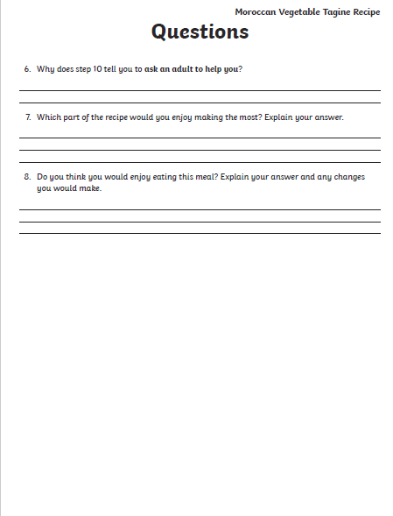

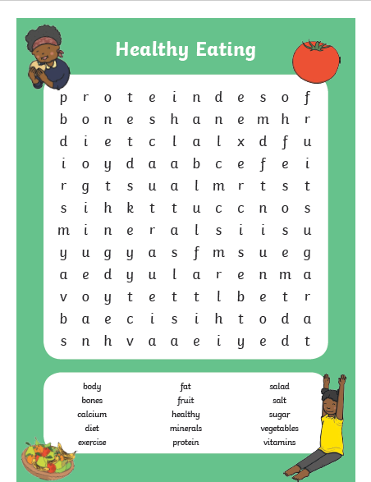

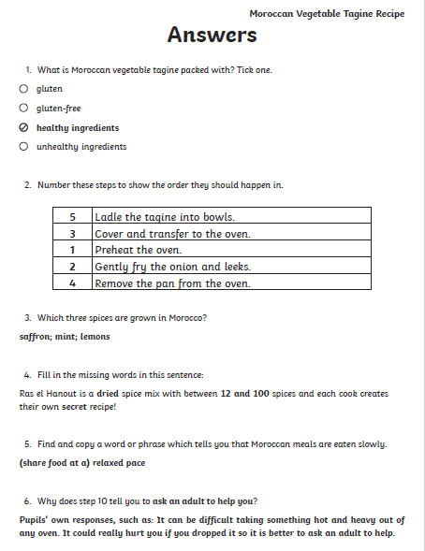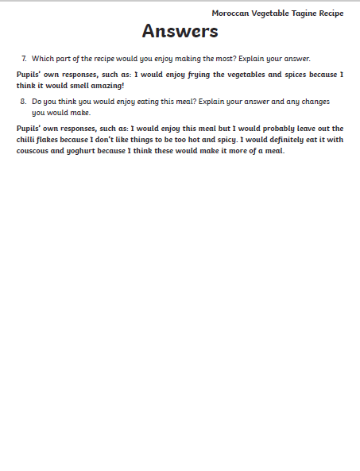

**Design your own healthy eating recipe and write the method using this template as a guide!**

