Week beginning: 04/05/2020 Class and Subject: Najiba 2nd English as an Additional Language Group SEN Teacher: Ms. Conran

Work below is to be carried out over a week. Uncompleted work can carry on to the following week.
Active Schools Week:
- This week is active schools week, so I have included some fun worksheets below to tie in with the activities that you are doing at home.
- Active Home Week Crossword
- Active Home Week Poem
- Write a diary of your activities during the week and reflect on what activities you enjoyed most!
- Reading: Poetry
- Activities Word Mat
- Recipe: Healthy Chocolate Energy Protein Balls
Week 6 | Active Home Week Crossword  - See if you can find the active home week words!  - Can you put these words into a sentence or a make rhyming sentences?    . |   Active Week Acrostic Poem  - Get creative and write your own acrostic poem for active home week!  - Maybe you can use some of the words that you found in your crossword!  - Don’t stop at one poem! See if you can write another poem, or even a song! Maybe you could include your favourite activities! | Activity Week Diary  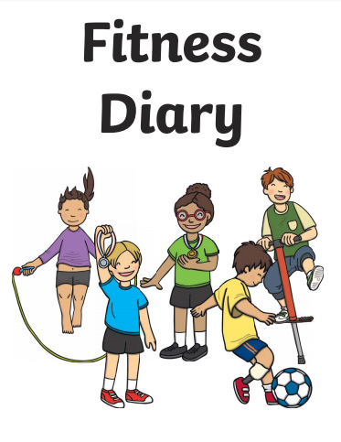  - Write a diary for each day outlining the activities that you did each day at home!
 | Reflecting on Active Home Week  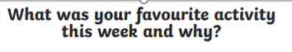  - Think about what activity or activities were your favourite for active homes week. Why? Is this a hobby that you would partake in normally? Did you learn any new activities or games? Who did you play with?  - Why is it important to stay active?  - Draw a picture of your favourite activity.  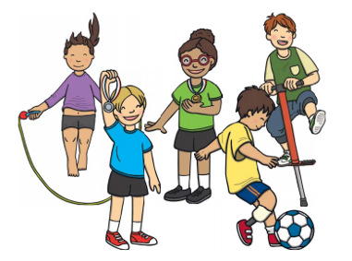 | Reading Poetry  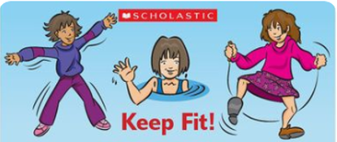  - Read and recite this poem with your child.  - Can you read this poem together with expression?  - What activities are mentioned in the poem for keeping fit?  - What are your favourite activities mentioned in the poem?  Activities Word Mat  - Read the different activities on the word mat.  - Put each activity into a sentence orally.  - Which activities are your favourite? Why? | Note to Parents:  - This is only a menu of work so feel free to pick and choose work that you feel is appropriate for your child and work away at your own level.

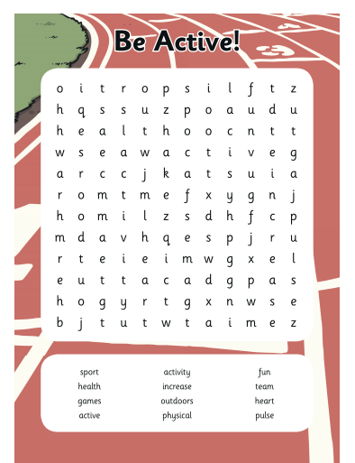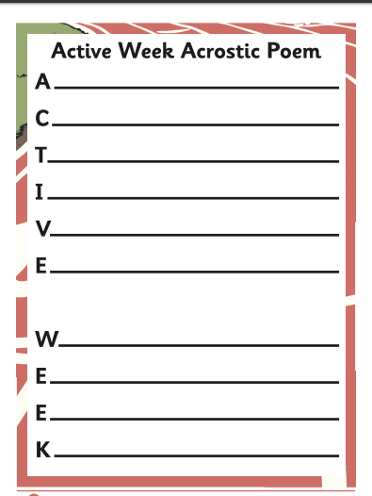
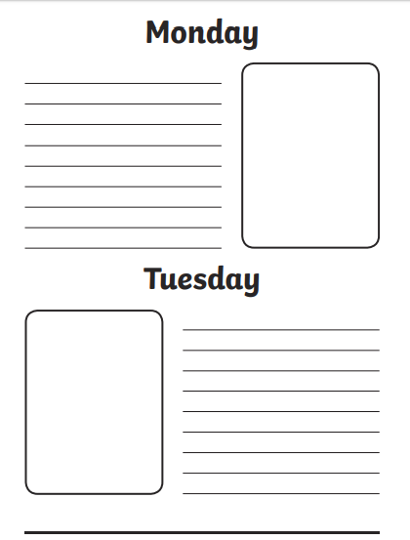
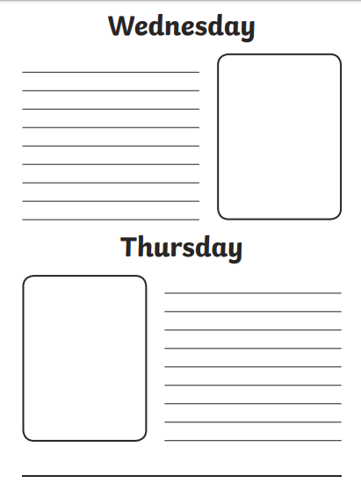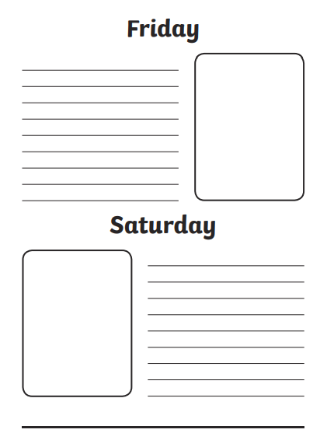
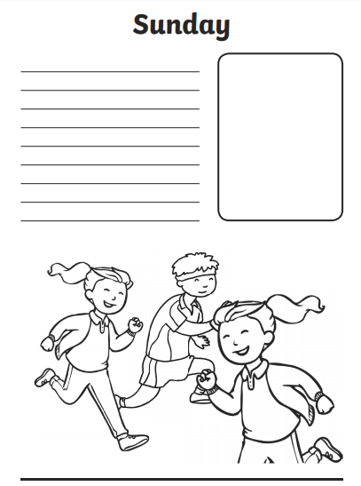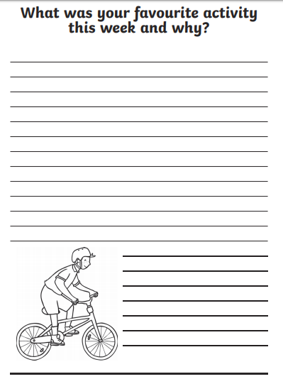
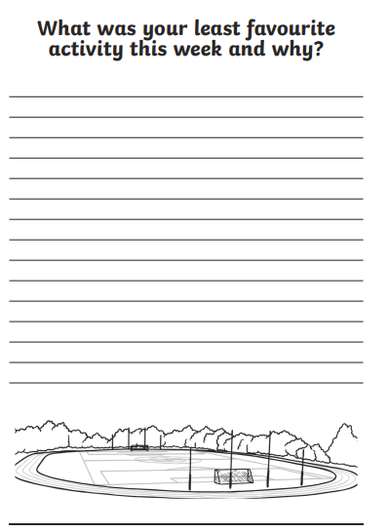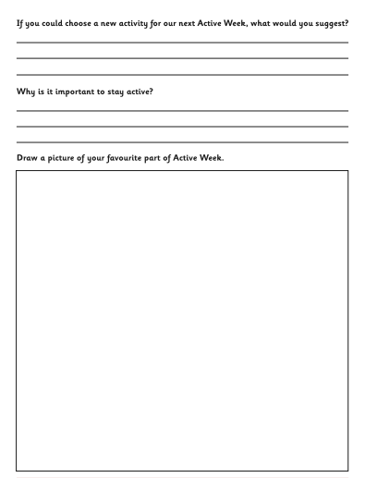
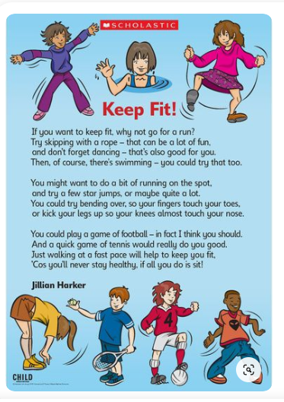

Why not try out a healthy recipe for some chocolate protein energy balls?! These will give you some extra energy during activity week, as well as being a nice treat!
