Week beginning: 04/05/2020 Class and Subject: Millie 4th Literacy SEN Teacher: Ms. Conran

Work below is to be carried out over a week. Uncompleted work can carry on to the following week.
Active Schools Week:
- This week is active schools week, so I have included some fun worksheets below to tie in with the activities that you are doing at home.
- Active Home Week Crossword
- Active Home Week Poem
- Write a diary of your activities during the week and reflect on what activities you enjoyed most!
- Shared Reading: Poetry
- Activities Word Mat
- Recipe: Healthy Chocolate Energy Protein Balls
Week 6 | Active Home Week Crossword  - See if you can find the active home week words!  - Can you put these words into a sentence or a make rhyming sentences?    .  Phonics;  - Look at the words below and see if you can name and spell some rhyming words:  - Fun  - Fit  - Skip | Activities Word Mat  - Read the different activities on the word mat.  - Put each activity into a sentence orally or typing.  - Which activities are your favourite? Why?  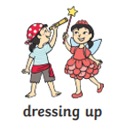 | Activity Week Diary  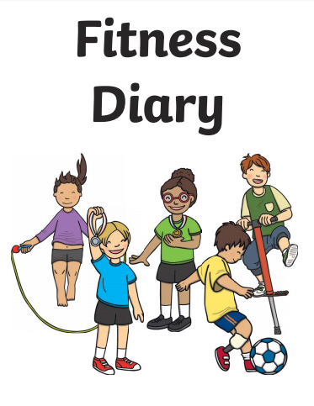  - Write a diary for each day outlining the activities that you did each day at home! You can type this or you can even tell it orally at the end of each day.
 | Reflecting on Active Home Week    - Think about what activity or activities were your favourite for active homes week. Why? Is this a hobby that you would partake in normally? Did you learn any new activities or games? Who did you play with?  - Why is it important to stay active?  - Draw a picture of your favourite activity.   | Shared Reading Poetry    - Read and recite this poem with your child.  - Can you read this poem together with expression?  - What activities are mentioned in the poem for keeping fit?  - What are your favourite activities mentioned in the poem? | Note to Parents:  - This is only a menu of work so feel free to pick and choose work that you feel is appropriate for your child and work away at your own level.

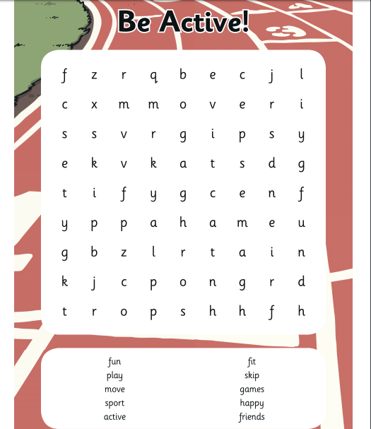
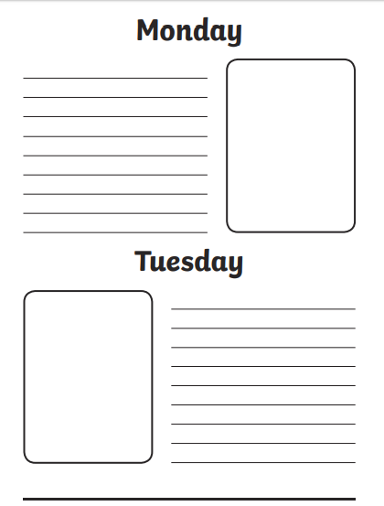
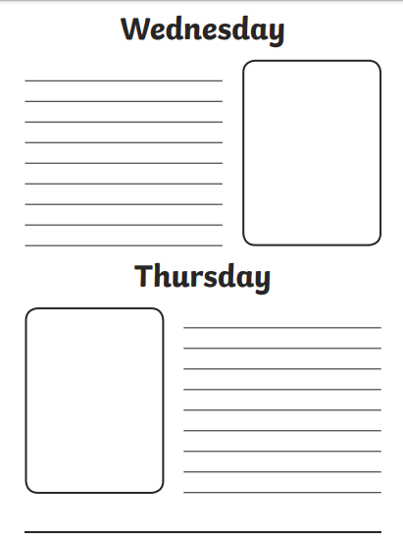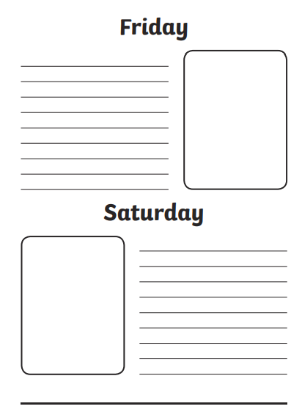
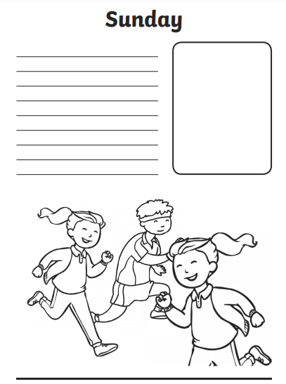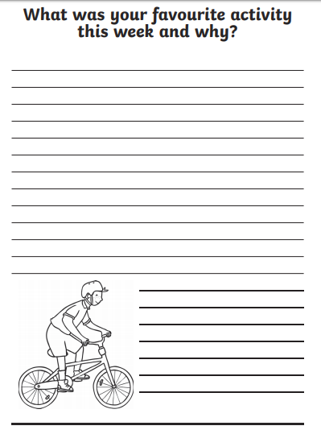
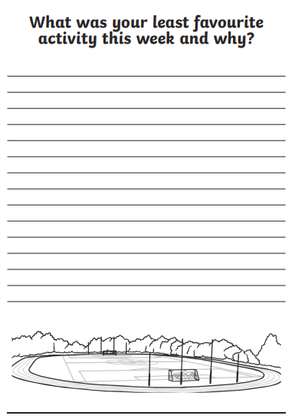

Draw a picture of your favourite activities from Active Home week!

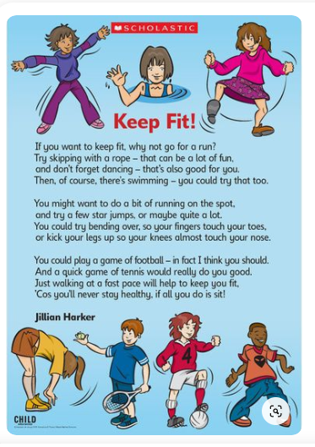

Why not try out a healthy recipe for some chocolate protein energy balls?! These will give you some extra energy during activity week, as well as being a nice treat!
