Week beginning: 11/05/2020 Class and Subject: MMcB 4th class Literacy SEN Teacher: Ms. Conran

Work below is to be carried out over a week. Uncompleted work can carry on to the following week.
Healthy Eating Week
- This week is healthy eating week, so I have included some fun worksheets below to tie in with healthy eating!

Week 7 | 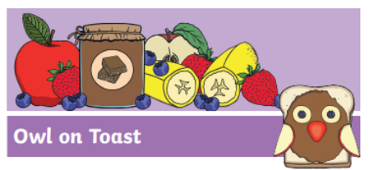  Healthy Owl on Toast Recipe  - Read and try out this fun healthy owl toast recipe!  - Have you ever tried fruit on toast before?  - Can you think of any other fun ways of decorating toast with fruit?  - Enjoy! | 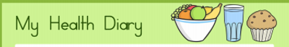  Healthy Food Diary  - Make a note of all of the delicious healthy foods that you eat during the day.  - How many fruits and vegetables are you eating each day!  - What are your favourite fruits and vegetables to eat and why? |   Design your own healthy smoothie recipes using the templates attached as a guide!  - What ingredients and utensils/tools do you need?  - What are the steps involved?  - What will the finished product look and taste like?  - Why did you choose this as a healthy recipe?
 | Fruits & Vegetable word mat  - Read the list of fruits and vegetables.  - What are your favourite fruits and vegetables and why?  - What fruits and vegetables do you eat most days?  - Are there any fruits and vegetables that you haven’t tried yet?  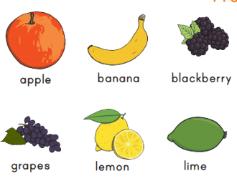 | 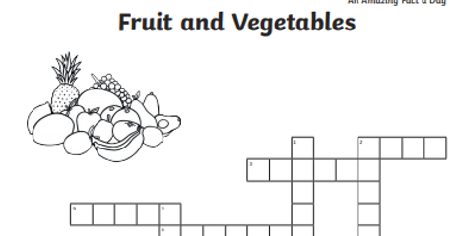  Shared Fruits and Vegetables Crossword  - Discuss with your daughter the clues to guess the fruits and vegetables to complete this crossword orally or in written form.  - Guessing game: Can you each think of a fruit or vegetable, give your partner clues about it and see if they can guess correctly! | Healthy Recipes  - Why not see if you can find some healthy recipes at home to try!  - Here are some useful websites that you might enjoy!  - https://produceforkids.com/  - https://www.healthylittlefoodies.com/  - https://www.myfussyeater.com/  Note to Parents:  - This is only a menu of work so feel free to pick and choose work that you feel is appropriate for your child and work away at your own level.

