Week beginning: 04-05-2020 Class and Subject: Millie 4th class maths SEN Teacher: Ms. Conran

Work below is to be carried out over a week. Uncompleted work can carry on to the following week.
Week 6 | Active Schools Week  - This week we are focusing on some fun maths games and activities for active home week! | Balls in the Bucket Game:  - Take turns throwing a ball into a bucket, seeing how many balls you can get into the bucket for a count of 10 throws.  - Whoever gets the most throws wins!  - Follow up activities:  - Double your number of throws  - Triple your number of throws  - Do 2 or 3 rounds and see what’s the highest digit that you can make with your numbers.  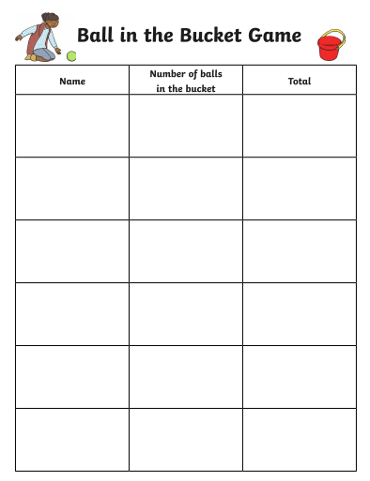 |   Maths Trails:  - Have a look at the maths trails activity sheets below and see if you can explore some maths in your environment at home! Enjoy!
 | Board Games  - Board Games: If you had ‘Snakes and Ladders’ at home, this would be great to practise your counting. You could also throw the dice twice and add the numbers before counting forward.  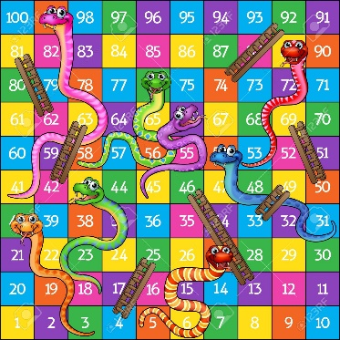  Near Doubles Game  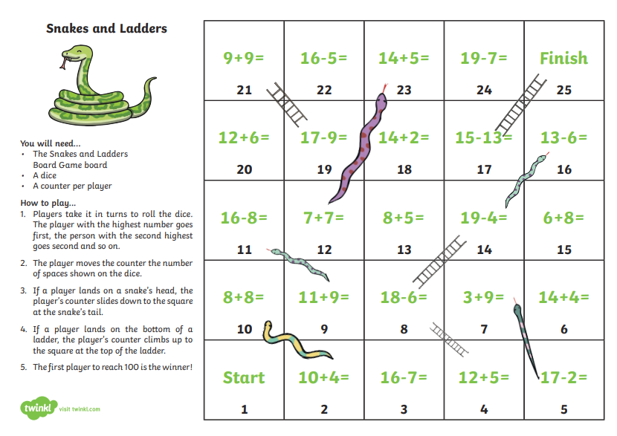  Subtraction Bus  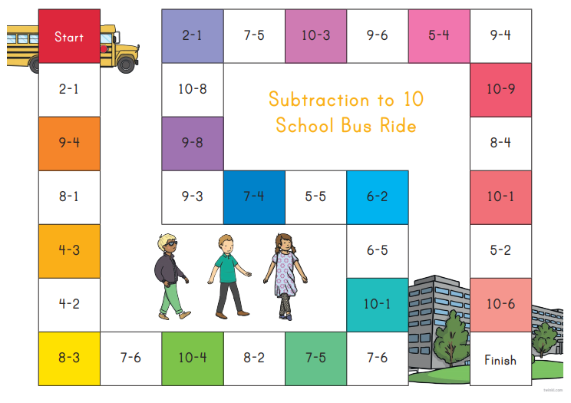  Near Doubles Addition Game  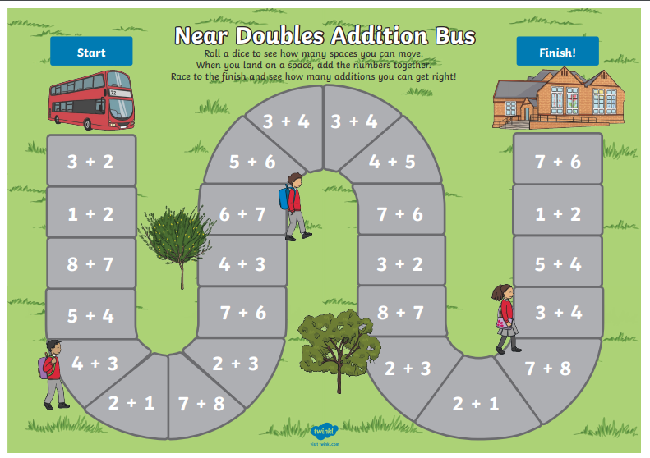 | Outdoor Games  - Outdoor Games: Throw a ball with a partner or in a circle of a few people and count on as you catch the ball. See how far you can count before the ball drops (you can count on from a higher number too, you don’t have to start at 1).  - Also, try skip counting in 2s, 3s, 4s, 5s, or 10s.  - Start at 100 and count backwards!  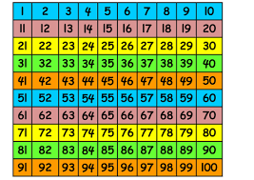 | Maths Hopscotch  - Play hopscotch outside, hopping on one or both legs.  - Throw the stone twice and make a calculation for the two numbers.  - You can add the two numbers.  - You can subtract the smaller number from the same number.  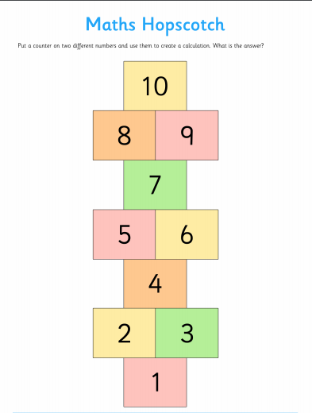  Building Bricks Addition and Subtraction Board Game  