Corrections

Feena’s Second Book of Facts – Table of Contents Q&A
- In what section would you find out about “Vikings”?__p.29
- What page does “Jobs and Work” begin on?__12
- What page does “Our Solar System” end on? _53
- How many topics are there in the section on “Birds”?___50
- How many pages long is the piece on “Computers”?__3
- Which section on “Sea Life” looks the most interesting to you.____your choice!.

Thomas Edison
- Thomas Edison was born in America / 1847.
- His mother taught him at home.
- As a boy he did experiments in his basement.
- He became famous for inventing the light bulb and also the phonograph.

Adverbs
- I wrote neatly in my best handwriting.
- She ran quickly way from the ghost.
- He drove nervously during his driving test.
- We waited patiently for the plane.

Machines in Homes
Electricity was invented by. Michael Faraday(oops I see I forgot to tell you that last week!) Lots of household inventions use electricity. A fridge keeps our food cool and fresh. To heat our food quickly we can use a microwave. A toaster is useful for heating bread. The timer in a toaster usually stops the toast from burning. Ancient Romans toasted bread so as to make it last longer.
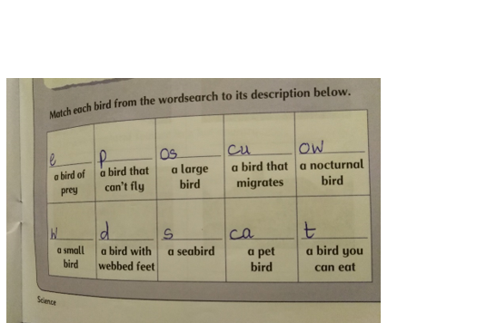
Answers
Eagle, penguin, ostrich, cuckoo, owl
Wren, duck, seagull, canary, turkey.

In any other work you did… rate yourself. Pick an emogi from the following list:
  or .

If there is anything you want help with please feel free to email me.

