**Religion**

**Grow In Love** <https://www.growinlove.ie/en/> Login in with an email of [trial@growinlove.ie](mailto:trial@growinlove.ie) and a password of growinlove.  **Theme 8. Revise lesson 2. Draw a picture to respond to what you have heard and learned.**

**Wednesday**

**English**

Let’s get started on that novel; The Magic Ring. It’s exciting to have something new! Mind this book for us as we will be asking for them back for next year’s second class to enjoy.

Look at the cover.

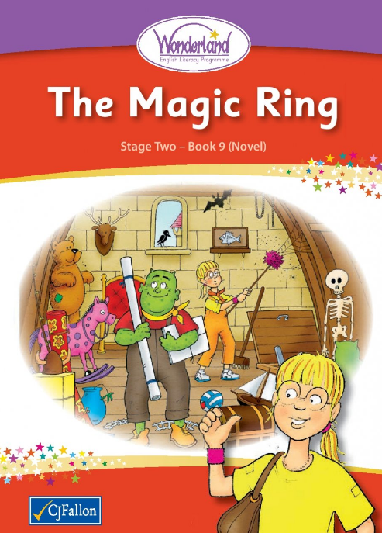

Where are they? How can you tell? (hint;Look out the window).

Why are they in that room?

What is in that room?

What do you think the novel is about?

Look at the Table of Contents.

How many chapters are there? Read the titles. Do you have a different prediction about the storyline now?

[Magic R Introduction-Click Here](https://www.youtube.com/watch?v=tyrkG7KchYU)

Go to chapter 1. Read pages 1 and 2. **Stop** there. Don’t be tempted to go on! I know what you bunnies are like! Can’t get enough of a good story!

Help me label this diagram of a house.

[Parts of the House Video-Click here](https://www.youtube.com/watch?v=l7rSzeWDHV0)

Here is a treasure chest. Draw what you would like to find in it.

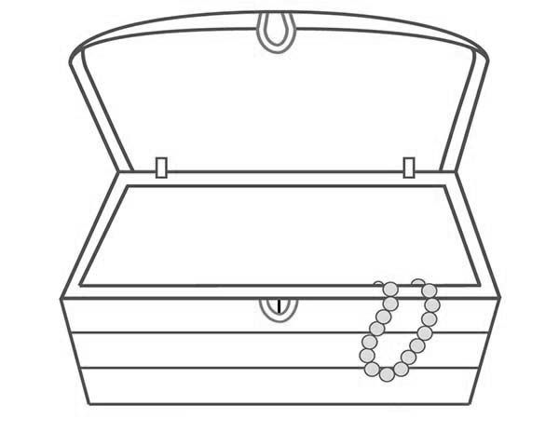

**SESE and English**

Le’s get all “summery” and talk about butterflies. Look at this video about their life-cycle.

<https://youtu.be/V5RSpMQQOpw>

Note a chrysalis can be called a pupa or a cocoon.

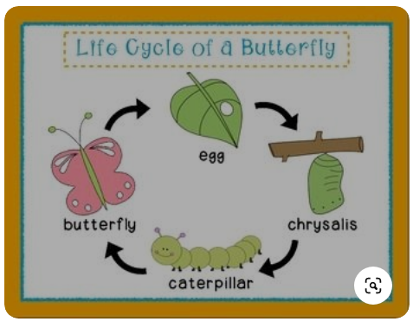

**Irish**

Bua na Cainte p.87. Listen to Mrs Quill as she explains to you about teilifís (television).

[Ms Quill Video Bua na Cainte Lch 87 Click here](https://www.youtube.com/watch?v=g0Ffdstv_Og&t=3s)

***Types of tv programme in Irish***

Cartún=cartoon

Nuacht=news

Clár dúlra=nature programme

Sorcas=circus

Clár ceoil=music programme

**Maths**

**Work It Out** –week 30 – Monday and Tuesday! Do what you can in 15 mins. Then stop.

Revise 2-d shapes**.**

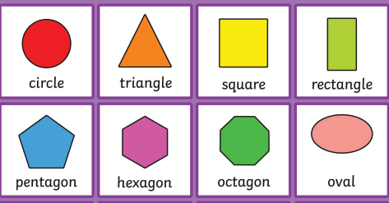

**Thursday**

**English**

The Magic Ring.

Now onto page 3. Let’s look at the emotions felt by the characters.

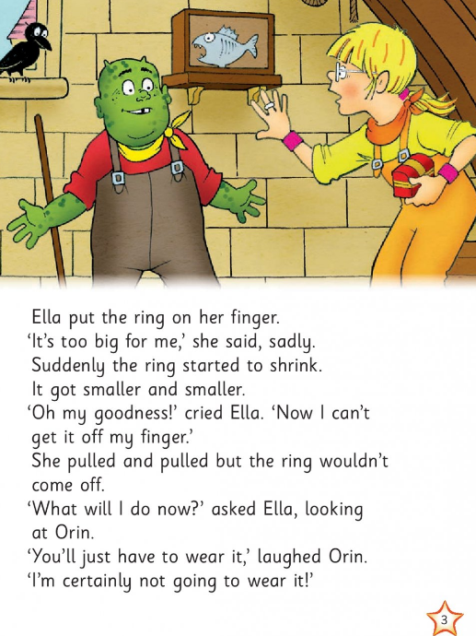

Amazed

Frightened

shocked

amused

entertained

puzzled

disappointed

dumbfounded

When have you felt those feelings. Make a connection. I wonder why wouldn’t Orin wear the ring?

Design a ring. Here is mine.



Chapter 2. The scene moves to Denzel’s cave. Read pg.4. Is this time travel or space travel or travel to another place? It is all very magical!

Draw what you think going through the tunnel was like. Draw it.

**SESE**

Butterflies. Here is a diagram of their lifecyle.

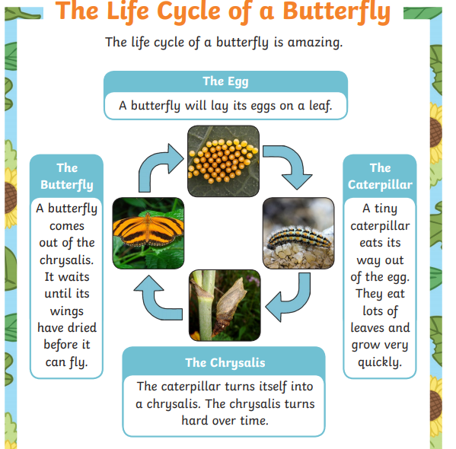

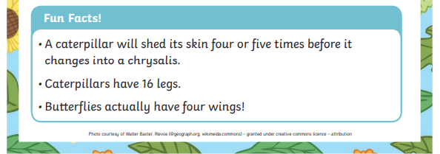

Can you draw it? If you can print the image below, you can cut and paste your own.

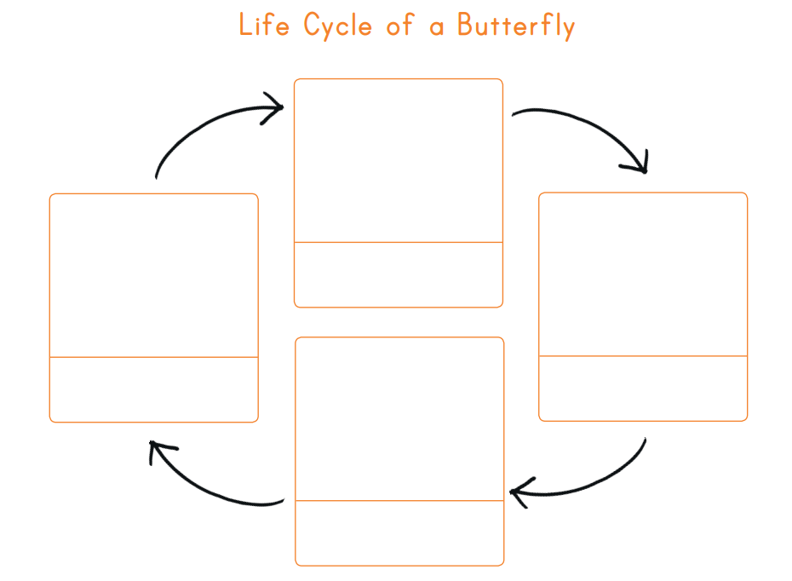

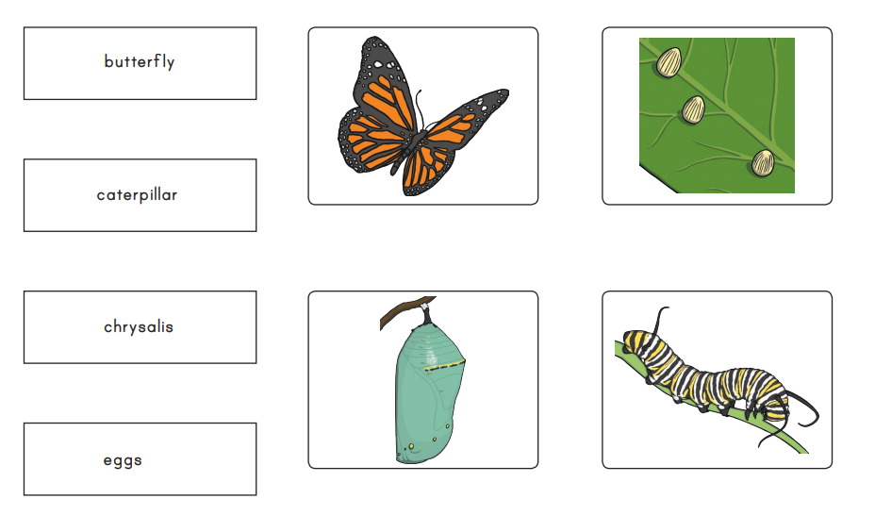

**Irish**

Remember we did time in Irish before?

Look at my minivideo- a chlog. O’clock is “a chlog”.

[a chlog Video-Click here](https://www.youtube.com/watch?v=TMgeW6LuR6M)

Trí a chlog= 3 o’clock.

Half past is “Leathuair tar éis a”..

Leathuair tar éis a trí = half past 3

Practise now with p.30 of Bua na Cainte, reading the clocks we did before.

Draw your own clock face. Have fun with it.

**Maths**

**Work It Out** –week 30 – Wednesday and Thursday 1-8. Again 15 minutes and then stop – no matter what. We are working on speed and accuracy.

Revise 3-d shapes

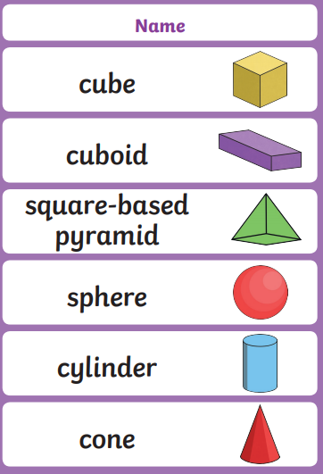 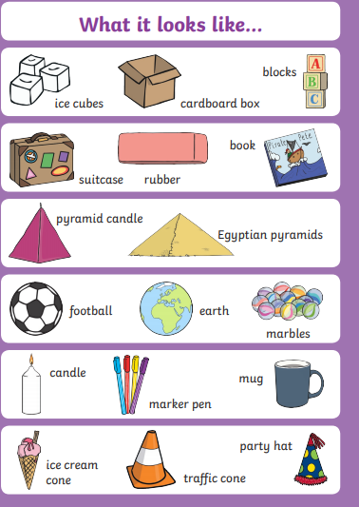

**Friday**

**English**

The Magic Ring.

Chapter 2. Read p.5. Let’s gather all the mysterious evidence.

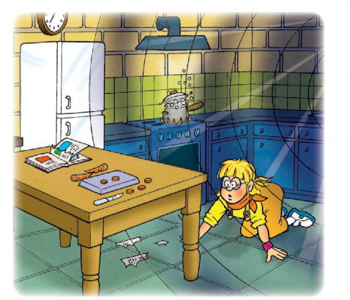

What happened here before Ella got here?

Read page 6. Why do you think the man was crying. Why was Ella surprised at the end of the chapter?

[Listen to my highlights from the first 2 chapters. Click here](https://youtu.be/HsmYqSQsg0c)

**Irish**

Time

Now we will look at quarter past and quarter to.

Leath=half.

Ceathrú=quarter.

Watch and try p.8.8 of Bua na Cainte.

[Click here Lch 88 Bua na Cainte](https://youtu.be/FD3XG9w86r0)

**Maths**

**Work It Out** –week 30 – Thursday 9-15

On the theme of Butterflies…..

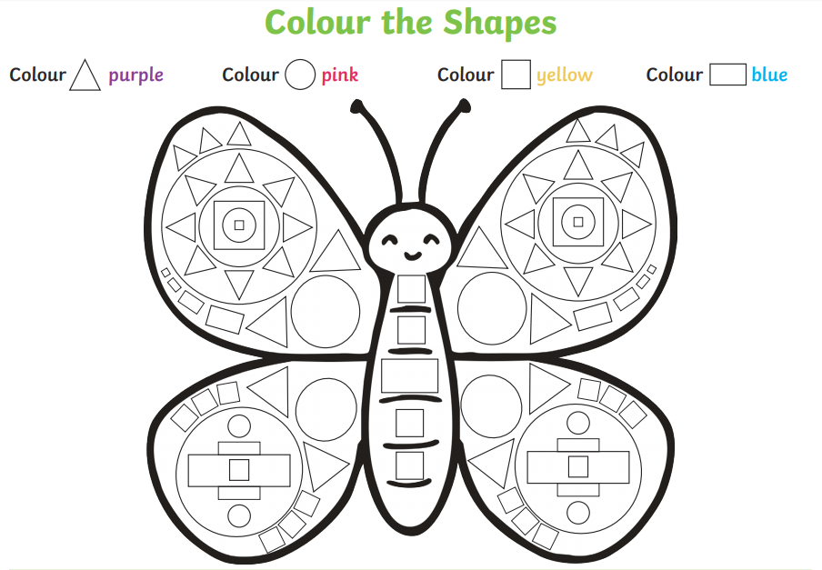

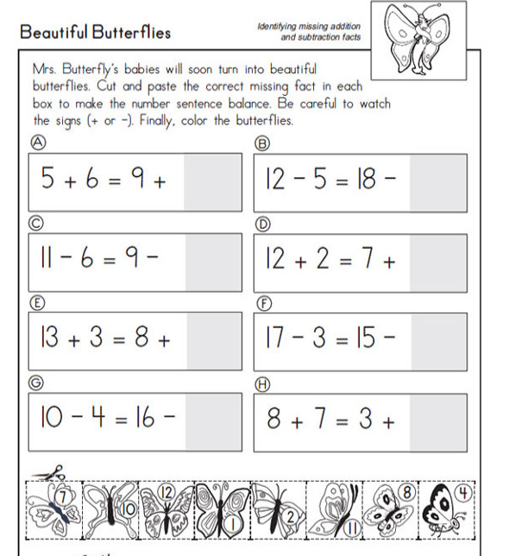

**Music**

Let’s have fun on twinkl.ie. Look at this video.

[Piano Fun- Click here](https://youtu.be/zlylTcwATFs)

**Other Ideas**

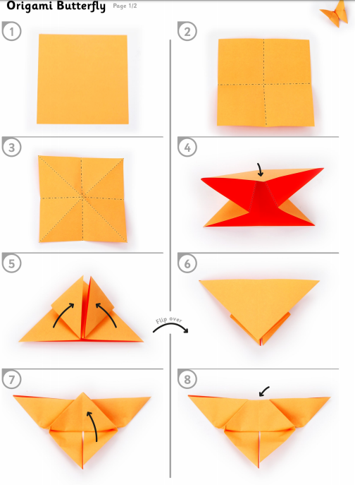

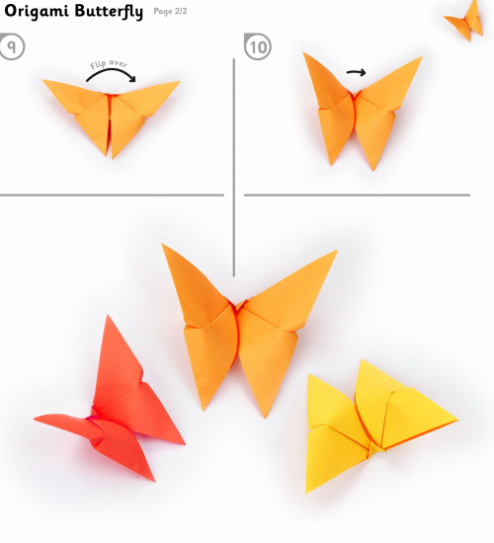

[PE With Joe | Wednesday 27th May](https://www.youtube.com/watch?v=Re8Cy9YRStI)

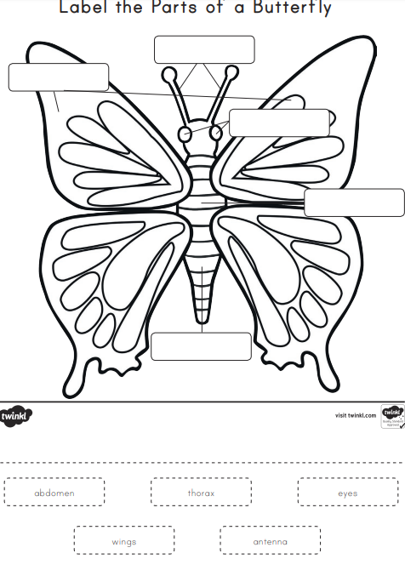

Th…………….

e………………

w…………….

Ab…………………

An………………….

## Head to “[Boredom Busters (Click here)](https://stpatricksgirls.net/?page_id=6449)” on the website for more inspiration.