**Work for Week 10**

**Wednesday 3rd June 2020 – Friday 5th June 2020**

Dear Parents and Girls,

Well we’re into the home stretch, hard to believe it’s the beginning of June! I know usually during this month we would have sports day and school tours and lots of other fun things but don’t worry girls we will try and create some of these fun activities online this year, but for now keep working away at the activities outlined in the daily timetable. Try and have fun with the work, go out and enjoy the good weather, play outside, build or make something, go for walks, observe nature. I found a little bird’s nest in my shed, I’ll put some pictures at the end with some nature worksheets/scavenger hunts! Look at some of the booklets I posted for Active Schools Week, (Week 6) try and make an obstacle course or create your own sports day with your family. Send me pictures!! Make the most of this time off girls and enjoy spending it with your family.

Take a look at the new section on the website BOREDOM BUSTERS!! Here there are lots of ideas and fun games that you can try on your own or with your family. [https://stpatricksgirls.net/?page_id=6449](https://stpatricksgirls.net/?page_id=6449%20)

This week is a short week, only 3 days! Try your best with the work and remember I would love to see some of your work so you can email me at 5thclass@stpatricksgirls.net using your parents email address.

Also watch out for Mrs Kelly’s challenges. They are usually at the top of the list of each new week’s work.

Have a good week, be good and remember to stay safe by practicing all our good Hygiene rules.

Ms. O’Sullivan ☺

**Daily Timetable of Work**

**9:00 – 9:30: Exercise**

**9:30 – 9:55: Gaeilge**

**9:55 – 10:20: Maths**

**10:20 – 10:45: English**

**10:45 – 11:00: Break**

**11:00 – 12:00: Watch RTE Home School HUB**

**12:00 - 12:45: Project Work**

**12:45 – 1:15 Lunch**

**1:15 – Free Time**

# Wednesday 3rd June

## 9:30 – 9:55: *Gaeilge*

Seo iad na ceartúcháin ón seachatin seo caite. (Here are last week’s corrections.)

SEO LEAT page 102 A

1. Chonaic na cairde dhá ghabhar I lár an bhóthair.
2. Rug Ollaí ar Mheigeall.
3. Thug Beití mála síolta d’Aoife.
4. Thug Aoife na síolta don mhúinteoir.
5. Chuir na páistí na síolta sa talamh.
6. Léim na páistí mar tháinig beach isteach sa seomra ranga agus shuigh sí i lár an bhoird.
7. Phreab an múinteoir agus rith sí amach an doras ar nós na gaoithe.
8. Chabhraigh Ollaí agus Hollaí leis an múinteoir.

Seo Leat page 103 D

1. Chaith an buachaill dána an bruscair ar fud na háite.
2. Dhoirt Fionn an bainne ar fud na háite.
3. Shéid an deatach ar fud na háite.
4. D’eitil an spideog ar fud na háite.
5. Thit na litreacha ar fud na háite.

**Litriú:**  *Read, say and learn the words from the word mats below. Spend 10 minutes at this each day. There will be a challenge on Friday to see how many you can remember and write!!*

**Léamh:**  Féach ar na mata focail agus léamh na focail nua.

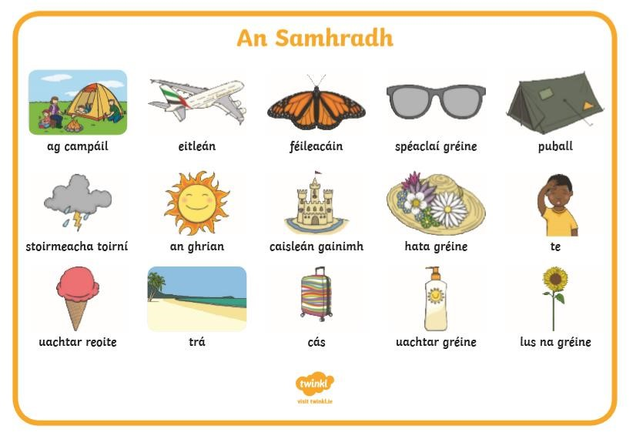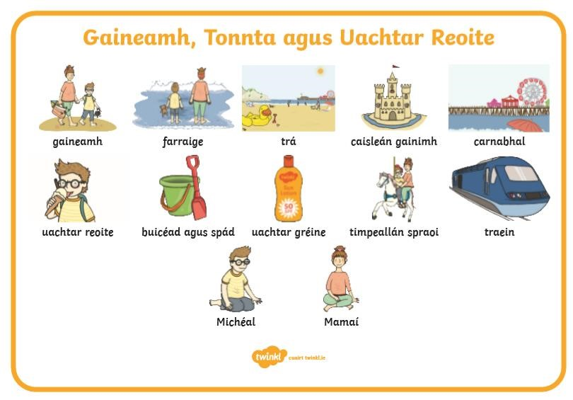

**Scríobh:** Sliocht ‘An Samhradh.’ (Using the words above, write a paragraph all about the theme of Summer.)

## Ceol

Báidín Fheilimí is a song about Phelim’s boat, keeping with our theme of transport. Listen to the song a few times and sing along when you’re ready. I bet your Mom or Dad will remember the song from their schooldays.

<https://www.youtube.com/watch?v=Ag99KDfF9Q8> (na Casadaigh singing )

**9:55 – 10:20: Maths**

**Corrections:** Take some time today to correct the maths work from last week – 3D Shapes.

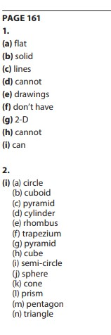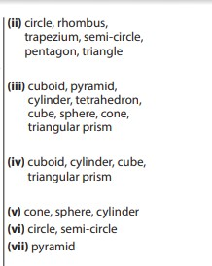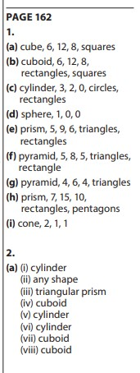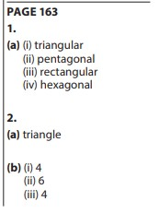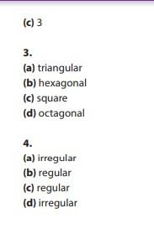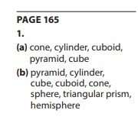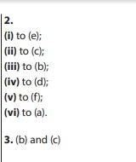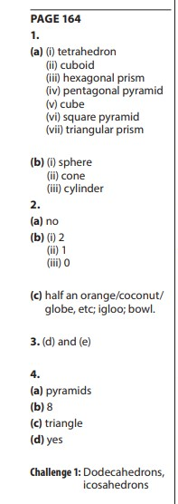

Here are the answers to the daily Maths Challenges.

Monday.

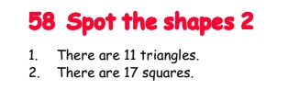

Tuesday.

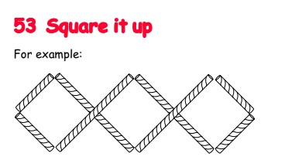

Thursday

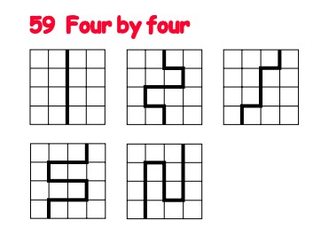

Revision of short Division:

Watch the video revising SHORT DIVISION

<https://www.youtube.com/watch?v=PTu1aZgN64o>

Try some of the examples below.



**Wednesday’s Maths Challenge: Try this crossword based on last week’s chapter 3D – Shapes!**

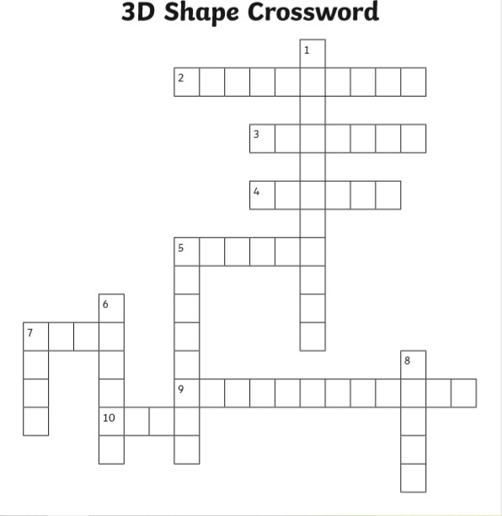

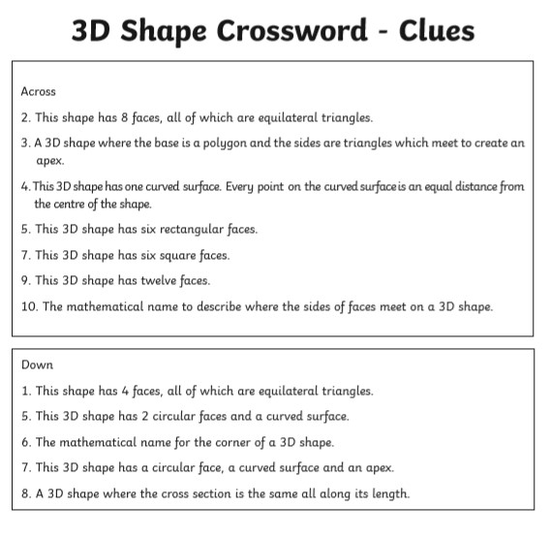

**10:20 – 10:45 English:**

**Here are last week’s answers U&R ‘Strange Flying Machines’ pg 212 – 217**

Page 216 B What have you learned?

1.Elmer of Malmesbury was injured when he tried to fly from the tower of Malmsebury Abbey. He crashed into the ground, breaking both of his legs.

2.Leonardo ds Vinci could not produce a flying machine because he did not have the means to power it. Engines were not invented until after his time.

3.Leonardo would probably have advised Elmer not to attempt to fly as it would be a disaster.

1. Clément Ader and Horatio Phillips designed aircrafts that were powered by steam engines.
2. The French were obviously interested in flight as a number of inventors and designers were French.
3. Phillips and Caproni used lots of wings in their inventions.
4. The Americans did not use the Spruce Goose because it was too expensive and took too long to build.
5. The Convair NB-36 was unusual because in was powered by a nuclear reactor.
6. The Convair NB-36 was always followed by another plane as a safety measure in case it crashed. The paratroopers in the second aircraft would have to secure the crash site and prevent anyone from coming into contact with the deadly radioactive wreckage.
7. Give a reason for your answer.

Page 216 C True or false.

1. False. 2. True. 3. True. 4. False. 5. False. 6. False. 7. True.

**Reading:** U&R pg 240 – 243

Watch this Video all about Train Journeys of the World <https://youtu.be/fkslRh5kWoo>

**Writing:** U&R pg 244 B qs 1 - 10

# Thursday 4th June

## 9:30 – 9:55: *Gaeilge*

**Litriú:**  *Read, say and learn the words from the word mats. Spend 10 minutes at this each day. There will be a challenge on Friday to see how many you can remember and write!!*

*(an trá and cois farraige are similar....****Bhí mé ag an trá – I was at the beach***

***Bhí mé cois farraige = I was at the seaside****.)*

**Léamh:** Read the story ‘Cairde Nua’ Léigh sa Bhaile Leabhar E pg 118 <https://my.cjfallon.ie/preview/student/16879/128>

[**(www.cjfallon.ie**](http://www.cjfallon.ie/) **– 5th class – Gaeilge – see the book Léigh sa Bhaile Leabhar E – pg 118 Cairde Nua)**

## [Éist leis an recording ‘Week 10 Thursday. Click here](https://youtu.be/KbzR4TGyxrk)

**Scríobh:** Do the Qs 1 – 5 pg 118.

Líon na Bearnaí sa phictiúr thíos – fill in the blanks in the picture below.

**EXTRA WORK** – if you want Scríobh 4/5 abairtí faoi ‘An Samhradh’ or continue with your paragraph from yesterday.

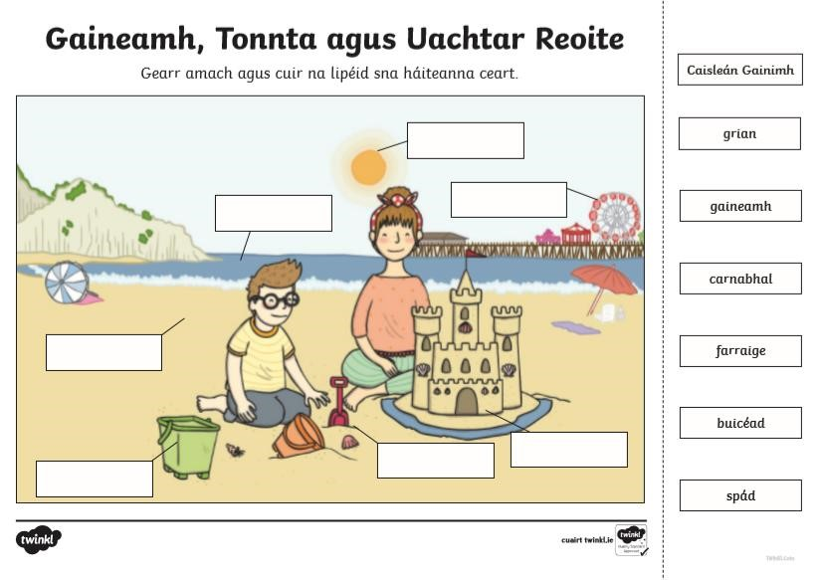

**9:55 – 10:20: Maths** Revision of long division:

[Watch the video revising LONG DIVISION-Click here](https://youtu.be/phnSDMtBD1k)

Try some of the word problems below. Remember….

**D**ivide, **M**ultiply, **S**ubtract, **B**ring **D**own.

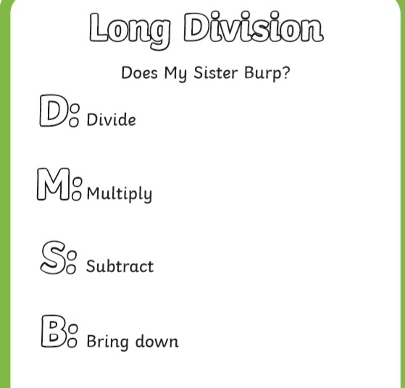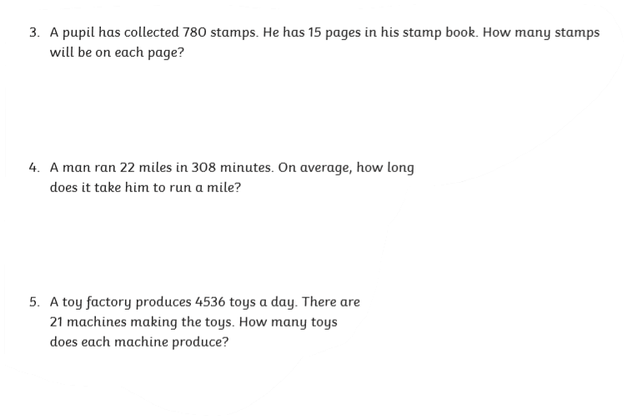

**Thursday’s Maths Challenge:**

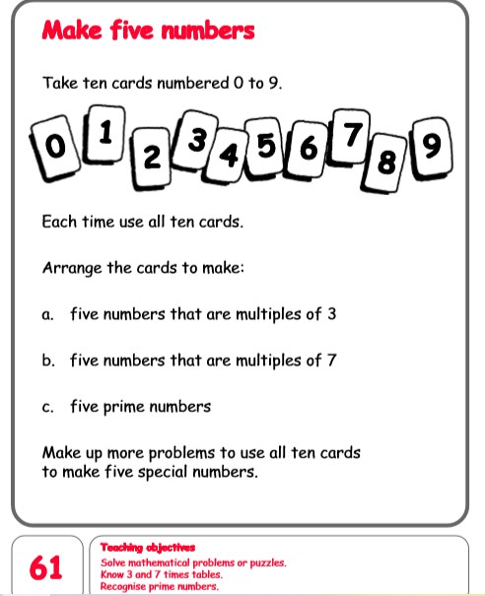

**10:20 – 10:45 English:**

**Reading:** U&R pg 240 – 243

**Writing:** U&R pg 245 E Complete the Cloze Procedure

**ADVERTISING** is used to sell or promote a product. Have a look at the examples of these ads. What do you notice about them? What information are they giving you? What draws your attention more, the writing or the pictures?

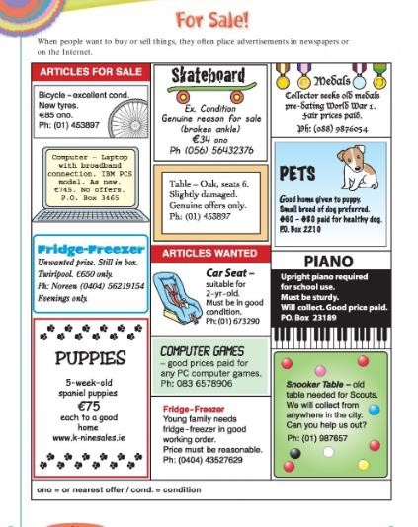

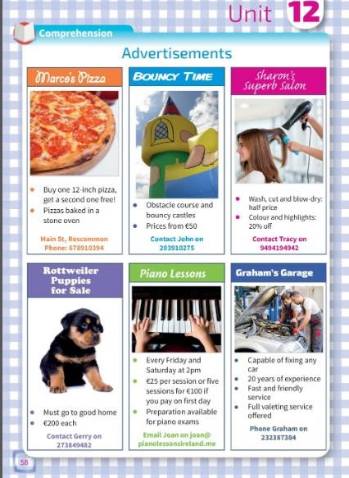

### Features of a good ADVERTISEMENT 1. Catchy Title or Slogan 2. Gives just the right amount of Information 3. Not too much writing – use pictures or diagrams 4. Humour – sometimes they are funny so that you will remember them 5. Colourful – use colour to draw the person’s attention

Can you find examples of ads – have a look through the newspaper/magazines/brochures/online (The LIDL and ALDI booklets are good!) Do these ads meet the criteria outlined above 1-5??

# Friday 5th June

## 9:30 – 9:55: *Gaeilge*

**Litriú** *Write down as many words as you can remember form the word mats. Once you are finished, go back and look at the word mats and correct your work.*

**Léamh:** Seo Leat lgh 117 Dán ‘Éirígí, a Pháistí’

[Éist leis an recording ‘Week 10 Friday’](https://youtu.be/PUiGDmCdTOA)

Féach ar G lch 117 – Aimsigh na difriochtaí agus faigh na 10 difriochtaí.

**Scríobh:** Write what you can see/hear/taste/feel in this summer garden.

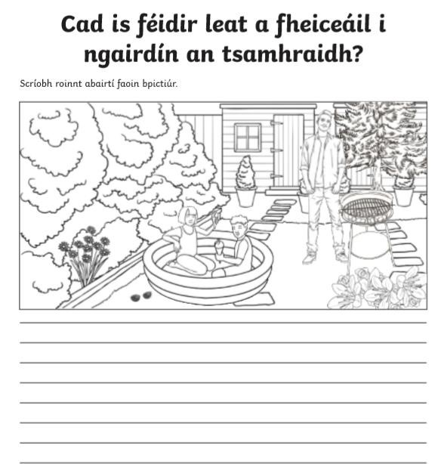

Úsáid an pictiúir seo chun cabhrú leat. (Use this picture to help you)

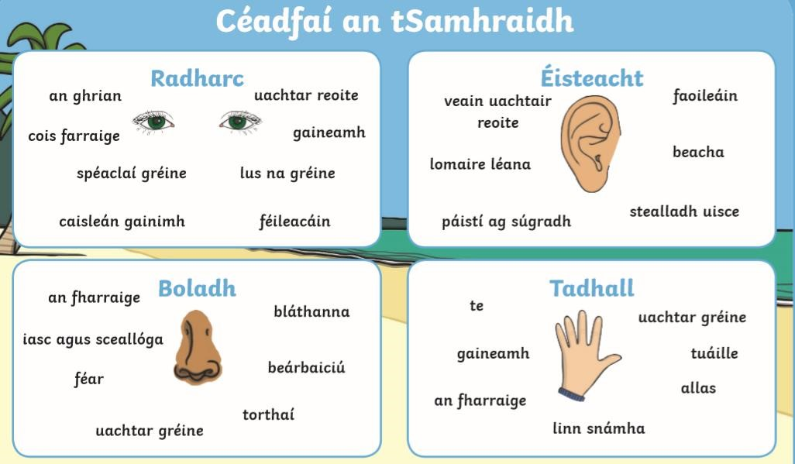

**9:55 – 10:20: Maths** Revision of long division:

Watch the video revising LONG DIVISION again <https://youtu.be/phnSDMtBD1k>Try some of the word problems below.

Remember….

**D**ivide, **M**ultiply, **S**ubtract, **B**ring **D**own.

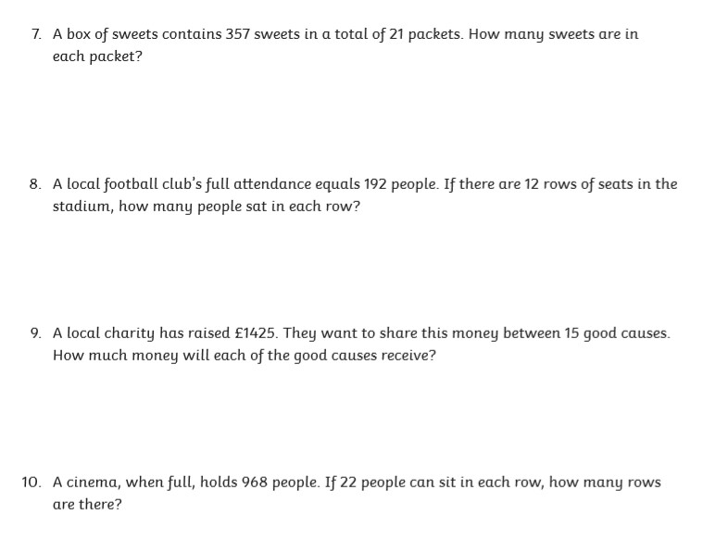

**Friday’s Maths Challenge:**

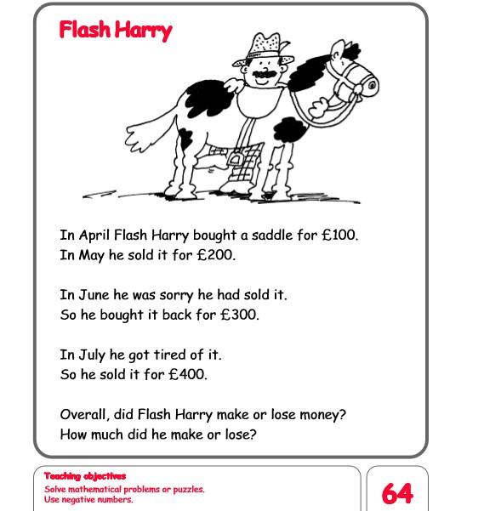

**10:20 – 10:45 English:**

**Reading:** U&R pg 240 – 243

**Writing:** U&R pg 244 C and D

Take a look at this video again all about Train Journeys of the World <https://youtu.be/fkslRh5kWoo>

Check back on what we learned yesterday about Advertising. Design an Advert for a train journey of your choice. Use information from pgs 240 – 243 and the video, or make it up. The information doesn’t have to be real but try and include the **Features of a good ADVERTISEMENT.**

**Project Work – Use this time to finish uncompleted work. If you have all this done and want more, choose something from the ‘BOREDOM BUSTERS’ section on the school website. Click on the button at the top of the school website or follow this link below.**

[https://stpatricksgirls.net/?page_id=6449](https://stpatricksgirls.net/?page_id=6449&preview_id=6449&preview_nonce=ef950080d8&preview=true)

