Week beginning: 11/05/2020 Class and Subject: 2nd class EAL SEN Teacher: Ms. Conran

Work below is to be carried out over a week. Uncompleted work can carry on to the following week.
Healthy Eating Week
- This week is healthy eating week, so I have included some fun worksheets below to tie in with healthy eating!

Week 7 | 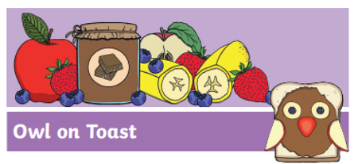  Healthy Owl on Toast Recipe  - Read and try out this fun healthy owl toast recipe!  - Have you ever tried fruit on toast before?  - Can you think of any other fun ways of decorating toast with fruit?  - Enjoy! |   Healthy Food Diary  - Make a note of all of the delicious healthy foods that you eat during the day.  - How many fruits and vegetables are you eating each day!  - What are your favourite fruits and vegetables to eat and why? |   Design your own healthy smoothie recipes using the templates attached as a guide!  - What ingredients and utensils/tools do you need?  - What are the steps involved?  - What will the finished product look and taste like?  - Why did you choose this as a healthy recipe?
 | Fruits & Vegetable word mat  - Read the list of fruits and vegetables.  - What are your favourite fruits and vegetables and why?  - What fruits and vegetables do you eat most days?  - Are there any fruits and vegetables that you haven’t tried yet?  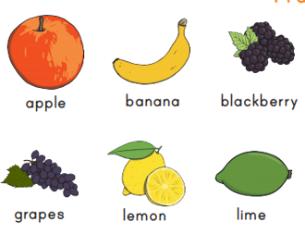 | 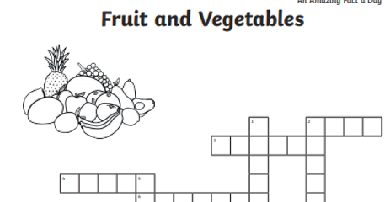  Fruits and Vegetables Crossword  - Discuss the clues to guess the fruits and vegetables to complete this crossword orally or in written form.  - Guessing game: Can you each think of a fruit or vegetable, give your partner clues about it and see if they can guess correctly! | Healthy Recipes  - Why not see if you can find some healthy recipes at home to try!  - Here are some useful websites that you might enjoy!  - https://produceforkids.com/  - https://www.healthylittlefoodies.com/  - https://www.myfussyeater.com/  Note to Parents:  - This is only a menu of work so feel free to pick and choose work that you feel is appropriate for your child and work away at your own level.

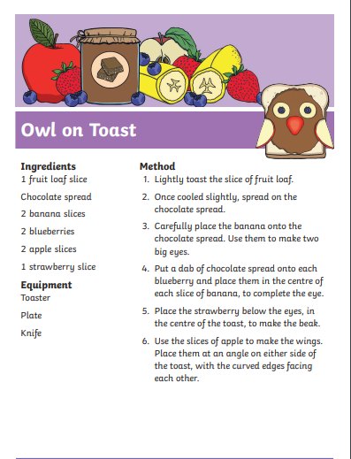
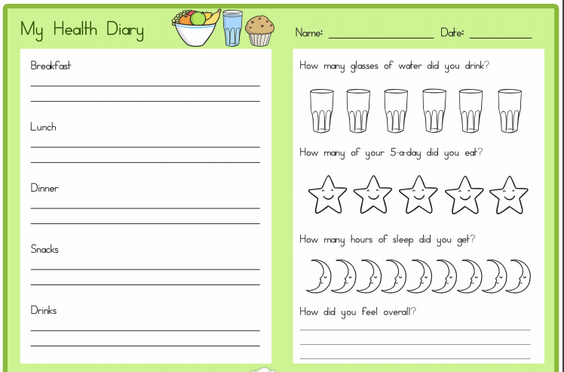
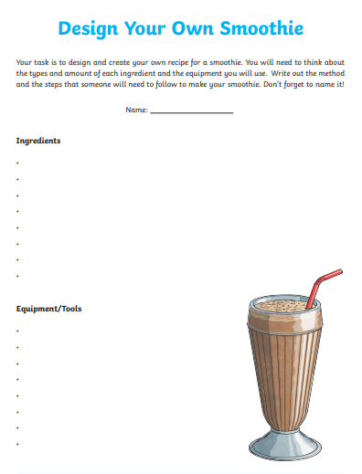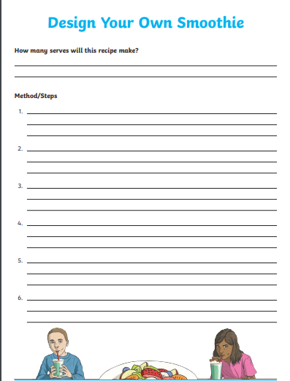
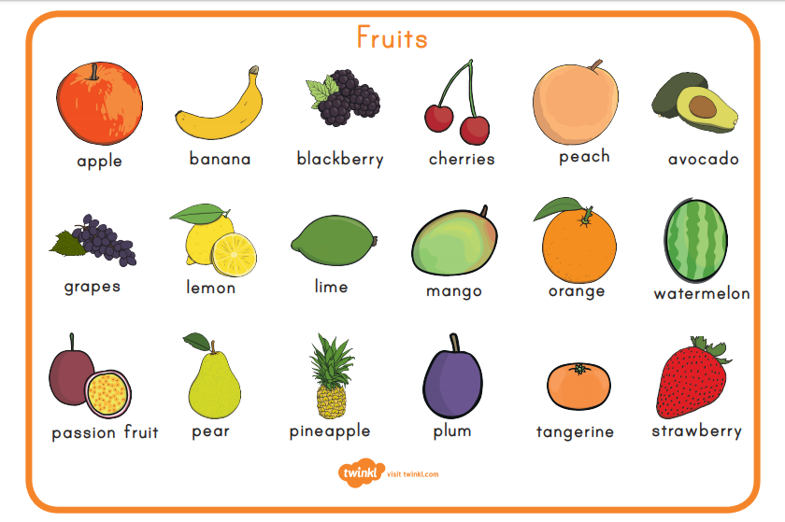

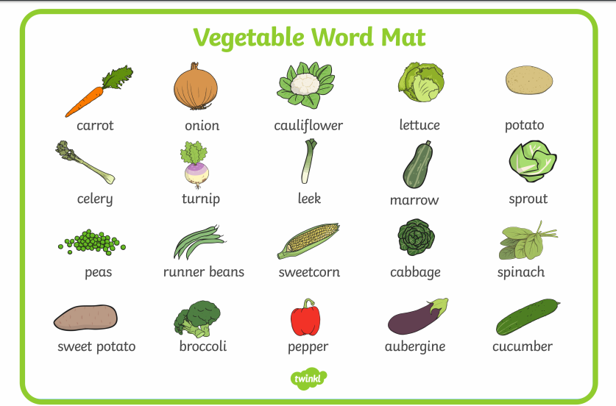

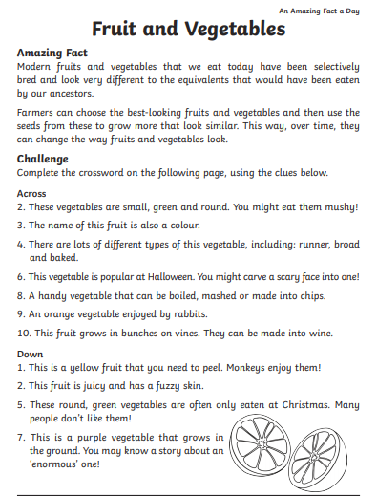
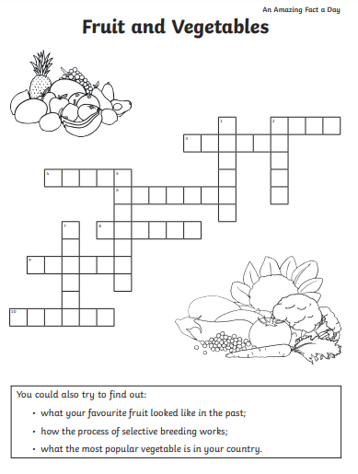
Design your own healthy eating recipe and write the method using this temlate as a guide!
