Dear girls, parents and guardians,

I hope you all had a lovely long weekend and that you enjoyed the glorious sunshine.

It’s a short week this week so you have only 3 days’ work. Therefore we will not do Work it Out or Spellbound. Just a quick note on the Work it Out answers from last Tuesday, there are two errors: no.13 says 72 but the answer is 90 and no.15 says 15, 16, 17 but it should be 15, 16, 18. Apologies about that.

There seems to be a clear winner on the hoodies but we could do with a few more suggestions for the end of year graduation song. If you think of a suitable song please forward on the suggestion to me or Mrs.Kelly.

Wishing you all a good week ahead.

Take care,

Jackie Landers

**Suggested Timetable**

**9:00 – 9:30** Exercise (e.g. Joe Wicks, Cosmic Yoga, stretching, walk the dog, a quick spin on bike/scooter)

**9:30 – 10:45** Core subjects from Schedule of Work

**10:45 – 11:00** Small Break

**11:00 – 12:00** RTE School’s Hub

**12:00 – 12: 45** Time to complete unfinished work from earlier or pick something from “Extra Activities” lists suggested in previous weeks

**12:45 – 13:15** Lunch

**13:15 onwards** Enjoy the rest of your day!

**Schedule of Work: Week 10**

**WEDNESDAY**

**Matamaitic**

1. Maths Corrections:

1)Work it Out: Week26 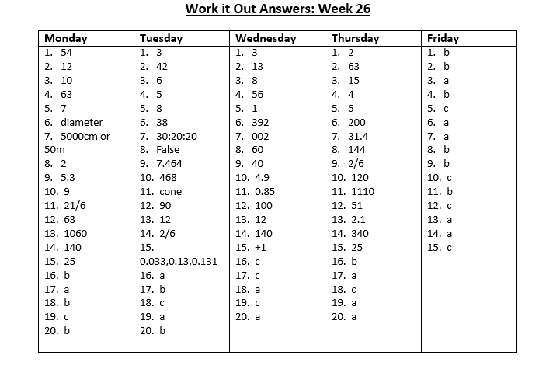

2)Busy at Maths p.116 – p.119 and Shadow Book p.52

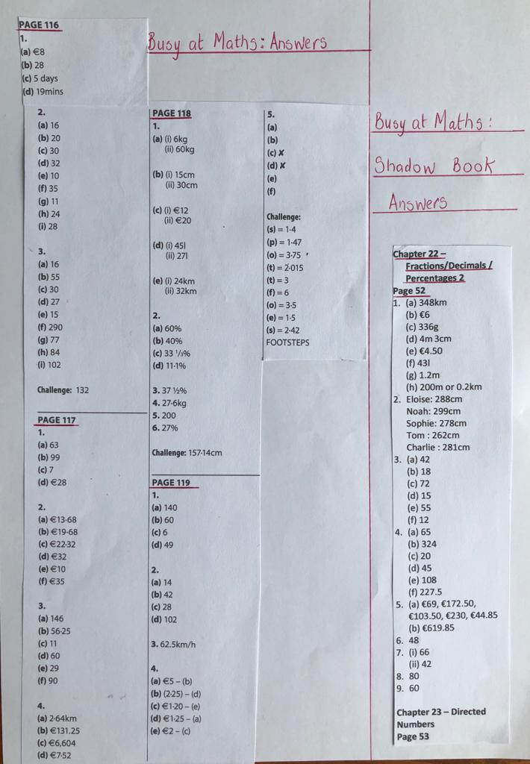

1. Busy at Maths, Chapter 22: Directed Numbers – p.120: A positive number is more than zero. A negative number is less than zero. Answer Qs 1 – 7 orally. Continue on to p.121 , answer Qs 1 – 13 (written work)
2. Extra Maths (for those who wish to try a few more): Busy at Maths Shadow Book p.53, no’s 1 – 6

**Gaeilge**

1. Corrections: Inis Dom lth 121: 1=chugam, 2=chuici, 3=chugainn, 4=chuige 5=mbanaltra, 6=chugaibh
2. Léigh an píosa Léitheoireacht “Tráthnóna Inné” agus freagrair na ceisteanna (Read the piece of Reaading “Yesterday Evening” and answer the questions )

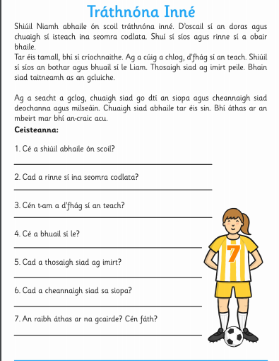

**Béarla**

1. English Corrections: 1)Spellbound 2)Racing Ahead p.271 3)The Apostrophe

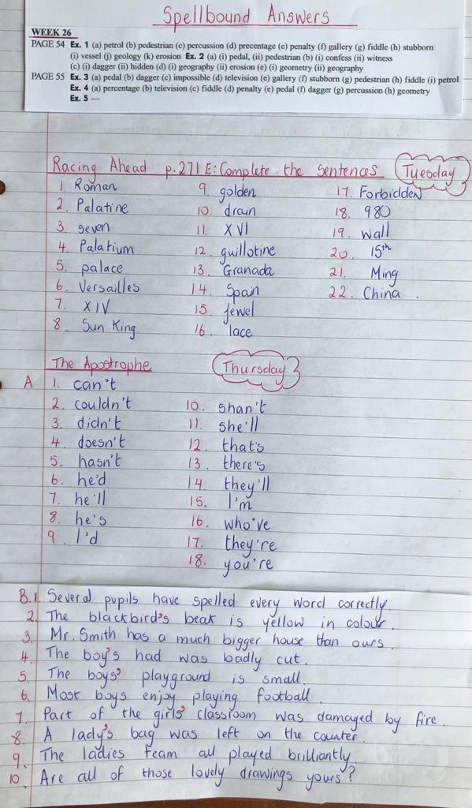

1. **Persuasive Writing**

Persuasive writing intends to convince readers to believe in an idea or opinion. We see persuasive writing in debates, newspaper articles, advertisements, brochures and leaflets. In this kind of writing we:

* Open our piece by strongly giving our point of view
* Show reasons to support our viewpoint
* Provide facts and evidence
* Use connective language e.g. Firstly…, Secondly…, Finally…
* Use persuasive language e.g. obviously, without doubt
* Finish with a strong conclusion. This involves restarting your opinion and summarising your arguments

Read the following persuasive piece of writing to identify the above elements

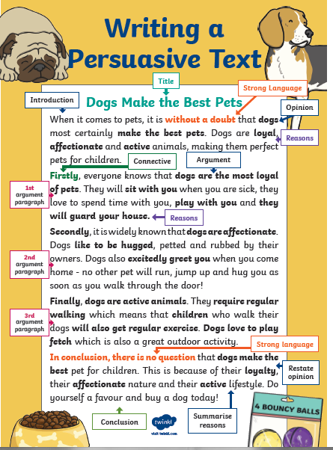

3. Could you write your own piece of persuasive writing? Choose one of the following arguments:

* Mobile phones are necessary
* All students should have daily chores
* Everyone should have a pet

**THURSDAY**

**Matamaitic**

1. Busy at Maths p.122: Read explanation about speed limits. Answer Qs 1 – 3 orally. Complete table in Q.4 (written work). Continue on to p.123 and complete all of the page : 1 – 4 (written work)

[**Click here Ms Lander's Maths Video**](https://youtu.be/zG9PjsSUVWA)

1. Extra Maths : Busy at Maths Shadow Book p.53, no. 7

**Gaeilge**

1. Inis Dom, lth126 :thuaidh, theas, thoir,thiar (north, south, east,west).

Look at the diagrams and answer the questions(1-8) underneath e.g. 1.Cá bhfuil Máire ag dul? Tá Máire ag dul go Baile Átha Cliath

**Béarla**

1. Look at the following brochure and answer the questions orally

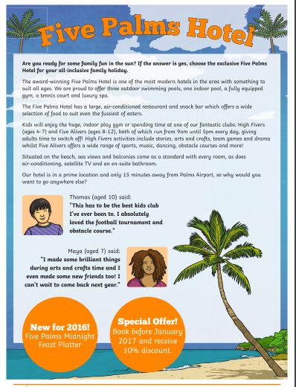

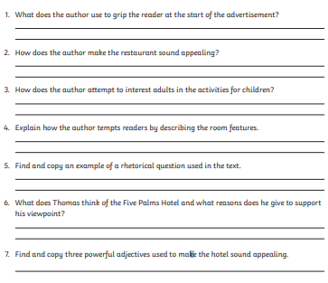

2. Design a brochure cover for one of the following places:

* The Montenotte Hotel
* Blackrock Castle
* Fota Wildlife Park
* The English Market

**FRIDAY**

**Matamaitic**

1. Busy at Maths p.124 no’s 1 – 4 (written work)

2. Extra Maths p.124 no’s 5 and 6

3. Continue on to Chapter 24: Area p.125 - Read examples at the top of the page : Area is the space covered by a 2-D shape, (answer is cm/m squared) and perimeter is the distance around the 2-D shape i.e. the edge(answer is cm/m) . Complete Q.1 (written work)

4. Extra Maths p.125 no’s 2 and 3

**Béarla**

1. Spend some time reading your favourite book

**SPHE** (Social, Personal and Health Education)

1. Please fill out the [Questionnaire here](https://forms.gle/FxkysXJfofkzJyK97) about your thoughts and feelings starting secondary school