**Week 10 –**June 3rd – 5th

**Wednesday June 3rd 2020**

**9am-9.30am** Kids workout <https://www.youtube.com/watch?v=dhCM0C6GnrY>

Joe Wicks <https://www.youtube.com/channel/UCAxW1XT0iEJo0TYlRfn6rYQ>

10 minute workout <https://www.youtube.com/watch?v=oc4QS2USKmk>

Fun workout <https://www.youtube.com/watch?v=BDYd2qFR45o>

Yoga <https://www.youtube.com/watch?v=dw-0bmtDPnk>

GO Noodle Dance <https://www.youtube.com/watch?v=KhfkYzUwYFk>

Jump on your trampoline C:\Users\Fujitsu\AppData\Local\Microsoft\Windows\INetCache\IE\3CY7X0QX\smileyface_thumbsup[1].jpg Play hopscotch outside.

**9.30am-9.55am English**

**1) Spellbound** p 70 no 1

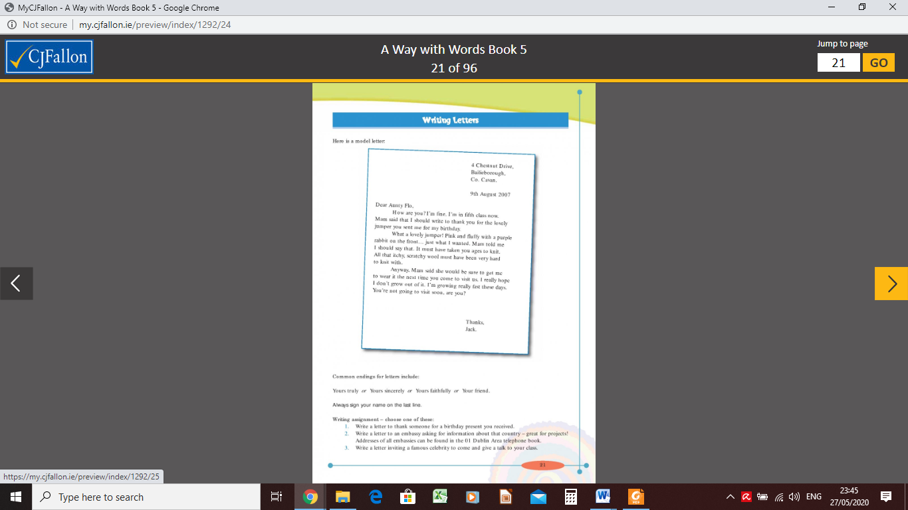**2) Letter Writing** Read this [sample](https://my.cjfallon.ie/preview/index/1292/24) letter

**When writing a letter you need to remember to include:**

- Write your home address in the top right corner of your page. Go to a new line for each line of your address.

- Write the date under your address

- Address the person you are writing to with “Dear \_\_\_\_\_\_, ” and put a comma after the name.

- Go to the next line to begin and “indent” about 2cm.

- Go to a new paragraph for each new idea/theme.

- You should finish a more formal letter with “Yours sincerely,”. A more informal letter to someone you know well may have “Thanks” or “see you soon”. Think about who you are writing to.

- Write your name underneath the greeting.

**Think about what you will write in your letter to the school about your time during COVID-19.**

**Do a plan and draft ideas for your letter.**

**9.55 – 10.20am Gaeilge**

1. **Seo Leat** p360/61 Revise this scéal “Sam Bocht”. You can have a look at the questions on the next page and do them orally if you can. It’s all revision!

[Click here](http://data.cjfallon.ie/resources/seo_leat/SL_4C_T02_U11/index.html) to hear the scéal

1. [Click here](http://data.cjfallon.ie/resources/seo_leat/SL_4C_T04_U11/index.html) to play the cluiche based on the vocabulary in the scéal Sam Bocht.
2. [Click here](https://www.youtube.com/watch?v=Sn1mxujspEA) to hear the scéal **Drochlá Ruairí.** “Rory’s Bad Day”.

10.20-10.45 **Maths** -  **Busy at Maths p172-173 Maths Trail**

Try questions **1 -13** on Wednesday

All of the questions in this Maths Trail are from different chapters. You should use a calculator as much as possible.

Give them a go and I’ll send on the answers next week. If you have difficulty with any part of the chapter, ask someone at home or you can let me know.

[Click here](https://www.arcademics.com/games/meteor) to play the Meteor Multiplication game

**10.45-11am Break**

**11am-12noon RTÉ HOME SCHOOL HUB ON RTÉ 2 AT 11AM**

**12noon – 1pm Geography in your Garden**

**Have a look at** [this video](https://www.youtube.com/watch?v=YJD577nF3m8) **which explains how to draw a map. (3-14mins)**

**Draw a map of your garden and create your own symbols to mark items in the garden. Use colour to show things like grass (green), paths (grey) etc**

**If you want, you can draw a map of your dream garden!!**

**Thursday June 4th 2020**

9am-9.30 Kids workout <https://www.youtube.com/watch?v=dhCM0C6GnrY>

Joe Wicks <https://www.youtube.com/channel/UCAxW1XT0iEJo0TYlRfn6rYQ>

10 minute workout <https://www.youtube.com/watch?v=oc4QS2USKmk>

Fun workout <https://www.youtube.com/watch?v=BDYd2qFR45o>

Yoga <https://www.youtube.com/watch?v=dw-0bmtDPnk>

GO Noodle Dance <https://www.youtube.com/watch?v=KhfkYzUwYFk>

Jump on your trampoline C:\Users\Fujitsu\AppData\Local\Microsoft\Windows\INetCache\IE\3CY7X0QX\smileyface_thumbsup[1].jpg Play hopscotch outside.

**9.30am-9.55am English**

**1)** Spellbound p 71 no 2

**2)**  Write your letter to the school about your time during COVID-19. –

Remember these:

|  |  |  |
| --- | --- | --- |
| Did you include these in your letter? | C:\Users\Fujitsu\AppData\Local\Microsoft\Windows\INetCache\IE\3CY7X0QX\smiley-face[1].jpg  Yes I did | C:\Users\Fujitsu\AppData\Local\Microsoft\Windows\INetCache\IE\J3QG7N6M\Frowny.svg[1].png  No I forgot |
| Write your home address in top right corner of page |  |  |
| Go to a new line for each line of your address |  |  |
| Write the date under your address |  |  |
| “Dear \_\_\_\_\_\_, ” and put a comma after the name |  |  |
| Go to the next line to begin and “indent” about 2cm |  |  |
| Go to a new paragraph for each new idea/theme |  |  |
| Write your name underneath the signing off greeting |  |  |

**9.55am – 10.20am Gaeilge**

1) **Seo Leat** p66-67 Revise this scéal “Ag an Margadh”. [Click here](http://data.cjfallon.ie/resources/seo_leat/SL_4C_T02_U12/index.html) to hear the story.

You can have a look at the questions on the next page and do them orally if you can. It’s all revision!

2)[Click here](http://data.cjfallon.ie/resources/seo_leat/SL_4C_T03_U12/index.html) to play the card matching game

3)[Click here](http://data.cjfallon.ie/resources/seo_leat/SL_4C_T07_U12/index.html) críochnaigh na abairtí

**10.20-10.45am Maths** -  **Busy at Maths p172-173 Maths Trail**

Try questions **14 -19** on Thursday

All of the questions in this Maths Trail are from different chapters. You should use a calculator as much as possible.

Give them a go and I’ll send on the answers next week. If you have difficulty with any part of the chapter, ask someone at home or you can let me know.

[Click here](https://www.arcademics.com/games/meteor) to play the Meteor Multiplication game

**10.45-11am Break**

**11am-12noon RTÉ HOME SCHOOL HUB ON RTÉ 2 AT 11AM**

**12noon – 1pm Science in your Garden – The Senses**

1. **Sit in your garden (if it’s dry!) and listen.**

**What can you hear? List everything you can hear**

**What can you see moving? Make a list**

**Can you smell anything? Freshly cut grass? cooking?**

**What can you feel? Name things that are hard, soft, rough, smooth, wet, sticky….. what other words can you use to describe what you feel?**

1. **Search your garden for minibeasts. List everything that you can find and where you found it. Use these pages to help you.**

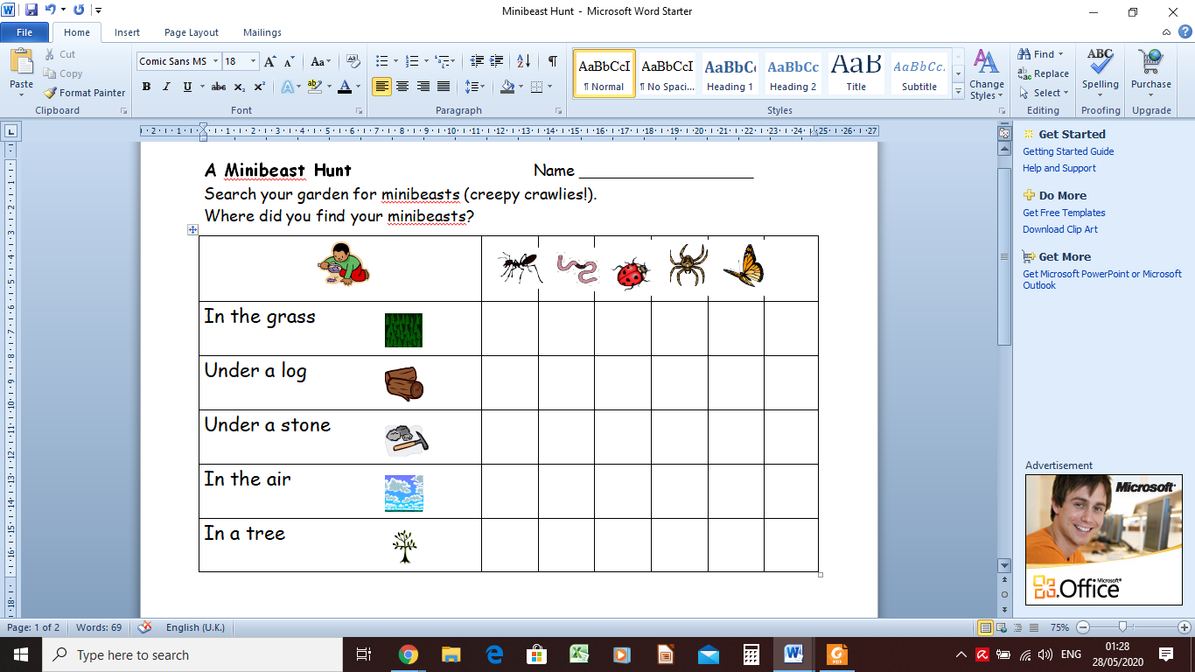

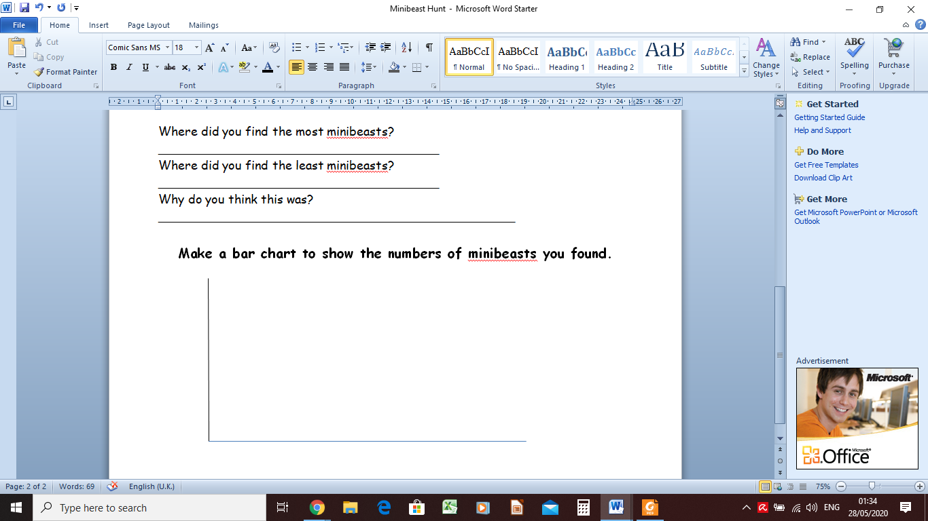

**Friday June 5th 2020**

**9am-9.30am** Kids workout <https://www.youtube.com/watch?v=dhCM0C6GnrY>

Joe Wicks <https://www.youtube.com/channel/UCAxW1XT0iEJo0TYlRfn6rYQ>

10 minute workout <https://www.youtube.com/watch?v=oc4QS2USKmk>

Fun workout <https://www.youtube.com/watch?v=BDYd2qFR45o>

Yoga <https://www.youtube.com/watch?v=dw-0bmtDPnk>

GO Noodle Dance <https://www.youtube.com/watch?v=KhfkYzUwYFk>

**9.30am-9.55am English**

**1) Spellbound** p 71 exercise 3

**2)** [Click here](https://www.arcademics.com/games/elephant-feed)to play Elephant Feed where you must click on the synonyms (words with similar meaning)

**9.55-10.20am** **Gaeilge**

**1) Féach ar** Breithlá Oísín - [Click here](https://www.rte.ie/player/series/tir-na-nog/SI0000006552?epguid=IP000064974) to watch the programme. Listen carefully to see if you can hear the vocabulary listed here;

**Ag dul ar eachtra** – go on an adventure

**Cóisir gan coinne** – surprise party

**Cárta lá breithe** – birthday card

**Balúin** - balloons

**ag coiméad Oísín gnóthach** - keeping Oísín busy

**Brioscaí** - biscuits

**Bonnóga** - buns

**Cáca breithe blasta** – tasty birthday cake

**Tá tigín bun ós cionn/trína chéile** – the house is “upside down” / all messed up

**Tá siad gafa** – they’re busy

**Cén t-am é a Mhac Tíre? -** What’s the time Mr. Wolf

**Cheap mé go ndearna sibh dearmad ar** – I thought you forgot it

**Bloiceanna thógála** – building blocks

**Ag déanamh brionglóida** - dreaming

**2) Déan cuireadh chun cóisir** Design a birthday invitation as Gaeilge

**10.20-10.45am** **Maths** -  **Busy at Maths p172-173 Maths Trail**

Try questions  **20 – 25 on Friday**

All of the questions in this Maths Trail are from different chapters. You should use a calculator as much as possible.

Give them a go and I’ll send on the answers next week. If you have difficulty with any part of the chapter, ask someone at home or you can let me know.

[Click here](https://www.arcademics.com/games/meteor) to play the Meteor Multiplication game

**10.45-11am Break**

**11am-12noon RTÉ HOME SCHOOL HUB ON RTÉ 2 AT 11AM**

**12noon – 1pm Summer Scavenger Hunt in the Garden**

|  |  |  |
| --- | --- | --- |
| **Find and Collect the following:** | **Found** | **Didn’t find** |
| **Trees** |  |  |
| A leaf with wavy edges |  |  |
| A long narrow leaf |  |  |
| **Flowers** |  |  |
| A white flower |  |  |
| A yellow flower |  |  |
| A tall flower |  |  |
| A small flower |  |  |
| A sweet scented flower |  |  |
| **From a shrub/tree with thorns** |  |  |
| A leaf |  |  |
| **From a prickly Shrub** |  |  |
| A flower |  |  |
| A leaf |  |  |
| **Mini-beasts** |  |  |
| A leaf with tiny mini-beasts |  |  |
| A mini-beast with no legs |  |  |
| **You are a super scavenger!** |  |  |
| Something unusual that will impress everyone |  |  |

**See if you can find these leaves when you’re out for a walk. They may be in your garden or on your roadway.**

