June 2nd – 5th
1st Class

Dear parents/guardians of 1st class students,
I hope you had an enjoyable and relaxing bank holiday weekend. Please find work for this week below. As always it is just a guide. Please do not feel under pressure to get everything done. Feel free to keep going on work your daughter has not finished yet and take each day at your daughter’s pace.
Choose a piece of ‘Project Work’ your daughter would like to do from the Boredom Busters folder. It is hoped that a project can be selected that the whole family can get involved in and have fun with. Thank you again for your continued support.
Best wishes,
Ms Gleeson.

Dear 1st class girls,
I hope you had a lovely long weekend. Choose a fun project from the ‘Boredom Busters’ folder to work on with your family this week. I have loved the emails I have received from you so far. Please send me on any work you are proud of and I will be sure to reply!
Be kind,
Ms. Gleeson.

Self-correcting for Cracking Maths

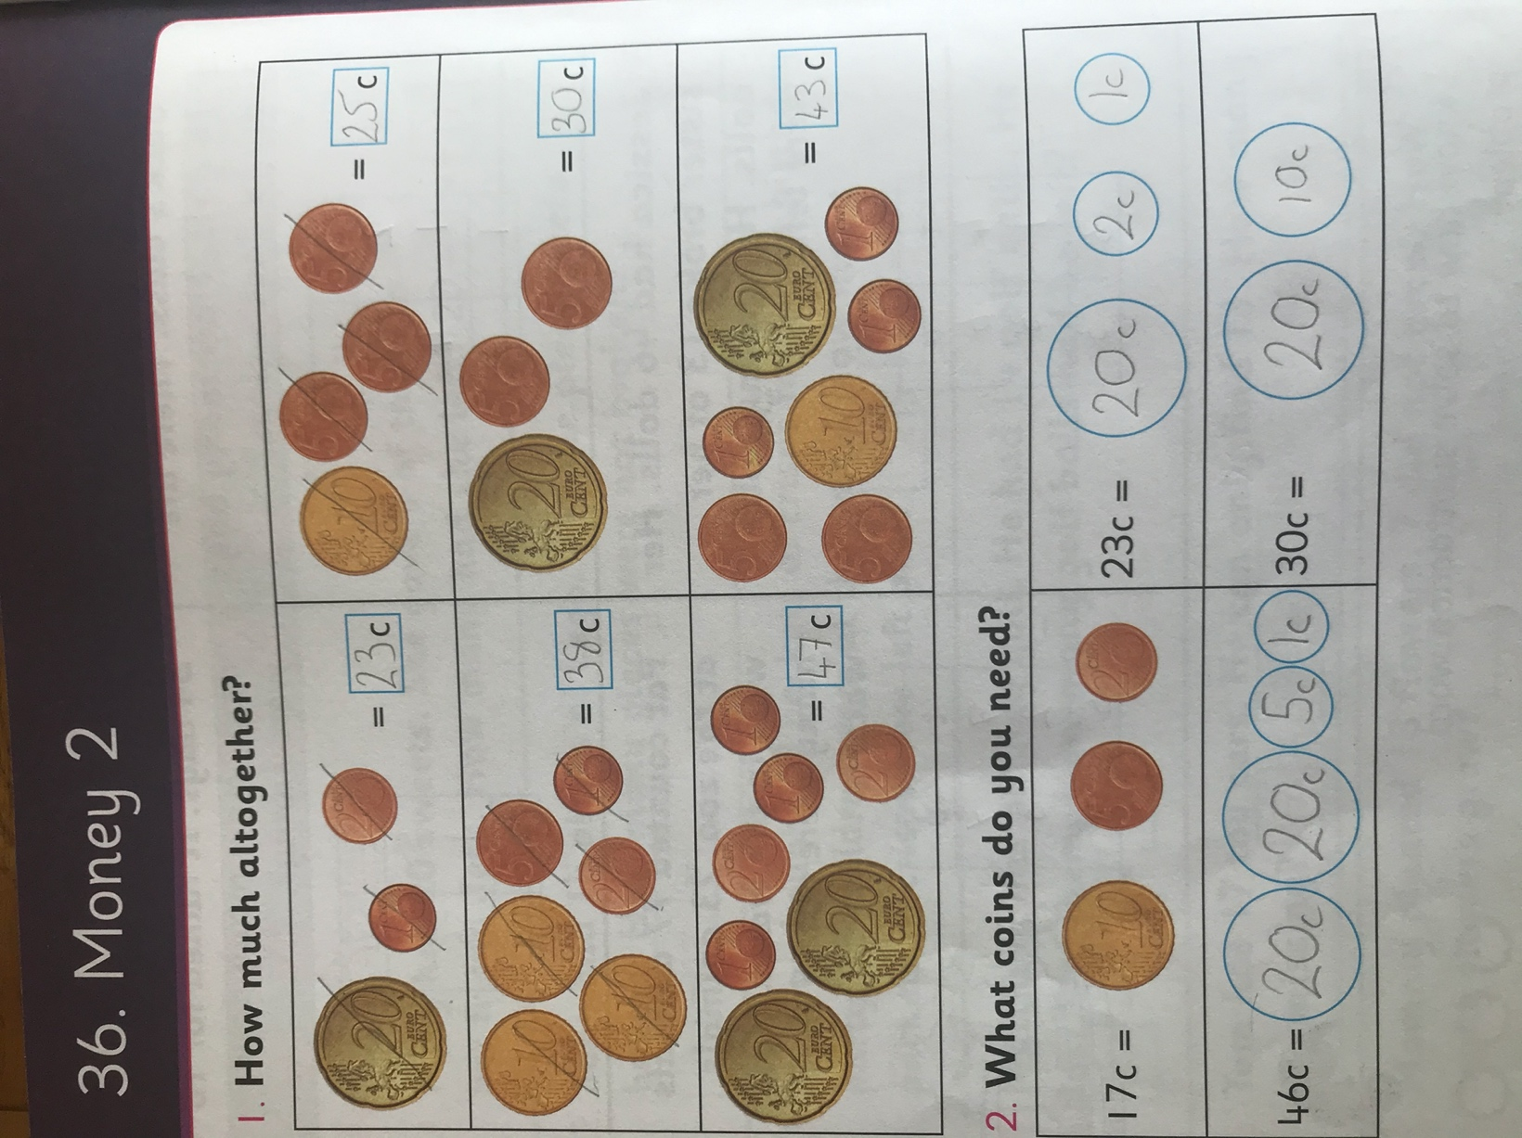
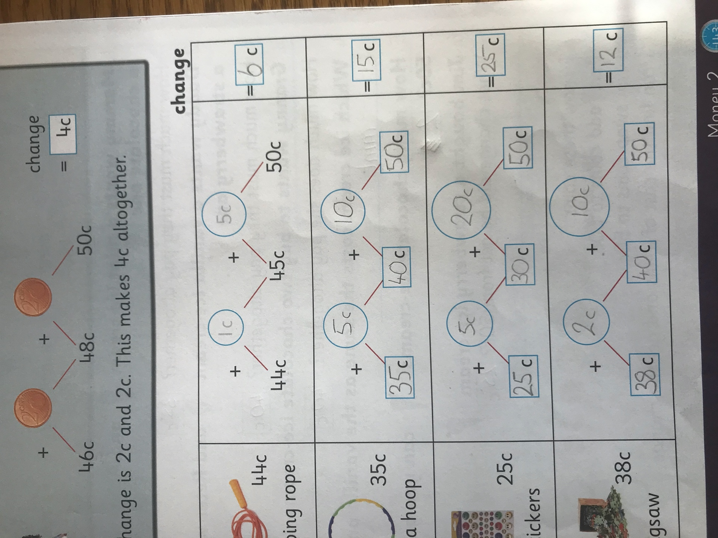

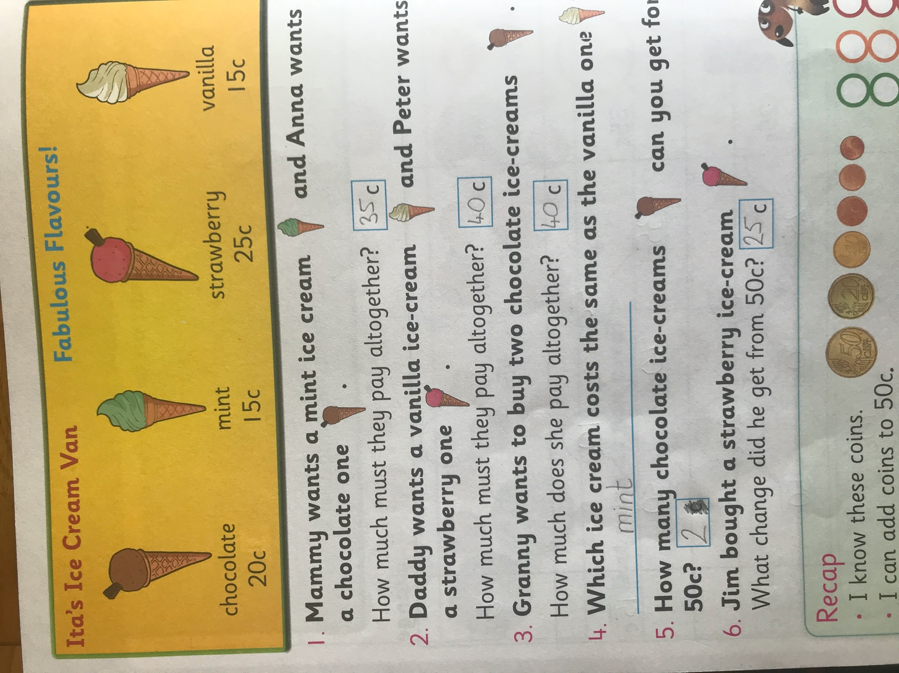

Suggested Daily Timetable

9.00-9.30 | Exercise (JoeWicks live (Youtube) / Cosmic Yoga (Youtube)/ Go Noodle website/ Active Break Ideas (see below)
9.30-10.45 | Work on the Core Subjects (English/Irish/Maths – See day-by-day activities below)
10.45-11.00 | Small Break-Have a snack and go outside for a run/play
11.00-12.00 | RTE School Hub
12.00-12.45 | Project Work – select an activity from project work section to work on this week.
12.45-1.15 | Lunch
1.15 onwards | Free Time
Core Subject Work

Class Maths Game

Add or Subtract
This week we have a great card came that will have participants practicing their numeracy skills of addition and subtraction.

What you need:

Deck of cards
Record Sheet
Two to four players

INSTRUCTIONS

The aim of the game is to have the highest total after 20 rounds.

Design a record sheet for each player.
Take out the jokers and picture cards from a regular deck of cards and then shuffle the pack. (ACE = 1)
Each player starts with 15 points.
Player 1 begins by taking a card from the top of the pack and will add or subtract depending on the value and colour of the card they picked.
The RED cards require players to SUBTRACT the value shown and the BLACK cards require players to ADD the value shown.
Players will take it in turns to draw a card and record the calculation and work out their running total.
Repeat this process until everybody has gone 20 times. (If you run out of cards, then just shuffle the pack again)
At the end of 20 rounds, the person with the highest total wins!
EXTENSIONS:

The picture cards may be added to the deck by assigning the following values:

Jack = 11

Queen = 12

King = 13

Wednesday

English:
My News – write a few sentences for your news. State the day, date, weather and some piece of news e.g. something you did at the weekend/ are looking forward to.
Starlight Combined Reading and Skills Book p.58 – read. P.59 Activity A and B
Spellbound p.74 Exercise 1
Homework copy: Write 2 sentences using your dolch words
Reading: Continue to encourage your daughter to read daily.
Oral Language Activity: Aesop’s Fables: Interactive Poster and Vocabulary Games
https://rainbow.cjfallon.ie/#/units/first/13

Maths:
Class Game
Cracking Maths – continue with any unfinished work
Capacity: p.146
Please correct any work your daughter does with her and help her learn from mistakes.
Work it Out – Catch up/finish a week you missed/ have not completed.

Gaeilge: Éist le scéal: choose a story to listen to and enjoy!
https://padlet.com/maire8/fv5mg5v9m27j

Science: What a Wonderful World: Habitats p.44
Try to take a photo of an animal that lives in your local area!

Thursday

English:
My News – write a few sentences for your news. State the day, date, weather and some piece of news e.g. something you did at the weekend/ are looking forward to.
Starlight Combined Reading and Skills Book p.60 Activity A and B
Spellbound p.74 Exercise 2
Homework copy: Write 2 sentences using your dolch words
Reading: Continue to encourage your daughter to read daily.
Listen to a story: https://www.oliverjeffers.com/books

Maths:
Class Game
Cracking Maths – continue with any unfinished work
1 Litre p.147
Please correct any work your daughter does with her and help her learn from mistakes.
Work it Out – Catch up/finish a week you missed/ have not completed.

Gaeilge: Cluiche: Choose a game to play today!
https://www.cula4.com/ga/cluichi/

Science: What a Wonderful World: Animal Habitats p.45

Fun Friday
English:
My News – write a few sentences for your news. State the day, date, weather and some piece of news e.g. something you did at the weekend/ are looking forward to.
Starlight Combined Reading and Skills Book p.61
Homework copy: Write 2 sentences using your dolch words
Reading: Continue to encourage your daughter to read daily.
Oral Language Activity: Aesop’s Fables: Interactive Poster and Vocabulary Games
https://rainbow.cjfallon.ie/#/units/first/13

Maths:
Class Game
Cracking Maths – At Home Experiments p.148
Please correct any work your daughter does with her and help her learn from mistakes.
Work it Out – Catch up/finish any Friday tests you have not finished

Gaeilge: Watch ‘Cúla4 Ar Scoil’ on TG4 at 10 o clock today or get it online later! Corpoideachas (PE) is up first!

History – What a Wonderful World – There is no one quite like me p.76

Active Breaks Ideas!

PE at home
https://www.youtube.com/watch?v=xwLnuOAswo0&feature=youtu.be

Cosmic Kids Yoga
https://www.youtube.com/user/CosmicKidsYoga

Home Bowling
https://www.youtube.com/watch?time_continue=6&v=IPm07eLvr2s&feature=emb_logo

Super Dance Challenge
https://www.youtube.com/watch?list=PLQK2XiUY9C2iJNn70BG_Rn95DKZEOeRz7&v=r2XsnEj6724&feature=emb_title

Kids Bop
https://www.youtube.com/channel/UCKE0Xnj818IDaHvIcRiq0Bg?app=desktop

