Week 6 – PE and Mental Health Awareness
 | Tuesday | Wednesday | Thursday | Friday
9am-9.30am Joe Wicks | Click here for link to Joe Wicks PE classes  Link to Joe Wicks, the Body Coach, an ideal way to start the day
9.30am – 10am Positive affirmation and yoga | Look in the mirror and say:  I am smart.  I am kind.  I am brave.  I am beautiful.  Today is a good day  Join Jamie on an Yoga adventure Click here for a fun Yoga sessionSquish the Fish | 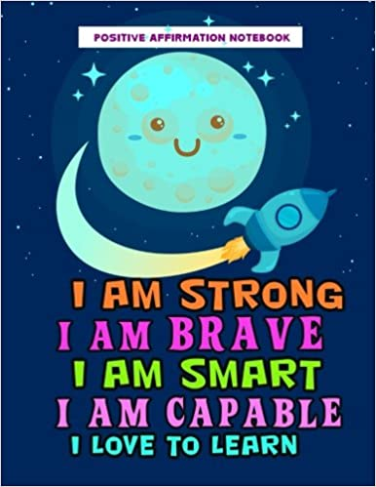  Look in the mirror and say:  Join Jamie on an Yoga adventure Click here for a fun Yoga session Frozen | Look in the mirror and say:  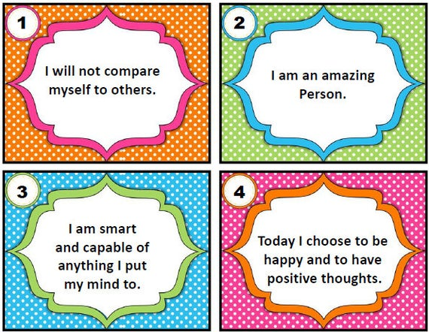  Now let’s have an underwater Yoga party! Fun Yoga moves click here | Look in the mirror and say:  I choose to be happy.  I stand for what is right.  I believe in me.  I am loved.  I am thankful.  I do the best I can.  I am becoming better every day.  Click here for Minecraft yoga
10am-10.45am  PE Skills | 1) You and your whole family can have a fun PE class with Clare. Do you recognise the Sport’s Star?Fun PE class Click here  2)Try the fun scooter pillow race Click here | 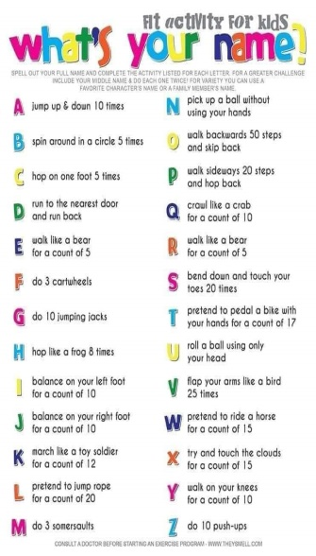  1)Click here for PE class with Múinteoir John – exercise circuit (begins 20mins in)  2) Do the activities on the poster below that spell your name. | 1) Click here for lesson about heart rate and exercise(begins 25 mins in)  2) Today’s skill - Bottle flip Challenge. Bottle Flip challenge Click here  3) Try Samba dancing Click here | 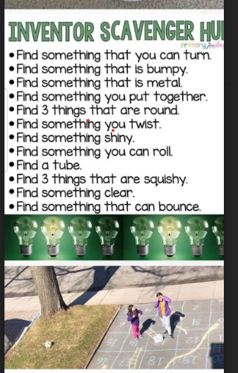  1)Click here to open class with Clare a fun PE class focusing on jumping.  2) Scavenger Hunt – full page listed below
10.45am-11am  Break | During your break, make sure that you drink plenty of water and have a healthy snack, some fresh fruit, snack on vegetables, wholemeal bread, cheese etc
11am-12noon RTE Home School Hub | Everyone should continue to watch the RTÉ Home School Hub every day from 11am to 12noon on RTÉ 2. If you miss it, you can catch up on RTÉ player or all episodes are on Youtube.
12pm-1pm Mission | - Continue to keep a daily diary  - Think of someone you know and find a way to make them smile or laugh  - Write down all the activities you did today in your Exercise Diary | - Continue to keep a daily diary  - Research a healthy recipe  - Bake your healthy recipe. Write the procedure for making your healthy recipe  - Send a photo to the School’s Twitter account | - Continue to keep a daily diary  - Think about your favourite Sport’s Star  - Do a project about them.  - Tell us why you admire them | - Continue to keep a daily diary  - You have been doing lots of great PE activities this week.  - Now our challenge to you is to design your own DREAM PE lesson
Is aoibhinn linn damhsa!!!  Dance every day!  (If you don’t want to do the one listed – try one from the list further down) | Click here for  Footloose | Click here for  Dance Monkey | Click here for  I’m Still Standing | Click here for  I Don’t Care

Bowling at home – great idea! click here for bowling activity

Tuesday
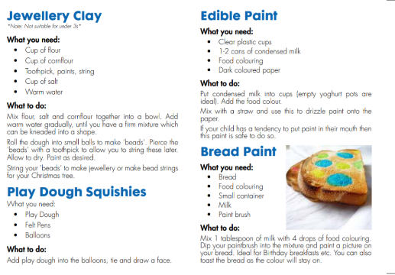

Investigate

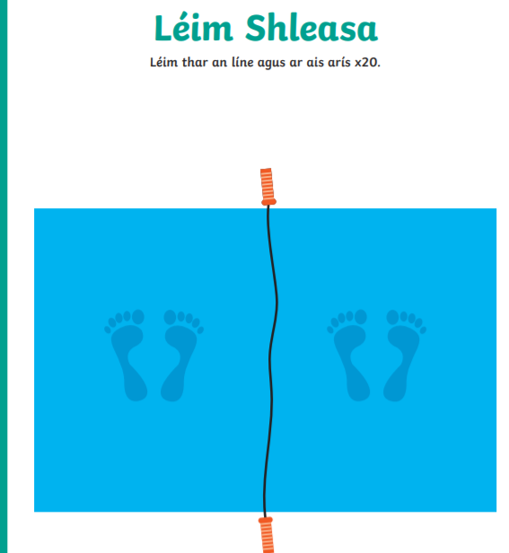
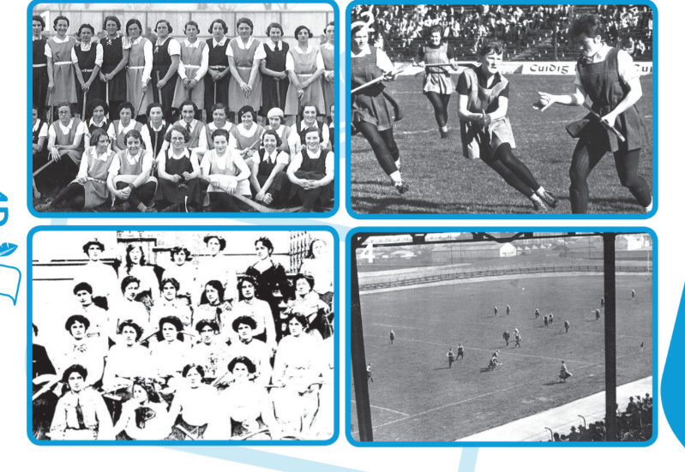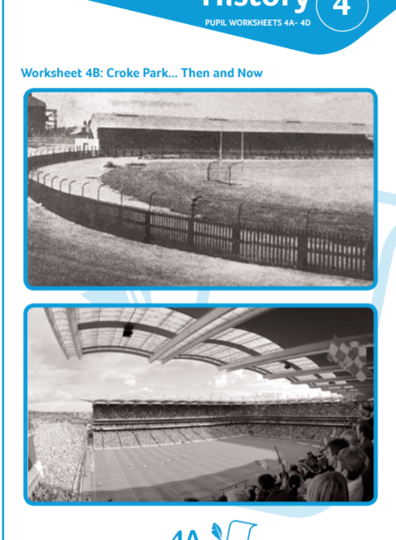
Look at the 2 photos
- Discuss similarities and differences between the photos
- Estimate what year these pictures were taken in
- Which is the oldest photograph? What changes have been made to the stadium, the clothing and playing equipment?

Wednesday
Skill
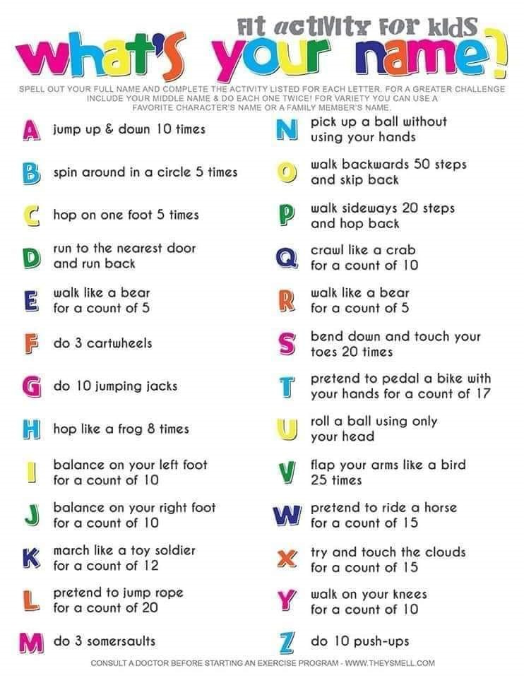

Friday

Try as many of these other activities as possible!

I like to Move it
Click on a song title to open link to dance
Can’t stop the feeling (learning video)
Can’t stop the feeling (performance)
I Feel Alive
I’m Still Standing
Twist and Shout
Believer
Footloose
I Gotta Feelin’
Wadillyocho
Always look on the bright side of life
I Don’t Care
Everybody
Keep in Touch

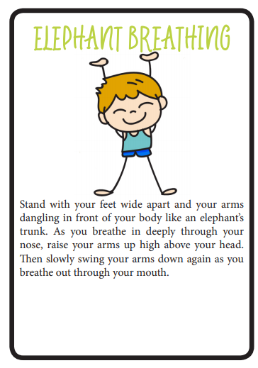
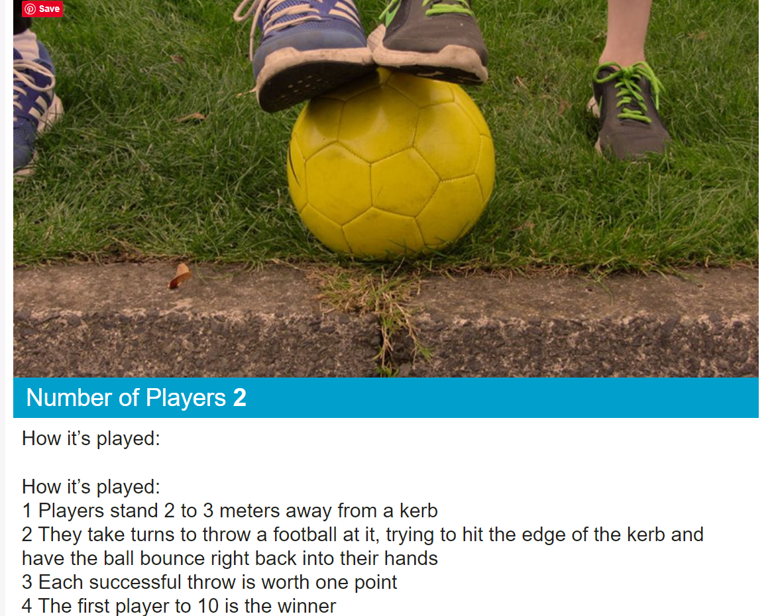

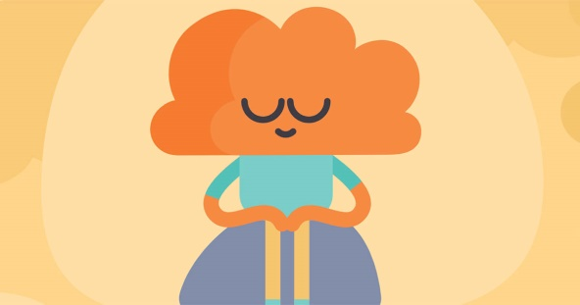

Click here for a lovely one minute mindfulness exercise

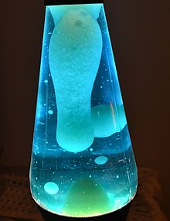

Lava lamps - Click on the link to make your own Lava Lamp How to make a Lava lamp Click here
https://www.youtube.com/watch?v=YeJGAhhIOYA (45mins in)

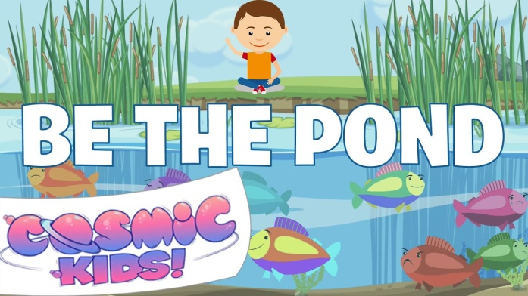

We are all experiencing many feeling at this time. Feelings are all normal. This exercise will help you with all your feelings.
Click here to watch a lovely video to help you to understand feelings

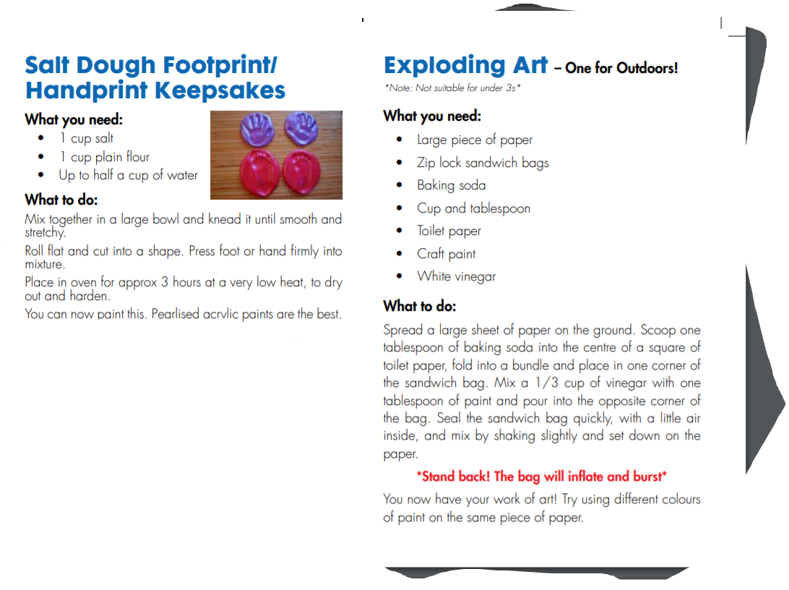
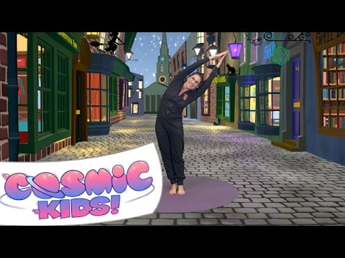
Some art activities

Click here for Harry Potter yoga

- Think about your favourite Yoga Pose
- Sketch a picture of it

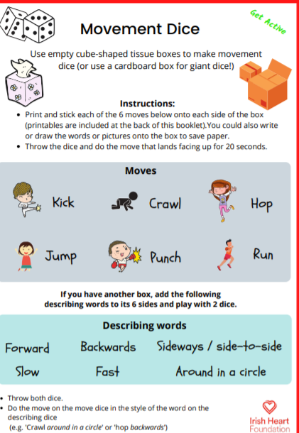

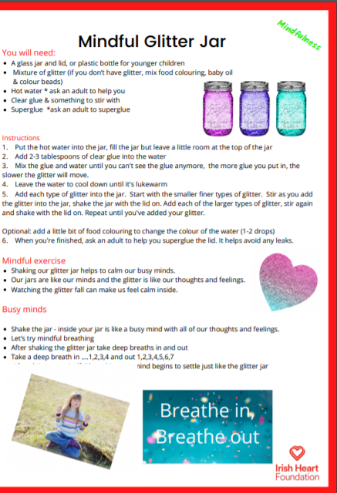


The 10@10 challenge
10 @10 10 Click here

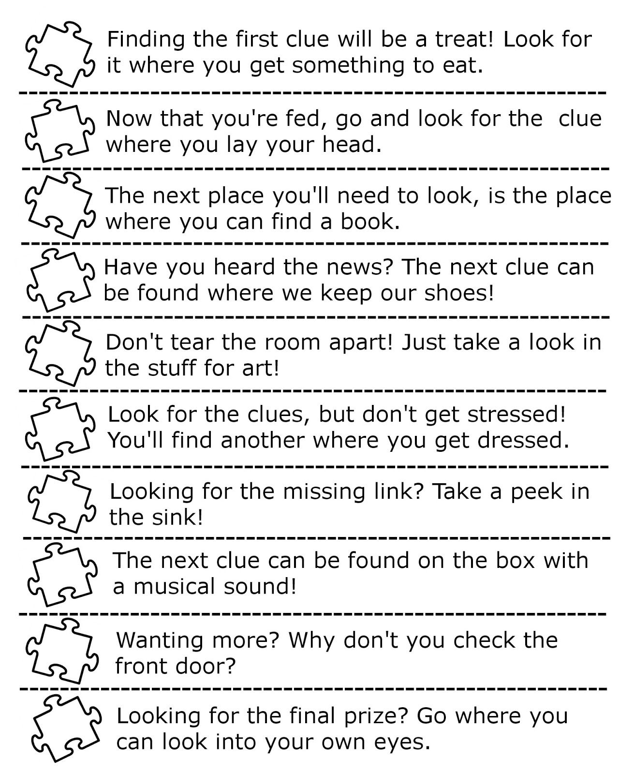

Why not design your own treasure hunt or scavenger hunt using these clues

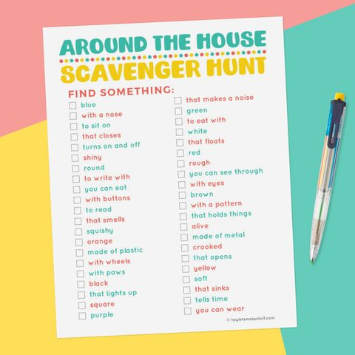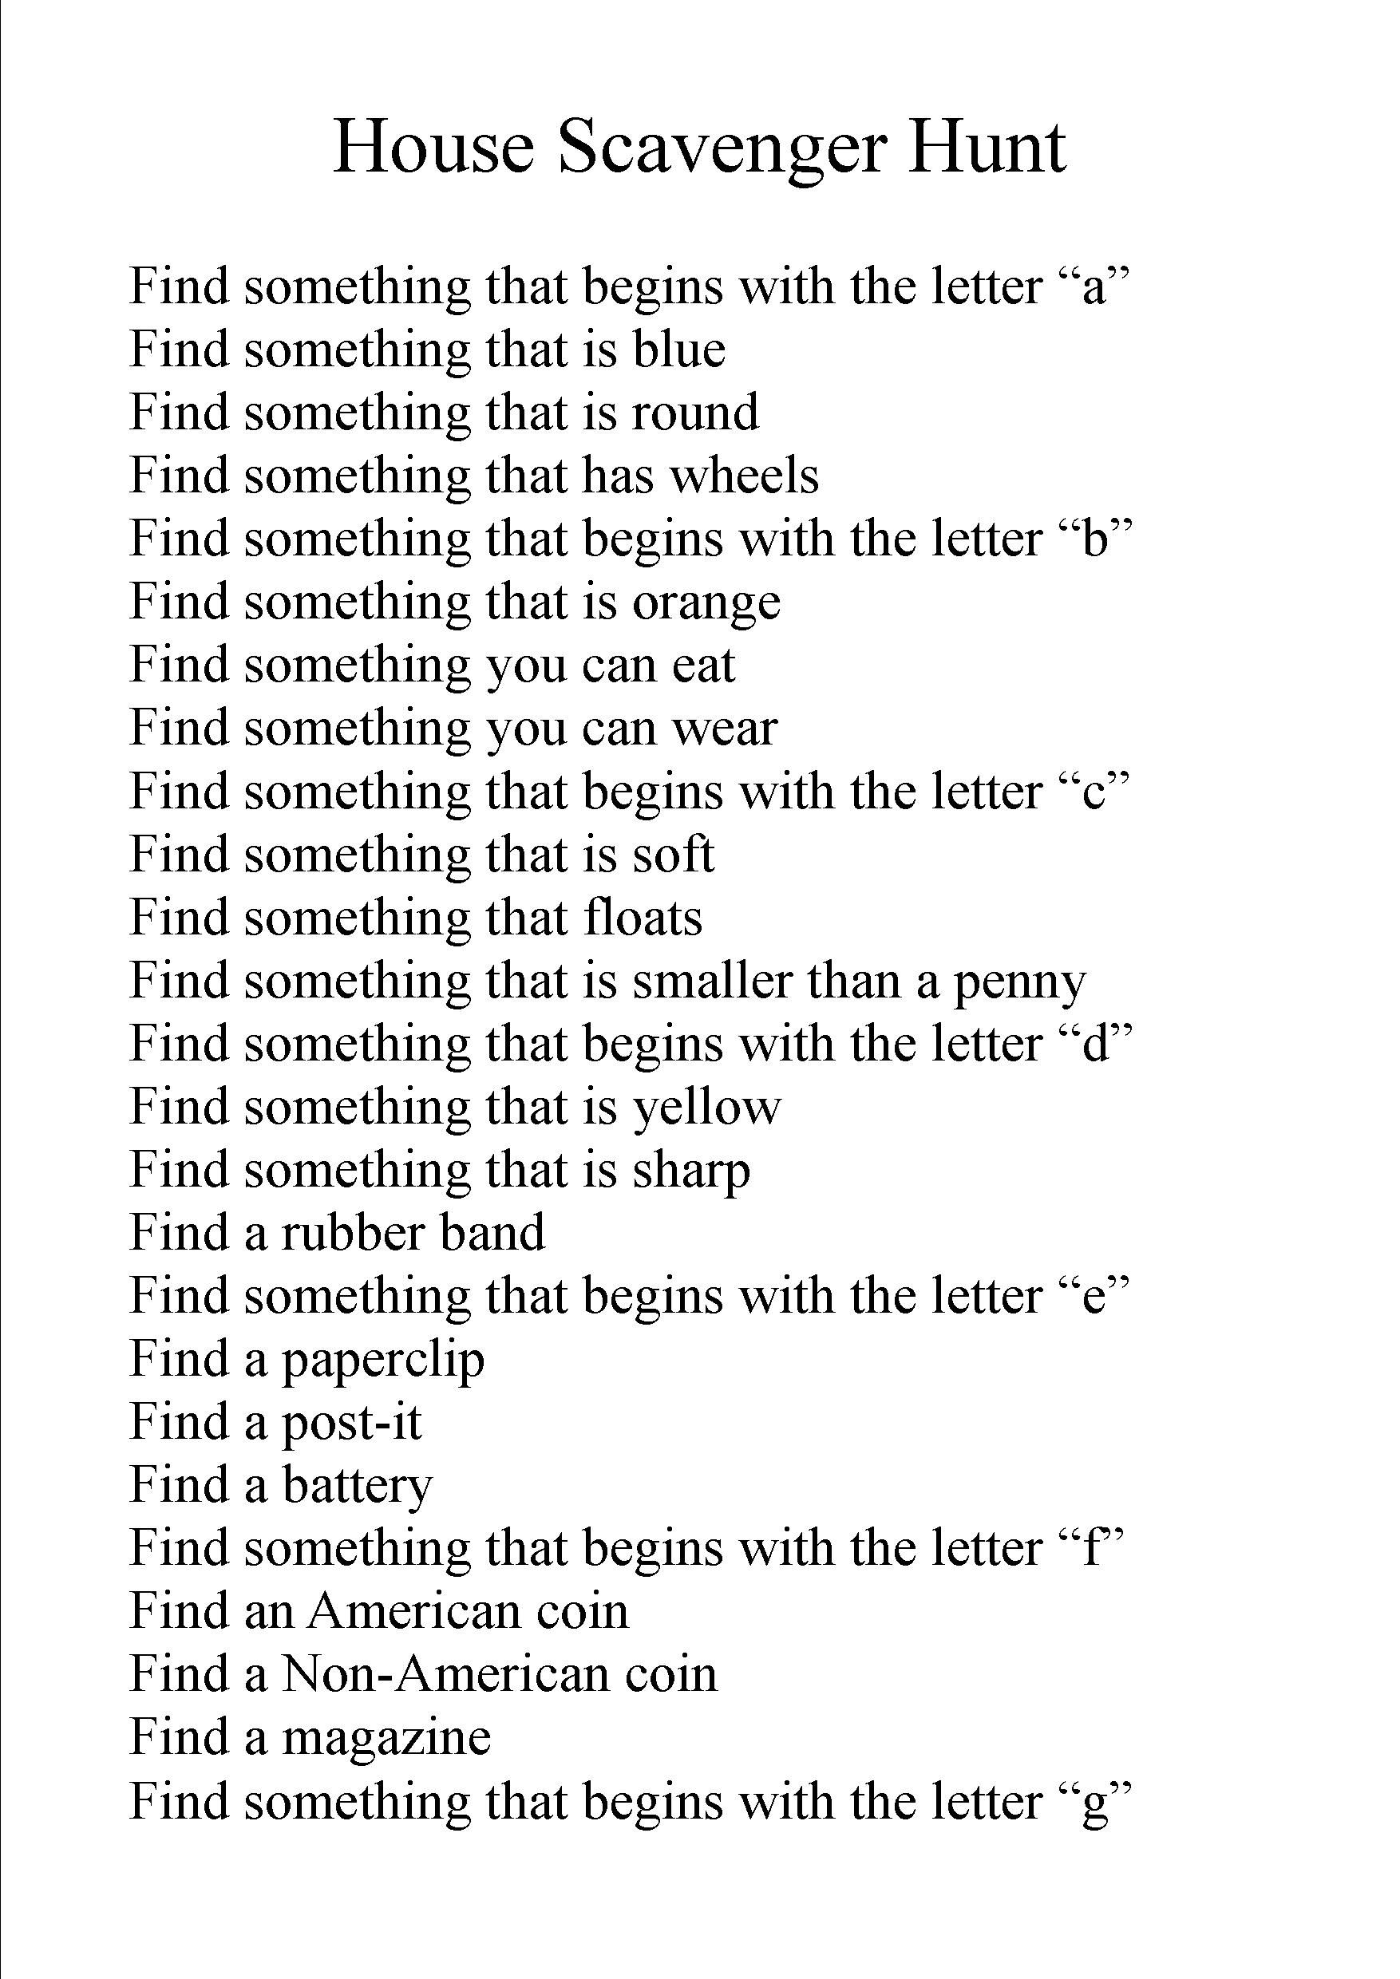
Change coin question to Irish/Non Irish coins!

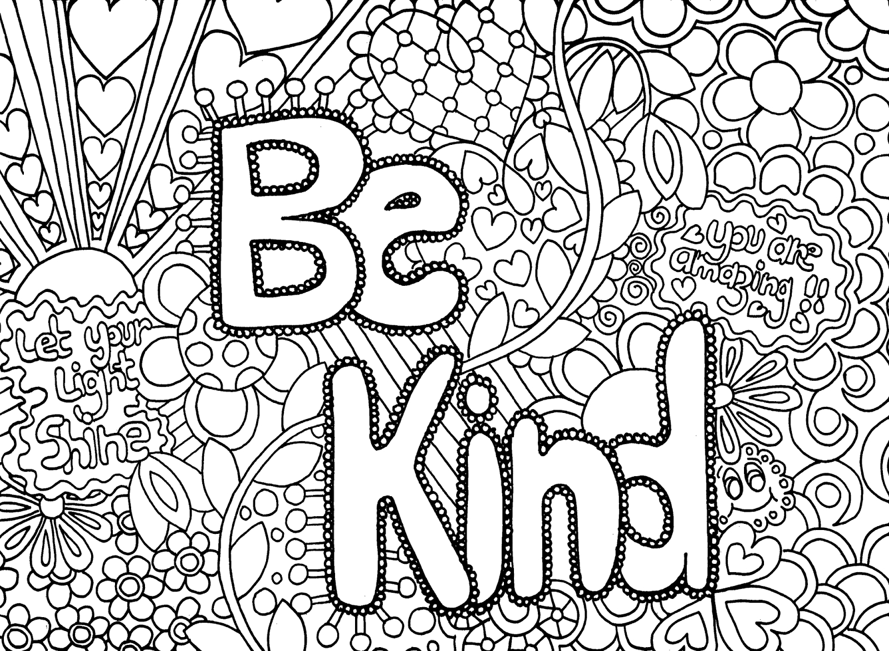
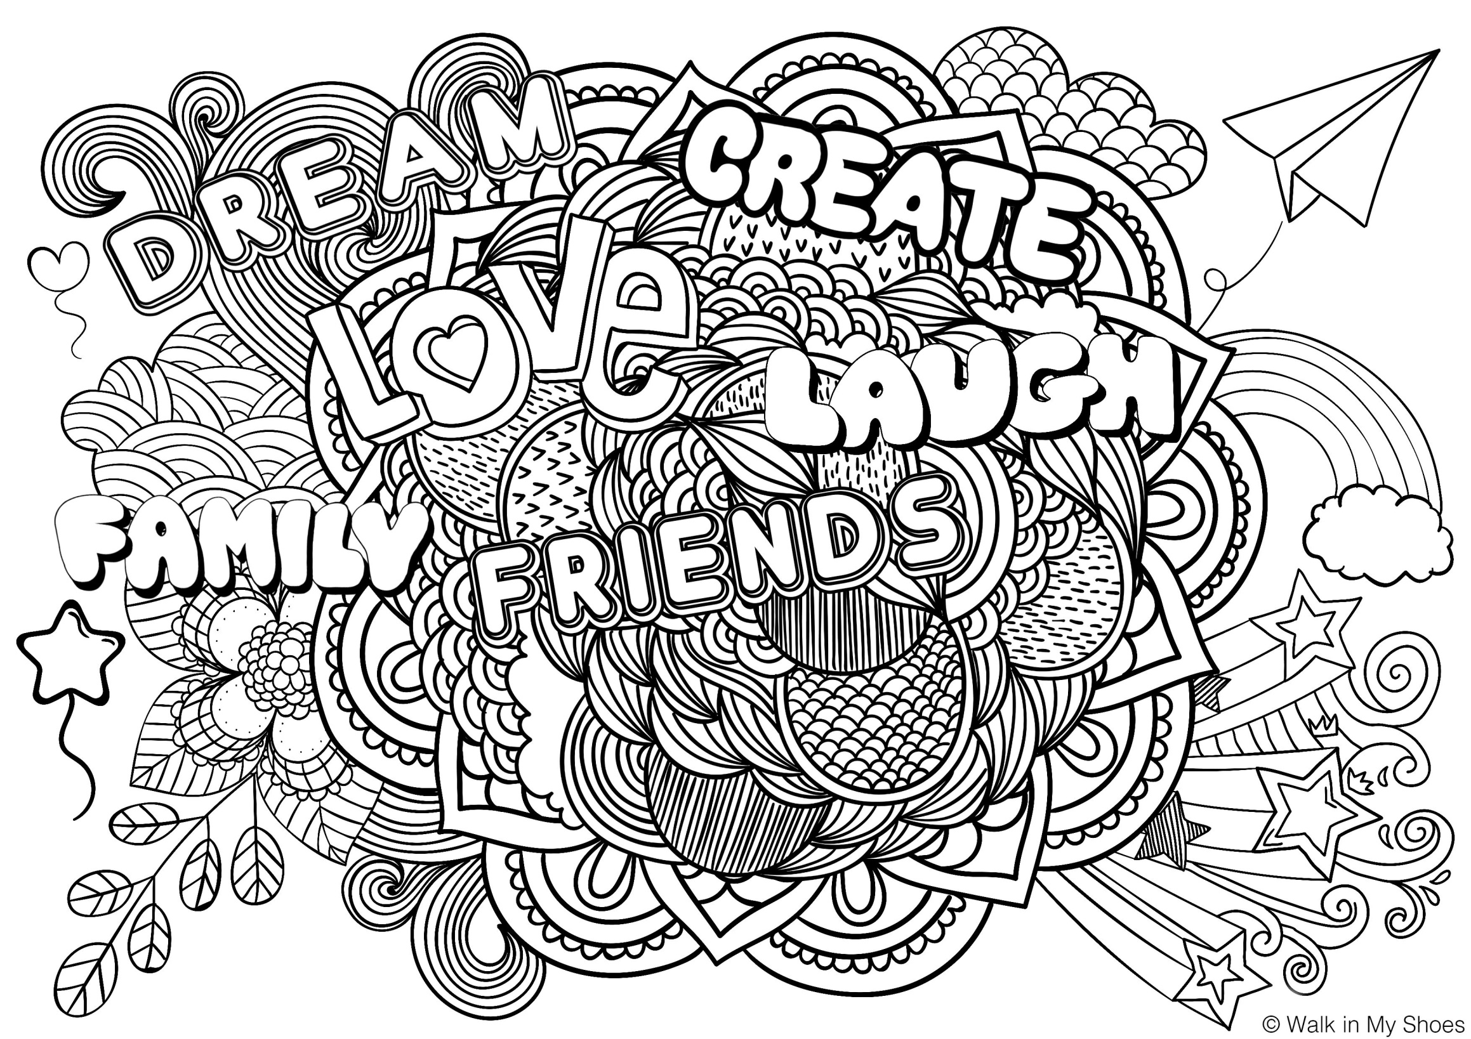

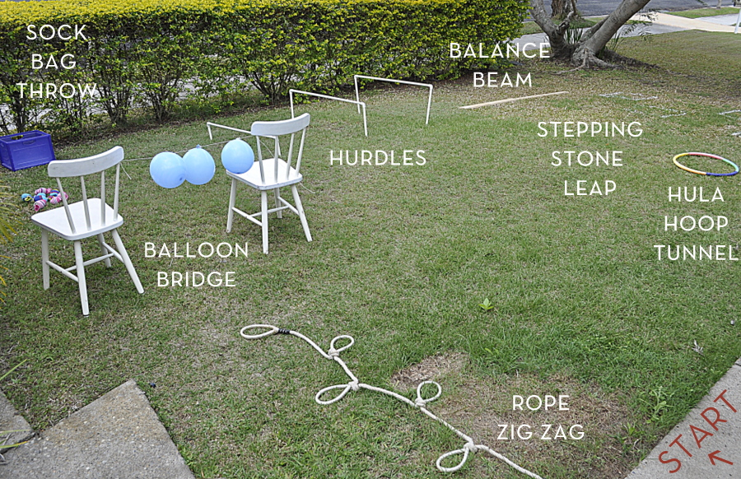
Why not try creating your own indoor or outdoor obstacle course?

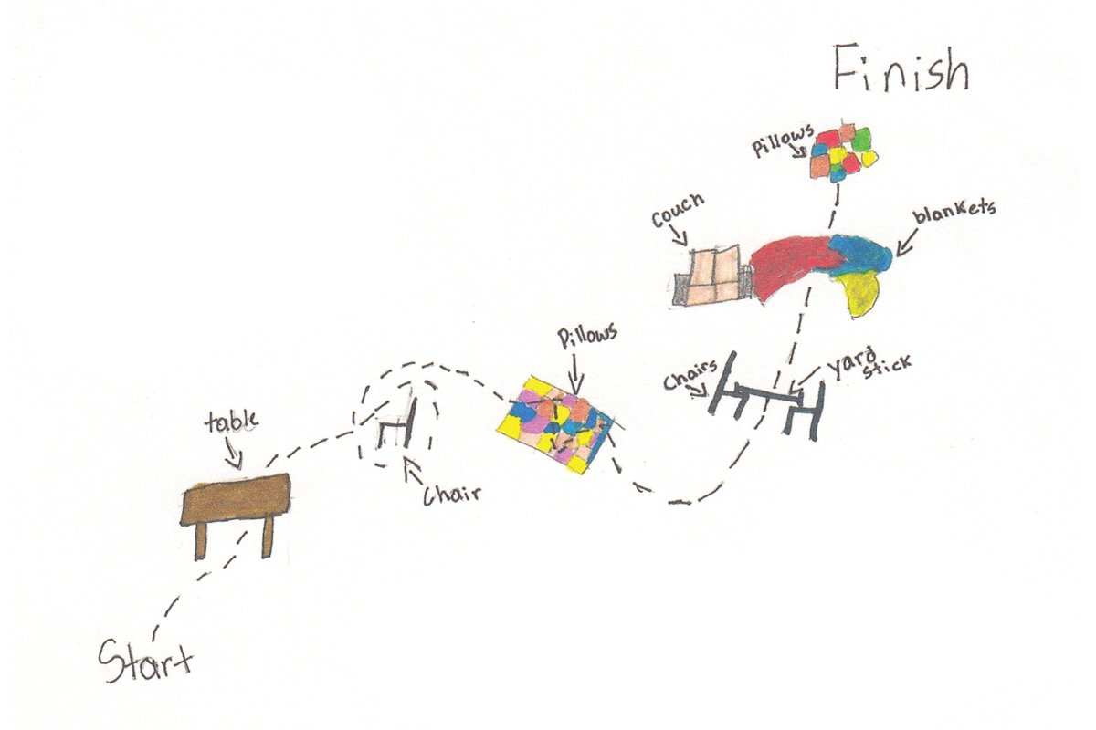
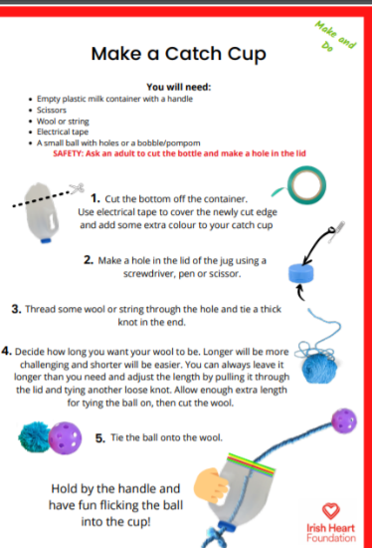
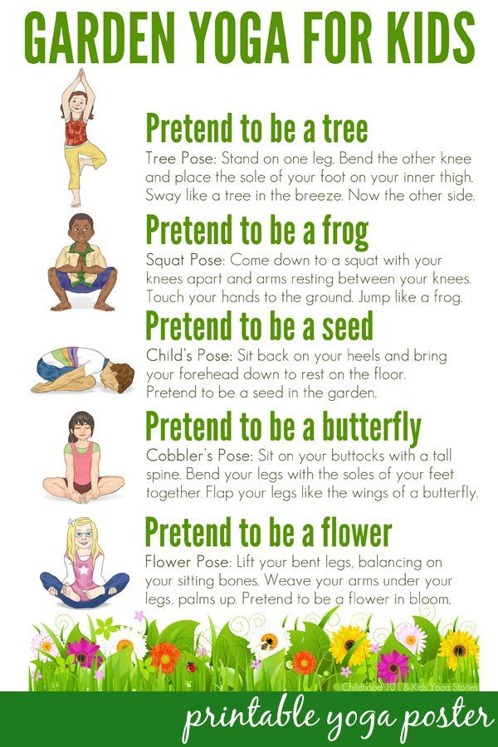

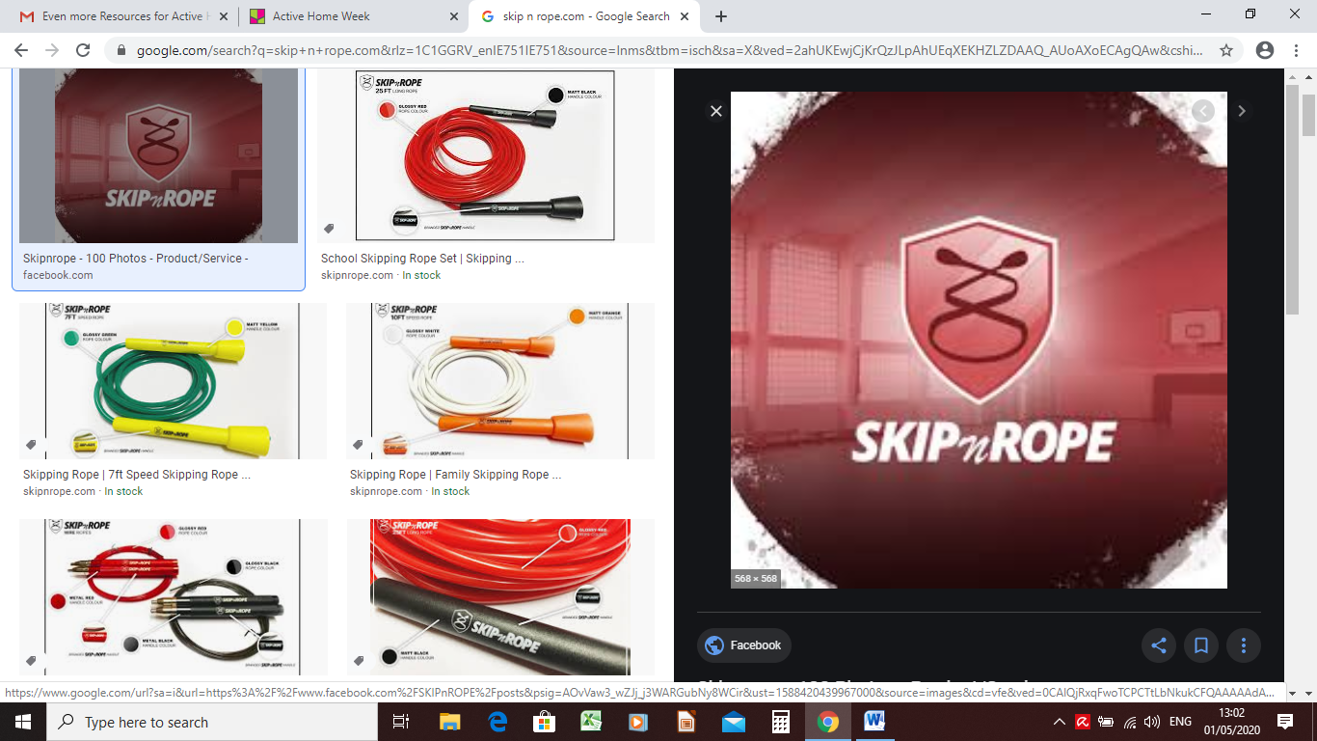
SkipnRope has fantastic skipping activities.

There are lots of youtube videos of Mark showing skipping skills https://www.youtube.com/channel/UChv0GUoeif1tHONdgg_bthQ

Try this to learn the “double under skip”
https://www.youtube.com/watch?v=48y6Bpsj8qA

