**A Chailíní and Parents and Guardians,**

**I hope you are all doing well. I have some news for you. Your teacher has an email address. You can make contact with your teacher. We need to set a few ground rules. You must use your parent or guardian's email. This is for your protection.**

**This week we are asking you to submit a photo of one piece of work that you are really proud of. The teachers are really excited about seeing this work.**

**Also, if you have a question about your work, you can send teacher an email.**

**Remember, your teacher will probably have a lot of questions to answer so you must give your teacher some time to answer.**

**Remember the rules for writing an email too. Remember to put a greeting at the beginning and ask how they are keeping.  Use paragraphs for each question you might have. Don't forget to sign off nicely too.**

**We look forward to hearing from you soon,**

**Kind regards,**

**Mrs Kelly**

**You can send your teacher an email at** [**3rdclass@stpatricksgirls.net**](mailto:3rdclass@stpatricksgirls.net)

**and if you have a question for Ms Crosse, Ms. Conran or Ms. Hogan, their email address is**[**learningsupport@stpatricksgirls.net**](mailto:learningsupport@stpatricksgirls.net)

Dear Parents and Girls,

Hoping you are all keeping well and that you enjoyed Active Week. We were unlucky with the weather but luckily you could do most of the activities indoors. We now know that we will not be back in school until September, so it really is important to continue to do your schoolwork. The Summer holidays are just around the corner, so we need to make a big effort until then.

A really good time to get your schoolwork done is in the morning and then you have the rest of the day to play. If you look at this week’s work we have a surprise for you on Friday !

We now have our 3rd class email address. You can ask your parents to send us a piece of work that you are proud of this week.

We are really looking forward to hearing from you.

Stay Safe,

Regards,

Ms Finn and Ms Linehan

Week 7 Work May 11th -15th Ms Finn and Ms Linehan’s 3rd Classes

[Click here for link to Joe Wicks PE classes](https://www.youtube.com/channel/UCAxW1XT0iEJo0TYlRfn6rYQ) **link to Joe Wicks the Body Coach an ideal way to start the day**

[Keep up with your times tables here](https://www.topmarks.co.uk/Search.aspx?q=hit%20the%20button)  **multiplication practice (Hit the Button online game)**

[Answer booklet to Work it out](https://educateplus.ie/sites/default/files/solutions/Work%20it%20Out%203rd%20Class%20Answer%20Book.pdf) (**answers to WIO)**

**Try to do 60 minutes of exercise daily on your bike/scooter/go for a walk /practice your GAA skills**

**Religion: May is the month of Holy Mary. Try to take time to pray the Rosary together as a family (Our Father +Ten Hail Marys+ Glory be to the Father and repeat five times). The EWN Catholic Channel (ON Sky 588) airs The Children’s Rosary daily (see link** [**https://youtu.be/OaZgs7GadCc**](https://youtu.be/OaZgs7GadCc)**)**

**Try to keep a diary daily! It might become famous one day like Anne Frank’s diary which she kept during World War 2.**

**Monday**

**English**

**1.SB** Week 30 Bk 105 Exercises 1 +2

**2.Starlight 15b** (Watch This!): Read aloud pages 176+177

**3.Dictionary work:** Using your dictionary find the meanings of the words in bold writing on pages 176+177.

Try to put these words into sentences (orally).

**Maths**

1. Revise **x7** tables. See Busy at Maths page 124 Q.1 Try this tip to count on in 7’s!

2**.Busy At Maths** : Chapter 23: **Multiplication and Division by 7** page 123

Try Questions 1, 3, 4 + 5 . See Answers below!

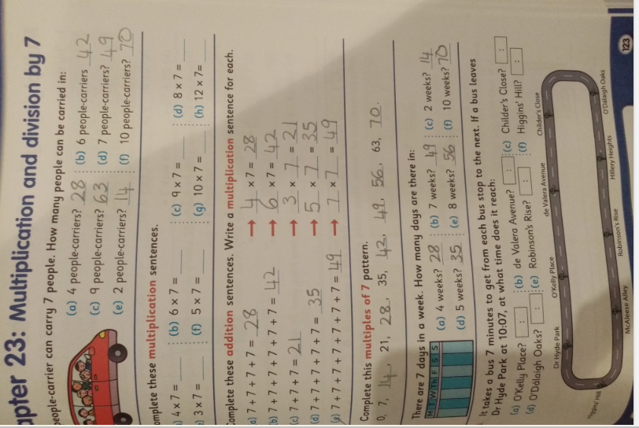

**Gaeilge**

**Bua na Cainte (Leabhar Litrithe)**: page 47 Ceacht 1

‘Os comhair an …’ = in front of (comhair pronounced as co-ir)

1. Tá mata os comhair na tine. There’s a mat in front of the fire.
2. Tá tolg os comhair na tine. There’s a couch in front of the fire.
3. Tá bord os comhair na tine. There’s a table in front of the fire.

**History**

Enjoy watching [Nancy and the Meercats](https://youtu.be/ZC0YZOXmvKs) and find out who first invented Television?

**Project:** Research and complete a project on the History of Television.

Perhaps you could interview your grandparents (on the phone) and find out how Television has changed over time.

**Tuesday**

**English**

1.**SB** Week 30 Bk 106 Exercises 3 +4

2.**Starlight 15b:** Read aloud page 178. Answer A +B (page 179) orally.

**Maths**

1.Continue to work on improving your speed on answering your 7’s. Have you played Hit the Button this Week?

2.Busy at Maths: page 125 Try questions 1, 2 and 4.

Do you remember the link between Multiplication and Division?

Division is the opposite of Multiplication!

See below for answers

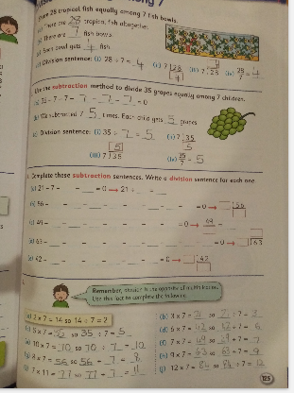

**Gaeilge**

1. **Bua na Cainte (Leabhar Litrithe)**: page 47 Ceacht 2

Rule: In Irish when you put **‘an (the)’** in front of a noun that begins with a vowel you must add **t-**

Éan but an t-éan

Asal but an t-asal

**Wednesday**

**English**

**1.SB** Bk 107 Exercises 5+6

**2.Starlight 15b:** Reread pages 176-178. Answer Activity C +D (page 179) orally.

Write as many synonyms for ‘hilarious’ as you can think of!

**Maths**

1. Revise your tables: x3 and x4
2. **Busy at Maths:** Chapter 26: Division 3 page 137.

Read the example to remind you of the meaning of R or the remainder! Try activities 1, 2 and 3.

Tip! If you don’t have straws or lollipop sticks use something else for example spoons/lego/ twistables…

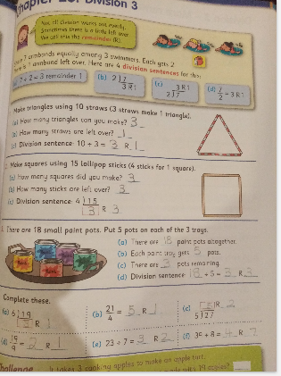

**Gaeilge**

1. Bua na Cainte (Leabhar Litrithe): page 48 Ceacht 3

**Geography**

Try the [Counties of Ireland Quiz](http://www.edware.ie/graphics/ireland_flash.swf) !

**Thursday**

**English**

**1.SB** Bk 108 Exc. 7**1.**

**SB** Test and self-correct. Write out misspellings into a sentence in copy!

**2. Starlight** **15b**: page 180 E Grammar (orally)

Remember!

A **noun** is a person, place, animal or thing for example man/girl/school/rabbit/desk.

A **verb** is an action word for example ran/cheered/danced…

**Starlight:** page 181 F: Writing skills: Enjoy adding to the Powerful Word Webs !

Remember: Using powerful language improves your writing and persuades the reader to see your point of view!

**Maths**

1. Revise your x6’s.
2. Busy at Maths: page 137 Question 4 + page 138 questions 2, 3 and 4.

See answers below.

3. **1.WIO** : Complete the next activity in the Test section (Give yourself a pat on the back if you beat last week’s score! Well done !)

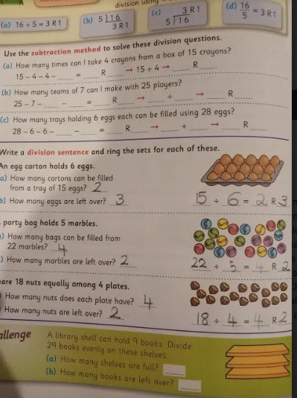

**Gaeilge**

1. Bua na Cainte (Leabhar Litrithe): 48 Ceacht 4

Clár dúlra = nature programme

Clár ceoil = music programme

Clár spóirt = a sport’s programme

**An Nuacht:**

1. Write (Write out the four Nuacht lines you practised in Week 5 and add your favourite TV programme for example **Is maith liom clár dúlra**.)

Inniu an …. Today is… (An Aoine)

Inné an… Yesterday was…(An Déardaoin)

Amárach an… Tomorrow will be…(An Satharn)

Tá sé …. (an aimsir).

Is maith liom clár……(I like ….programme)

**Music**

**How many traditional Irish instruments can you name?**

**Watch** [**Traditional Irish Instruments**](https://www.scoilnet.ie/uploads/resources/31478/31214.pptx) **to check you answers!**

**Fun Friday**

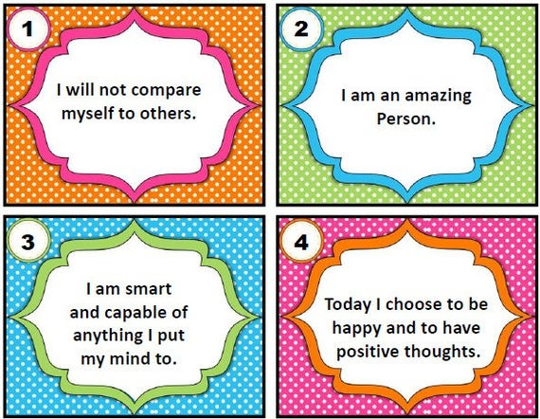

Look in the mirror and say

**Science**

Who is brave enough to try some Kitchen Chemistry???

Enjoy these experiments on Tie Dye Milk and Runaway Pepper!

You should find all the ingredients in your own kitchen

Just click on <https://vimeo.com/178586302>

**Dance**

Is aoibhinn linn damhsa!

Dance every day

Click here for [I feel alive dance](https://www.youtube.com/watch?v=RCgtcEz6SGk) or choose another dance

**Yoga**

These exercises are a great way to start your day.

They are also great to do before you go to bed at night

**Art**

You could try making your own bird box or bird feeder using recycled materials

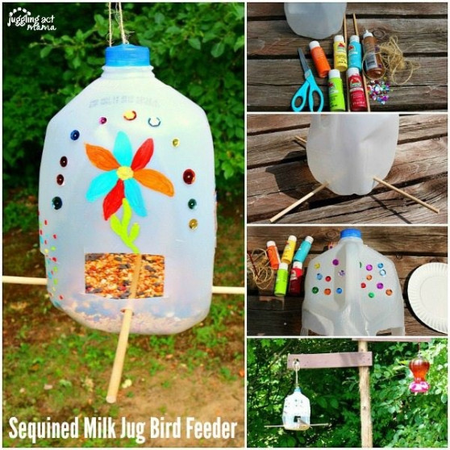

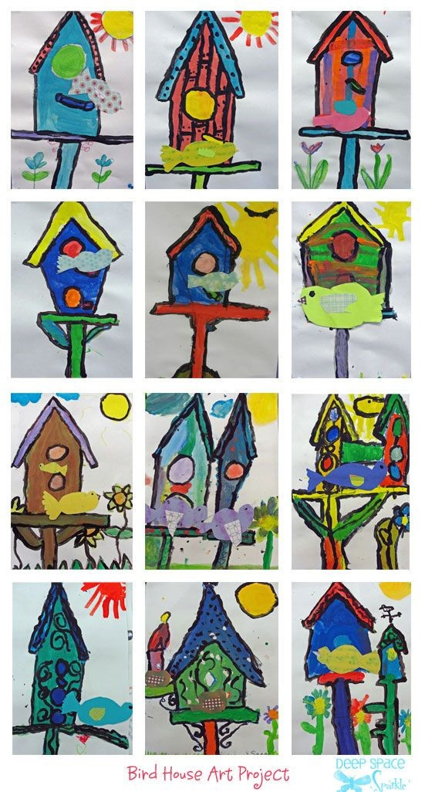

Another lovely idea is to design your own bird house and colour it in

**Other activities**

* Take out a board game you haven’t played with for a while and play with it
* Try to write your own positive affirmation
* Curl up on the couch and red your favourite book
* Now that we can go a bit further from home plan a different walking route.
* Start collecting junk art and make a really creative design