Hi Girls, Parents and guardians,

I hope you enjoyed Active Home Week/ Wellbeing Week and that you tried out a few different activities to normal.

As you will have seen over the weekend the Taoiseach has announced that all schools are to remain closed until the new school year. I’m sure most of you are disappointed with this decision. We are all missing our friends and our routines but we are conscious that the decision was based on ensuring the safety of the whole community.

For you girls the news has been particularly sad as this means that the traditional rites of passage which are associated with the end of Sixth Class cannot now take place. Rest assured girls, once we are permitted to do so, you will get to celebrate as a class group as you deserve to.

Below is a listed schedule of work for next week: Week 7. Try and stick to a routine of getting most of the work completed in the morning.

I have included some extra activity ideas for those who would like to do a bit more work. Remember don’t worry if you don’t get all of the work completed.

Parent s/Guardians, usually at this time of year we would have some lessons on Puberty and changes in girls’ and boys’ bodies. I often use Busy Bodies, a DVD and booklet which are available to view online. If you google Busy Bodies it’s all there. There are different sections and I would recommend you look at it first before discussing the topics with your girls.

I hope you all have a good week.

Take care,

Ms.Landers

**Schedule of Work: Week 7**

**MONDAY**

Matamaitic

* Work it Out: Week 24 : Monday
* Correct “Equations” from Busy at Maths p.105 & p.106 (see attached)
* Continue with p.106: No.3

Extra Maths for those finished early or who want to do more:

The Busy at Maths Shadow Book can be viewed online . On the St. Patrick’s GNS website click on “Online Books” – C.J. Fallon.ie –Student Resources - Level: Primary – Class:6th – Subject: Maths – Series: Busy at Maths – Title : Busy at Maths 6, Sixth Class Shadow Book. Then on “Actions” click on the “eye” icon to view the book. Go to **p.49** to do extra work on equations

Gaeilge

* Frásaí don seachtain (phrases for the week)

1. Cúpla seachtain ó shin…. = A few weeks ago….

2.Diaidh ar ar ndiaidh…. = Gradually….

3.Faoi dheireadh…. = At last…

4.Faoi mar a tharla…. = As it happened….

5.Faoinn am seo….= By this time….

* Scríobh **An Nuacht**:

Remember an dáta (Inniú an…), an aimsir ,(Tá sé scamallach/grianmhar/fliuch..),

What you did (Ar an Luan, An Aoine seo caite)

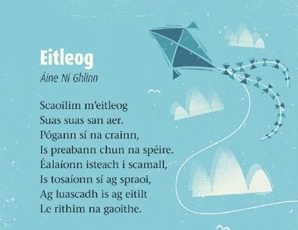

* Practise reading the poem “Eitleog” by Áine Ní Ghlinn, see if you understand most of it and answer the following questions orally:

~Cá théann an eitleog?

~Cad a phógann sí?

~An dtosaíonn sí ag spraoi?

~Cad a bhíonn sí ag eitilt le?

**Béarla**

* Correct Spellbound: Week 23

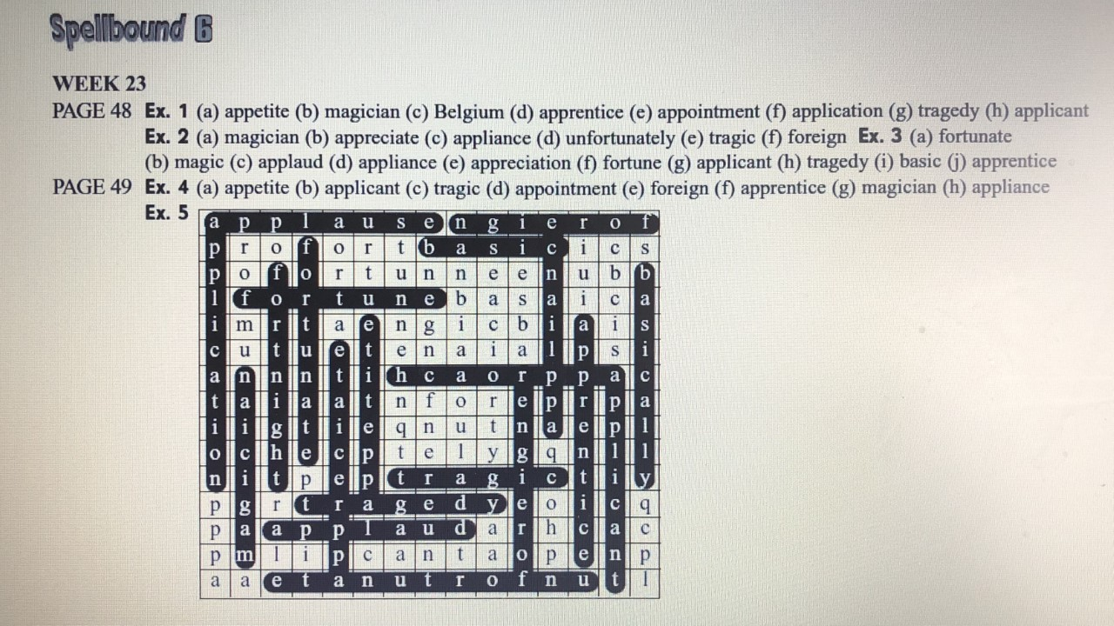

* Spellbound: Week 24 : Revision : Do all exercises – Exercise 1 to Exercise 5

**Reiligiún**

We remember Mary in a special way during the month of May. We celebrate the Annunciation during this month. We decorate our Sacred Space/Altar in memory of Mary.

* Grow in Love p.130 & p131 : Read about the key words : Assumption, Immaculate Conception and Annunciation. Read the Gospel story on p.131 and orally answer questions underneath.

On a page draw a May Altar and include what you think should go on it (e.g. flowers, candles, picture/statue of Mary). Write a few sentences about Mary and what she means to you. It would be nice if you stuck this into your Confirmation scrapbook.

**TUESDAY**

**Matamaitic**

* Work it Out: Week 24 :Tuesday
* Busy at Maths p.107 no.’s **1 – 4** (see clip attached)

Extra Maths: continue on p.107 no.’s 5 - 8

**Gaeilge**

* Go over frásaí
* Inis Dom p96 & p.97 1)Léigh na ceisteanna sa comhrá p.96 :read the questions in the comhrá p.96 2)Féach ar na pictiúirí: look at the pictures 3) Léigh an scéal **Timpiste** p.97 4)**Written Work :** Freagair na ceisteanna :answer the questions

**Béarla**

* Racing Ahead: Read the factual piece on **The Bermuda Triangle** p.212-216
* **Written Work** : Complete Activity E : Complete the Sentences

**Reiligiún**

* Grow in Love p.152 : Write out **The Memorare.** Decorate it and put it into your Confirmation Scrapbook. It would be nice if you could try and learn this for the month of May

**WEDNESDAY**

**Matamaitic**

* Work it Out: Week 24 :Wednesday
* Busy at Maths : p.108 no.’s **1,2,3** & **7,8,9,10 11**

Extra Maths: 1) Busy at Maths p.108 no.’s 4, 5, 6

2) Busy at Maths Shadow Book p.50 (online, see notes on Monday)

**Gaeilge**

* Oral work:

Aimsigh an Focal Mícheart (Name the Odd One Out)

1. Dearg, bán, clog, dubh

2. Bróg, bríste, t-léine , teilifís

3. Brón, áthas, fearg, gruaig

4. Peann, cailc, marcóir, teach

5. Scoil, páistí, ospidéal, siopa

6. An Fhrainc, Málta, geansaí, An Ghréig

7. Subh, turcaí, feoil, cat

8. Doras, briosca, fuinneog, cathaoir

9. Mála, leabhar, madra, peann

10. Sacar, peil, iomáint, carr

11. Úll, piorra, banana, práta

12. bó, caora, capaill, cailín

13. Máirt, Deardaoin, Eanáir, Domhnach

14. Lámh, béal, srón, úll

15. Bord, peil, cathaoir, doras

* Written work (Scríbhneoireacht) : Déan liosta cosúil leis an ceann thuas 1 -10 ( Make your own “Odd One Out”list)

**Béarla**

* Racing Ahead p.217 : Do Activity F (Finish the story) **or** Activity G (Look it up)

**THURSDAY**

**Matamaitic**

* Work it Out: Week 24: Thursday
* Busy at Maths : New Chapter :Data no.1 & no.2 p.109 (see clip attached)

Extra Maths: Busy at Maths Shadow Book (online) p.51

or

Make up your own bar chart and display information in a table form

**Gaeilge**

* Inis Dom p.116 no.5 :

Write a story based on the 5 pictures and conclude story by making up your own picture no.6. Decide on a tideal (Title). Use the word given to help you and remember all the phrases we are learning ;

Siopa seodara – Jewellery shop, beirt gadaithe – two robbers, sceana – knives, eagla an domhain – very frightened, thar an gcuntar – over the counter, scipéad airgid –skip/bag of money, siúlscealaí – walker by

**Stair (History)**

* History Quest : 1916 Easter Rising:

1) Read pages 80, 81, 82 & 83

2) Write up the ten main facts of these pages, Title: 1916 Easter Rising

**FRIDAY**

* Complete Scrúdú Litriú (Frásaí)
* Complete Work it Out Friday Test
* Get your favourite book and spend some time reading

Fun Friday Activity: Art

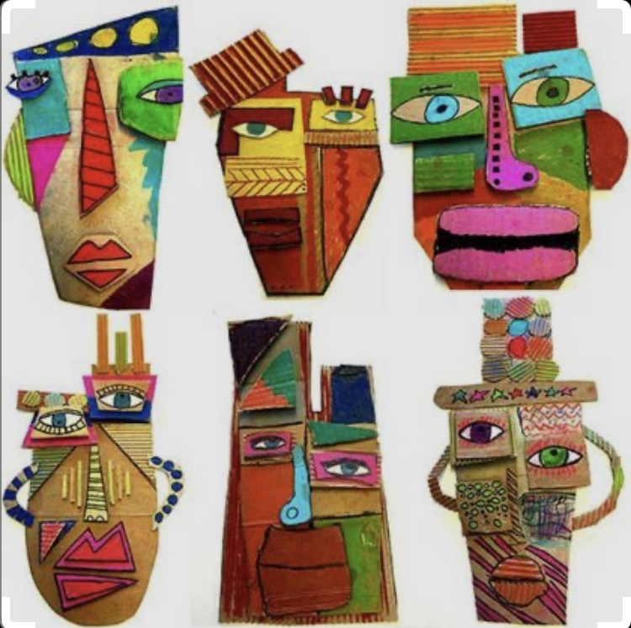

Pablo Picasso was a famous Spanish artist, sculptor, printmaker and ceramicist from the 20th century. He, with another artist, pioneered the artist style of cubism. In Picasso’s paintings, you can see that the figures have been broken apart and repositioned in an abstract way.

* Could you design and colour a face based on Picasso’s ideas

**Extra activities/ websites that may be useful**

**Gaeilge**

* Play some of the games and activities on the Seo Leat “Interactive” part of C.J.Fallon
* Duolingo.com is a great website for working on vocabulary
* Cula4.com – try some Gaeilge activities and games online
* TG4 – watch some cartoons/ programmes
* Fiche Ceist (20 questions – choose a famous person from a book/movie/singer/actor etc …asking only 20 questions you must guess who the person is

**Béarla & Matamaitic**

* Make and illustrate a comic strip
* Write some poetry e.g. a limerick, an acrostic, a pyramid poem
* Design an advertisement for a product you like
* Write a story e.g. The Cave/ A Kind Act/ The Helpful Giant
* Write a letter/ postcard/ email to someone you can’t see at the moment
* John Boyne Short Story Competition _ A writing competition for children aged 6-18
* Topmarks.co.uk – a fantastic resource for maths and english

**PE**

* Gonoodle - a selection of dances, exercises and meditations for all ages
* PE with Joe – Follow Joe Wicks’ exercise sessions daily on YouTube

**Art**

* Redtedart.com : plenty of art and craft ideas suitable for all ages
* Kitchentableclassroom.com : Free art tutorials for all ages

**Music**

* DabbledooMusic are offering one month free subscription to parents . It’s a fantastic resource for all things music

**SESE**

* Pretend it is 30 years time, the year 2050. Create a project/ make a power point presentation/ write a speech/ design a history book explaining to the children of the future what is happening right now
* Keep a diary and create a timeline of your time off
* Gather information and make a family tree
* Choose a person you admire, either from the past or present. Create a project/ make a power point presentation on him/her
* Horrible-histories.co.uk
* Askaboutireland.ie

**Art**

* Use cereal boxes etc to create a 3D image of your bedroom
* Sketch some summer flowers

