Dear girls,

How are you all? Can you believe we are well into May? I was thinking of you all on May 9th. I hope you had your own fun and we will have our day together please God.

I hope you are getting out on the nice days. Bit by bit things are picking up. You have been wonderful and brave and hardworking! Keep it up. Email me, if you like, to show me something you are proud of, to say hello or to ask for help.

Love,

Ms Coughlan.

Dear parents

Thankyou for all your support. Another week of work is attached from which you can select.

Regards,

Margaret Coughlan

**Religion**

**It is May – Mary’s month. See how your May altar is coming along. We often sing these during our May procession at school.**

<https://vimeo.com/280568269>

<https://vimeo.com/280568199>

**Draw a nice picture of Our Lady. Practise the Hail Mary. If you haven’t already got a chance, try the activities on p. 54 and 55 in Grow in Love. The Rosary is the focus. It is a special prayer to Our Lady.** <https://www.growinlove.ie/en/> Login in with an email of [trial@growinlove.ie](mailto:trial@growinlove.ie) and a password of growinlove.  **Theme 11, lesson 1, The Rosary. Try the actions for the Hail Mary as shown in the video.**

**Corrections from last Week**

What a Wonderful World; p. 35

1. A.Lough Allen B. Lough Ree C . Lough Derg
2. A.Portumna B. Athone C.Carrick-on-Shannon
3. Limerick
4. Atlantic
5. River Lee.

Work It Out Week 27

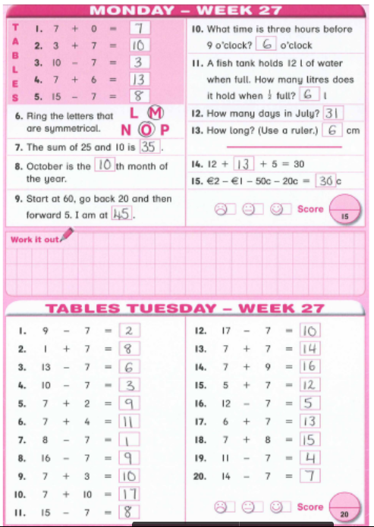

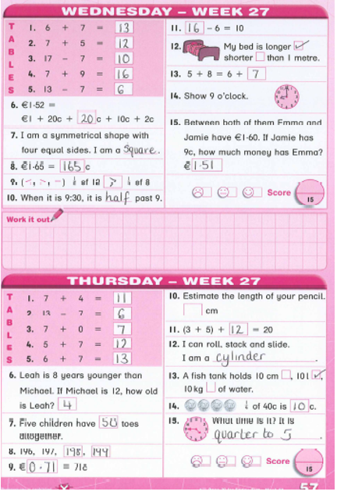

Report cloze

Ireland

(definition)Ireland is an island off the west coast of Europe.

(Country facts)The capital is Dublin. The main language is English. Its currency is the euro. Nearly 5 million people live there.

(tourist facts) Tourists love to visit Ireland. The Phoenix Park is popular. It is home to our zoo. Our President Michael D Higgins lives in a beautiful white house there. The Ring of Kerry in the south is very scenic. Many travel to see Fungi the dolphin off the coast of Dingle. You can take a cruise on the River Shannon – our longest river. Our Irish music and dancing are very popular.

(food facts) Traditional meals from Ireland are stew, bacon and cabbage and potatoes.

(Other facts) Ireland has its own national sport called hurling. The girls’ version is called camogie.

(Conclusion) With its lovely flag of green, white and gold, Ireland is famous all over the world, especially on our national holiday – March 17th, St. Patrick’s Day.

**Monday**

**English**

Spellbound, Week 29. P.60. Learn first 4 spellings. Pick one word and put it into a sentence.

Starlight

Watch this video about Italy.

<https://youtu.be/r8PdH2FfVJI>

Read my facts about Italy.

**Italy**  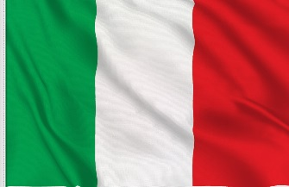

Italy is European country,-shaped like a boot –that “kicks” an island called Sicily into the Mediterranean Sea. Italy borders six countries: [France](https://www.kids-world-travel-guide.com/france-facts.html), [Austria](https://www.kids-world-travel-guide.com/austria-facts.html), Switzerland, Slovenia, Vatican City and San Marino. 62 million people live in Italy. Its capital is Rome. The people speak Italian. Like us, their currency is the euro. Their National Day is June 2nd.

Italy is popular for its beaches and mountain ranges. The highest mountain peak in Italy is Mont Blanc in the Alps. The longest river in Italy is the Po River in Northern Italy. Lake Garda is the largest lake in Italy.

Did you know that in Italy, there are still active volcanos? These are: Vesuvius near Naples, Etna on Sicily and Stromboli off the Coast of Italy. Tourists love to see the Leaning Tower of Pisa, Venice’s canals and ancient Rome. Italians love soccer.

Italian dishes are pasta, tomatoes, pizza and lasagne.

Many famous people came from Italy like Christopher Columbus and Leonardo da Vinci. Did you know that Italians also invented the piano, ice-cream and the thermometer?

Let’s build a report on Italy using that information. Look at Starlight p.33 and fill in the plan using my facts above. I have underlined all the important facts above for your activity in your book. We will come back to it tomorrow then.

**Irish**

Ag siopadóireacht (shopping) is our focus again. Go to Bua na Cainte p.94. Tá leitís uaim = I would like lettuce.

Tá leitís uaidh= He would like lettuce.

Tá leitís uaithi= She would like lettuce.

We are only doing the top half today. Watch my video to explain it.

Insert p 94 uaidh

**Maths**

Work It Out week 28 Monday

Let’s look at 100plus square counting again.

Go to p.138 and use the 100-200 square to work out the patterns.

You are counting backwards. See my video.

Insert CM P.138

198-8=

188-8=…….Notice the pattern.(8-8=)

190-7=

180-7=…….Notice the pattern.(10-7=)

193-6=

183-6= …….Notice the pattern.(13-6=)

**Tuesday**

**English**

Spellbound. Week 29. P.60. Next 4 spellings. Pick one word to put into a sentence. Try exercise 1.

Starlight

I wrote a report on Italy using the plan we worked on. Here is my plan.

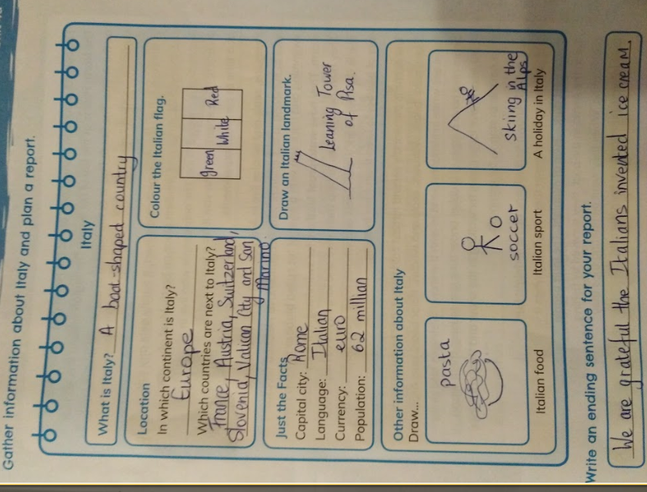

Yours maybe a bit different but that’s ok.

Here is my “Italy” report – built from the facts above -for you to read and fill in any missing words.

(Title)Italy

(Definition) Italy is a _________-shaped country that is in the continent of ____________.

(facts) Italy is bordered by F______, A________, S__________, Slovenia, Vatican City and San Marino. The capital city is _________. ___ million people live there. People there speak __________. The currency is the ______. Italy’s flag is ________, ________ and ________. Italians love the sport of _________.

(Food)Italy is famous for its food such as ________________ ________________________________________________.

(Tourism) Tourists love to see the sights, like the Leaning ________ of ______. Many people go there on _____________ holidays in the mountains.

(Conclusion) Italy is a very interesting country and guess what it is the home of ice-cream!

**Irish**

Ag siopadóireacht.

Go to Bua na Cainte p.94. Remember –

Tá leitís uaim = I would like lettuce.

Tá leitís uaidh= He would like lettuce.

Tá leitís uaithi= She would like lettuce.

We are doing the bottom half today. Watch my video to explain it.

Insert p 94 uaithi

**Maths**

Work It Out week 28

Back to money. 100c is €1.00. To help us in our work this week, we go need to go over hundreds, tens and units.

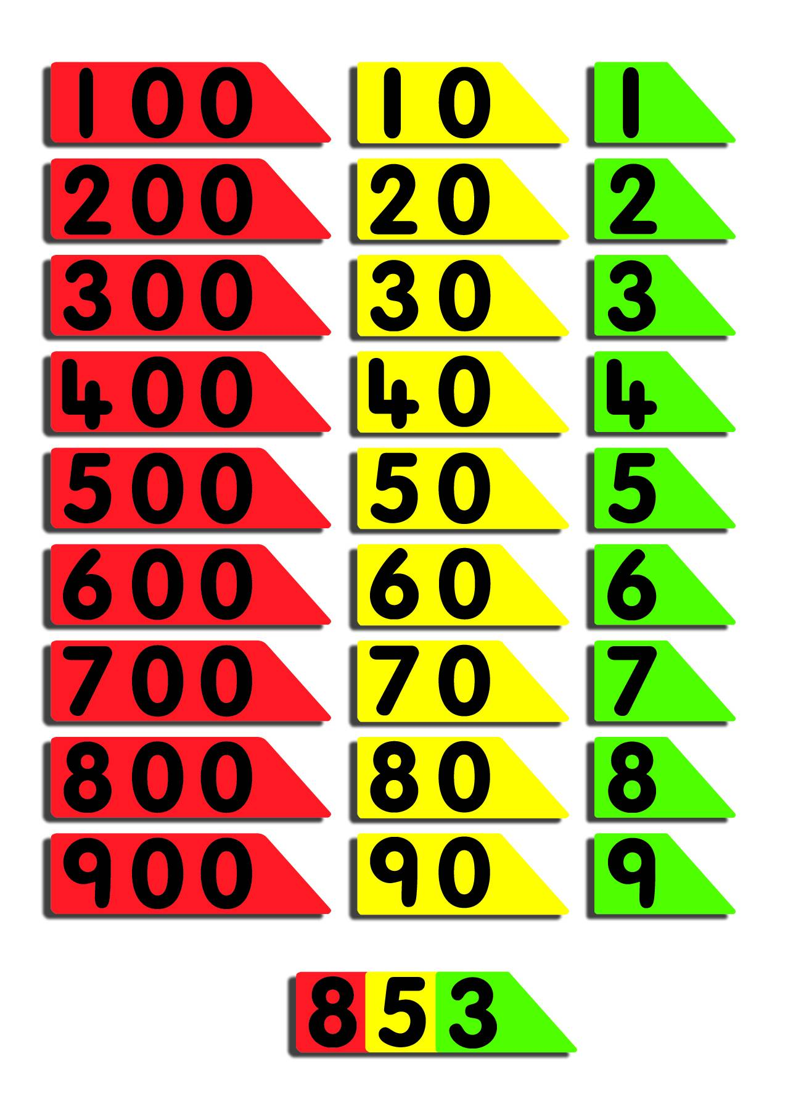

Remember we used the arrow cards to build numbers. So 853 os made up of 800 and 50 and 3.

124 is 100 and 20 and 4. Every 100c makes a euro. So if we have 124c, the hundred goes into the euro department.

Euro . cent

1

And then the 24 cent are put in the cent department. The euro sign is more powerful than the cent sign and so that is the one we use.

€ 1. 24

Remember;-100c is €1.00.

So we can write money in two different ways.

110c=€1.10

157c=€1.57 - the 100 cent of 157 is recorded as 1 euro to the left of the dot or “decimal point”. The left over 57c is written on the right side of the decimal point…which is the cent department…but don’t write cent. Only use one sign or the other ever. € sign is used when using the decimal point.

p.110 Cracking Maths will give you some practice.

**Wednesday**

**English**

Spellbound. Week 29. P.60. Write the words you have found hardest this week in rainbow colours.

Next 4 spellings. Try exercise 2, p.61 – the word snake.

Read a report about old Italy – Ancient Rome on page 28 of Feena’s Second Book of Facts.

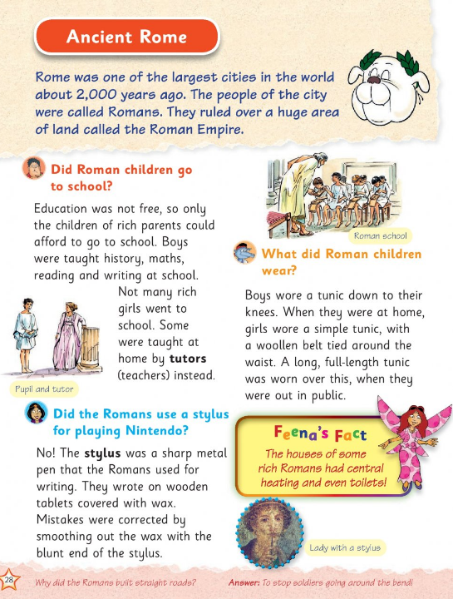

**Irish**

Ag siopadóireacht. We have a story on p. 96 of Bua na Cainte. No writing today.

Inert video p.96 scéal

**Maths**

Work It Out week 28

Money.

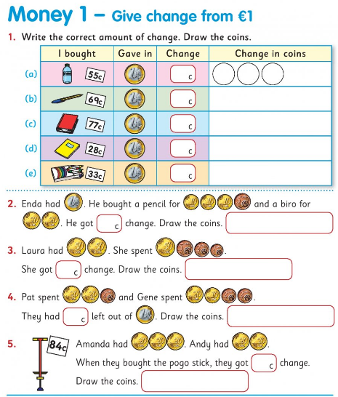

**Thursday**

**English**

Spellbound. Week 29. P.60. Finish the list. Wordbuilding! See how many words you can make that end in –ark. Try as many of Exercise 4 on p.61 as you can.

Florence is in Italy. Florence Nightingale was born there. Remember we read about her on p.50 of What a Wonderful World? Look back over it. Now read more.

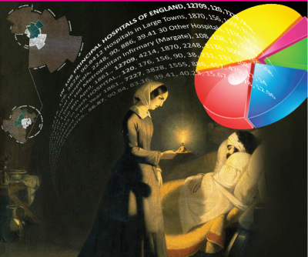

#### **At this time we celebrate the front-line workers, especially nurses. Florence was a famous nurse known as the “lady of the Lamp”.**

**She was born in Florence on May 12th in 1820 into a wealthy English family and showed great talent in mathematics from an early age.**

**She was never content to be what society expected of a lady of those times – hosting tea parties and wearing fancy clothes. She wanted to become a nurse That is what she did! She trained in Germany.**

**Florence went to the Crimean War in Turkey in 1854 to care for injured soldiers. There she found that far more soldiers were dying of disease than wounds. She tried to improve hygiene.**

**Using data (number information) she had gathered, she had lots of facts about wounds, infections and the importance of handwashing and clean bandages. She developed visual displays (maths picture) similar to the pie chart that is common today. A pie chart is another form of bar chart. (See p.29 of Cracking Maths for an example of a bar chart). Here is what a pie chart looks like. This one is about how people get to school. People like the way you can read the information quickly from a pie chart.**

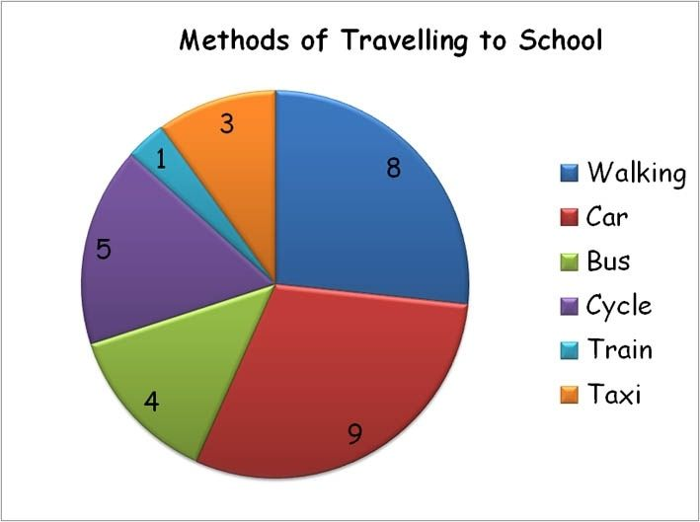

**With her data and pie charts she got politicians to listen to her advice and work for change. This had a huge impact on the design and work practices of hospitals resulting in a significant drop in death rates. On her return to England she educated nurses.**

**Florence died in London in 1910.**

#### **To summarise, Florence Nightingale is considered the founder of modern nursing and the 12th of May (last week), was the 200th anniversary of her birth – her birthday. She was great at maths and used it to fight the spread of illness. May 12th is also designated as International Women in Mathematics day.**

Write these sentences in your copy and fill in the blanks.

1. Florence was born __________ years ago.
2. She came from a ___________ family.
3. From an early age she was good at ____________.
4. She dreamed of becoming a _______________.
5. She was sent to nurse soldiers during the Crimean __________.
6. The soldiers called her ‘The _________ of the ____________’.
7. She realised more soldiers were dying from _____________ than from their wounds.
8. Florence worked to improve h____________ in hospitals.

Draw Florence at work.

**Irish**

Ag siopadóireacht. Back to p.96 of Bua na Cainte. Watch my video to help you do the activity.

Insert video p . 96activity.

**Maths**

Work It Out week 28

Try this website for money games.

<https://www.topmarks.co.uk/money/toy-shop-money/eur> Click on mixed coins – and then up to one euro. Experiment with under two euro.

More shopping bills. A little challenge – these needs you to think bigger than a euro but the idea is the same.

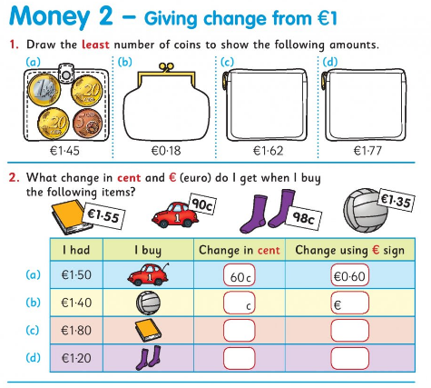

**Friday**

**English**

Spellbound. Week 29. P.60

Let’s have fun with words and be poets! Look at p. 45 of you Starlight for a framework on writing a list poem. Verse 1 of the poem “Not-So Fast Food” on p.42 is an example. It could be a list for Art, sport, a sleepover…You choose.

**Irish and Maths**

Ag siopadóireacht. Make up a shop. Get toys, or books or clothes – or whatever you like. Make price tags for each item and attach. Keep the prices low… each under €1.

Make a sign – Siopa (shop). Give yourself a nametag – eg Siopadóir Máire (Shopkeeper Mary). A doll or teddy can be a customer if no one is free at home.

Useful phrases. Listen to my audio. Insert audio useful phrases shop

Dia duit…Dia’s Muire duit(hello)

Conas atá tú ?...How are you?

Tá mé ar mhuin na muice. (I’m fantastic….on the pig’s back is the literal translation).

Cad atá uait? What would you like?

Tá …… uaim. I would like…

Tá ……uaidh. He would like…

Tá …..uaithi. She would like..

Más é do thoil é…please

Go raibh maith agat…thankyou

Slán (bye)

You can practice saying the amounts in Irish. You can add up in English and practise saying the amounts in both cent and in euro.

**Map Work**

What a Wonderful World

p.53

Here is a map. Find the bank. Now compare the distance from the bank of different locations. See which is furthest. (Questions 1,2,3).

Now find Green Park. This time you will be looking for places that are nearest to the park. (Questions 4,5,6)

Time to have fun and create a treasure map. Here is one Mrs Quill did.

Insert Mrs Quill treasure map video

**Other Suggestions for Boredom Moments!**

**SPHE**

Be proud of you. -My favourite bit of TV on Home School Hub in recent weeks: [**https://youtu.be/lihWQ_nbEiQ**](https://youtu.be/lihWQ_nbEiQ)

**PE; Design your own hopscotch game.**

**Watch a Joewicks PE coaching session or GoNoodle.**

**Write a postcard to a relation of friend.**

**Draw a portrait.**

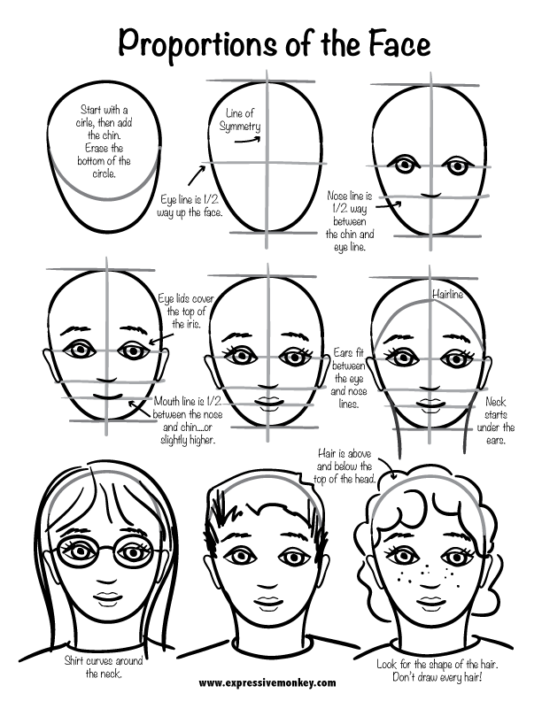**.**

**Listen to the songs-** [**https://youtu.be/m2uTFF_3MaA**](https://youtu.be/m2uTFF_3MaA)

[**https://youtu.be/Q-RNhpKamsI**](https://youtu.be/Q-RNhpKamsI)

[**https://youtu.be/K6DSMZ8b3LE**](https://youtu.be/K6DSMZ8b3LE)

**Pick your favourite.**

**Pick an Irish creature – fox, hare, badger etc. Look up images. Sketch. Write 4 sentences sharing facts that you know.**