Week beginning: 08/06/2020 Class and Subject: 3rd class Literacy Boost SEN Teacher: Ms. Conran

Work below is to be carried out over a week. Uncompleted work can carry on to the following week.
Week 11 | Enjoyable Online Reading Resources:  - Download the app: “Epic Reading” app, which is free to download for the first month free trial. Choose and customise reading for your child by choosing their reading level and interests. Stories will then be suggested for your child based on these criteria.  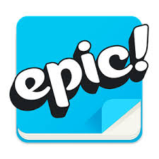  - Website: “Storybird”. You can sign up for a month free trial. There is a large variety of story books that your child can read. Focus on picture books and comics as there will be a lot to discuss with your child based on the pictures as well as the reading  .  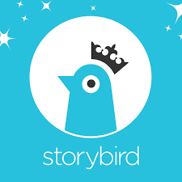 | Dolch sight words:  - Website: “dolchword.net” You can click your child’s level to access games and activities to familiarise your child with these sight words. Games include memory, matching & spelling activities as well as ‘jigsound’ games. Enjoy!    In My Beach Bag  - Imagine in a few weeks time that you are going to plan a fun trip to the beach.  - What items will you need to bring with you and why are they important?  - Use the worksheet templates to help you!  - Look at the summer word mat and see if you can put some of the words into sentences, orally or in written form. | Oxford Reading Tree  - Website: “oxfordowl.co.uk” This website will allow you to access ebooks of various levels once you set up an account.  - Read:  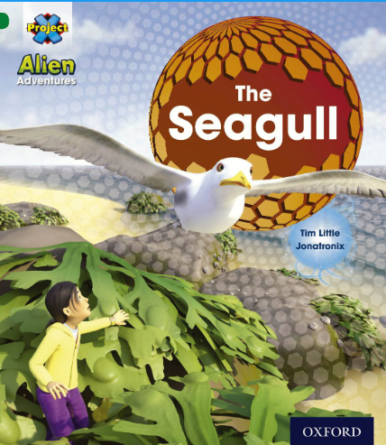  - Children can listen to and read along with the audio.  - There are interactive activities to supplement reading as well as post reading questions and reflections.  - Listen to your child’s reading. Focus on vocabulary development, discussing the meaning of certain words. Ask them questions about what they have read to develop their comprehension and understanding. Ask them to predict what will happen next in the story. The child can summarize the story in their own words afterwards.  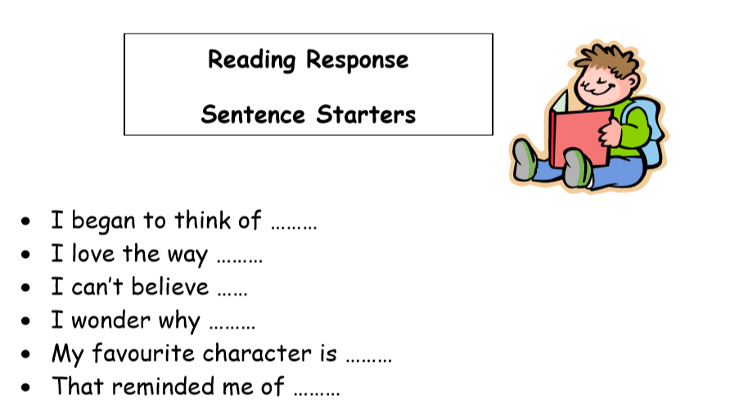  - Retell the story in your own words using the main images in the story line. What were the main events from the story in sequence?
 | SNIP Programme  - Continue with the Snip programme doing an extra week of spellings and activities each week. Parents can test your child on these spellings weekly. If you finish the activities, you can write sentences with the words that you have for spellings | Daily Writing Activities  - Encourage your child to undertake short focused writing activities and tasks. For example:  - My News  - Writing a short letter or postcard to grandparents  - Writing a shopping list  - Writing a daily diary  - Writing imaginative short stories | Note to Parents:  - This is only a menu of work so feel free to pick and choose work that you feel is appropriate for your child and work away at your own level.

