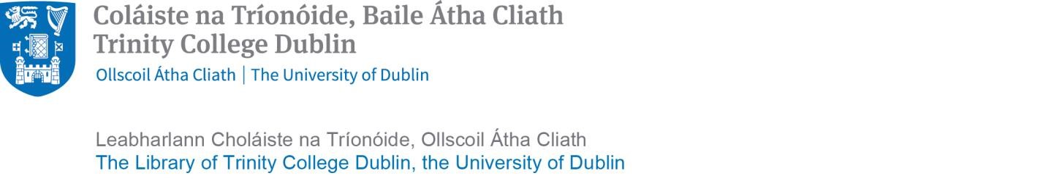

Copyright declaration regarding use of original creative works donated to the Library through the Trinity Access Programme’s Primary School Quarantine Archive programme.

I, the undersigned, being the author of the work named/described below wish to donate this work to Trinity College Library. I hereby give permission to Trinity College Library to administer the copyright of this work in relation to allowing it to be used for research purposes.

Signature of author/artist:

____________________________________

|  |  |
| --- | --- |
| School: | _________________________________________ |
|  | _________________________________________ |
|  | ____________________________________ |

Title/description of work being donated:

__________________________________________________

Signature of parent/guardian: (confirming that the above named child has assented to her/his record being donated to the Library for use in research):

____________________________________

Date: _____________2020

