**June 22nd – 26th**

**1st Class**

Dear parents/guardians of 1st class students,

It is hard to believe it is the week of the summer holidays and your daughters last, official, week in 1st class. Thank you so much for engaging with distance learning. I know it can’t have been easy to juggle school work with home life but I am blown away by the huge effort everyone has made.

This week we have some fun activities planned that I hope the girls enjoy. Please find virtual school tours and virtual sports day activities on our Padlet website. I have a sample plan written below but feel free to use the activities on Padlet to plan your own week with what suits you/your daughter.

I hope you all enjoy a well-deserved break over the summer. We look forward to seeing you all in September.

Best wishes,

Ms Gleeson.

Dear 1st class girls,

Well done for working so hard on your school work at home this year. This week we have virtual school tours and sports day activities to enjoy every day so have loads of fun! Choose a day this week to do the Ms Finn and Ms Linehan Virtual Sports Day! I hope you all have a wonderful fun-filled summer. We are so excited to welcome you all back to school in September and I know you will love second class.

Be kind,

Ms. Gleeson.

**Suggested Daily Timetable**

|  |  |
| --- | --- |
| 9.00-9.30 | See Virtual Sports Day ideas on Padlet/Exercise (JoeWicks live (Youtube) / Cosmic Yoga (Youtube)/ Go Noodle website/suggested sports day activities below |
| 9.30-10.45 | Virtual School Tour and chat about it |
| 10.45-11.00 | Small Break-Have a snack and go outside for a run/play |
| 11.00-12.00 | RTE School Hub |
| 12.00-12.45 | Sports Day Activity |
| 12.45-1.15 | Lunch |
| 1.15 onwards | Free Time  *RTE School Hub have a fun week planned this week so it is worth tuning in  **Choose a day to plan and complete a virtual sports day. |

**Sample Week Plan**

**Monday**

**Virtual Tour**

Virtual Tours of Zoos and Animals

**Sports Day Activities**

**Pokemon Yoga**

[**https://www.youtube.com/watch?v=tbCjkPlsaes&feature=emb_logo**](https://www.youtube.com/watch?v=tbCjkPlsaes&feature=emb_logo)

**PE with Coach Claire**

[**https://www.youtube.com/watch?v=Zv0b9VzlOdE&feature=emb_logo**](https://www.youtube.com/watch?v=Zv0b9VzlOdE&feature=emb_logo)

**PE with Numbers**

[**https://www.youtube.com/watch?v=0y6b5PD3EXQ&feature=emb_logo**](https://www.youtube.com/watch?v=0y6b5PD3EXQ&feature=emb_logo)

**Zumba Kids Electronic Song**

[**https://www.youtube.com/watch?v=FP0wgVhUC9w&feature=emb_title**](https://www.youtube.com/watch?v=FP0wgVhUC9w&feature=emb_title)

**Get Running – Traffic Lights**

Find a space in a large open playing area. On a signal from an adult move around the playing area in response to the following commands. Turn it into a game of moving statues to develop.

• Red: stop

• Amber: walk

• Green: run

<https://youtu.be/Uj9_pdx_vEA>

**Rock, Paper, Scissors tag**

Play with a partner ....... standing one metre apart and facing each other. Begins by performing a rock-paper-scissors routine. A rock is a closed fist, paper is a flat hand, and scissors are the index and middle fingers in a cutting position. Paper always covers rock, rock breaks scissors, and scissors cut paper. To determine a winner, count to three and form a rock, paper, or scissors. The winner then chases their partner toward their safety line, attempting to tag them before they are safe. Line up again and repeat the activity.

<https://youtu.be/oYCPKHFvveM>

**Tuesday**

**Virtual Tour**

Virtual Tours of The World and Beyond

**Sports Day Activities**

Balance a book on your head and race!

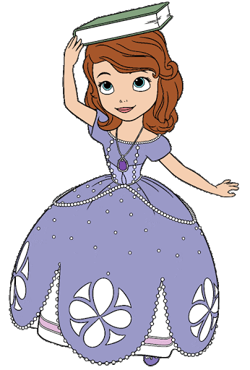

**Activity 2 - Wheelbarrow Races** 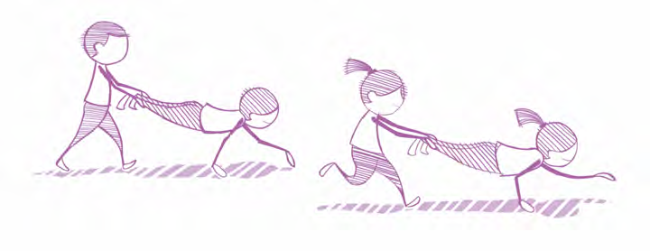

Arrange yourselves in pairs. Set up a course. One person adopts the high plank position and their partner lifts their legs below the knee. The pupil holding the high plank moves their hands to go forward, with their partner carrying their legs behind.

<https://youtu.be/I9X8PowsdAU>

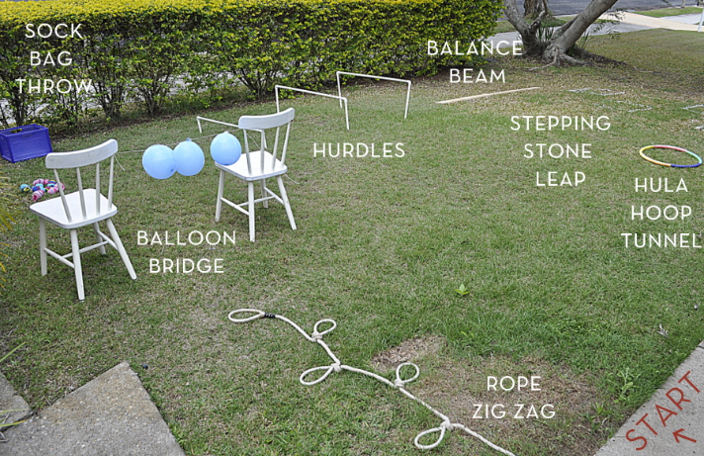

**Activity 3 - Obstacle Course**

Set up and run your own obstacle course. Use any equipment available - household or otherwise. Time yourself and try to beat your original time.

<https://youtu.be/sXjDO9G2JQY>

**Wednesday**

**Plan and run a sports day** use Ms Finn and Ms Linehan’s plan in the ‘Teachers’ Ideas’ section on Padlet!

**Thursday**

**Virtual Tour**

Virtual Tours of Ireland and Art Galleries

**Sports Day Activities**

**Salut the Sun**

https://family.gonoodle.com/activities/how-to-salute-the-sun

**Fastest First**

<https://www.youtube.com/watch?time_continue=1&v=NAwPRSGLfkw&feature=emb_logo>

**Laundry Giggles**

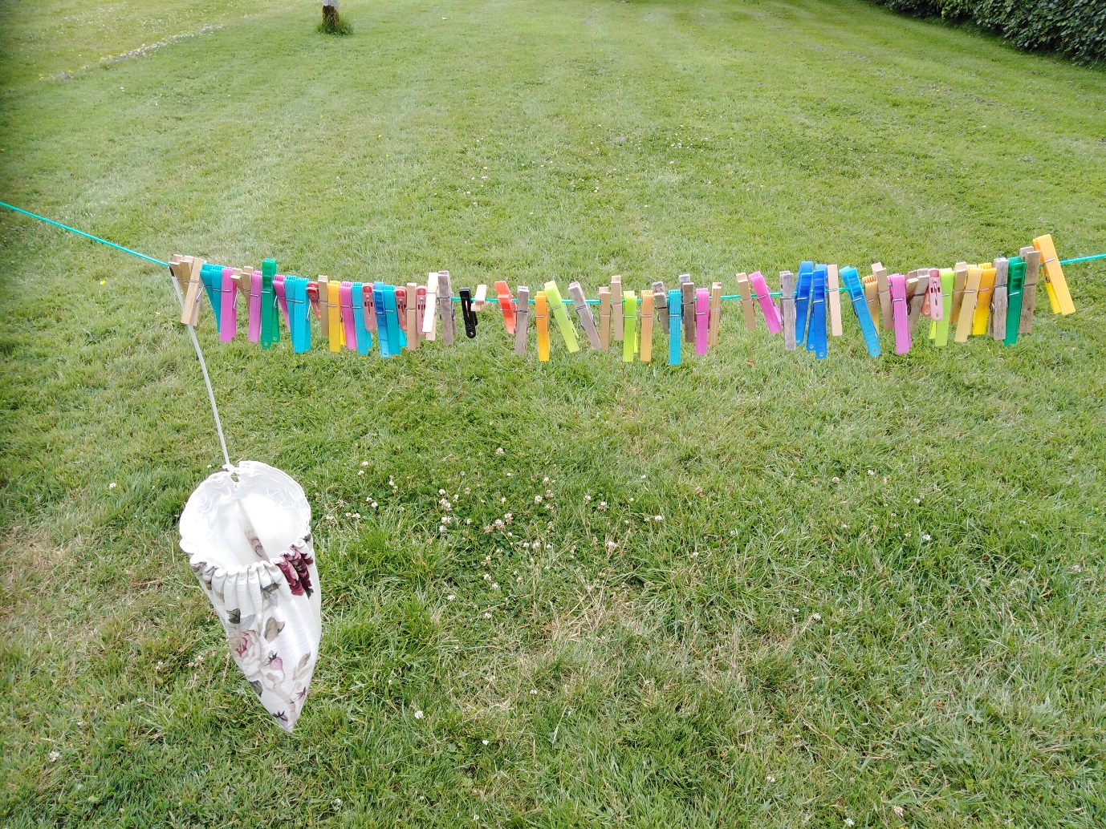

Silly me! I forgot to hang out the clothes!

Your challenge! Set up your clothes line like I did. Then set a timer – a minute or two – (you choose). See how many pegs you can unpeg with one hand behind your back. I got to 23. Count your tally when the time is up. Can anyone in the family beat you?

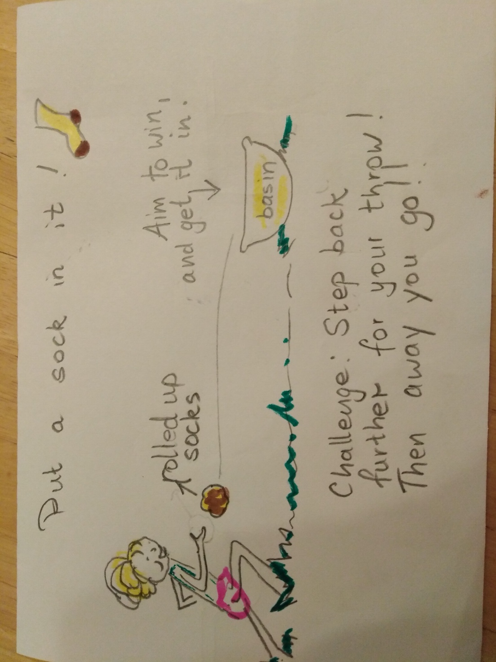

**Friday**

**Virtual Tour**

Virtual Tours of Theme Parks

**Sports Day Activities**

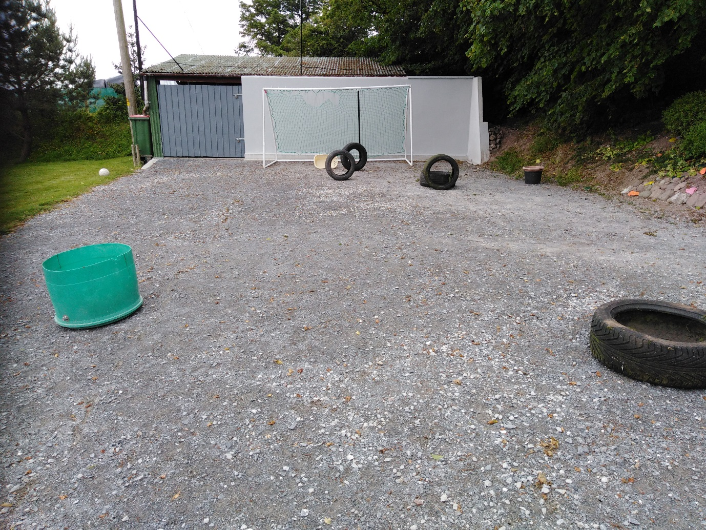

Build a course with obstacles...anything you have...flowerpots, paper plates, rubbish bin....

Set up a laundry basket on its side at the end of your course.

Aim: Kick the ball with a minimum number of shots to get the ball into the laundry basket. It took Miss Coughlan 6 shots to score into the basket. Boy does she need practice!!! Bet you can do less when you try with your course.

**Art: How to draw the Puppy Emoji**

<https://www.youtube.com/watch?time_continue=3&v=NatsdDyn6yY&feature=emb_logo>