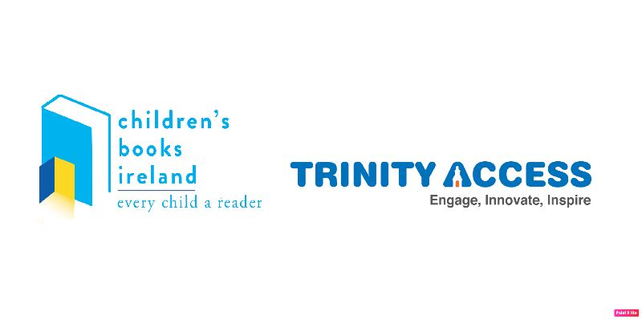
You’re Living through History Now!

Congratulations!! You’ve been selected to take part in our Archive Project and we’re so excited to see what you decide to create! Because we think your thoughts and feelings right now are really important, we’d like to keep them in the Library of Trinity College in Dublin.

We want you to tell us all about the life you’re living right now in lockdown and all the changes you and your family have experienced. And there are lots of different ways you can do that!

This can be a story about your life. Where you live, who your friends are, what you want to be when you grow up. Your story. Your story is important because no one else has a story like yours. You can write a story that’s inspired by what’s happening in the world right now; that means that you can make up characters who are feeling the way you and your friends and family feel, and give them a story where they have a figure out a problem or try and stay together. That’s a fictional story, like the books you read from the library. It can be funny, like a Roald Dahl story or it be a fantasy story like something Rick Riordan might write. You could write a story that’s inspired by what’s happening now – you could be a superhero battling a virus supervillain!

You could write a letter to your future self or to someone who might read it a hundred years after the quarantine has ended

You could write a journal or a diary of your days; pages where you write down the thoughts and feelings you’ve had as well as all of the things that have happened that you think are important Or you might like to write about your favourite memories in an essay. Because your memories are more important than anything.

Creative Writing:

Creative writing means that you get to use your imagination! You can write a story or a poem or a reflection (what you think or feel about something) or a play or a conversation between imaginary characters.

Draw Your Life!

If you like to draw, you can do that too! You can paint, you can use pencils, crayons, markers, anything at all that lets you make the picture you want to make.

You could draw or paint or colour a picture of;
- Your favourite place to be right now, like your garden or a walk you take with your family or somewhere that you miss and can’t wait to see again – can you remember it clearly and draw it?
- You could draw a portrait of someone in your family, or your whole family or your pets!
- You could draw a picture of how you imagine the world might look like when the rules change – or how you would like the world to look in the future.
- OR ANYTHING AT ALL THAT YOU WANT TO DRAW! YOUR IMAGINATION IS IN CHARGE!

More than anything, this is your chance to make a record of your life and your family’s life during these strange days. It’s really important because your life is really important.



