Week beginning: 08/06/2020 Class and Subject: 2nd class EAL SEN Teacher: Ms. Conran

Work below is to be carried out over a week. Uncompleted work can carry on to the following week.
Week 11 | Enjoyable Online Reading Resources:  - Download the app: “Epic Reading” app, which is free to download for the first month free trial. Choose and customise reading for your child by choosing their reading level and interests. Stories will then be suggested for your child based on these criteria.    - Website: “Storybird”. You can sign up for a month free trial. There is a large variety of story books that your child can read. Focus on picture books and comics as there will be a lot to discuss with your child based on the pictures as well as the reading  .  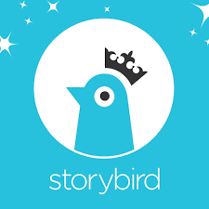 | Dolch sight words:  - Website: “dolchword.net” You can click your child’s level to access games and activities to familiarise your child with these sight words. Games include memory, matching & spelling activities as well as ‘jigsound’ games. Enjoy!    Games & Language Development  - Use the suggested games below to develop conversation and oral language development in a fun and interactive way.  - Perhaps use some props to enhance the child’s learning experience.  True or False Activities  - Building comprehension and vocabulary.  - Read the sentences, look at the picture and discuss whether the sentences are true or false. | Oxford Reading Tree  - Website: “oxfordowl.co.uk” This website will allow you to access ebooks of various levels once you set up an account.  - Read:  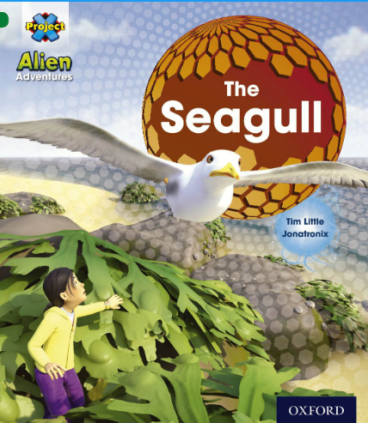  - Children can listen to and read along with the audio.  - There are interactive activities to supplement reading as well as post reading questions and reflections.  - Listen to your child’s reading. Focus on vocabulary development, discussing the meaning of certain words. Ask them questions about what they have read to develop their comprehension and understanding. Ask them to predict what will happen next in the story. The child can summarize the story in their own words afterwards.  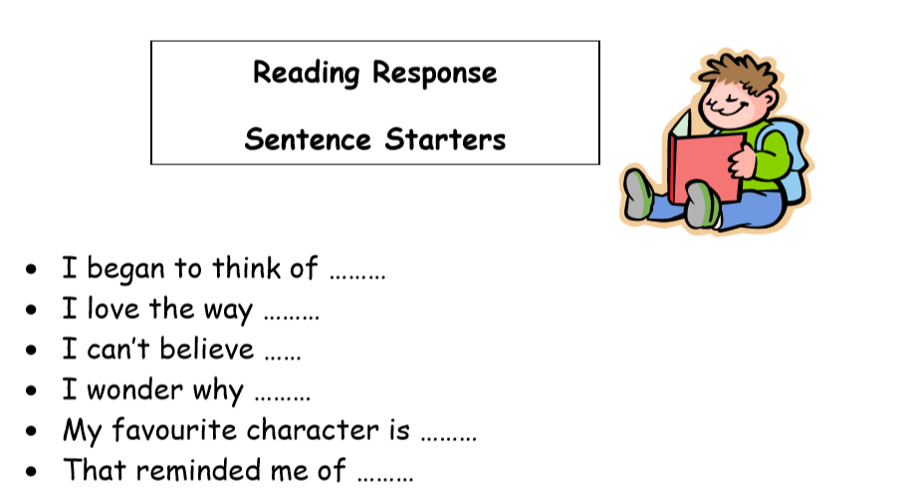  - Retell the story in your own words using the main images in the story line. What were the main events from the story in sequence?
 | - Continue using the language booklets that I printed out for the girls.  - Revise topics such as:  - Food  - Clothing  - Colours & shapes  - Spot the difference  - The Weather (perhaps watch the weather forecast each day)  - Language games:  - I went to the shop memory & recall game (I went to the shop and I bought… apples… I went to the shop and I bought apples and milk, etc.  - I spy with my little eye  - Talking with friends or family on the phone using English – my news, how is your day? | Daily Writing Activities  - Encourage your child to undertake short focused writing activities and tasks. For example:  - My News  - Writing a short letter or postcard to grandparents  - Writing a shopping list  - Writing a daily diary  - Writing imaginative short stories | Note to Parents:  - This is only a menu of work so feel free to pick and choose work that you feel is appropriate for your child and work away at your own level.

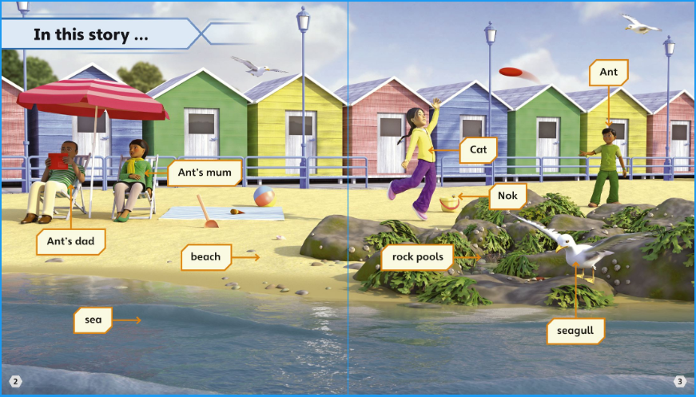

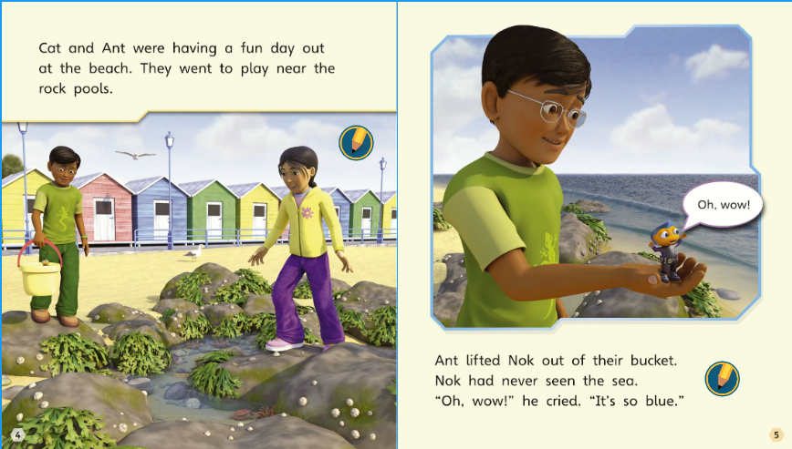

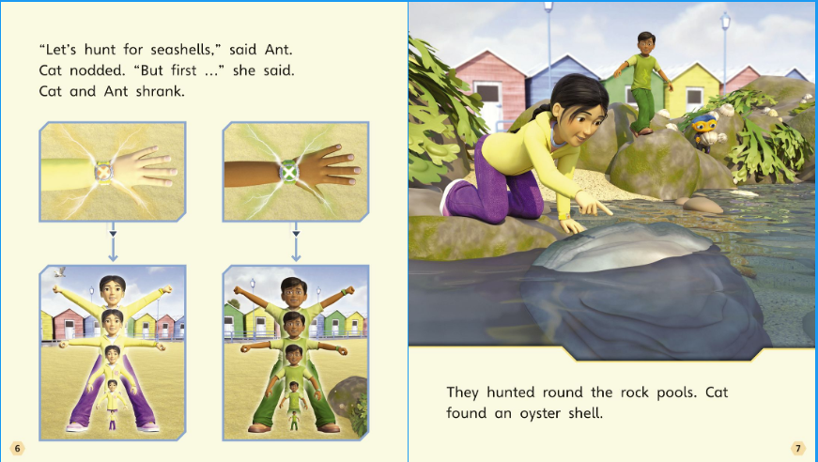

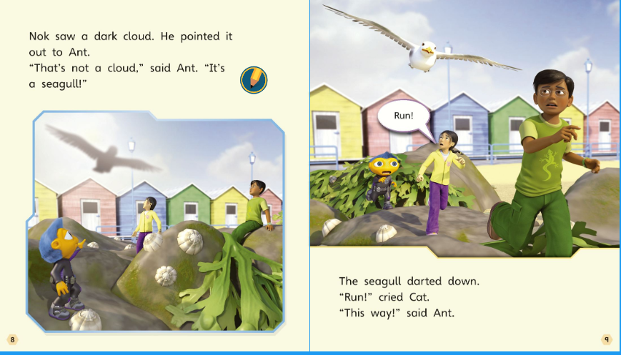

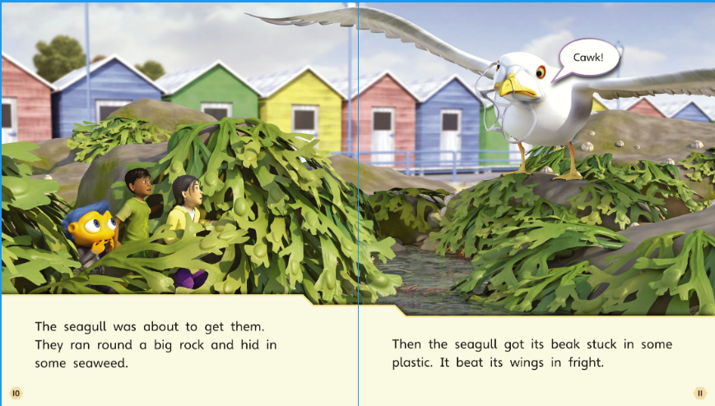

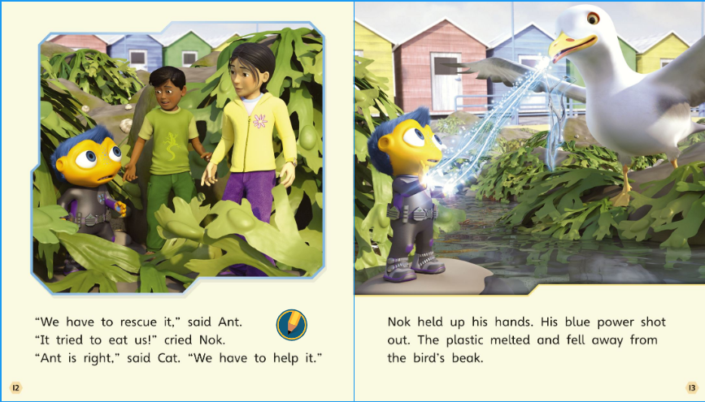

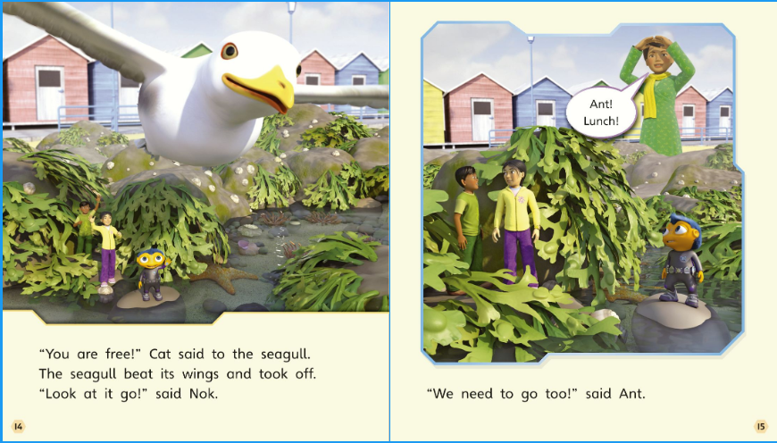

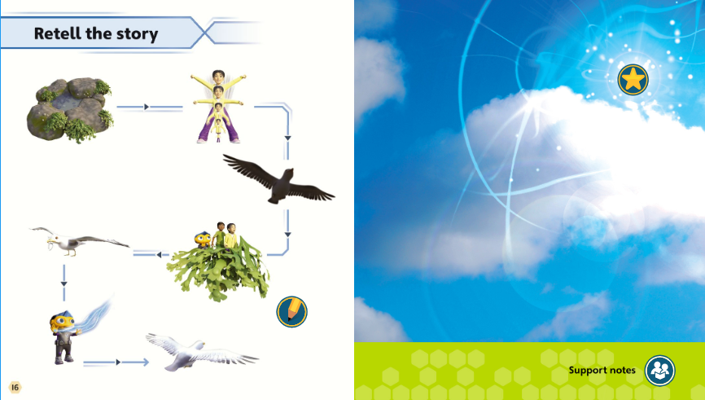

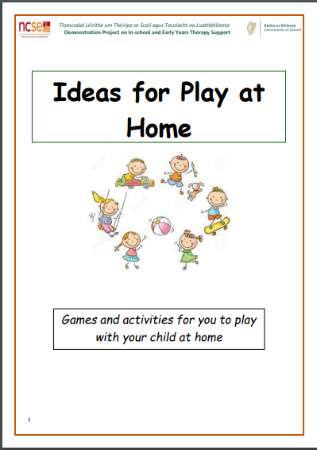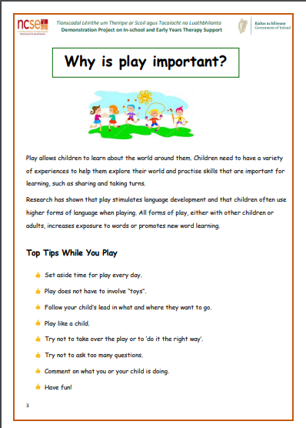

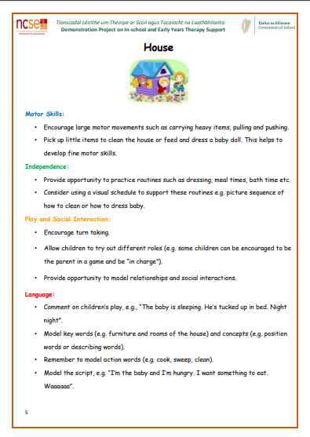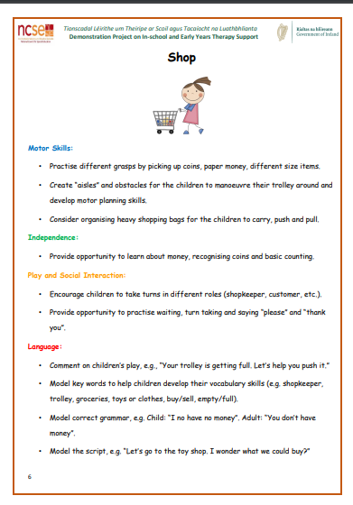

Look at the summer word mat and see if you can put some of the words into sentences, orally or in written form.
