**Suggested Timetable**

**9:00 – 9:30** Exercise (e.g. Joe Wicks, Cosmic Yoga, stretching, walk the dog, a quick spin on bike/scooter)

**9:30 – 10:45** Core subjects from Schedule of Work

**10:45 – 11:00** Small Break

**11:00 – 12:00** RTE School’s Hub

**12:00 – 12: 45** Time to complete unfinished work from earlier or pick something from “Extra Activities” lists suggested in previous weeks

**12:45 – 13:15** Lunch

**13:15 onwards** Enjoy the rest of your day!

**Schedule of Work: Week 11**

**MONDAY**

**Matamaitic**

**1.** Maths Corrections : 1)Busy at Maths p.120 – p.125 and 2)Busy at Maths Shadow Book p.53 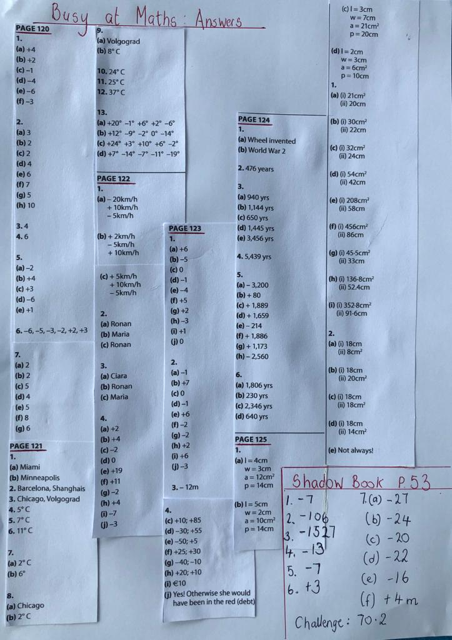

**2.** Busy at Maths p.126: Calculating trickier shapes. The example at the top of the page explains these types of questions very well. Hint: You must break the shapes into rectangles or squares as we know the formula to get the area of these (L×W)

[**Video Page 126 Maths**](https://youtu.be/Y3fkOKKgINI)

~Do all of Q.1 (a – e)

Optional

**3.** Challenge on p.126 and Work it Out, Week 27: Monday

**Gaeilge**

**1.** Corrections: **Scéal: Tráthnóna Inné : Freagraí**

1. Shiúil Niamh abhaile ón scoil.

2. Rinne sí a obair bhaile.

3. D’fhág sí an teach ag a cúig a chlog.

4. Bhuail sí le Liam.

5. Thosaigh said ag imirt peile.

6. Cheannaigh said deochanna agus milseáin.

7. Bhí áthas ar na gcairde mar bhí an craic acu.

**Inis Dom, lth 126**

1. Tá Máire ag dul go Baile Átha Cliath.

2. Tá Laoise ag dul ó thuaidh go Doire.

3. Tá Áine ag teacht anuaidh ó Dhoire.

4. Tá Síle ag teacht aneas ó Chorcaigh.

5. Níl Eoin ag teacht aniar ó Ghaillimh.

6. Níl Ciara ag dul siar go Gaillimh.

7. Tá Tomás ag dul ó dheas.

8. Tá Eoin ag teacht anoir ó Bhaile Átha Cliath.

**2.** See can you find all these Summer words:

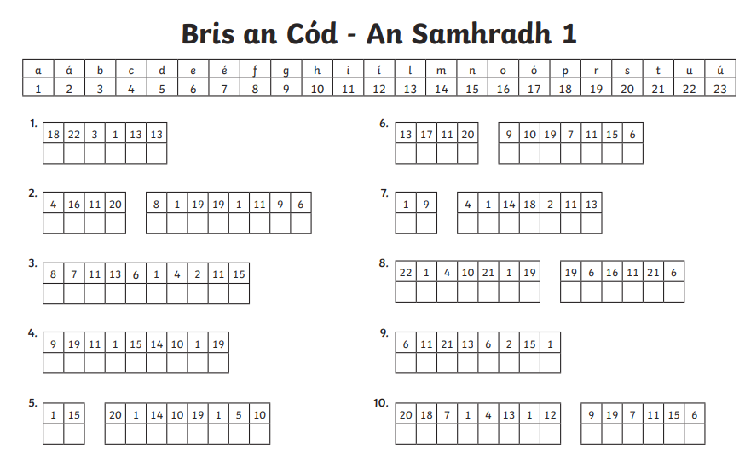

**Béarla/ Stair**

**1.** Spellound : Week 27 ; learn Block 93

**2.** History Quest : Ch.11 : World War II : Read p.s 92, 93 and 94

**3.** Answer Q’s: Activity A, p.96

Optional

**4.** Do some research on Auschwitz

**TUESDAY**

**Matamaitic**

**1.** Busy at Maths p.128: **Scale –** Scale is the ratio of the length of an object on a drawing to the length of the object in real life e.g. a house is too big to fit onto a page so we draw it to scale of 1cm = 1m (1cm on the page represents 1m of the actual length of the house)

~Complete Q.s 1, 2 & 3 p.128

**2.** Area is measured in cm/m squared. Larger areas are measured in ares and hectares. 100m squared = 1 are, 100 ares = 1 hectare

~Complete Q.s 2 & 3 p.129 e.g. 2(a) (i) 300m squared = 3 ares, (ii) 700m squared = 7 ares

3(a)(i) 2hectares = 200m squared 3(b)(i)200 ares = 2h (hectares)

Optional

**3.** Extra Maths: Work it Out: Week 27, Tuesday

**Gaeilge**

**1.** Déan “Bris an Cód – Samhradh 2”. See can crack the code with this second set of summer words:

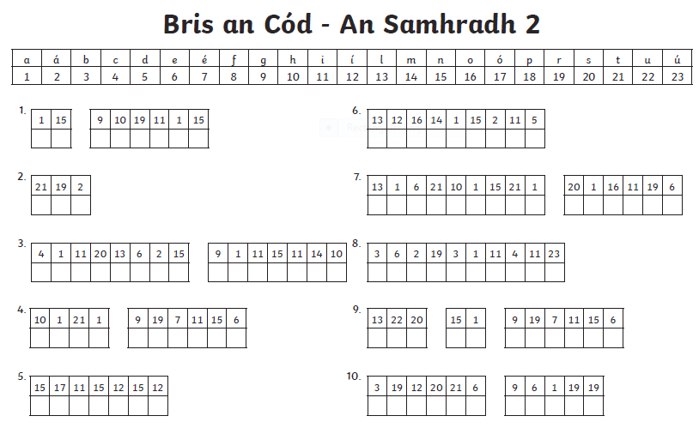

**Béarla / Stair**

**1.** Spellbound: Week 27, learn block 94

**2.** History Quest : Continue with World War II : Read p.s 95 – 100

**3.** Complete Activity C p.101

**4.** Activity F: complete no.5 **or no.6**

**Reiligiún**

~ Grow in Love: p.124 – Read the story about Chiara Luce Badano, a Christian hero. Answer the questions that are underneath orally.

**WEDNESDAY**

**Matamaitic**

**1.** Busy at Maths: P.132 : Chapter 25: Fractions / Decimals / Percentages 3

~ P.132: Calculating profit and loss: no.1 and 2 (you can use a calculator): Selling Price - Cost Price = Profit or Loss

~P.133: Calculating % profit and % loss: Use the examples at the top of the page: no.1 Remember to find a % profit = profit × 100 % loss = loss × 100

cost price 1 cost price 1

Optional

**2.** Busy at Maths p.133 no.2

**3.** Work it Out: Week 27, Wednesday

**Gaeilge**

~ Based on the “Summer” words found in Crack the Code on Mon & Tue write a story called “Ag an Trá” (Write a story : At the Beach). Ná dean dearmad na frasaí a bhíomar ag foghlaim don scrúdú a usáid chomh maith. (Don’t forget to use the phrases that we have been learning for our weekly tests as well.)

**Béarla / Stair**

**1.** Spellbound: week 27: learn block 95

**2.** History Quest: Complete Activity D p.102

**THURSDAY**

**Matamaitic**

**1.** Busy at Maths p.134: Cost Price and Selling Price :

~No.1 and no.2 (see attached for video and answers)

[**Ms Landers' Video**](https://youtu.be/Y3fkOKKgINI)

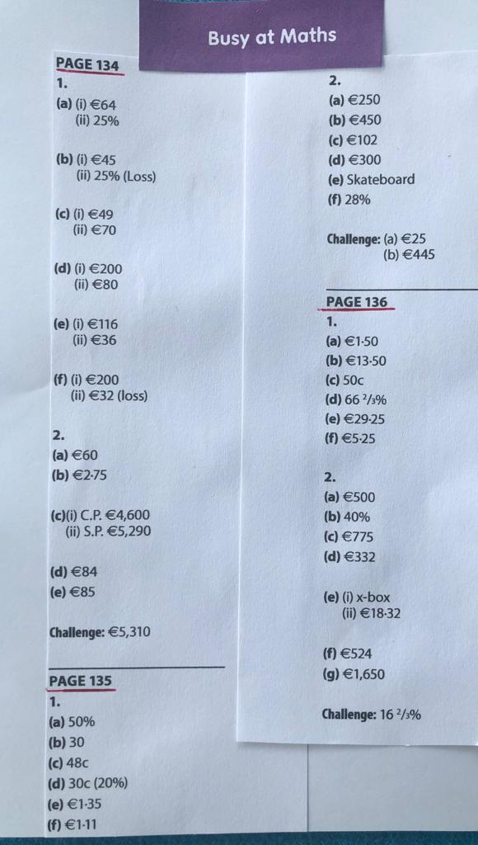

Optional

**2.** Work it Out: Week 27, Thursday

**Gaeilge**

**~** Aimsigh an focal ceart sa bhosca agus críochnaigh na habairtí (Choose the correct word from the box and finish the sentences):

|  |
| --- |
| Bhuaigh Chuardaigh  D’fhéach Rinne  Dhúisigh Chodail  Scrúdaigh Thiomáin  Cheannaigh Chuidigh |

1. ___________ Daidí úlla san ollmhargadh.

2. ___________ an dochtúir lámh Pheadair nuair a thit sé.

3. ___________ foireann na scoile an cluiche peile.

4. ___________ Daidí i ngach áit don sparán caillte.

5. ___________ Ifram leis an tseanbhean dul trasna an bhóthair.

6. ___________ Cian ar a naoi a chlog ar maidin.

7. ___________ Daideo bronntanas do Chlíona ar a breithlá.

8. ___________ an seanfhear an carr go dtí an siopa.

9. ___________ Eimear go déanach maidin De Sathairn.

10. __________ Siobhán ar an teilifís sa seomra suí inné.

**Béarla**

**1.** Spellbound : Week 27, learn block 96

**2.** Spellbound : p.56 & 57 : Complete Exercises 1 - 5

**FRIDAY**

**Scrúdú Litriú** : Spellbound: Week 27

**Matamaitic**

**1.** Busy at Maths p.135: no.2

**2.** Busy at Maths .136: no.1

Optional

**3.** Work it Out : Friday test, Week 27

**SPHE**

~ Attached below is a Graduation Booklet that I put together, with the help of online material. You might like to print it out or make something similar. It will give you a chance to reflect on your years in primary school and to look forward to your life beyond St. Patrick’s. Of course you could add other pieces to it or take away some that you would prefer not to use☺.