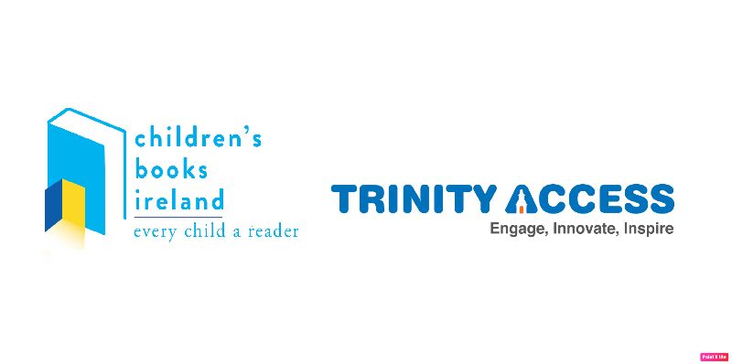

Trinity Access Primary School Archive Project

Dear Parents & Guardians,

What’s happening right now in here in Ireland and around the world during this pandemic is something that none of us ever imagined we’d live through. We at the Access Programme in Trinity College, working with our Library and Children’s Books Ireland, have decided to create an archive dedicated to collecting and preserving the thoughts and feelings of children in Ireland at this time, to give them a chance to have their voices heard.

We’re so thrilled that your child has been nominated to contribute to the archive by their teacher!

What we want is for your child to tell us how they’re feeling during right now; what they think about life during the time of Coronavirus, what they hope the world might be like when we manage to get back to normal, what they miss, what home and family mean to them now. We want to hear their voices so really, there are no rules; it’s all about what they want to say.

They can write a piece for the archive or they can create an artwork. All of the details are contained in their Letter of Congratulations!

So, here’s what you can do to help your child submit to the archive by the Closing Date of Tuesday the 1st of September;

- Once your child has created the piece of writing or artwork they want to submit to the archive, we would ask that you take a picture of it (with a ruler beside it for scale, if possible!)
- Help your child sign the consent form contained in this pack and sign it yourself as well, and take a photo of this too.
- Send the photo of your child’s work and the photo of the signed consent form, along with your child’s name, age and the name of the work to this email address; archive@ta21.ie
- Keep the original work safe! We’re hoping to be able to collect them once primary schools re-open!

What children are thinking right now in Ireland is so important, and we want to recognise that with this project; not just now but into the future as well.

That’s why we’ve teamed up with Children’s Books Ireland to provide class prizes for the most engaging entries, and individual prizes for the most interesting 6th class entries!

There are two categories, Best Written Piece and Best Artwork and any student from 4th and 5th class can win a workshop with an author or an artist for their class! A lucky student from 6th class will win an individual book prize – that means 15 books handpicked by the experts at Children’s Books Ireland!

We’re so looking forward to receiving your child’s submission! This is a chance for them to contribute to what we hope will be a hugely important archive in the coming months and years, as the world reaches a place where we can reflect on what this time has meant.

Yours,

The Trinity Access Team

