Tour 1
This first mini tour takes us out of Ireland…There’s a first for a second class tour.
Join Mrs Quill and me in this Google Earth 1 Click here
Stonehenge was awesome, wasn’t it? Here are some art ideas. Paint your background – or use twistables. Cut out black rock shapes and build your own Stonehenge.
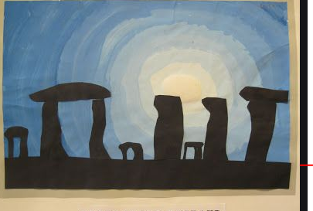
Or use clay or playdough. Remember you can make your own playdough. (See What a Wonderful World). Or find rocks and build.
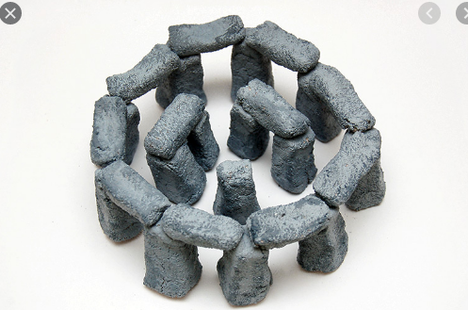
Now let’s go to other amazing places
Video earth.google2
https://earth.google.com/web/@0,78.04199275,0a,22251752.77375655d,35y,0h,0t,0r/data=CiQSIhIgMTA1NDZmMzhmZGM3MTFlNmEyN2MxYjMxZWFiNDNjN2Q

Colour the Taj Mahal or the Pyramid.

