**Week 11 (Monday 8th June – Friday 12th June)**

**Letter to the girls**

Dear girls,

I hope you enjoyed the gorgeous sunshine last week and that you have lots of freckles! Maybe you noticed a few visitors in your garden – butterflies, ladybirds, snails and worms. I’ll be giving those names in Irish this week. We’ll be going underwater for a song and art. Of course, we’ll continue to read The Magic Ring and we’ll be talking about Area in Maths. Do your best as usual. You can send on a photo to me of the part of your homework you’re most proud of using this email address [2ndclass@stpatricksgirls.net](mailto:2ndclass@stpatricksgirls.net). I’d love to see your work!

Lots of love,

Mrs. Quill.

**Letter to Parents**

Dear Parents/Guardians,

Hope everybody is well and that the sunshine has kept up the spirits! This is Week 11 of our school closure. If the girls want to send me some work you can use this email address [2ndclass@stpatricksgirls.net](mailto:2ndclass@stpatricksgirls.net).

Thank you for your support.

Kind regards,

Mrs. Quill.

**Monday 8th June**

**Religion**

Go to the website  <https://www.growinlove.ie/en/>

Login in with the email [trial@growinlove.ie](mailto:trial@growinlove.ie)  and the password growinlove.

When in the website click on the image of the textbook – Second Class /P4.

Go to Theme 8, Lesson 1.

Click on this icon and watch the video.



Go to Grow in Love p. 46.

Watch this video of Mrs. Quill explaining what is happening in the pictures and then you need to write a sentence underneath each picture.

[Grow in Love pg. 46 Mrs. Quill.](https://www.loom.com/share/087635afde484199b469089912039f10)

**Gaeilge**

[Sa Ghairdín Mrs. Quill](https://www.loom.com/share/4885d9038b2a42159aaca9173f82bc70)

Watch this video and do the same as me in your copy.

**Maths**

* Work It Out p. 73 (Week 15 and Week 16 Friday Tests)
* Cracking Maths p. 133. Watch this video and then complete the page.

[Cracking Maths p. 133 Mrs. Quill](https://www.loom.com/share/d1a6d07d9dc74363a79c765d52ff1374)

This is the solution to the Puzzler at the bottom of the page:

[Solution to the Puzzler P. 133 Cracking Maths](https://www.loom.com/share/f718331f83744d3597c342af00cb64e3)

* Here are the corrections for Work It Out p. 70, 71 and 72.

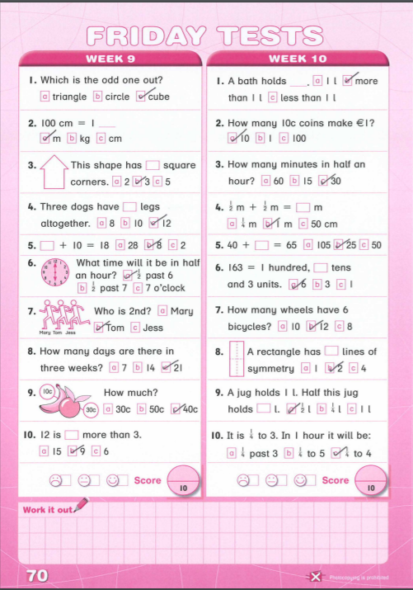

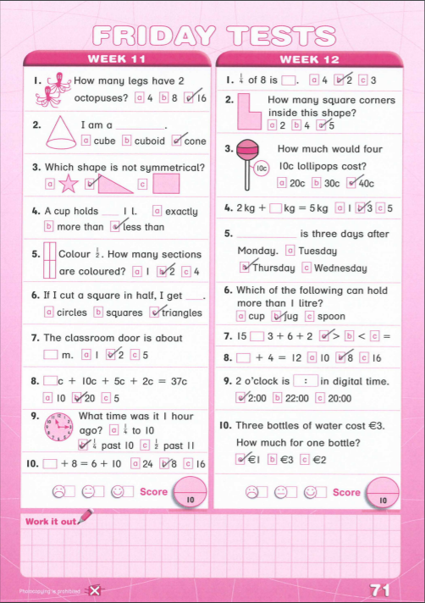

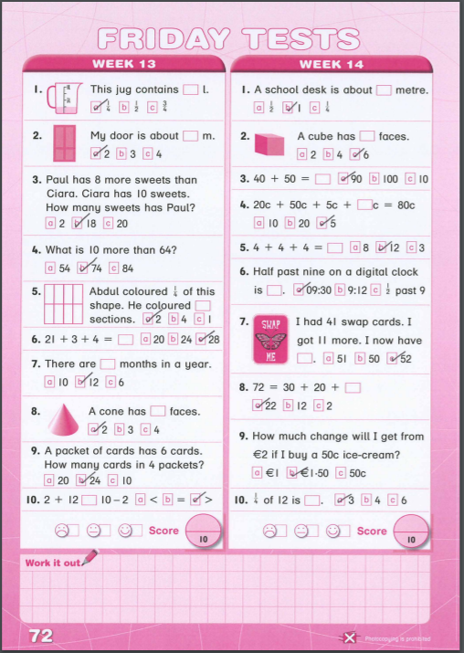

**English**

* Spellbound p. 64. Box 1. Write 2 sentences as usual.
* Reading

**Chapter 3** -Read pg.7.

Let’s get to know Alex.

You will discover his problem.

In stories, problems make the drama.

Read page 8.

Look at all the problems he has. He has quite a temper!

Can you connect with a time when you felt that annoyed about something?

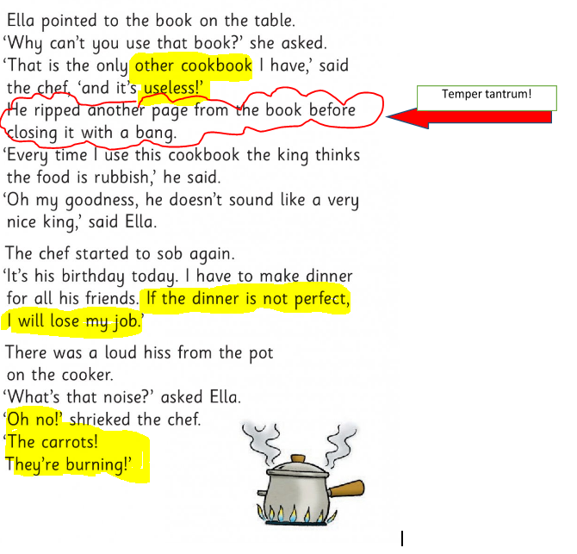

Read Page 9. I couldn’t work with Alex. He is crazy in the kitchen!



What did he burn?

What is your favourite main course?

Read Pages 10,11 and 12. Watch this video of Ms. Coughlan comparing Alex’s panic and Ella’s calm.

[Ella vs Alex Chapter 3](https://youtu.be/vqD0zl-D7pI)

We hear about Sid. What do you think about him?

Design a dessert! Ice-cream is a favourite with me.

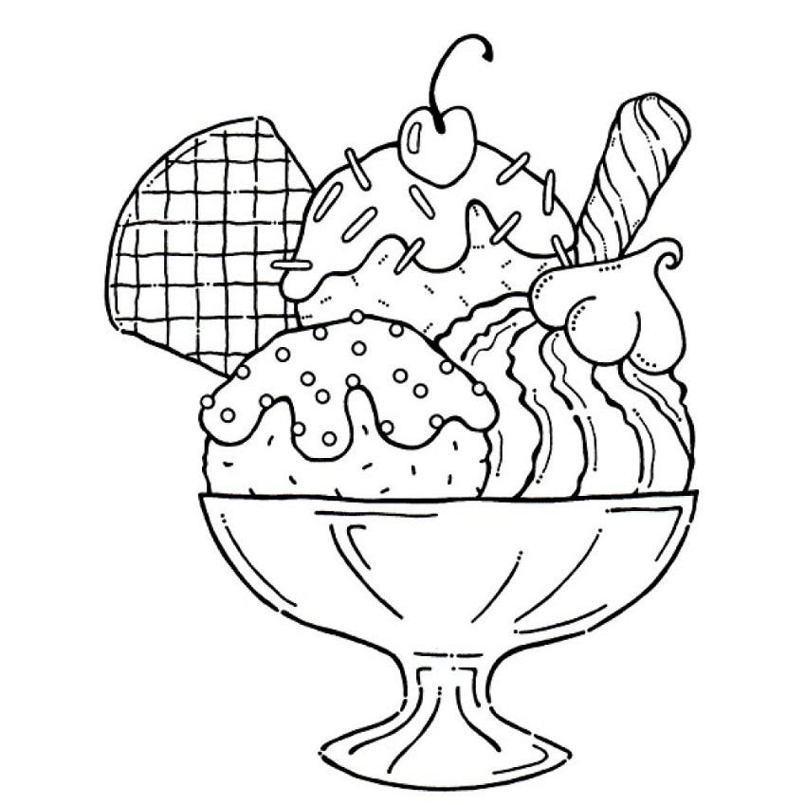

Who is your favourite character so far?

**Tuesday 9th June**

**English**

* Spellbound p. 64. Box 2 Write 2 sentences as usual.
* Reading

**Chapter 4.** Whose birthday is it?

Read pages 13,14 and 15.

Detective time! 

Can you spot signs that show us Alex is afraid of the king? (pg 13)

Can you see how Alex sees trouble more than good positive things? (p.14)

Pg 15 gives us a clue that Ella hasn’t travelled in time but rather to another place. Can you find it?

Not to worry if you are stuck. Watch Ms. Coughlan’s video showing you the answers.

[Detective 13,14,15](https://youtu.be/6GBoyCiFAjI)

Read p.16 and 17.

See some tips below.

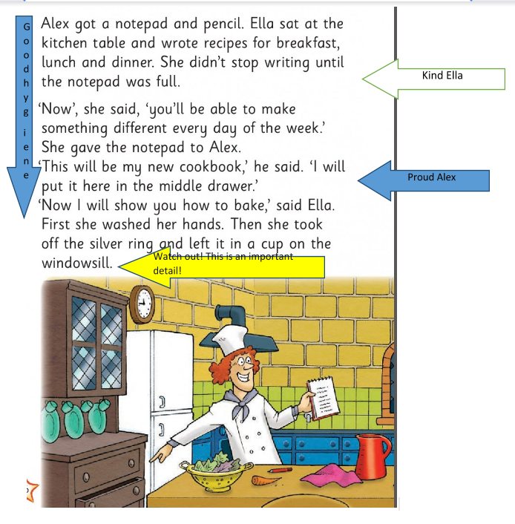

Notice how at the end of Page 17 we are left on a cliff hanger!

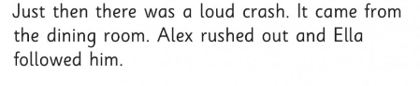

Note - a cliff hanger is where you are left with a big surprise in a story..at the end of a chapter and it leaves you crazy to find out more.

  Predict what will happen!

**Music**

Today we’re going to sing a song by ‘The Beatles’.

Ask your parents or grandparents what they know about them.

They were from Liverpool in England and were very famous.

Watch this video of their song ‘Octopus’ Garden’

[**Octopus' Garden video with lyrics**](https://www.youtube.com/watch?v=DA5ULA23XzA)

**Maths**

* Cracking Maths p. 134. Watch this video to help you complete the page.

[Cracking Maths p. 134 Mrs. Quill](https://www.loom.com/share/63befdf7b763408185c37877702ad277)

* Play a game to find out how many square meters the area of the painting is. <https://www.mathsisfun.com/definitions/area.html>

**Gaeilge**

* Bua na Cainte p. 49. Watch this video and complete the page.

[Bua na Cainte p. 49 Mrs. Quill.](https://www.loom.com/share/e5213546eb3d4299828e2a70d67288ca)

**Wednesday 10th June**

**Religion**

Go to the website  <https://www.growinlove.ie/en/>

Login in with the email [trial@growinlove.ie](mailto:trial@growinlove.ie)  and the password growinlove.

When in the website click on the image of the textbook – Second Class /P4.

Go to Theme 8, Lesson 2.

Click on these icons and watch the two videos.

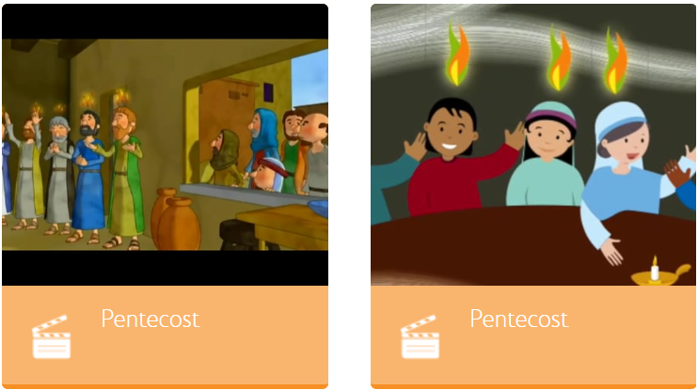

Go to Grow in Love p. 47.

Complete the page.

**Maths**

* Work It Out p. 74 (Week 17 and 18 of Friday Tests)
* Cracking Maths p. 120

Watch this video first and then complete the page.

[Cracking Maths p. 120 Word Problems Mrs. Quill.](https://www.loom.com/share/244d2080035d4b5c83e147b33bcefbf6)

**Gaeilge**

* Bua na Cainte p. 48. Watch the video and complete the page.

[Bua na Cainte p. 48 Mrs. Quill.](https://www.loom.com/share/bc2bcfbe5a8540c4863ddc7b5eb4b338)

**English**

* Spellbound p. 64. Box 3. Write 2 sentences as usual.
* Reading

Read **chapter 5.**

Why is Ella so pale? Music can really make a movie dramatic. Can you imagine music to go with this chapter?

Watch this video of Ms. Coughlan reading through Chapter 5 with dramatic music in the background!

[Chapter 5](https://youtu.be/KcAHQcMTYaw)

* Writing

Starlight p. 40.

Watch this video and then complete the page with me.

[Starlight p. 40 Contractions Mrs. Quill.](https://www.loom.com/share/854eee52bab548cf915bc38ff6b18401)

**Thursday 11th June**

**Maths**

* Cracking Maths p. 121.

Watch this video and then complete the page.

[Cracking Maths p. 121 Word Problems at the Bakery Mrs. Quill.](https://www.loom.com/share/d2da27014d7844cdb7562c246049d020)

**English**

* Spellbound p. 64 Block 4.
* Spellbound p. 65 Complete the page.
* Reading

Read **chapter 6.**

Why do you think it is called a “Sleepless Night?”

I never liked that Sid fellow! 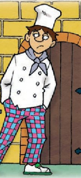

Make a list of the crimes we think he should be charged with.



**Gaeilge**

* Bua na Cainte p. 50

Watch this video and complete the page.

[Bua na Cainte p. 50 Mrs. Quill.](https://www.loom.com/share/6caffd65ac8e4f8b9b99479d028d8a4c)

**SESE**

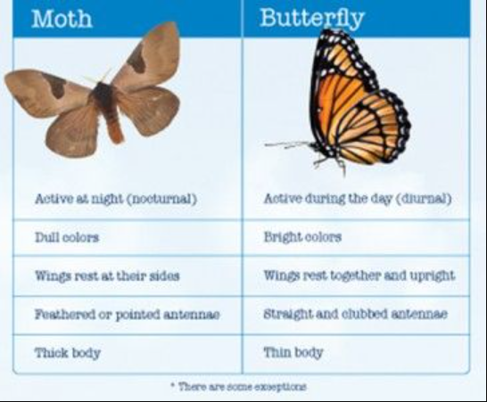

You would guess that moths and butterflies are from the same family of insects. Above you can read the differences between them. You’ve heard of the word ‘nocturnal’ (active at night) but did you know that ‘diurnal’ means active during the day?

We will be talking about a special moth next week in our WWW book.

**Friday 12th June**

**Maths**

* Work It Out p. 75 (Week 19 and 20 Friday Tests).

**Gaeilge**

* Bua na Cainte p. 51.

Watch the video and complete the page.

[Bua na Cainte p. 51 Mrs. Quill.](https://www.loom.com/share/11df26b10fcd41cea989d18f539cb787)

**English**

* Spelling Test (Yippee!)

Ask an adult to call out any ten spellings from p. 62 of Spellbound. Correct them and give yourself a pat on the back!

* Reading & Writing

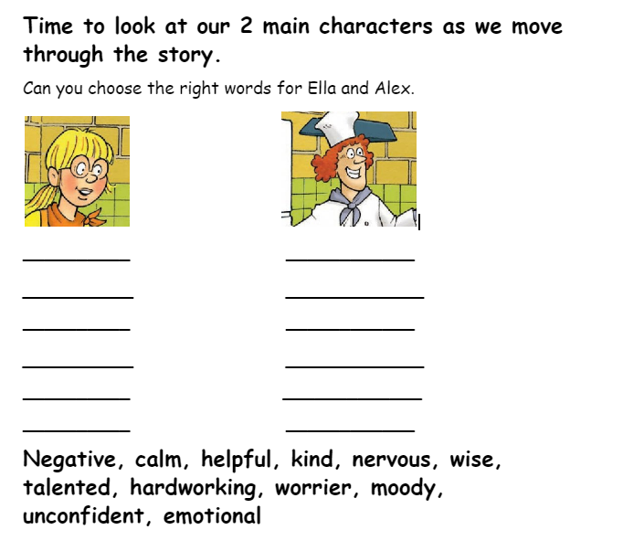Read Chapter 7.

Write the list of character traits underneath each character. You can do it in your copy.

What mystery did Ella solve at the end of Chapter 7?



**PE**

* Joe Wicks’ PE Class.

This is a workout that Joe did outside in his garden on a nice, sunny day.

[Morning Weekend Family Workout with Joe | Sat 9th May 2020](https://www.youtube.com/watch?v=TLyzayctPgU)

**Art**

Inspired by The Beatles song ‘Octopus’ Garden’ that we listened to earlier in the week, today we are going to make our own picture of an Octopus’ Garden.

Watch this video where I give you some ideas and then you can send a photo of your artwork to me using the email address mentioned above in the letters.

[Octopus' Garden Art Mrs. Quill.](https://www.loom.com/share/2a19c112c7a446d386fa35b155063400)