Week 11
Dear girls,
Hope you are all well and happy. It’s great to be settled into June. I have changed things this week with a Wellness Wednesday and a Fun Friday. Our novel will keep us entertained and we can have lots of art and don’t forget the boredom busters on the school website. I’d love to see what you create, so why not email me a picture of it to 2ndclass@stpatricksgirls.net.
Love Ms Coughlan

Dear parents,
Hope you and your family are keeping well and are in good spirits. I attach this week’s menu. Don’t forget I am only an email away at 2ndclass@stpatricksgirls.net and am only glad to help.
Regards
Margaret Coughlan
Corrections from Week 10
In any other work you did… rate yourself. Pick an emogi from the following list:
  or .

If there is anything you want help with please feel free to email me.

Religion for Week 11
Grow In Love https://www.growinlove.ie/en/ Login in with an email of trial@growinlove.ie and a password of growinlove. Theme 8. Open lesson 3. It’s all about us being missionaries – people who act out Jesus’ love and kindness. Look at the videos, songs etc. Work on pages 48 and 49 of your book.

Monday
English
Spellbound. Wk 31 OUR LAST WEEK OF SPELLBOUND! The remaining 5 units are revision. Going forward, I would suggest that you use some of- not all – the activities in the revision units for rainy day boredom busters.
Wk 31. First 4 spellings today – ending in –ick. Read the rest of the words and try exercise 1.
Magic Ring
Last week we enjoyed chpts 1 and 2.
Chapter 3 -Read pg.7.

Let’s get to know Alex.
You will discover his problem.
In stories, problems make the drama.
Read page 8.
Look at all the problems he has. He has quite a temper!
Can you connect with a time when you felt that annoyed about something?
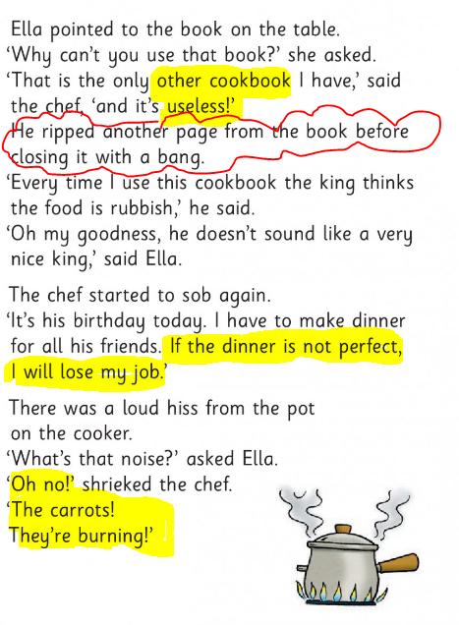
Temper tantrum!
Read pg 9. I couldn’t work with Alex.. He is crazy in the kitchen!

What did he burn?
What is your favourite main course?

Irish
Bua na Cainte p.138
Ag____ = is the phrase we use in Irish for doing something. Look at p.138. Listen to my audio and practise the phrases. Write them in.
BNC LCH 138

Maths
Cracking Maths p.133.
I want to talk to you about area. Area is the amount of space something takes up. Let’s look at p.133 and my video will help you.
Cracking Maths Page 133
Work It Out
Friday test Week 20 – if you haven’t done it already.

Our Wonderful World
Last week we looked at the butterfly. Let’s compare the butterfly and the moth.
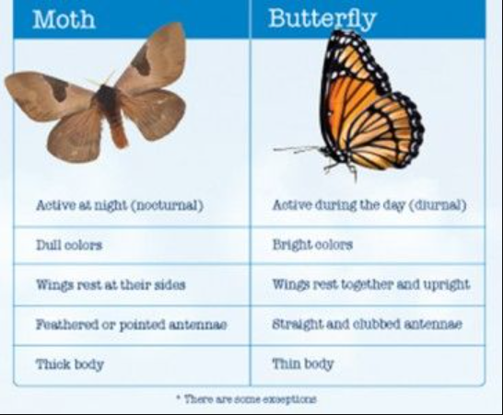
They belong to the same family of insects. Above you can read the differences between them. You’ve heard of the word ‘nocturnal’ (active at night) but did you know that ‘diurnal’ means active during the day? Are you nocturnal or diurnal?

Tuesday
English
Spellbound Wk 31. Look at the next 2 boxes – rock, sock, shock, knock, flock, clock, frock, stocking. Pick any 4 or 5 spellings today – ending in –ock from that list. Don’t do them all.
Did you notice knock begins with a silent k and has 3 meanings?
- To fall over something
- To tap at a door
- A town in Co. Mayo
Do you know that a frock is an old word for a dress. Could you design a pattern on this frock for me?
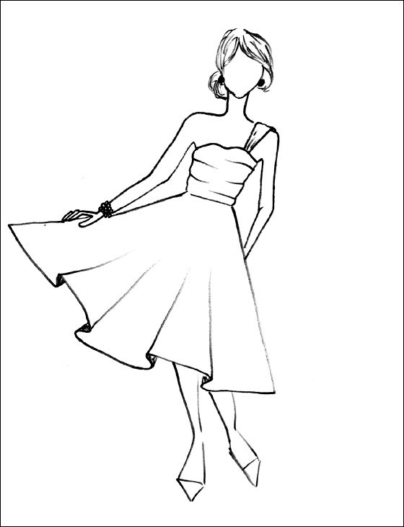

Try exercise 2 on p.65 – wordworm.
A break from the novel today. There is a nice bit of reading in What a Wonderful World below.
Irish
Bua na Cainte.
Is maith liom = I like
Is maith leis = He likes
Is maith leí= She likes
Watch the attached video where Mrs Quill will explain the work to you.
Bua na Cainte Page 89

Work It Out Friday test 21
Cracking Maths -Area
- p 134. Watch this video and Mrs Quill will help you complete the page.
Cracking Maths p. 134 Mrs. Quill
- Play a game to find out how many square meters the area of the painting is. https://www.mathsisfun.com/definitions/area.html

Other- What a Wonderful World.
P.70. The Silkworm.
The silkworm are grows into a moth. Moths are the less colourful relation of butterflies.
Silkworm -What a wonderful world pg 70
Now try the activity on the next page. Skip the top section.
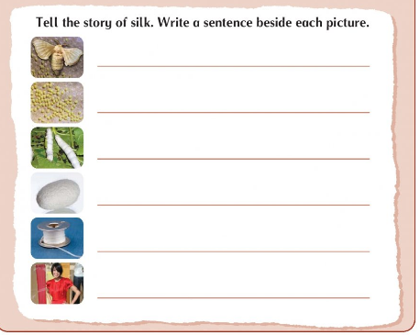
How the thread is taken from the cocoon…
A sentence about the silkworm…
A sentence about moths laying eggs…
A sentence about the moth..
Silk fashion..
Mention the cocoon…
Who discovered silk?
The legend at the top of page 71 tells you the answer or you could watch…
https://youtu.be/ZGwKbk-TqIg

Wellness Wednesday
English
No new spellings today. Revise. Using different coloured pens try and rainbow write the answers to exercise 3 on p.65.
A spelling later this week is “horse”.
Time for some mindful colouring of a horse and you can label it in rainbow writing if you like.
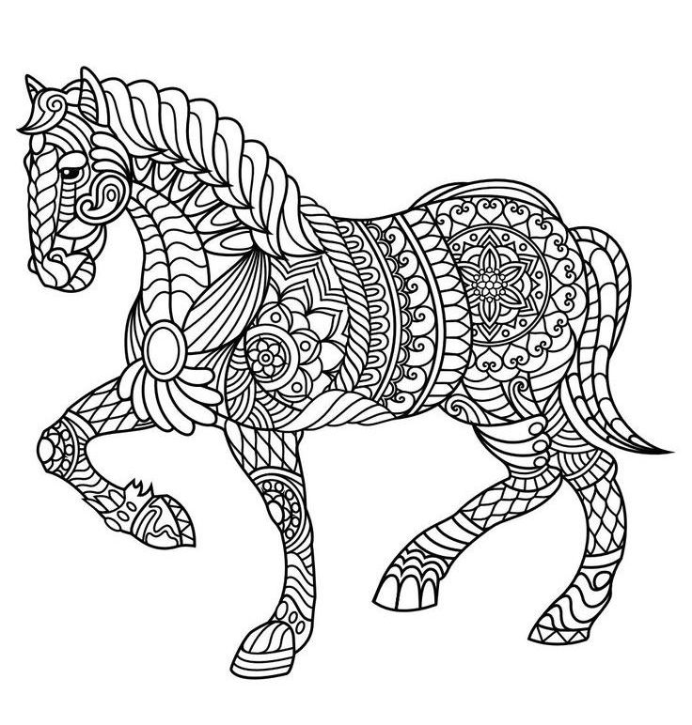
Magic Ring
Read pgs 10,11 and 12 of chapter 3. Watch my video where I compare Alex’s panic and Ella’s calm. Being calm helps us deal with problems better. It’s not easy but Ella shows us how. We hear about Sid. What do you think about him?

Design a dessert! Ice-cream is a favourite with me.
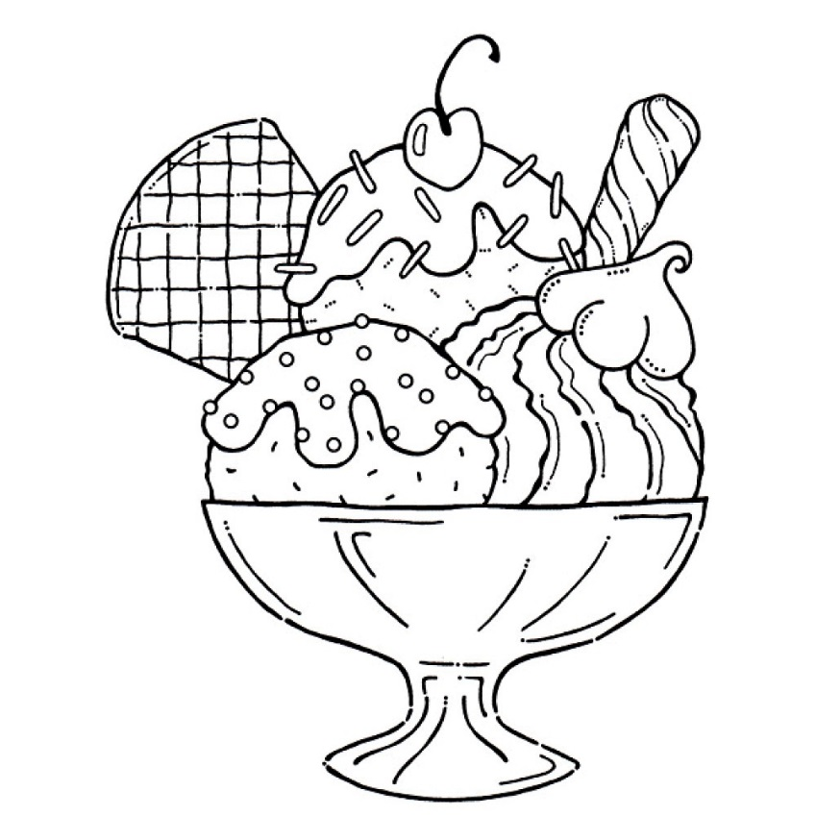
Who is your favourite character so far?

Irish agus Ealaín
Draw a beach scene and listen to the relaxing music.
https://youtu.be/FFoKaSaN05E
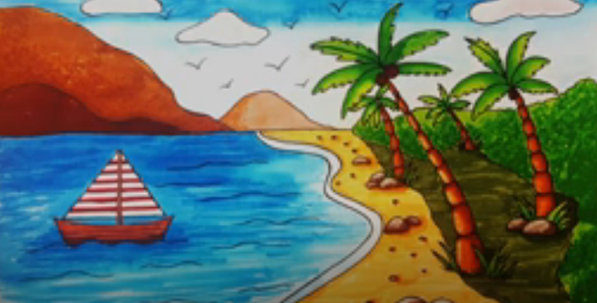
Listen to my audio about the scene, An Samhradh
An Samhradh atá ann. It is summer.
Tá an bád san fharraige. The boat is in the water.
Is bréa liom an gaineamh. I like the sea.
Is breá liom an fharraige.I like the water.

Maths.

Mathematicians work out area by counting the number of squares a shape covers.
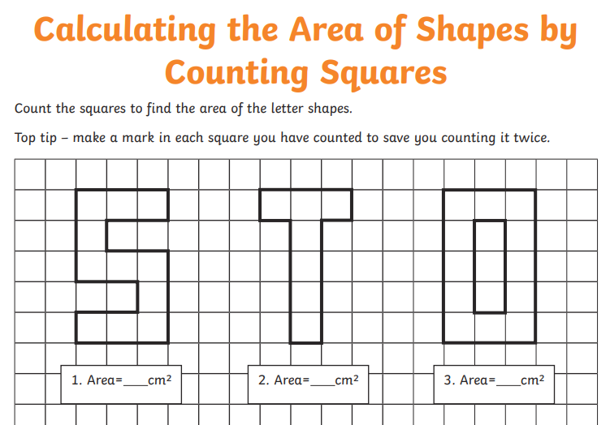

Now get a simple shape – a can, a butter box – and put it down on boxed paper. Trace around the shape. Lift and count the number of squares it takes up. That is its area.


Or you could sellotape lots of sheets of newspaper together and put them on the floor. Lie down on them. Get someone to trace around your body outine with a marker. It might tickle! Stand up and look at the shape left behind. That is the area of our body outline!

Other – some PE fun with Coach Clare. We met this lady virtually on active school’s week. Here is a lesson on jumping and feeling thankful.
https://youtu.be/AGpLIPCa4oo
Being thankful or showing gratitude is good for you.

Here is a nice gratitude activity.

It’s nice to say “thank you” to someone who has unknowingly made our day. Give thanks to God for our beautiful world. Thank people for the littlest acts of kindness. You will feel good too.

Gratitude Rock
Just find a rock!
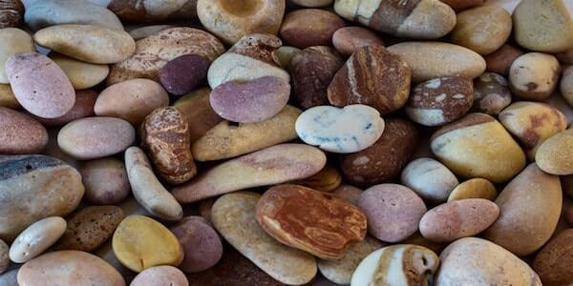
Make sure to pick one you like. It may be smooth or have an interesting texture, or it may be from a special place. If you have another small object you’d rather use instead that’s fine.
Carry this rock around in your pocket. Whenever you see it or touch it, pause to think about at least one thing you are grateful for. It can be something as small as the sun shining down on you. You will feel happier with all these thankful feelings.

Thursday
English
Spellbound. Learn the last 4 spellings on pg. 64.
Try writing the sentences in order in exercise 4 p. 65

Magic Ring
Chapter 4. Whose birthday is it?
Read pgs 13,14 and 15.
Detective time! 
Can you spot signs that show us Alex is afraid of the king?(pg 13)
Can you see how Alex sees trouble more than good positive things? (p.14)
Pg 15 gives us a clue that Ella hasn’t travelled in time but rather to another place. Can you find it?
Not to worry if you are stuck. Watch my video where I highlight the answers.
Detective 13,14,15
Irish
An Samhradh. Bua na Cainte. P. 140. Listen to my audio to go with the page.
Bua na Cainte Lch 140

Maths
Work It Out Friday test 22
Cracking Maths p. 120
Mrs Quill is going to do some story sums with you.
Read each question slowly. Note that “altogether” means “add”.
Cracking Maths Page 120
Other
Time for Toast!!!!
What a Wonderful World p.52. The sun gives us heat. Heat can change things.
This a nice experiment – that will feed you too. Follow the steps.
Remember our science words….
If you can’t change something back to the way it was then it is …
irreversible

If we can undo the change, it is ..
reversible

So making toast is an ……………….. action.

Fun Friday
English
Spelling test! That doesn’t sound like fun. So try this instead. Read the list. Pick any 7. Memorise them. Write them in bubble writing and colour.

Magic Ring - Find a magical place to read! –Under the table, in the garden shed, on a swing?
Read p.16 and 17.
See my tips below.
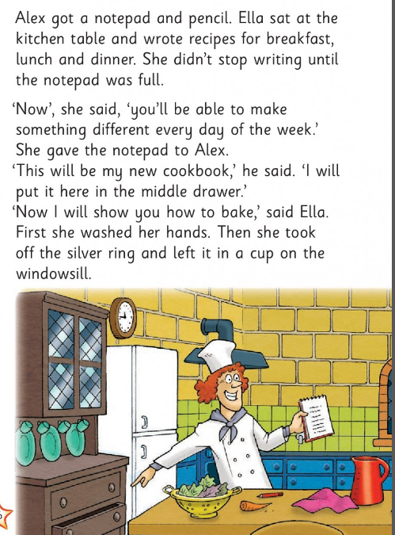
Good hyg
iene
Watch out! This is an important detail!
Proud Alex
Kind Ella

p.17
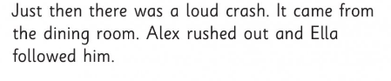

Cliff hanger!
Note - a cliff hanger is where you are left with a big surprise in a story..at the end of a chapter and it leaves you crazy to find out more.
 Predict what will happen! You to wait until Monday to find out what will happen!!!!!!

Irish
Watch me play a game as Gaeilge. You can find lots motr on Séidéan Sí.ie.
Séidean Sí Sciob

Maths
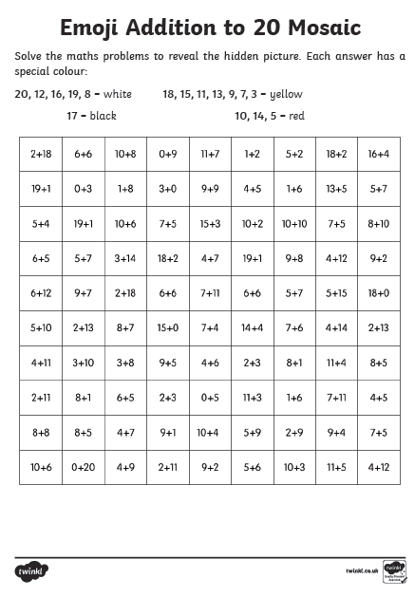
Other - Music
Today we’re going to sing a song by ‘The Beatles’.
Ask your parents or grandparents what they know about them.
They were from Liverpool in England and were very famous.
Watch this video of their song ‘Octopus’ Garden’
Octopus' Garden video with lyrics
Art
Inspired by The Beatles song ‘Octopus’ Garden’ today we are going to make our own picture of an Octopus’ Garden.
Watch this video where Mrs Quill gives you some great ideas and then you can send a photo of your artwork to us using the email address 2ndclass@stpatricksgirls.net
Octopus' Garden Art Mrs. Quill.

Other ideas can be found online in the Boredom Busters section.

