**Work for Week 11**

**Monday 8th June 2020 – Friday 12th June 2020**

**Daily Timetable of Work**

**9:00 – 9:30: Exercise**

**9:30 – 9:55: Gaeilge**

# 9:55 – 10:20: Maths

**10:20 – 10:45: English**

**10:45 – 11:00: Break**

**11:00 – 12:00: Watch RTE Home School HUB**

**12:00 - 12:45: Project Work**

**12:45 – 1:15 Lunch**

**1:15 – Free Time**

# Monday 8th June

**9:30 – 9:55: *Gaeilge***

Seo iad na ceartúcháin ón seachatin seo caite. (Here are last week’s corrections.)

Ceartúcháin Dé Déardaoin (Thursday’s answers)

**Week 11 Ceartúcháin - Léigh sa Bhaile lgh 118 ‘Cairde Nua.’**

1. Bhí an chlann ar saoire sa Fhrainc.
2. Bhuail Rossa agus Clár le cairde nua, Isabelle agus Franco.
3. Isabelle agus Franco ab ainm dóibh.
4. B’as an Iodáil iad.
5. Gach lá bhuail siad le chéile i ndiaidh an bhricféasta. Ansin, d’imir siad cluichí le chéile agus chuaigh siad ag snámh le chéile.

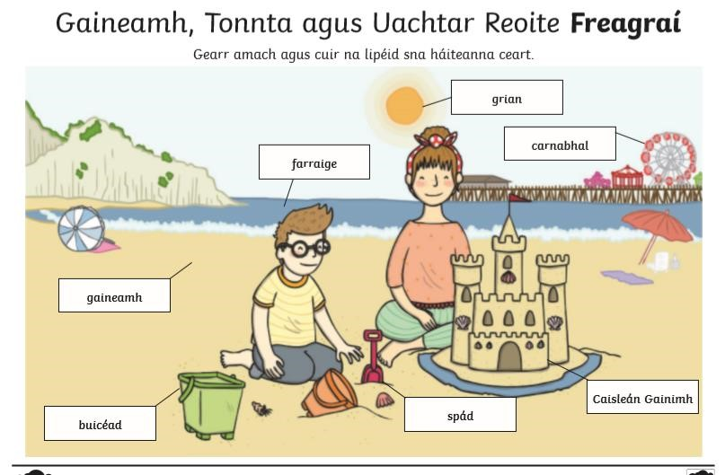

Ceartúcháin Dé hAoine (Friday’s answers) Seo Leat Lgh 117 – Aimsigh na Difriochtaí

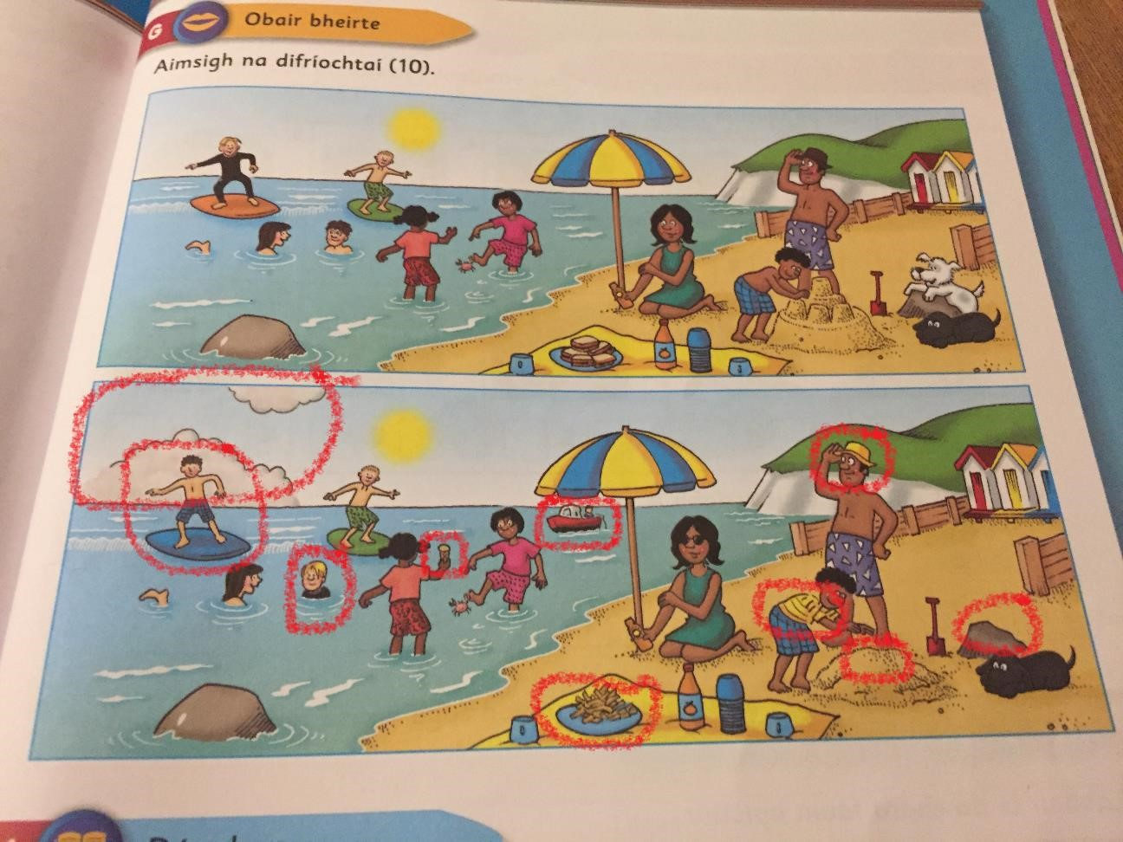

**Litriú:** Seo Leat ‘An Scipatón’ lgh 106 *ag ullmhú=**preparing*

*Gach tráthnóna = each afternoon*

*Táim ag tnúth leis = I am looking forward to*

**Léamh:**  Seo Leat ‘An Scipatón’ lgh 106

Éist leis an recording ‘Week 11 Monday’

[**Week 11 Monday**](https://youtu.be/xTigy8UfQZ0)

**Scríobh:** 4/5 abairtí ag úsáid na litriú.

**EXTRA WORK!!** Seo Leat lgh 109: ‘Ní féidir liom é a dhéanamh. Cinnte is féidir leat!’ (I can’t do it. Of course you can!)

If you want, design a poster using the phrase above. See pg 109 for examples. You can work on this throughout the week.

## 9:55 – 10:20: Maths

**Corrections:** Take some time today to correct the maths work from last week.

Wednesday’s answers:

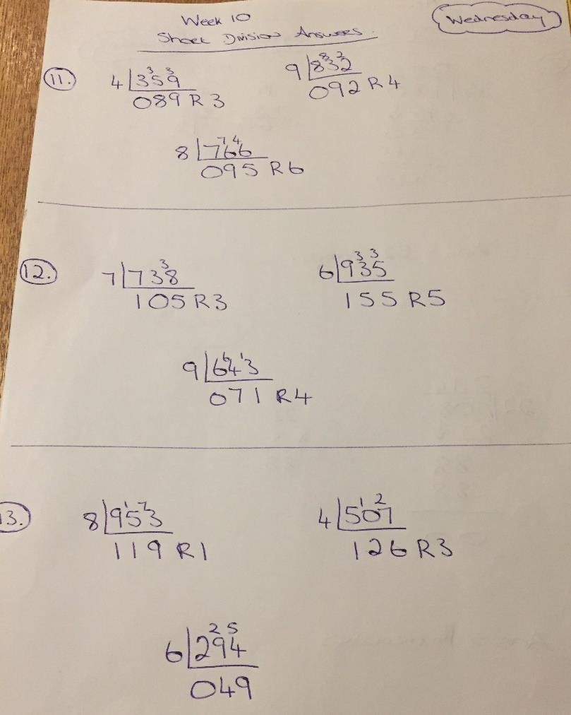

Wednesday’s Challenge:

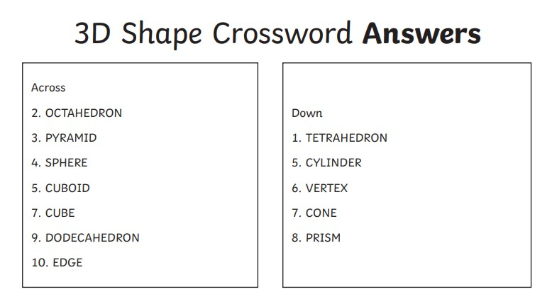

Thursday’s answers:

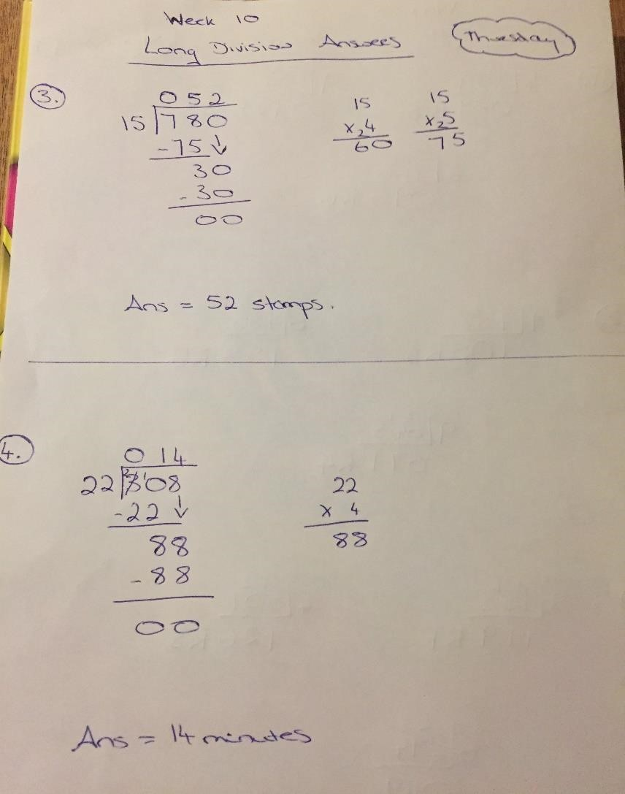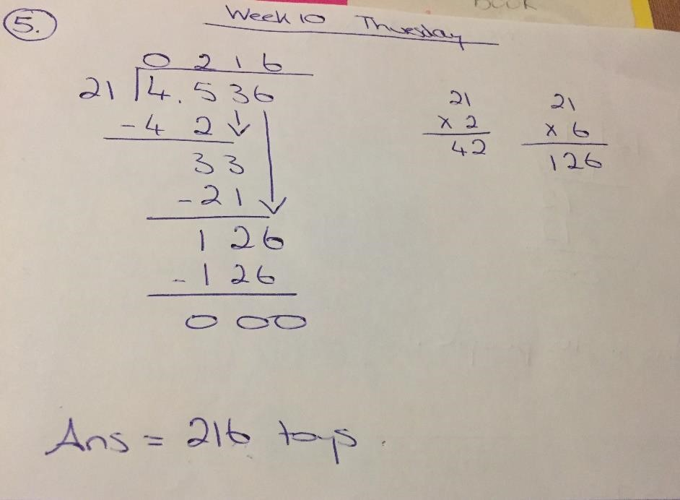

Thursday’s Challenge:

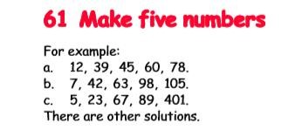

Friday’s answers:

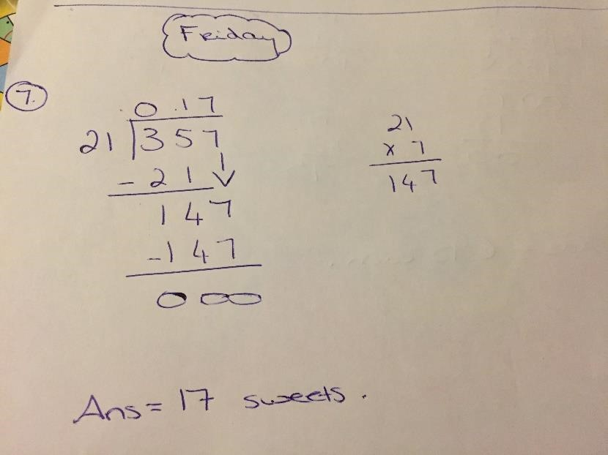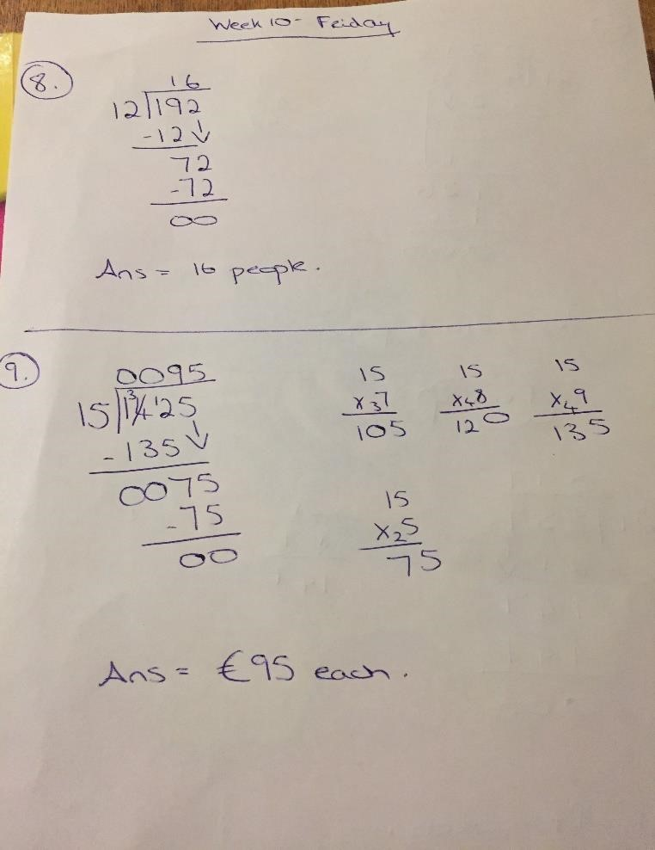

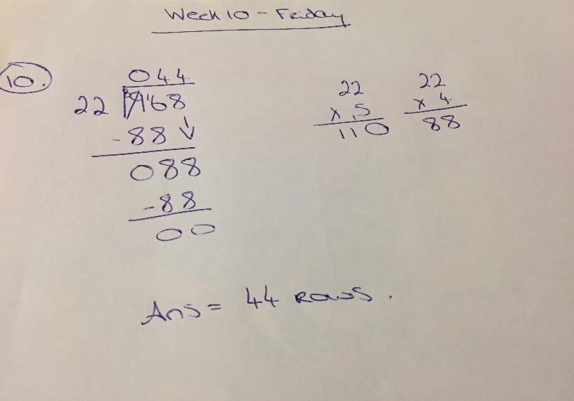

Friday’s Challenge:



## 9:55 – 10:20: Maths

### BOM Chpt 34: Animalmathics – Dublin Zoo pg 184 - 185 Pg 184 - Do Qs 1 & 2

**10:20 – 10:45 English:**

**Here are last week’s answers U&R ‘Stations and Train Journeys.’ Pgs 240 – 245**

|  |
| --- |
| Up and Running- Stations and Train Journeys page 244 B     1. Paddington Bear is called after Paddington Station, where he was found. 2. In remote parts of Canada and the USA passengers had to “flag down” trains to get them to stop on the platform. 3. Make your own list. 4. Chennai Central is in India. (India is the last country on the list, so the two stations refer to the last country mentioned) 5. Approximately 750,000 people pass through Grand Central terminal every day. 6. Shinjuku Station in Tokyo is the world’s busiest station. 6. Nagoya Station in Japan has twin towers: one is 55 storeys high and the other is 59 storeys high. 7. Atocha Station in Madrid has an immense tropical garden growing under its domed roof. |

1. The longest train journey in the world is the Trans-Siberian Railway which runs from Moscow to Vladivostok. It is 9,259km long.
2. Passengers must dress formally on the Orient Express.

Pg 244 C - True or False.

1. False. 2. True. 3. False. 4. False. 5. True

Pg 244 - D. Complete the sentences

1. The Trans-Siberian Railway runs from Moscow to Vladivostok
2. The exclusive Royal Scotsman carries only 36 passengers on its journey.
3. The Orient Express has featured in many films and murder-mystery novels.
4. One Orient Express journey is from London’s Victoria station to Venice, Italy.
5. “People pushers” are employed in Japan to shove commuters onto packed trains.

Pg 245 - E Complete the passage.

The first railway stations were simply platforms with very little else. In some remote areas of America and Canada, people had to flag down trains to get them to stop. One of the first real stations was Liverpool Road Station. It looked like a row of houses. Grand Central Terminal in New York is the world’s largest station, in terms of platforms. About 750,000 people pass through it daily. However, Shinjuku Station in Tokyo is busier, catering for about 3.5 million passengers every day. Indeed, during rush hour, people pushers are employed to shove passengers onto trains so that the doors can be closed. Japan also boast the world’s tallest station. Called Nagoya Station, it has twin towers over fifty storeys high.

**PROJECT!!!**

Over the last few weeks girls we have been learning a lot about different forms of transport. We have learned all about Famous Shipwrecks, Strange Flying Machines and Stations and Train Journeys. We have looked at Sea, Air and Rail Travel. What other types of travel are there? *\*\*HINT** (LAND – cars, buses, taxis, trams, The Luas, tractors, etc.)* We have learned about some of the earliest forms of travel and transport. We have explored some famous inventors, like the Wright brothers, some very brave people, like Amelia Earhart and Lady Mary Heath and we have seen how travel and transport has changed and evolved over time.

Do you think the different ways of transport have improved over time? How?

Do you think travel is more or less important these days?

Are the different ways of transport more or less efficient these days compared to long ago?

Why do we need different forms of transport? *(So that people and goods, food, animals can move from place to place.)*

This week I would like you to explore the theme **‘Transport – Old vs New.’** Invent a future form of transport. It can include some ideas from an old or new form of transport that you have explored, get creative and think how you would like to travel in the future. What is important – how fast you get to a place, comfort, how many people can travel at once, how will it move???

Draw a design and create a fact file/project/information brochure outlining how it works. Once you have invented a new future form of transport, you are to design an advertisement promoting it. (look back on last week’s work **Features of a good ADVERTISEMENT** So your project should have 3 parts:

1. – Design a future form of transport
2. – Draw it. Write a fact file/project/information brochure all about it
3. – Design an advertisement promoting it.

**RESEARCH IDEAS!!!**

Have a look at some of these videos exploring how Transport began and how it changed and evolved over time.

<https://youtu.be/FaLCQo8NJFA>

<https://youtu.be/wiV8YUcwBZk>

<https://youtu.be/25IaUQ_oUyM>

<https://youtu.be/d0ySC2tzlZI>

Take a look at some of these websites on the Scoilnet.ie Learning Path <https://www.scoilnet.ie/learning-path/ref/16347/>

**HINT** When you click into the link 1 – The Wright Brothers, scroll to the end of the page and click ‘INTERACTIVE EXPERIMENTS.’ Here you can play games and see some artefacts belonging to the Wright Brothers.

Read ‘Tilly and the Time Machine.’ Page 74. This is in the Book ‘Above the Clouds,’ which you can find at this link. <https://my.cjfallon.ie/preview/student/34017/82>[**www.**cjfallon.ie](http://www.cjfallon.ie/) 5th class English section, Rainbow Stage 4, Above the Clouds pg 74

Read the poem ‘Oh How I’d Like to Travel.’ Page 82. This is in the Book ‘Above the Clouds,’ which you can find at this link. <https://my.cjfallon.ie/preview/student/34017/90>[**www.**cjfallon.ie](http://www.cjfallon.ie/) 5th class English section, Rainbow Stage 4, Above the Clouds pg 82)

Look Back at some of the stories in U&R, use your fact file from WEEK 9 and remember the Balloon Powered Car Experiments from WEEK 9.

Remember be as creative as you can be. I look forward to seeing pictures of your future forms of transport and if anyone would like to build a version of their new form of transport I would love to see pictures or videos of it!

# Tuesday 9th June

**9:30 – 9:55: *Gaeilge***

**Litriú:**  Seo Leat ‘An Scipatón’ lgh 106

*Bhí an ghrian ag taitneamh = the sun was shining*

*go hálainn* = lovely  *airgead = money*

**Léamh:** Seo Leat ‘An Scipatón’ lgh 106

Éist leis an recording ‘Week 11 Tuesday’

[**Week 11 Tuesday**](https://youtu.be/k2aN5mYHXss)

**Scríobh:** S.L. lgh 108 A qs 1-5

**EXTRA WORK** – if you want Scríobh 4/5 abairtí ag úsáid na litriú

## 9:55 – 10:20: Maths

### BOM Chpt 34: Animalmathics – Dublin Zoo pg 184 - 185

Pg 184 - Do Qs 3 – remember even spacing between numbers on the vertical and horizontal lines

- Use a pencil and ruler to draw graph

Pg 185 – Do Qs 4 & 5

**10:20 – 10:45 English:**

Continue with Project.

# Wednesday 10th June

Wellness Wednesday!

## Exercise

* Joe Wick’s PE workout every weekday at 9am
* Go Noodle
* Cosmic Yoga
* Skipping, cycling, dancing, going for a walks.. Do some activities from the Active Schools’ Week list.

## Art

* ‘Draw with Don’ YouTube channel  ‘Art Attack’ series on YouTube
* Mindfulness colouring
* Free drawing
* Paint (with Bob Ross on Netflix / YouTube)
* Origami
* Sculpt with clay

## Gardening

 Pull weeds

* Water flowers
* Plant new flowers

## Skills / Talents

* Baking
* Knitting
* Learn to juggle
* Do a magic trick
* Write a play, a poem or a story
* Learn a dance
* Sing a song

## Meditation

* Headspace for kids (app)
* Cosmic Yoga
* Read for pleasure
* ‘Spark joy!’ and organise possessions (eg. toys, clothes..)

## Games

* Board games (eg. Scrabble, Articulate, Headbands…)
* Cards (eg. Snap, Go Fish, Solitaire…)
* Pen and paper games (eg. X’s and O’s, Stop the bus…)
* Music games (eg. Karaoke, Musical statues..)
* Outdoor games (eg. Obstacle course, football..)

## Music

* Learn to play an instrument or learn a new song
* Listen to different genres or decades of music
* Compose a song or piece of music
* Strictly Come Dancing: Pick a song and prepare a dance routine
* Do a music quiz

## Television

* RTE’s School Hub
* Favourite movie/ T.V programme
* Nature programmes eg. David Attenborough’s Blue Planet

# Thursday 11th June

**9:30 – 9:55: *Gaeilge***

**Litriú:**  Seo Leat ‘An Scipatón’ lgh 107

*ionadh an domhain = very surprised ag luascadh = swinging tuirseach traochta = exhausted*

**Léamh:** Seo Leat lgh 107

Éist leis an recording ‘Week 11 Thursday

[**Week 11 Thursday**](https://youtu.be/yNMFGZVSdQA)

**Scríobh:** S.L. lgh 109 D

**9:55 – 10:20: Maths**

## BOM Chpt 34: Animalmathics – Dublin Zoo pg 184 – 185

Pg 185 – Do Qs 6 & 7

**10:20 – 10:45 English:**

**Continue with Project.**

# Friday 12th June

**9:30 – 9:55: *Gaeilge***

**Litriú:**  Ask a parent/brother/sister to give you a spelling test based on this week’s spellings.

**Léamh:** Seo Leat lgh 107

Éist leis an recording ‘Week 11 Friday

[Week 11 Friday](https://youtu.be/SeVxpnCxyEo)

**Scríobh:** S.L. lgh 108 A 6 – 8

**9:55 – 10:20: Maths**

## BOM Chpt 34: Animalmathics – Dublin Zoo pg 184 – 185

Pg 185 – Do Qs 6 & 7

**10:20 – 10:45 English:**

**Continue with Project.**

**Project Work – Use this time to finish uncompleted work. If you have all this done and want more, choose something from the ‘BOREDOM BUSTERS’ section on the school website. Click on the button at the top of the school website or follow this link below.**

[https://stpatricksgirls.net/?page_id=6449](https://stpatricksgirls.net/?page_id=6449&preview_id=6449&preview_nonce=ef950080d8&preview=true)