June 15th – 19th
1st Class

Dear parents/guardians of 1st class students,
I hope you are enjoying a bit more freedom of movement! It is hard to believe we are nearly finished another year in school. This week is our last week of book work so it is a good opportunity to finish off bits your daughter may not have completed. The final weeks in school are always so enjoyable but I hope ye are enjoying the time at home too.
Similar to last week select a piece of ‘Project Work’ your daughter would like to work on for the week from the Boredom Busters folder. Thank you again for your continued support.
Best wishes,
Ms Gleeson.

Dear 1st class girls,
I hope you are enjoying getting outside a bit more. It is our last week doing work from our books as next week I have just fun activities planned! This week we get to learn the dance to Frozen. I hope you have lots of fun!
Be kind,
Ms. Gleeson.

Self-correcting for Cracking Maths

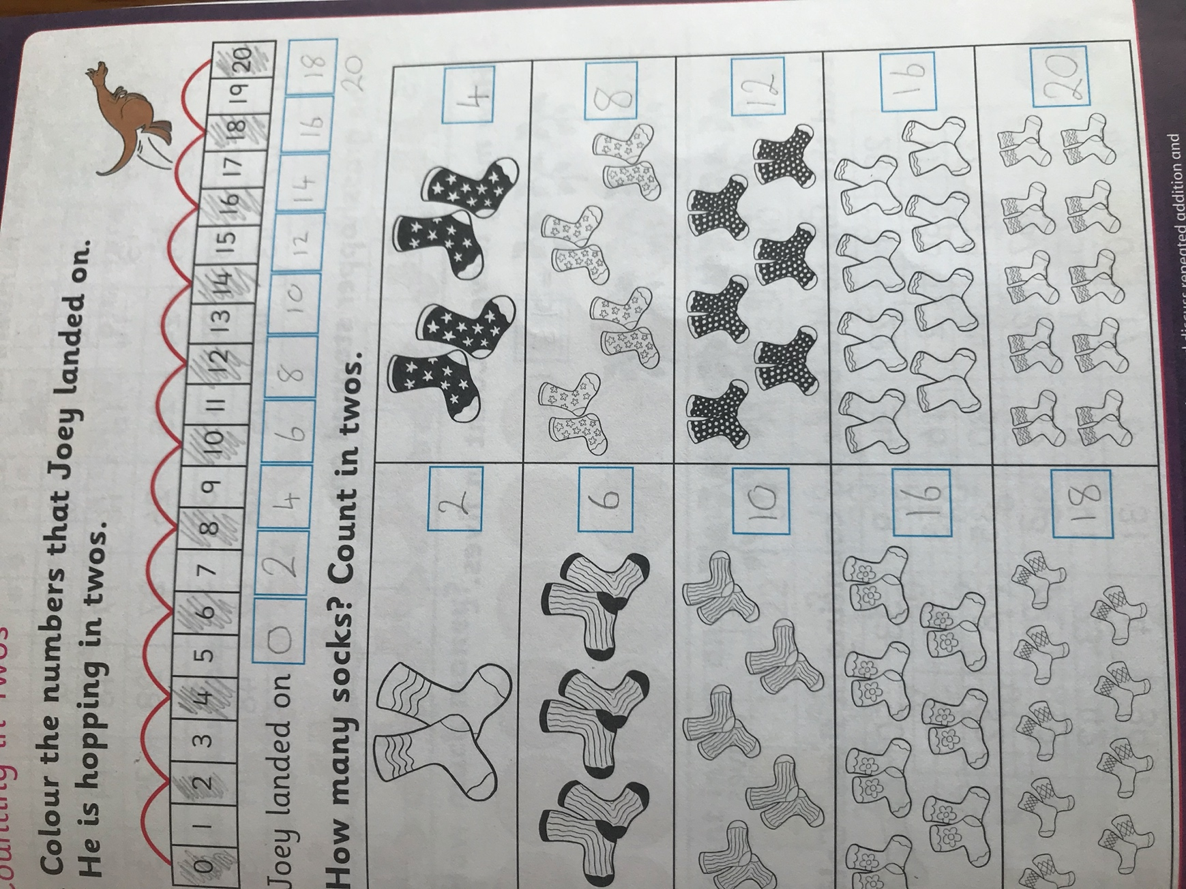
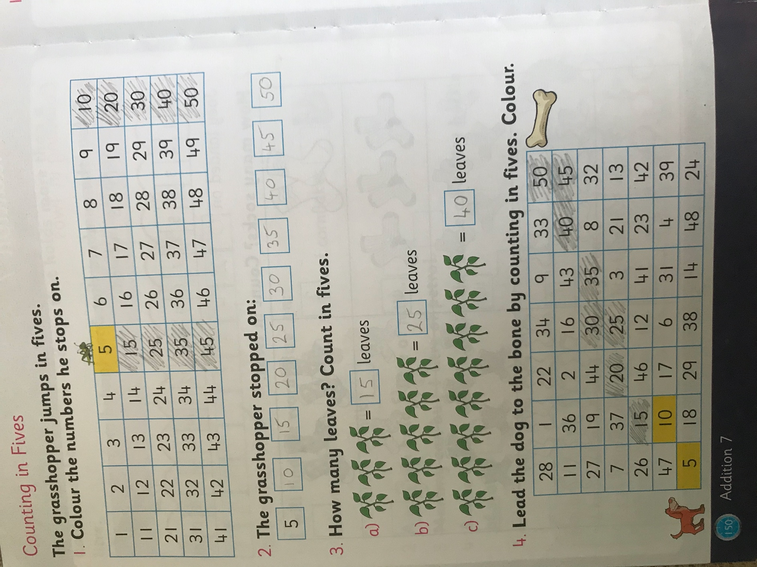
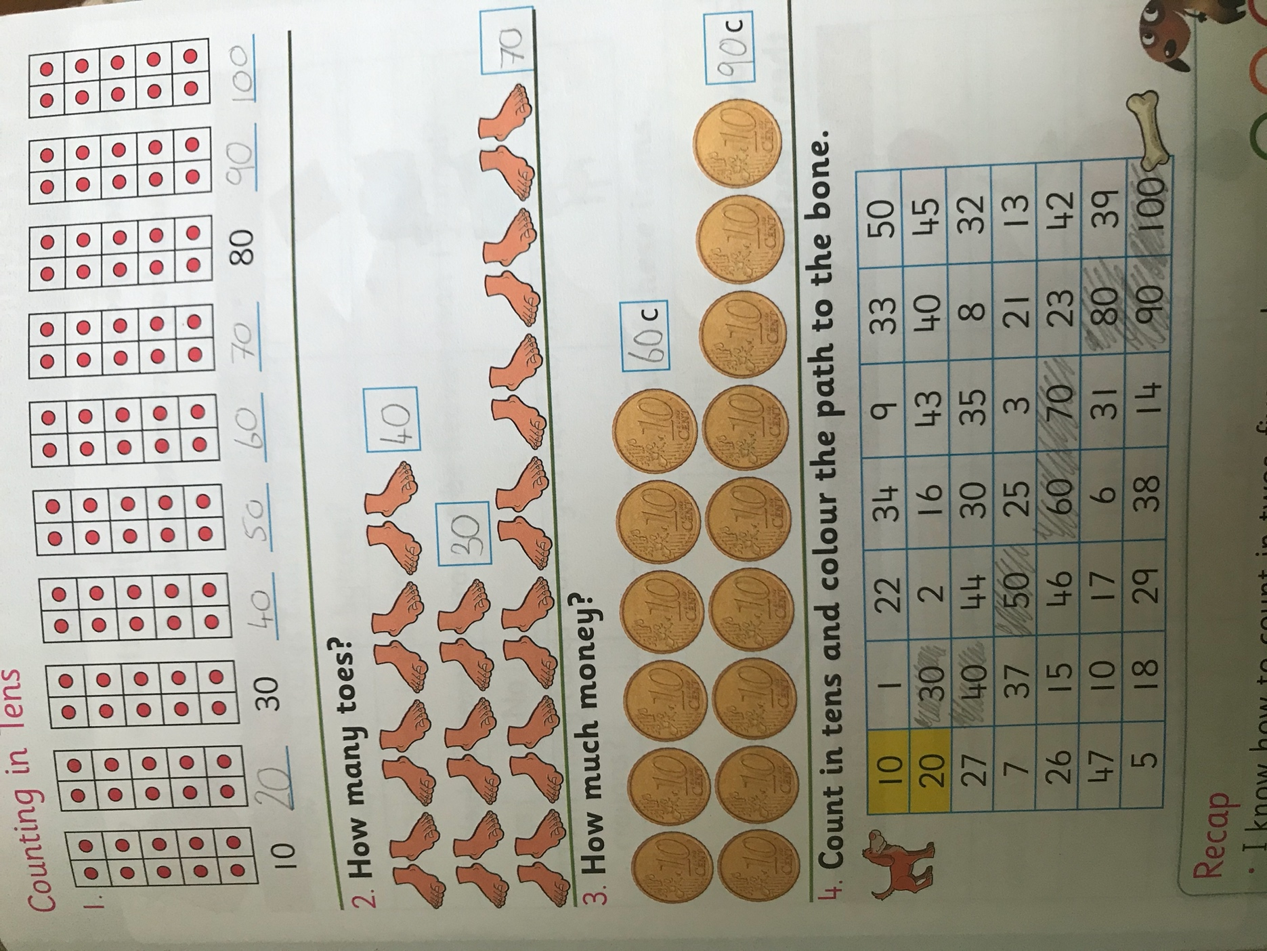

Suggested Daily Timetable

9.00-9.30 | Exercise (JoeWicks live (Youtube) / Cosmic Yoga (Youtube)/ Go Noodle website/ Active Break Ideas (see below)
9.30-10.45 | Work on the Core Subjects (English/Irish/Maths – See day-by-day activities below)
10.45-11.00 | Small Break-Have a snack and go outside for a run/play
11.00-12.00 | RTE School Hub
12.00-12.45 | Project Work – select an activity from project work section to work on this week.
12.45-1.15 | Lunch
1.15 onwards | Free Time
Core Subject Work

Monday

English:
My News – write a few sentences for your news. State the day, date, weather and some piece of news e.g. something you did at the weekend/ are looking forward to.
Starlight Combined Reading and Skills Book p.66 – read. P.67 Activity A and B
Spellbound: Complete any pages you have not finished
Homework copy: Write 2 sentences using your dolch words
Reading: Continue to encourage your daughter to read daily.
Oral Language Activity: Imagine you are in the circus. What would your talent be?

Maths:
Weight: Fun interactive balance activity online
https://toolkit4maths.com/cpdcol/cpd_math_manipulatives10/index.php?tpage=simple_balance/#/simple_balance

Cracking Maths – continue with any unfinished work
Weight p.153
Please correct any work your daughter does with her and help her learn from mistakes.

Gaeilge: An Páiste Cabáiste https://www.youtube.com/watch?v=JoKSeb34ixs&list=PLbcLsUBW9b3C_Ly8-utDRumtVXHf1Bn9z&index=2

Geography: What a Wonderful World: Night and Day p.43
Tuesday

English:
My News – write a few sentences for your news. State the day, date, weather and some piece of news e.g. something you did at the weekend/ are looking forward to.
Starlight Combined Reading and Skills Book p.68 Activity A, B and C
Spellbound: Complete any unfinished work
Homework copy: Write 2 sentences using your dolch words
Reading: Continue to encourage your daughter to read daily.

Maths:

Weight: Fun interactive balance activity online
https://toolkit4maths.com/cpdcol/cpd_math_manipulatives10/index.php?tpage=simple_balance/#/simple_balance

Cracking Maths – continue with any unfinished work
Weight p.154 (a bag of sugar weighs 1kg)

Please correct any work your daughter does with her and help her learn from mistakes.

Gaeilge: An Páiste Cabáiste https://www.youtube.com/watch?v=JoKSeb34ixs&list=PLbcLsUBW9b3C_Ly8-utDRumtVXHf1Bn9z&index=2

What a Wonderful World: Complete any activities you have not finished

Wellness Wednesday Activities

Please choose a few of these activities to do with your siblings or altogether as a family instead of school work.
Wellness Wednesdays are all about doing things that bring enjoyment and happiness.

Get out in the sunshine as much as possible today and make sure you get at least 60 minutes of exercise.

Boredom Busters has more activities that may be suitable for your family to take part in today.

Exercise
Joe Wick’s PE workout every weekday at 9am
Go Noodle
Cosmic Yoga
Skipping, cycling, dancing, going for a walks.
See Project Work/Active Breaks section for more!

Art
‘Draw with Don’ YouTube channel
‘Art Attack’ series on YouTube
Mindfulness colouring
Free drawing
Paint (with Bob Ross on Netflix / YouTube)
Origami
Sculpt with clay

Gardening
Pull weeds
Water flowers
Plant new flowers

Skills / Talents
Baking
Knitting
Learn to juggle
Do a magic trick
Write a play, a poem or a story

Meditation
Headspace for kids (app)
Cosmic Yoga
Read for pleasure
‘Spark joy!’ and organise possessions (eg. toys, clothes)

Games
Board games (eg. Scrabble, Articulate, Headbands…)
Cards (eg. Snap, Go Fish, Solitaire…)
Pen and paper games (eg. X’s and O’s, Stop the bus…)
Music games (eg. Karaoke, Musical statues..)
Outdoor games (eg. Obstacle course, football..)

Music
Learn to play an instrument or learn a new song
Listen to different genres or decades of music
Compose a song or piece of music
Strictly Come Dancing: Pick a song and prepare a dance routine
Do a music quiz

Television
RTE’s School Hub
Favourite movie/ T.V programme
Nature programmes eg. David Attenborough’s Blue Planet.
Thursday

English:
My News – write a few sentences for your news. State the day, date, weather and some piece of news e.g. something you did at the weekend/ are looking forward to.
Starlight Combined Reading and Skills Book p.69
Spellbound – finish any pages that are not finished
Homework copy: Write 2 sentences using your dolch words
Reading: Continue to encourage your daughter to read daily.
Listen to a story: https://www.oliverjeffers.com/books

Maths:
Metric weight activity
https://toolkit4maths.com/cpdcol/cpd_math_manipulatives10/index.php?tpage=metric_balance/#/metric_balance

Cracking Maths – continue with any unfinished work
Weight p.155
Please correct any work your daughter does with her and help her learn from mistakes.

Gaeilge: Damhsa: Kriss Kross https://www.youtube.com/watch?v=w3lLTxRIUcE&list=PLbcLsUBW9b3C_Ly8-utDRumtVXHf1Bn9z&index=6

What a Wonderful World: Complete any pages you have not finished

Fun Friday
English:
My News – write a few sentences for your news. State the day, date, weather and some piece of news e.g. something you did at the weekend/ are looking forward to.
Starlight Combined Reading and Skills Book – Reading Skills Test p.70 and 71
Homework copy: Write 2 sentences using your dolch words
Reading: Continue to encourage your daughter to read daily.

Maths:
Revise time: Use this fun online clock to revise telling the time. Ask your daughter to tell the time on the hour/ half past the hour for various times. Ask what is an hour before/after various times. Ask what is half an hour before/after various times. https://toolkit4maths.com/cpdcol/cpd_math_manipulatives10/index.php?tpage=clock/#/clock

Cracking Maths – Check up 4 p.156
Please correct any work your daughter does with her and help her learn from mistakes.

Gaeilge: Damhsa: Kriss Kross https://www.youtube.com/watch?v=w3lLTxRIUcE&list=PLbcLsUBW9b3C_Ly8-utDRumtVXHf1Bn9z&index=6

Summer Holidays: Brainstorm and create a poster with a list of the activities you would love to do this summer. Tick them off as you do them during the summer.

Active Breaks Ideas!

Frozen Dance Class
https://www.youtube.com/watch?v=y0RGGDusyKI

Supergirl Workout
https://www.youtube.com/watch?v=TGex6z_t4Mk

Cosmic Kids Yoga
https://www.youtube.com/user/CosmicKidsYoga

Kids Bop
https://www.youtube.com/channel/UCKE0Xnj818IDaHvIcRiq0Bg?app=desktop

